VLAN Configuration

Question
1. Draw a simple network diagram showing three devices connected to a switch and label the VLANs.

Answer
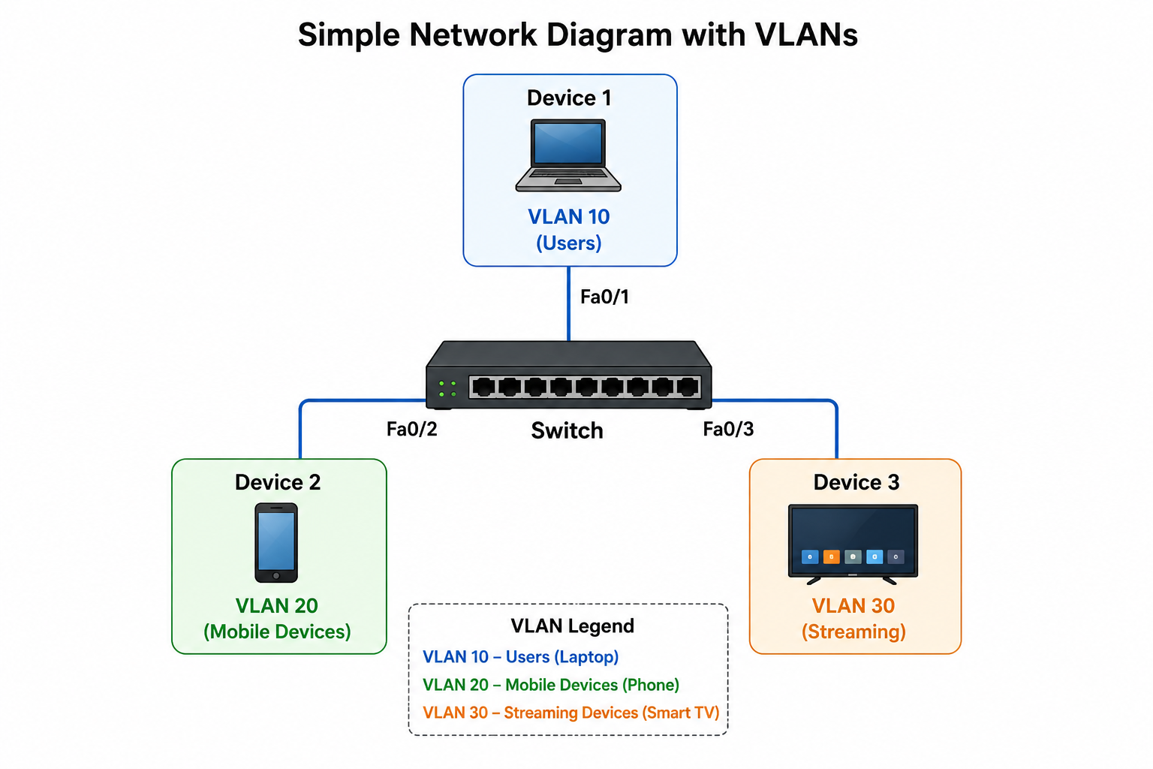

Question
2. Configure a simulated switch with VLAN 10 and VLAN 20, assign PCs, and verify connectivity.

Answer
Sample Cisco CLI Commands:
enable
configure terminal
vlan 10
name STREAMING
vlan 20
name PERSONAL
interface range fa0/1-3
switchport mode access
switchport access vlan 10
interface range fa0/4-5
switchport mode access
switchport access vlan 20
Test:
PCs in VLAN 10 can ping each other.
PCs in VLAN 20 can ping each other.
PCs in different VLANs cannot ping because no inter-VLAN routing is configured.

Question
3. Move a PC from VLAN 10 to VLAN 20 and verify connectivity.

Answer
Before:
interface fa0/3
switchport access vlan 10
After:
interface fa0/3
switchport access vlan 20
Result:
The PC can no longer communicate with VLAN 10 devices. It can now communicate with devices in VLAN 20 after receiving the correct IP configuration.

Question
4. Write a command list to assign 10 ports to VLAN 30 using a range command.

Answer
Sample Cisco CLI:
enable
configure terminal
vlan 30
name OFFICE
interface range fa0/1-10
switchport mode access
switchport access vlan 30
end
write memory
The 'interface range' command configures ports Fa0/1 to Fa0/10 together, avoiding repeated commands.

