Day 4: Hands-on Subnetting

Question
1. Given a network address of 192.168.10.0/24, divide it into 4 equal subnets and write down the subnet mask, network address, and broadcast address for each subnet.

Answer
To create 4 equal subnets, borrow 2 bits from the host portion.
New subnet mask: 255.255.255.192 (/26)
Subnet 1: Network 192.168.10.0 Broadcast 192.168.10.63
Subnet 2: Network 192.168.10.64 Broadcast 192.168.10.127
Subnet 3: Network 192.168.10.128 Broadcast 192.168.10.191
Subnet 4: Network 192.168.10.192 Broadcast 192.168.10.255

Question
2. For one of the subnets, assign valid IP addresses to 5 devices.

Answer
Using Subnet 1 (192.168.10.0/26)
Router: 192.168.10.1
Laptop 1: 192.168.10.2
Laptop 2: 192.168.10.3
Printer: 192.168.10.4
Mobile Phone: 192.168.10.5
Usable host range: 192.168.10.1 – 192.168.10.62.
The network address (.0) and broadcast address (.63) are not assigned to devices.

Question
3. Draw a simple diagram showing your subnet plan.

Answer
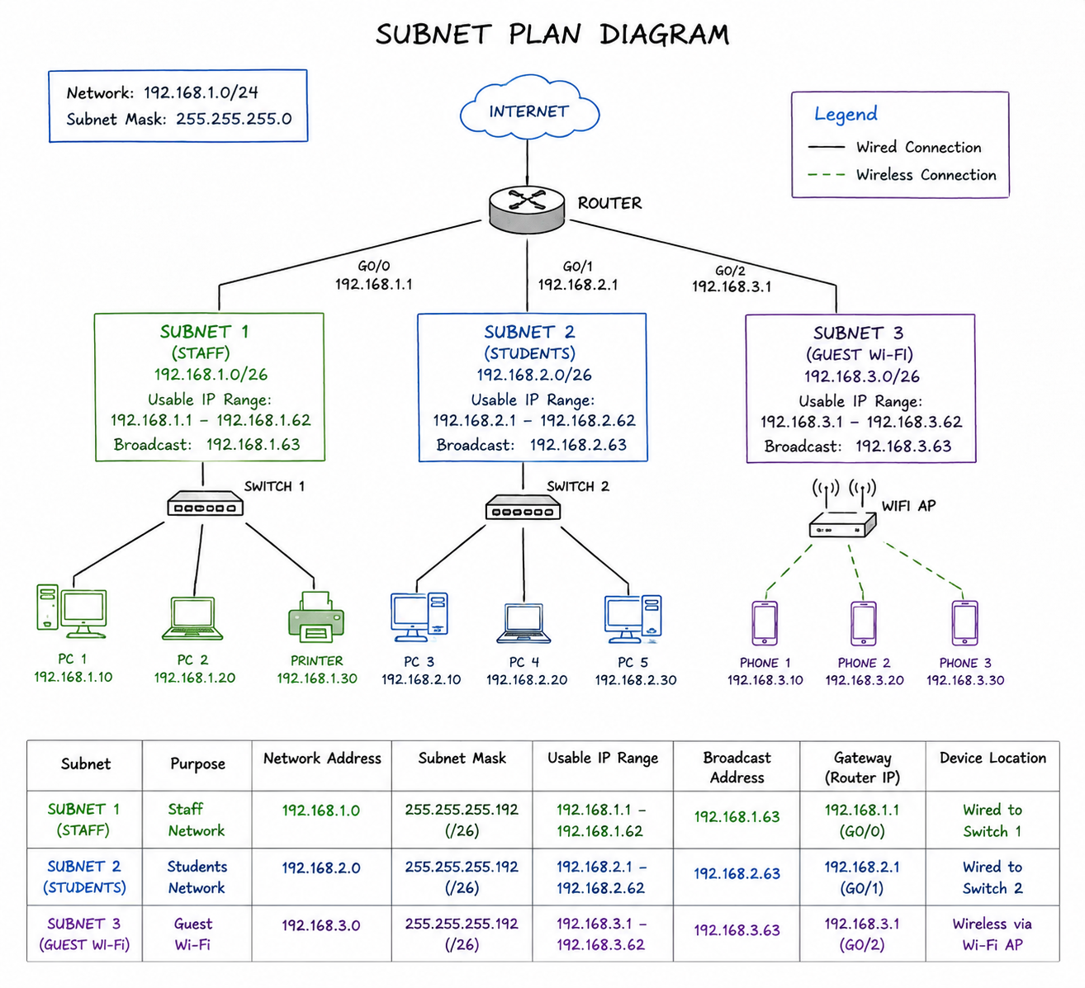

Question
4. Document the step-by-step subnetting process.

Answer
Step 1: Start with the network 192.168.10.0/24.
Step 2: To create 4 equal subnets, borrow 2 host bits because 2² = 4 subnets.
Step 3: The new subnet mask becomes /26 (255.255.255.192).
Step 4: Each subnet has 64 IP addresses, of which 62 are usable for devices.
Step 5: Choose one subnet and assign unique IP addresses to each device. Do not use the network or broadcast address because they are reserved.

