Wi-Fi Standards

Question
1. List 3 popular Wi-Fi standards (e.g., 802.11n, 802.11ac, 802.11ax) and for each, write one key difference in speed or frequency band.

Answer

Wi-Fi Standard | Frequency Band | Key Difference
802.11n (Wi‑Fi 4) | 2.4 GHz & 5 GHz | Up to 600 Mbps
802.11ac (Wi‑Fi 5) | 5 GHz | Higher speed, up to several Gbps
802.11ax (Wi‑Fi 6) | 2.4 GHz & 5 GHz (6 GHz on Wi‑Fi 6E) | Better speed, efficiency, and performance with many devices

Question
2. Draw a simple diagram showing how your smartphone connects to the internet via a Wi-Fi router at home.

Answer
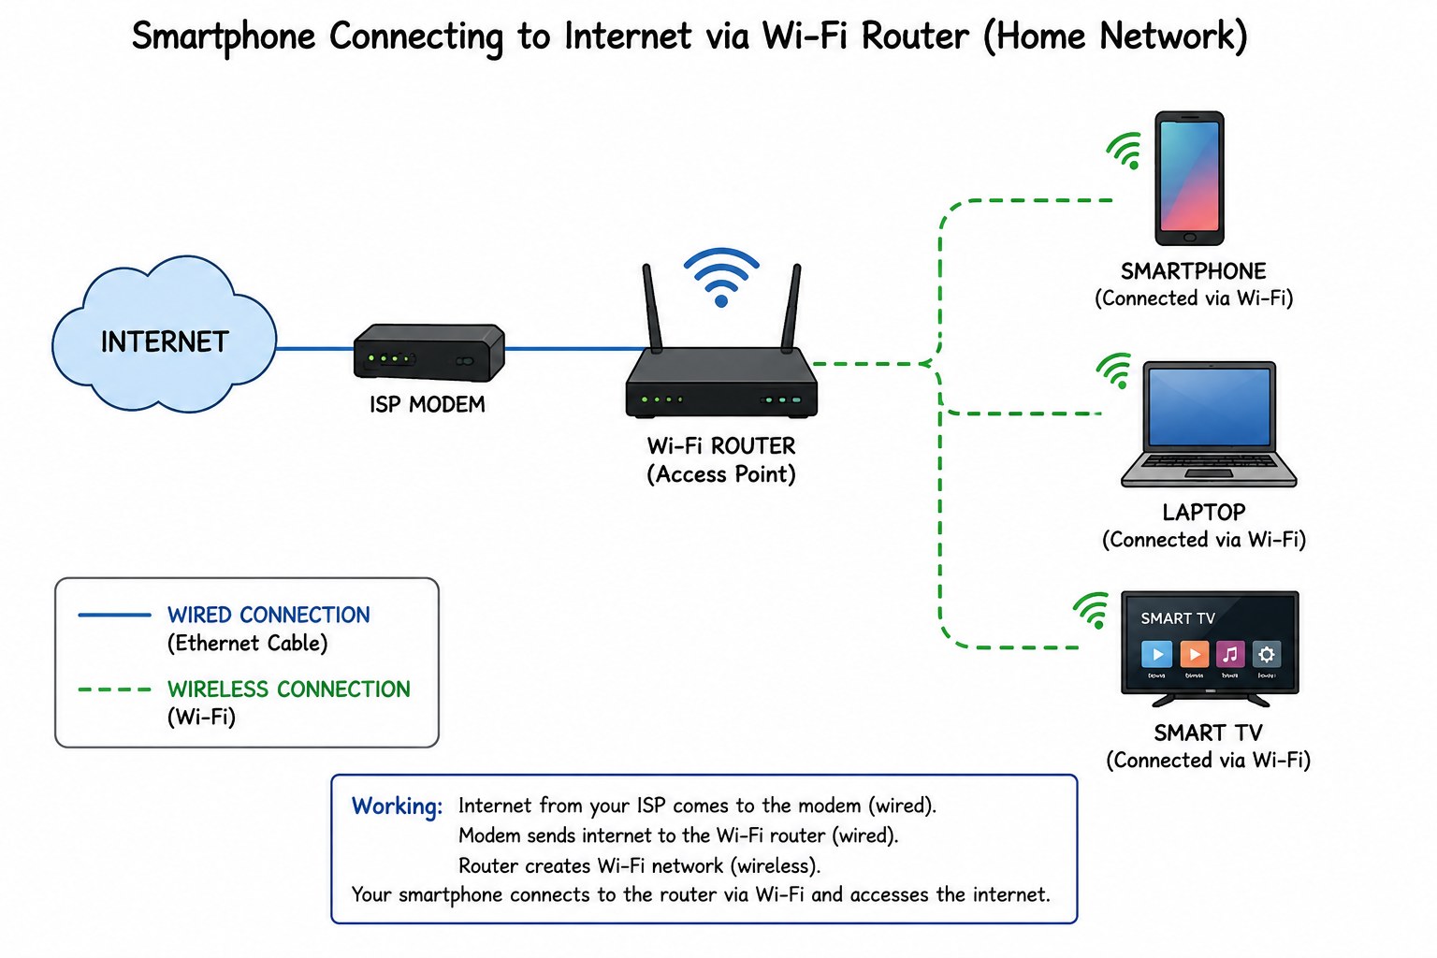
Wireless Connection: Smartphone ↔ Wi-Fi Router
Wired Connection: Router ↔ Modem/ISP ↔ Internet

Question
3. Scan for available Wi-Fi networks, note the SSID, signal strength, and security type for at least 3 networks, and explain which one you would choose.

Answer
Example (replace with your own scan results if required):
SSID Signal Strength Security
Home_WiFi Strong (90%) WPA3
Neighbor_5G Medium (65%) WPA2
Cafe_FreeWiFi Weak (40%) Open
I would choose Home_WiFi because it has the strongest signal and uses WPA3 security, providing better speed and protection.

Question
4. Explain what 'SSID hiding' is and give one advantage and one disadvantage.

Answer
SSID hiding means the Wi-Fi network name is not broadcast publicly. Users must manually enter the network name to connect.
Advantage:
It reduces the visibility of the network to casual users.
Disadvantage:
It does not provide strong security because attackers can still detect hidden networks using network tools, and it makes connecting new devices less convenient.

