Ex 2 – Darshini. R (20BCE1054)

Hotel Management System

FAQ Page

<!DOCTYPE html>

<!--Darshini. R 20BCE1054 27-07-2022-->

<html>

<head>

    <title>FAQs</title>

</head>

<body>

    <h1 align="center">Welcome to hotel DSquare</h1>

    <video width="500" height="400" controls>

        <source src="video.mp4">

    </video>

    <dl>

        <h2><b>Reservation</b></h2>

        <dt><p><b>Are there any restrictions on reserving a room in other countries?</b></p></dt>

        <dd>Reservations can be made at all DSquare hotels and resorts, including properties located outside the United States.</dd>

        <dt><p><b>Where can I find room descriptions?</b></p></dt>

        <dd>Descriptions of rooms can be viewed on hotel-specific sites or during the online room reservation process.</dd>

        <dt><p><b>What is the room rate? What taxes and/or additional charges apply?</b></p></dt>

        <dd>Room rates and availability display on dsqaure.com during the online reservation process.The total rate, including additional charges and taxes appears on the "Reservation Summary". Rates displayed do not include charges for special requests.</dd>

        <dt><p><b>Can I get my corporate rate when making a reservation online?</b></p></dt>

        <dd>When available, corporate rates may be reserved online.</dd>

        <dt><p><b>Can I book more than one room at a time?</b></p></dt>

        <dd>Yes, you can reserve two rooms at a time.Make a reservation now at dsqaure.com.</dd>

        <dt><p><b>How will I know if the room I've selected is available?</b></p></dt>

        <dd>Only available rooms will display during the reservation process.</dd>

        <dt><p><b>Will I be guaranteed that my room will have the bed type, view or location I requested?</b></p></dt>

        <dd>When making a reservation online, you can select a bed type specific room. Choices vary depending on availability. DSquare is committed to accommodating room type preferences and requests. Occasionally, we receive more requests than are available at a particular hotel or resort. If this happens, every effort will be made to meet your room preferences.</dd>

    </dl>

    <footer>

        <a href="">About Us</a>

        <a href="">Contact Us</a>

        <a href="">Home page</a>

        <br><br>

        Created By: Darshini. R (20BCE1054) 27.07.2022

    </footer>

</body>

</html>

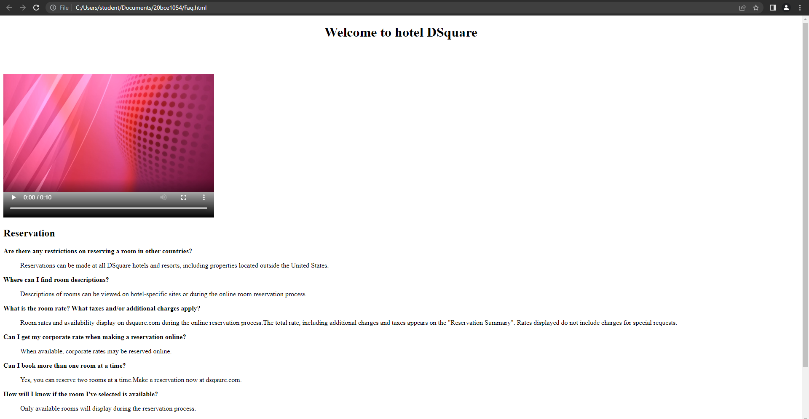

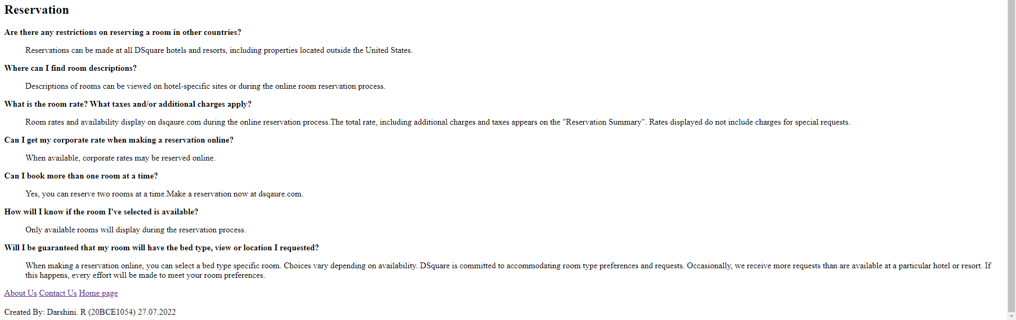

Form.html

<!DOCTYPE html>

<!--Darshini. R 20BCE1054 27-07-2022-->

<html>

<head>

    <title>Sign Up</title>

</head>

<body>

    <form align="center">

        <table align="center">

            <tr>

                <td><b>Name</b></td>

                <td><input type="text" placeholder="Name" name="c_name"></td>

            </tr>

            <tr>

                <td><b>Username</b></td>

                <td><input type="text" placeholder="Username" name="user_name"></td>

            </tr>

            <tr>

                <td><b>Email Address</b></td>

                <td><input type="email" placeholder="Email address" name="email_id"></td>

            </tr>

            <tr>

                <td><b>Password</b></td>

                <td><input type="password" placeholder="Password" name="pass_word"></td>

            </tr>

            <tr>

                <td><b>Re Password</b></td>

                <td><input type="password" placeholder="RePassword" name="repass_word"></td>

            </tr>

            <tr>

                <td><input type="submit" name="Sign Up"></td>

            </tr>

        </table>

        <a href="">Login</a>

    </form>

</body>

</html>

SignUp page

<!DOCTYPE html>

<!--Darshini.R 20BCE1054 27-07-2022-->

<html>

<head>

    <title>Sign Up</title>

</head>

<body>

    <h1 align="center">Welcome to hotel DSquare</h1>

    <img src="https://cdn1.goibibo.com/voy_ing/t_g/0c1457f659f611ea93b80242ac110009.jpg">

    <br><br>

    <audio controls>

        <source src="song.mp3">

    </audio>

    <br><br>

    <iframe src="Form.html" width="500" height="250"></iframe>

    <br><br>

    <a href="https://en.wikipedia.org/wiki/Hotel">Click Here to Know More</a>

    <br><br>

    <br><br>

    <footer>

        Created By: Darshini. R (20BCE1054) 27.07.2022

    </footer>

</body>

</html>

