**Lesson 03 Demo 07**

**Deploying a Voting Application**

**Objective:** To deploy a voting application using Kubernetes pods

**Tools required:** kubeadm, kubectl, kubelet, and containerd

**Prerequisites:** A Kubernetes cluster (refer to Demo 01 from Lesson 01 for setting up a cluster)

Steps to be followed:

1. Create a namespace
2. Create an application for deployment
3. Verify the deployment of the application

**Step 1: Create a namespace**

1. Create a namespace named **vote** in the master node using the following command:

**kubectl create namespace vote**

to facilitate

1. Execute the following command to set the **vote** namespace as the current context:

**kubectl config set-context --current --namespace=vote**

**Step 2: Create an application for deployment**

1. Execute the following command to clone the repository that contains the voting application:

**git clone https://github.com/dockersamples/example-voting-app.git**

1. Navigate to the cloned directory using the following command:

**cd example-voting-app/**

1. Execute the following command to deploy the resources defined in the configuration files located in the **k8s-specifications** directory:

**kubectl create -f k8s-specifications/**

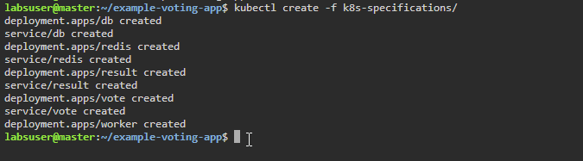

**Step 3: Verify the deployment of the application**

1. Verify the created Kubernetes pod state using the following command:

**kubectl get pod -n vote -o wide**

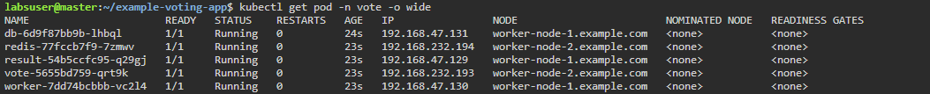

1. Execute the following command to retrieve information about deployments in the **vote** namespace:

**kubectl get deployment -n vote**

1. To get detailed information about the pods within the **vote** namespace, run the following commands:

**kubectl get pod --namespace vote -o wide**

**kubectl get svc --namespace vote -o wide**

Remember to note the **NODE** and **PORT(S)** where the pod is running.

1. Execute the following command to get the **INTERNAL-IP** address of **worker-node-1.example.com**:

**kubectl get nodes -o wide**



1. Open the **Firefox** browser on the master node's desktop and paste the **INTERNAL-IP** address and port number

|  |
| --- |
| **Note:** Use the current IP address of **worker-node-1.example.com** and the port number where the **resulting** pod is deployed |

By following these steps, you have successfully deployed a voting application using Kubernetes pods.