**UI Design**

Project Name: *Employee Management System*

The following section outlines the overall frontend design and flow of the *WorkTrack*: Employee Management System.

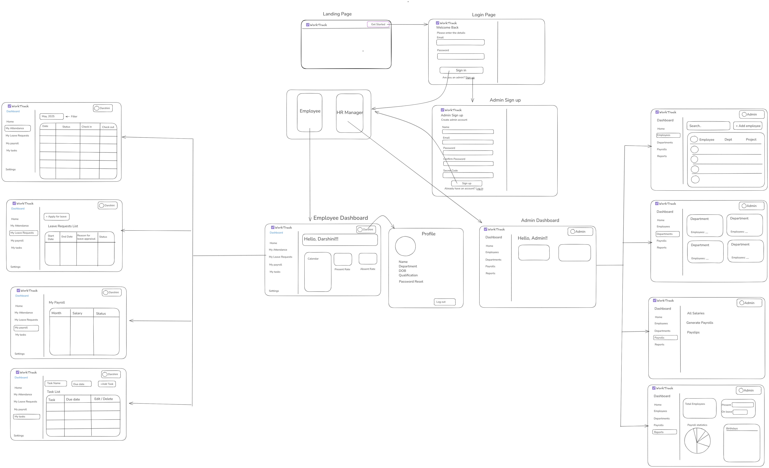

|  |  |
| --- | --- |
| The **WorkTrack** application begins with a minimalistic and professional **Landing Page** that introduces the system. This page contains a prominent “Get Started” button that directs the user to the **Login Page**. On the login screen, users are prompted to enter their credentials—email and password. Beneath the form, there’s an option to sign up as an admin if the user does not have an account. Once logged in, users are directed to their respective dashboards based on their role. |  |

|  |  |
| --- | --- |
|  | If the user is an admin, they are redirected to the **Admin Dashboard**. The Admin Dashboard is structured with a clean layout that includes a left-side vertical navigation bar. This navigation bar remains consistent throughout the admin view and includes links to Home, Employees, Departments, Payrolls, and Reports. At the top-right corner of the screen, a circular profile icon displays the logged-in admin’s image, allowing access to account details and logout functionality. |

The Home screen displays key statistics such as the total number of employees, active departments, number of employees currently working (based on attendance), number of employees on leave, and birthdays for the current day.

Clicking on the Employees section leads to a screen showing a searchable and filterable list of all employees with options to add new employees, view or update details, or deactivate accounts. The Departments section allows the admin to view existing departments and add or remove departments as needed. The Payrolls screen is used to view all salaries, bonuses, deductions, and generate payslips for a specific period. The Reports section provides visual insights including charts on attendance trends, payroll statistics, and leave summaries.

|  |  |
| --- | --- |
| On the other hand, if the logged-in user is an employee, they are redirected to the **Employee Dashboard**. The sidebar for employees includes Home, My Attendance, My Leave Requests, My Payroll, My Tasks, and Settings. The Home screen welcomes the employee by name and provides a snapshot of their current status, including a calendar view of attendance and visual indicators for presence and absence rates. |  |

The My Attendance section allows employees to view their daily attendance records with date, check-in, check-out, and status. My Leave Requests shows a list of all applied leaves, their status, and an option to request a new leave by selecting a date range and providing a reason.

|  |  |
| --- | --- |
|  | My Payroll displays details like basic salary, deductions, bonuses, and net salary along with payslip downloads. The Tasks section displays any tasks assigned to the employee by department or HR, including task status and deadlines.  Profile management is accessible through the circular avatar on the top right, which when clicked opens the Profile screen showing the employee’s name, department, date of birth, and an option to reset the password. |

All forms, modals, and tables throughout the UI are styled using CSS for a consistent, modern look. JavaScript is used to add interactivity such as form validations, dynamic table loading, sidebar toggling, and modal behaviour. This structure ensures that the system is intuitive, informative, and responsive for both admins and employees, supporting seamless interaction and data flow throughout the application.

You can access the design using this link also: <https://excalidraw.com/#json=DWEQMI4qv70GaD1uyT4ql,UbnuFItc6TPZatUTGEw2Hw>