What is Unit Testing?

**Unit testing** is a type of software testing where individual units or components of a software are tested. The purpose is to validate that each unit of the software code performs as expected.

What is Functional Testing?

Functional testing is a type of software testing that validates the software system against the functional requirements/specifications.

Benefits of testing as Developer Perspective

* It ensures the proper working of all the functionalities of an application/software/product.
* It ensures that the software/product works as expected.
* It ensures security and safety.
* It enables the developer to fine-tune code and ensure that the module functions properly.
* it allows you to test parts of a project without relying on others for completion.
* It improves the quality of the product.

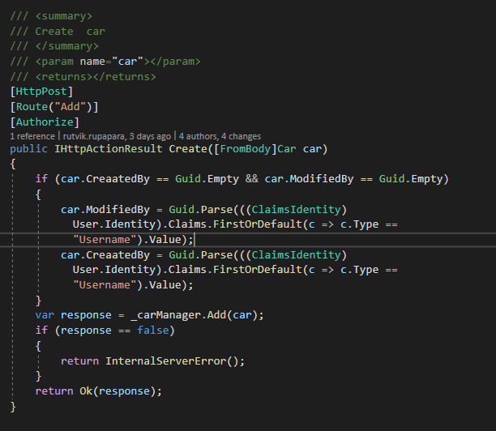**Example 1:**

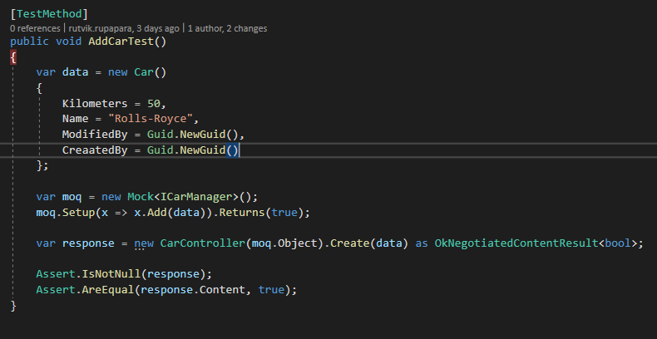**Unit Test 1:**

**Example 2:**

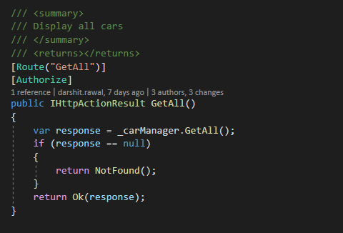

**Unit Test 2:**

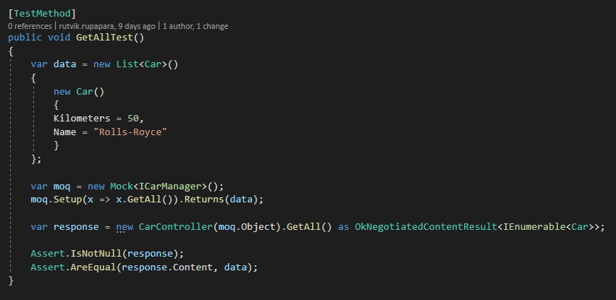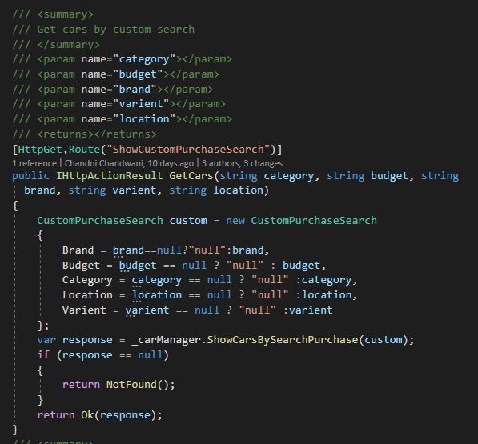**Example 3:**

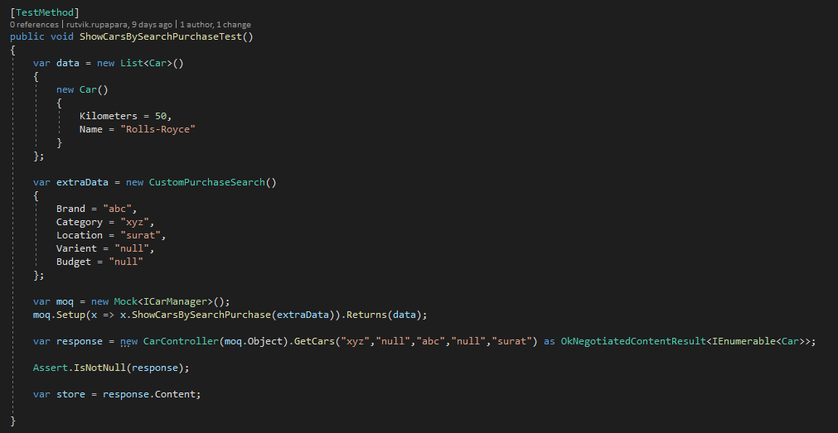**Unit test 3:**

**Example 4:**

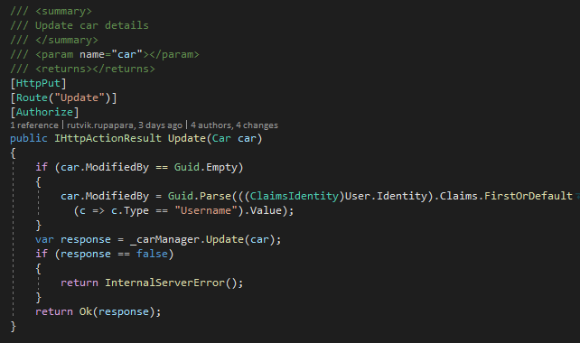

**Unit Test 4:**

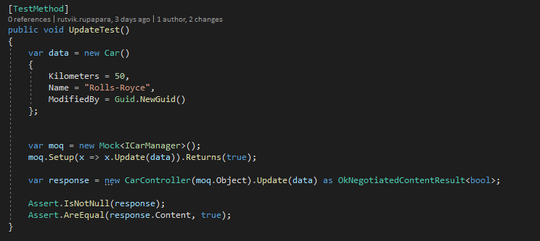

**Example 5:**

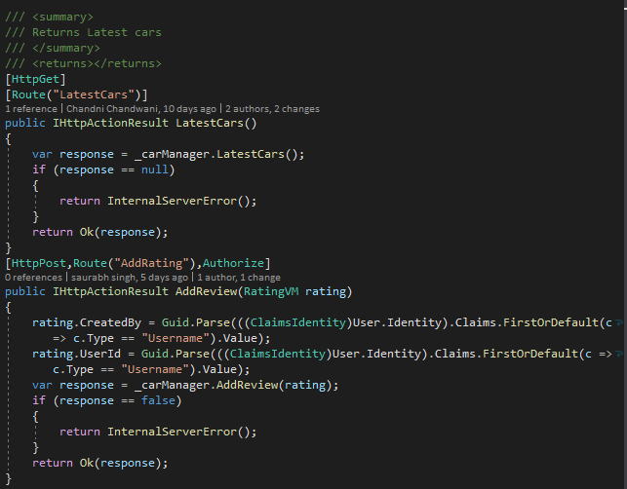

**Unit Test 5:**

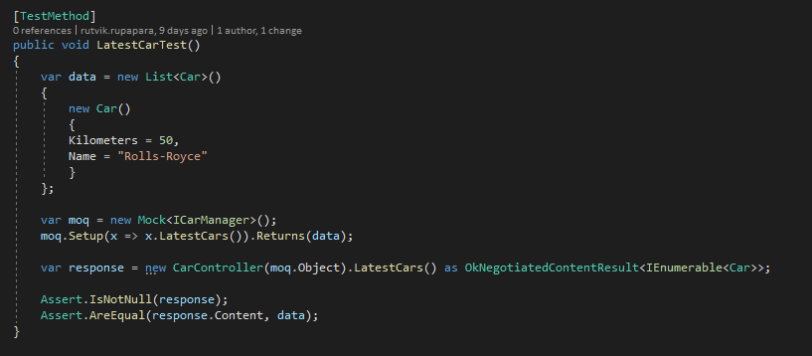

**Example 6:**

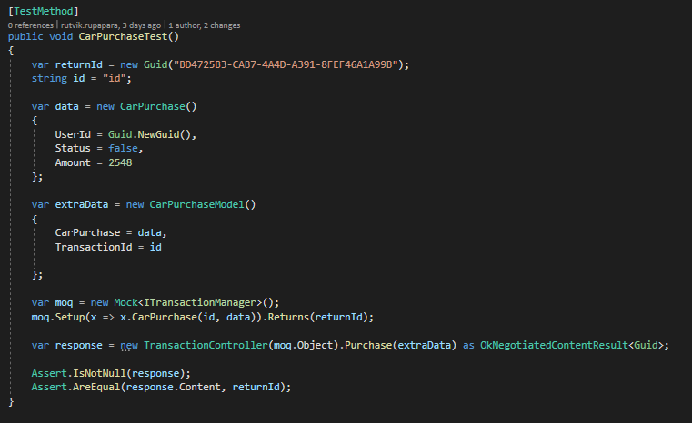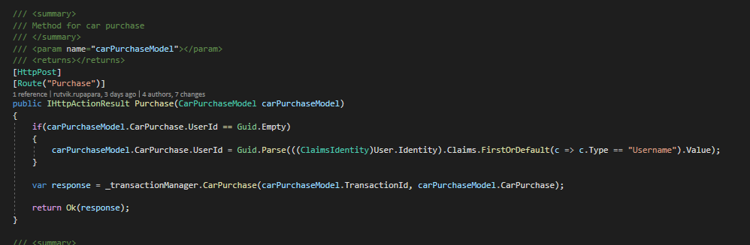**Unit Test 6:**

**Example 7:**

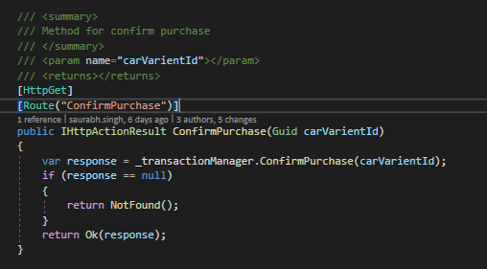

**Unit Test 7:**

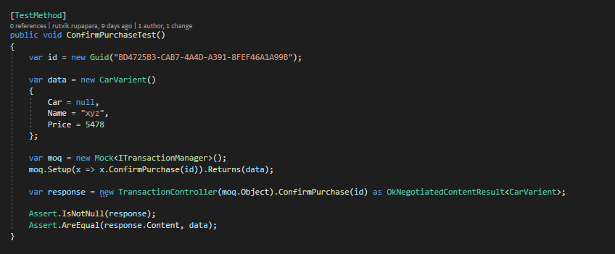

**Example 8:**

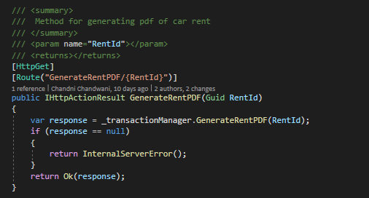

**Unit Test 8:**

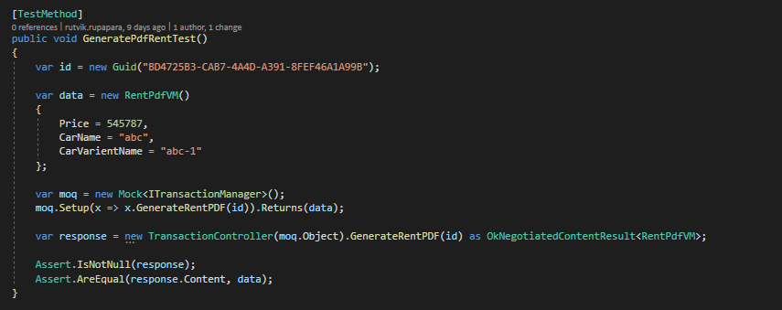

**Example 9:**

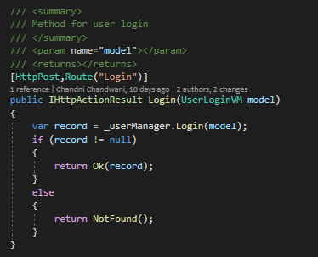

**Unit test 9:**

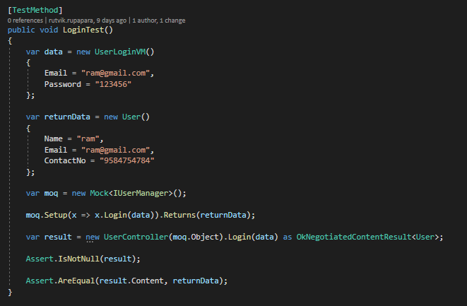

**Example 10:**

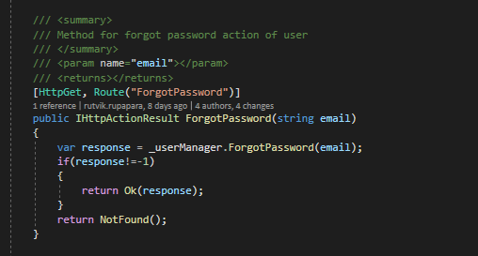

**Unit test 10:**

