
SAL EDUCATION
SAL ENGINEERING AND TECHNICAL INSTITUTE
Opp. Science city, Sola-Bhadaj Road, Ahmedabad, Gujarat 380060
Ph:- 079 67129000 Website: www.sal.edu.in

Student’s Weekly Report of Internship

Student Name: | Thakkar Krinal Balkrushanbhai
Enrollment Number: | 231263116020
Name Of Organization: | Demaze Technologies
External Guide Name: | Deep Suthar
External Guide Contact details: | Email: | info@demaze.in | Mob No: | 7069633777
Internal Faculty Guide Name: | Prof. Himani Patel

Week 2: JavaScript Advanced & DOM
Monday:
DOM Manipulation: Accessing HTML element

DOM Manipulation: Accessing HTML Elements (Theory)
The DOM (Document Object Model) is a structured representation of an HTML document.
It allows JavaScript to access, modify, add, or remove HTML elements dynamically after the page loads.
Accessing HTML elements means selecting specific elements from the webpage so JavaScript can work with them.

Why Accessing Elements Is Important
- To change content dynamically
- To update styles
- To handle user interactions
- To make web pages interactive and responsive
Without accessing elements, JavaScript cannot affect the webpage.

Common Ways to Access HTML Elements
- By ID – Selects a single unique element
- By Class Name – Selects multiple elements with the same class
- By Tag Name – Selects elements based on HTML tag
- Query Selector – Uses CSS-style selectors for flexibility
Each method helps target elements accurately based on the page structure.

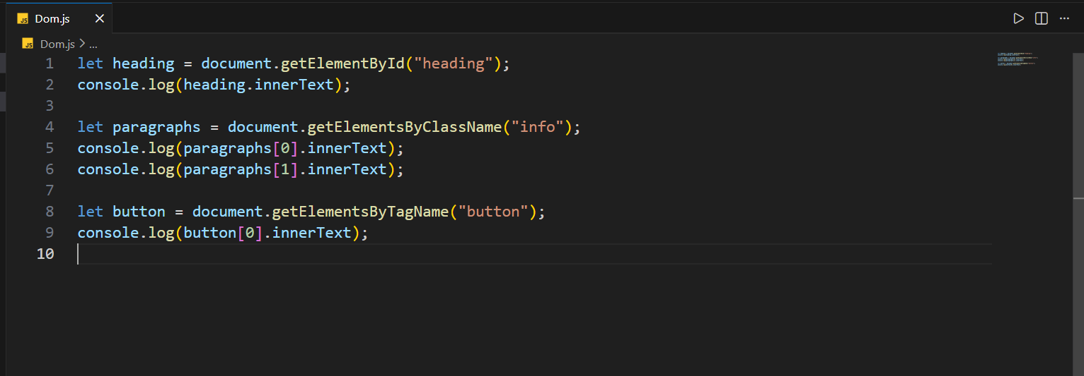
Output (Console):

Welcome
JavaScript DOM Example
Internship Practice
Click

Tuesday:
Event handling is the process of responding to user actions on a webpage.
An event occurs when a user interacts with an element, and JavaScript executes specific code to handle that action.
Key idea:
User action → Event occurs → JavaScript responds
Why Event Handling Is Important
- Makes web pages interactive
- Allows response to user input
- Connects user actions with program logic
- Essential for forms, buttons, and navigation
Without event handling, a webpage remains static.

Common Types of Events
- Mouse events (click, double-click)
- Keyboard events (key press, key release)
- Form events (submit, change)
- Window events (load, resize)
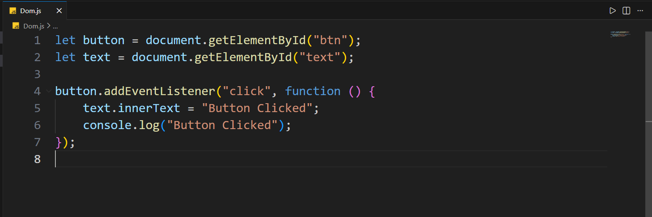
Wednesday:
JavaScript ES6 features: Template literals, Destructuring

Template Literals (Theory)
Template literals provide a modern way to create strings.
They allow values and expressions to be embedded directly inside strings, improving readability.
Key characteristics:
- Use backticks instead of quotes
- Support variable embedding
- Allow multi-line strings
- Reduce string concatenation
Why they are useful:
- Make code easier to read
- Improve clarity in dynamic text
- Commonly used in messages, UI text, and logs

Destructuring (Theory)
Destructuring is a feature that allows extracting values from arrays or objects and storing them into variables in a concise way.
Key characteristics:
- Works with arrays and objects
- Reduces repetitive code
- Improves readability
- Makes data handling simpler
Why it is useful:
- Clean and structured variable assignment
- Easy access to required values
- Frequently used in functions and APIs

Thursday:
Local storage & session storage
Local Storage
- Used to store data in the browser permanently
- Data remains available even after closing and reopening the browser
- Stores data in key–value pair format
- Commonly used for saving user preferences and settings

Session Storage
- Used to store data for a single browser session
- Data is removed automatically when the browser tab is closed
- Stores data in key–value pair format like local storage
- Commonly used for temporary data such as login session information

Friday:
Small project: To-Do List using JS and DOM

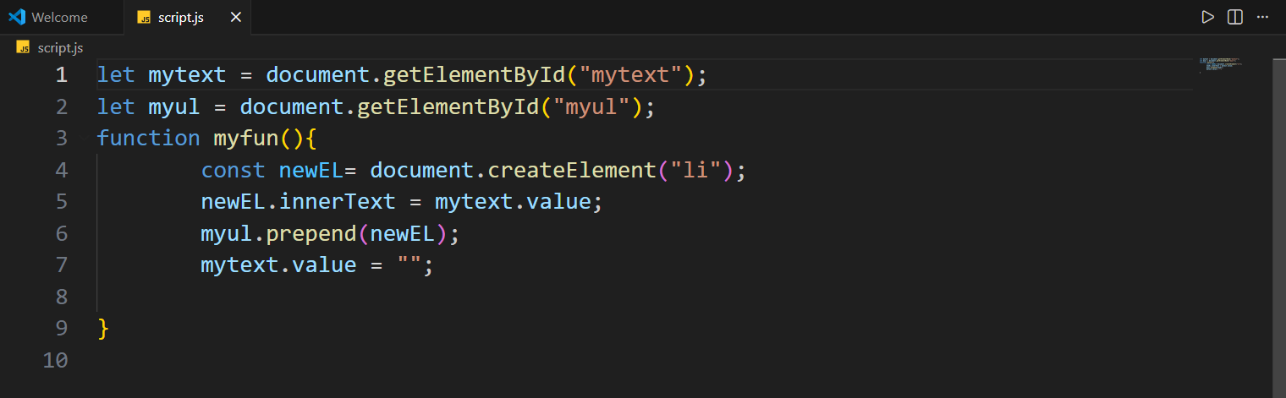

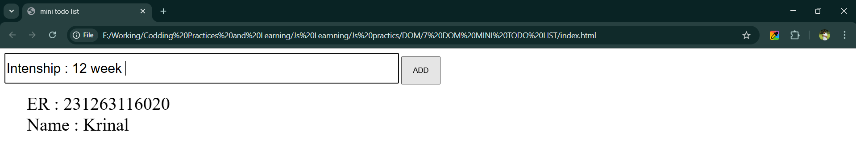

Summary of Work Done Till Date

- Learned DOM manipulation and accessing HTML elements
- Studied event handling and user interactions
- Learned ES6 features like template literals and destructuring
- Understood local storage and session storage
- Developed a To-Do List project using JavaScript and DOM

Plans for next week:

- Start learning React.js fundamentals
- Understand JSX syntax
- Learn component-based architecture
- Create basic React components

Total Working Hrs: ______________ Signature of Student:

The above entries are correct and the grading of work done by Trainee is
Excellent | Very Good | Good | Fair | Below Average | Poor

Signature of External Guide with Company Seal: Signature of Internal Guide

Date: Date:

