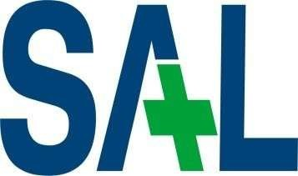

SAL EDUCATION

SAL ENGINEERING AND TECHNICAL INSTITUTE

Opp. Science city, Sola

-

Bhadaj Road, Ahmedabad, Gujarat 380060

Ph:

-

079 67129000

Website: www.sal.edu.in

Student’s Weekly Report of Internship

Student Name: | Thakkar Krinal Balkrushanbhai
Enrollment Number: | 231263116020
Name Of Organiza on: | Demaze Technologies
External Guide Name: | Deep Suthar
External Guide Contact details: | Email: | info@demaze.in | Mob No: | 7069633777
Internal Faculty Guide Name: | Prof. Himani Patel

Week 12 – Final System Testing & Documentation
Objective of Week 12
- Perform final system testing
- Fix all bugs and errors
- Improve performance
- Complete UI/UX final review
- Prepare final documentation

Monday – Full System Testing
Work Done:
- Tested complete system flow:
  - User registration & login
  - Admin login & dashboard
  - Job posting & applying
  - AI Resume Builder
  - Message panel
  - Notification system
- Checked data flow between frontend and backend
Code Used (Testing API Example):
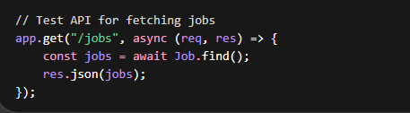
Explanation:
This API is used to fetch job data from the database. It was tested using Postman to ensure correct data retrieval.
Output:
- All modules were working together correctly
- Minor UI alignment issues were identified+

Tuesday – Bug Fixing
Work Done:
- Fixed issues found during testing:
  - Resolved login session expiration issue
  - Fixed delay in email notifications
  - Corrected message synchronization problem
Code Example (Session Fix):
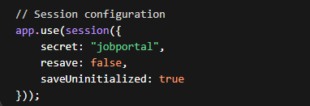
Explanation:
This middleware maintains the user session so that users remain logged in without interruption.
Output:
- Login system became stable
- Notifications worked properly
- No data mismatch issues

Wednesday – Performance Optimization
Work Done:
- Optimized database queries
- Reduced API response time
- Improved dashboard loading speed
Code Example (Optimized Query):
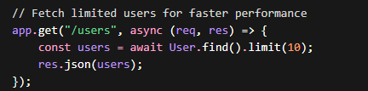
Explanation:
Instead of loading all users at once, only a limited number of records are fetched to improve performance.
Output:
- Faster system response
- Smooth dashboard experience

Thursday – UI/UX Final Review
Work Done:
- Reviewed complete UI:
  - Mobile responsiveness
  - Button alignment
  - Dashboard layout
  - Notification design
- Improved styling consistency
Code Example (UI Improvement):
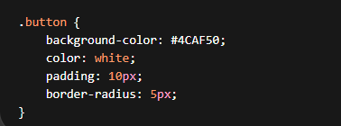
Explanation:
Improved button styling to make the interface more user-friendly and visually appealing.
Output:
- Fully responsive design
- Clean and professional interface

Friday – Final Documentation
Work Done:
- Prepared complete project documentation:
  - Project overview
  - Features and modules
  - Code snippets
  - Outputs and screenshots
- Organized report for final submission
Documentation Includes:
- Super Admin Dashboard
- AI Resume Builder
- Notification System
- Message Panel
- UI/UX Design
Output:
- Final report completed
- Ready for submission

Project Output :

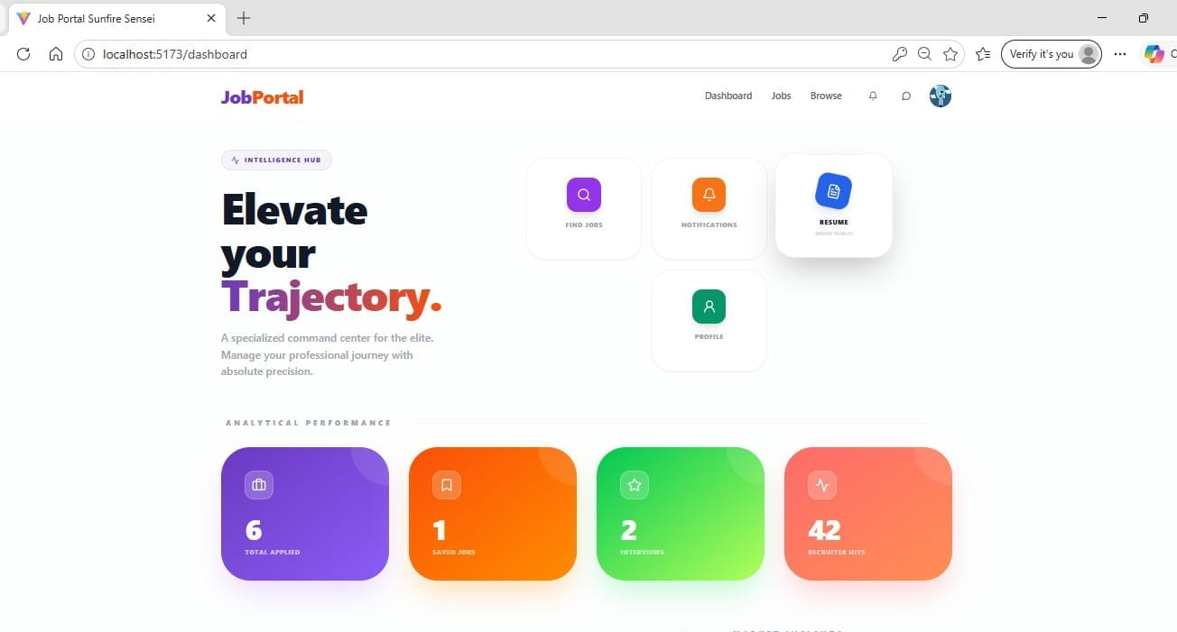

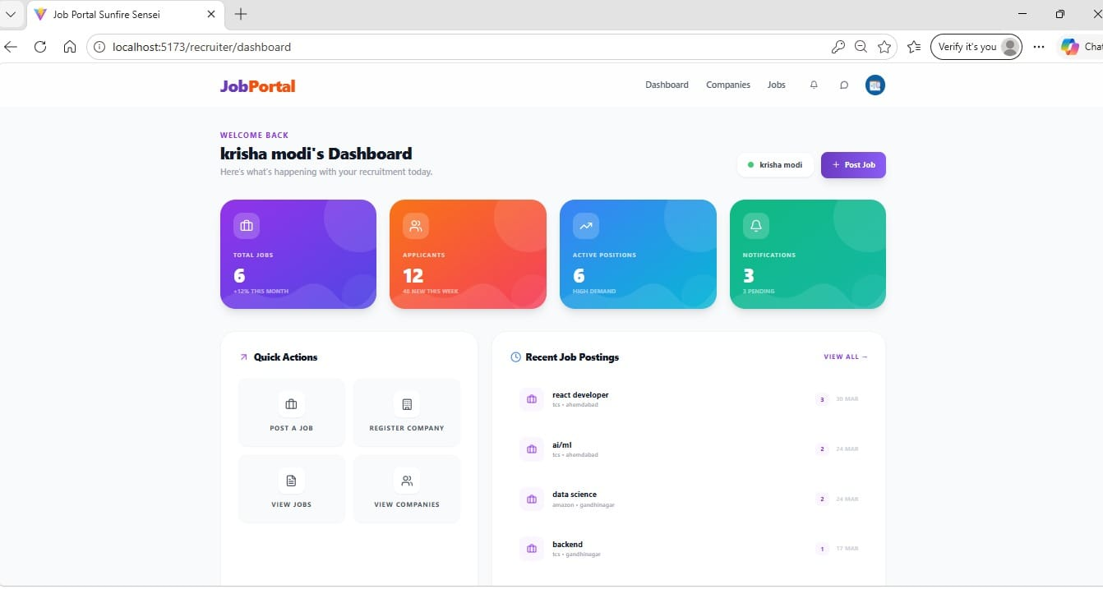
Summary Of Work Done ll Date :
- Completed full system testing
- Fixed all bugs and issues
- Improved performance and speed
- Finalized UI/UX design
- Completed project documentation
👉 The system is now:
- Fully functional
- Stable and optimized
- Ready for deployment

Total Working Hrs: ______________ Signature of Student:

The above entries are correct and the grading of work done by Trainee is
Excellent | Very Good | Good | Fair | Below Average | Poor

Signature of External Guide with Company Seal: Signature of Internal Guide

Date: Date:

