**Task 1: Automated Instance Management Using AWS Lambda and Boto3**

***Objective:****Create a Lambda function that will automatically manage EC2 instances based on their tags.*

Creating 2 EC2Instances

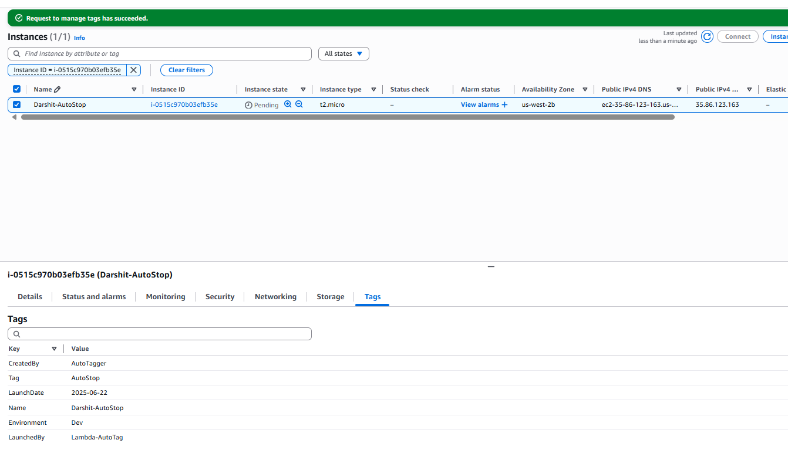

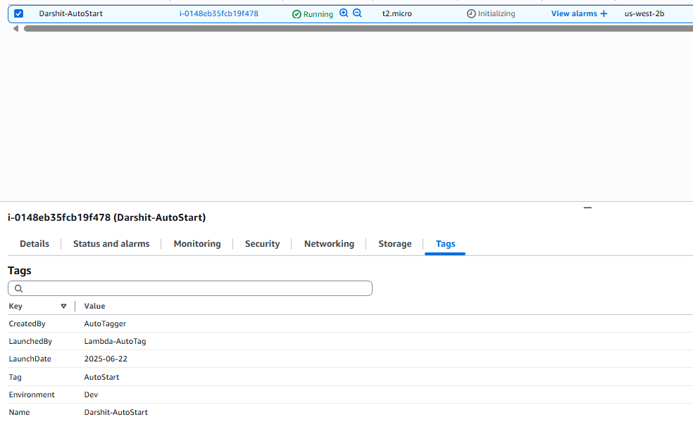

2 EC2 instances have been created with the appropriate tags.

IAM Role Created

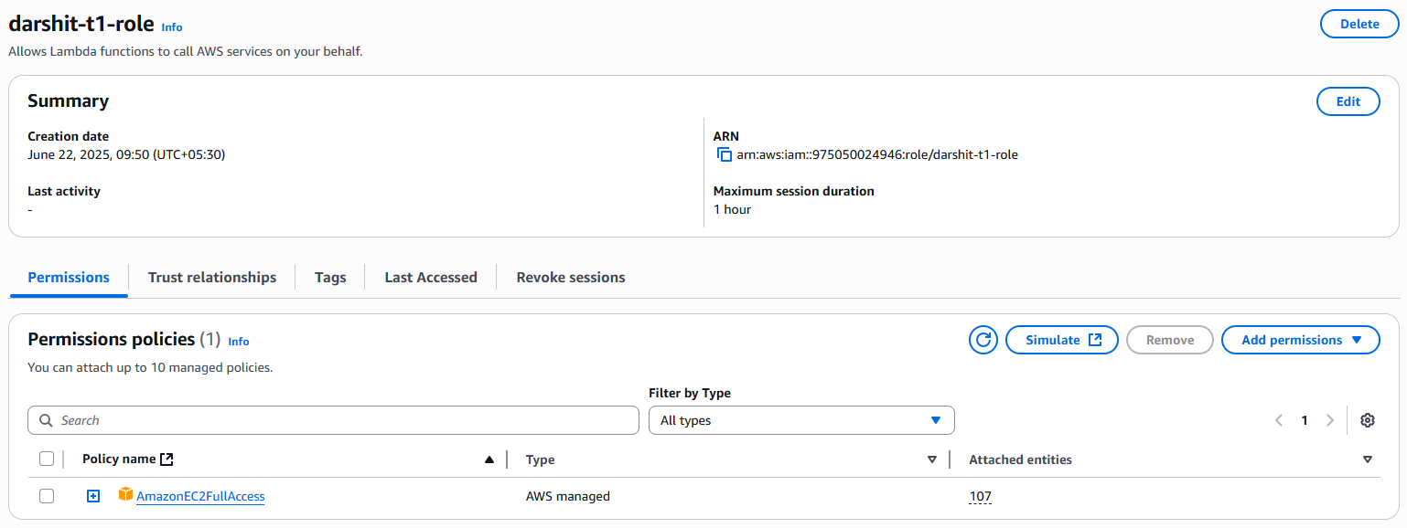

Lambda Function created.

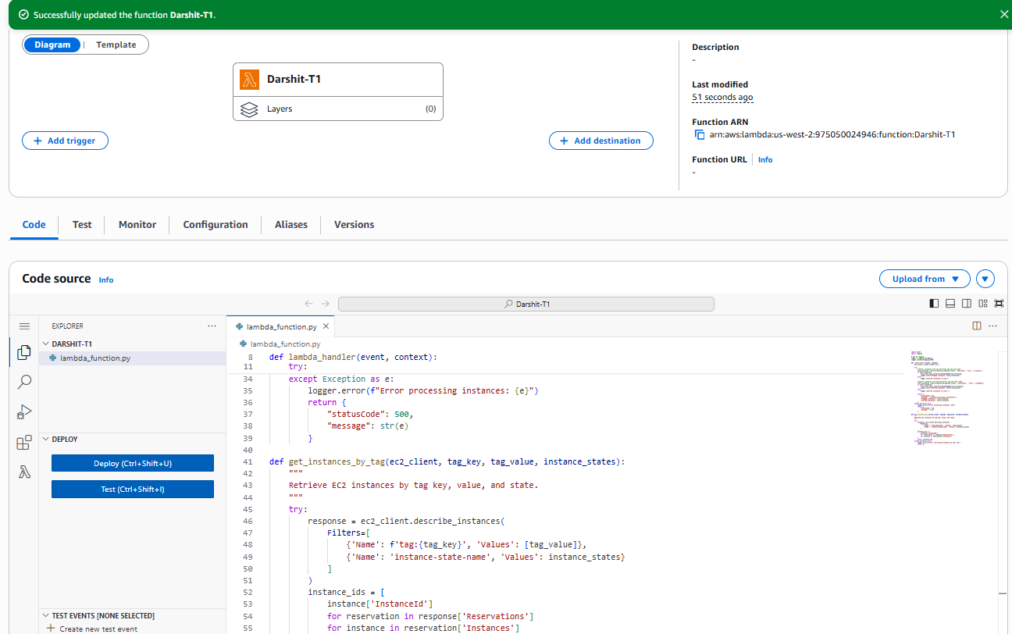

On Running the function, the end summary clearly shows an instance being stopped.

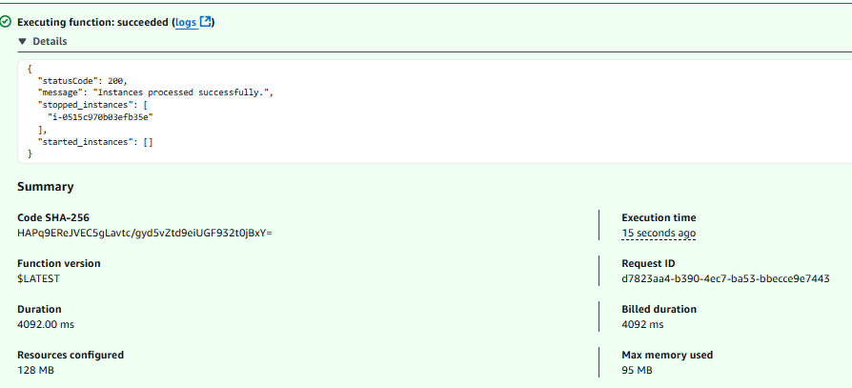

When checking at the Instance page, we can see that an instance is indeed stopped.

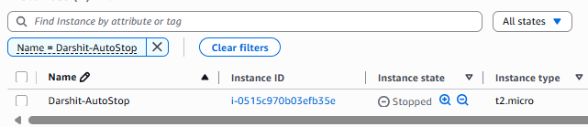

Task 3: **Monitor Unencrypted S3 Buckets Using AWS Lambda and Boto3**

**Objective:**To enhance your AWS security posture by setting up a Lambda function that detects any S3 bucket without server-side encryption.

S3 Bucket Creation

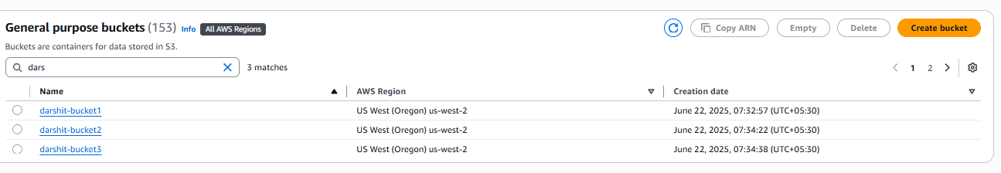

3 buckets are created with *1 and *3 without server side encryption.

IAM Roles Creation

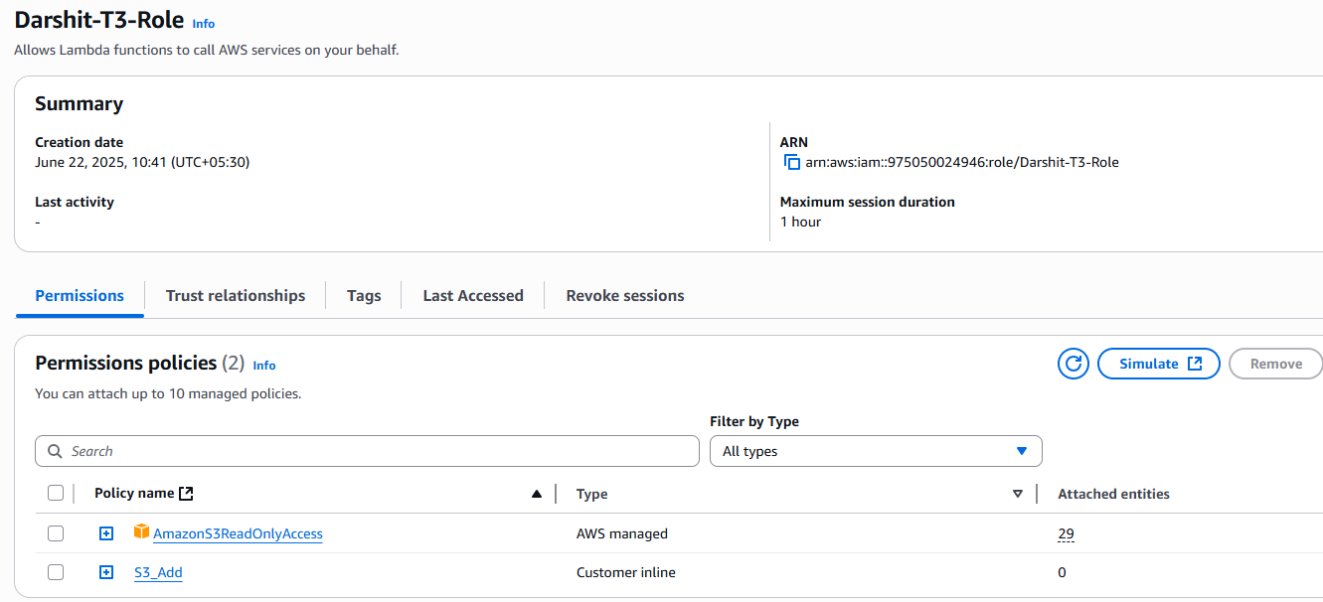

Lambda Function Creation

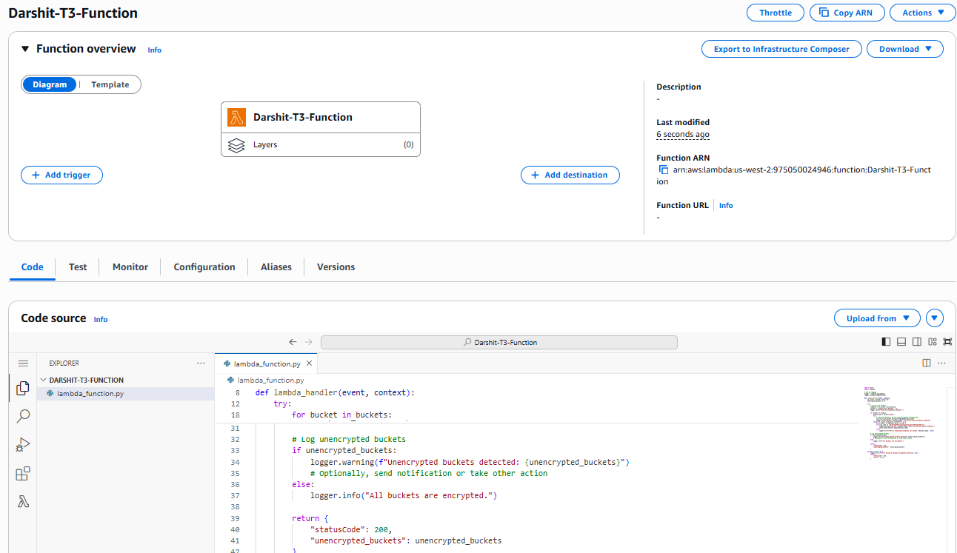

Task 5: **Auto-Tagging EC2 Instances on Launch Using AWS Lambda and Boto3**

***Objective: Learn to automate the tagging of EC2 instances as soon as they are launched, ensuring better resource tracking and management.***

Creating IAM Roles

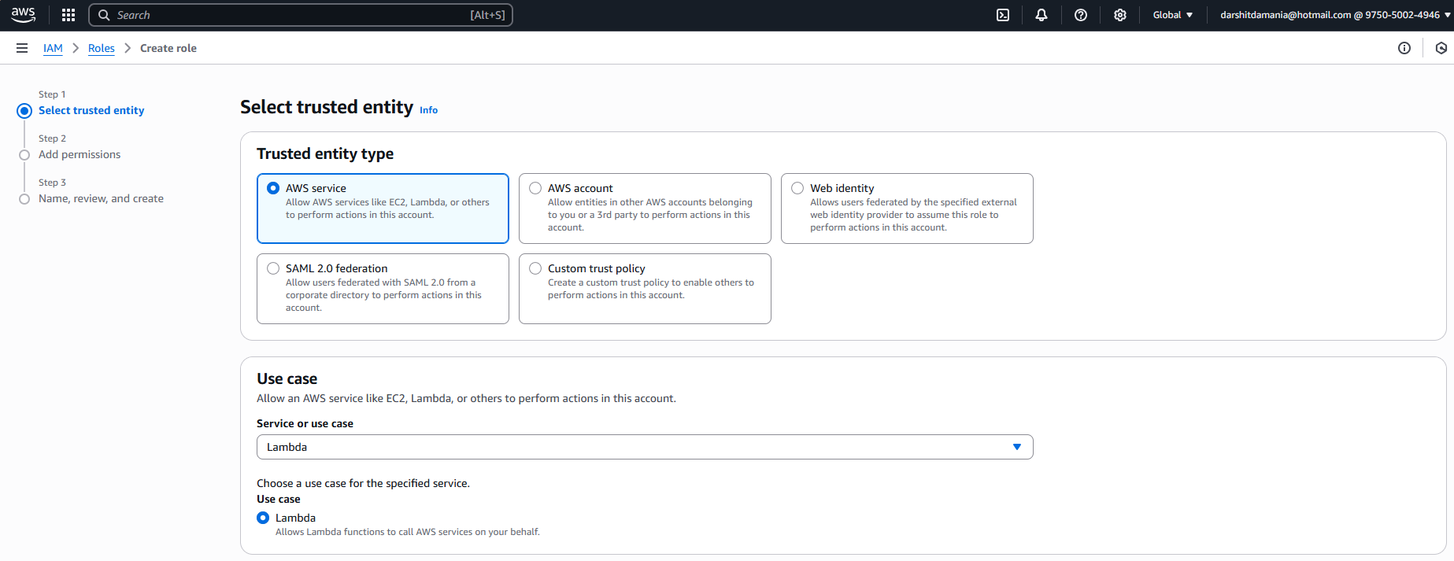

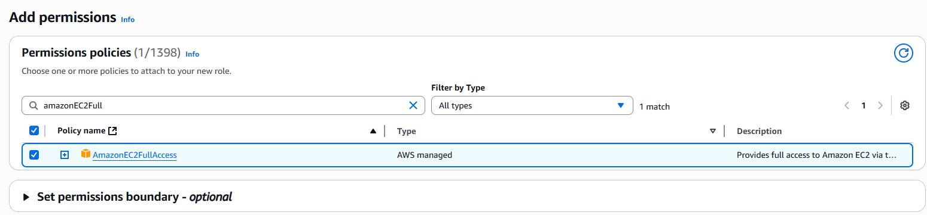

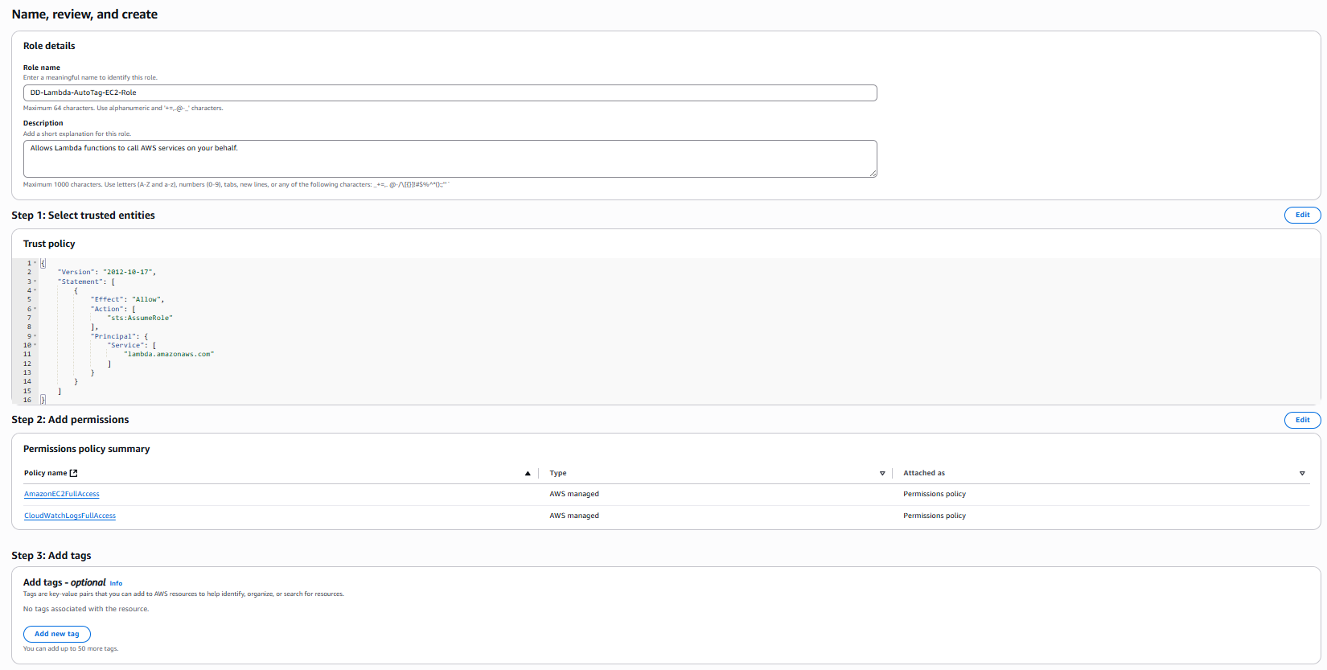



Creating Lambda Function

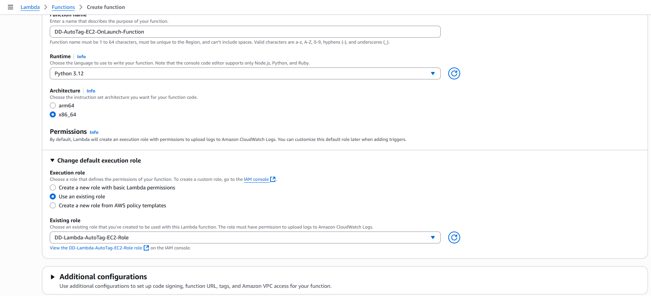

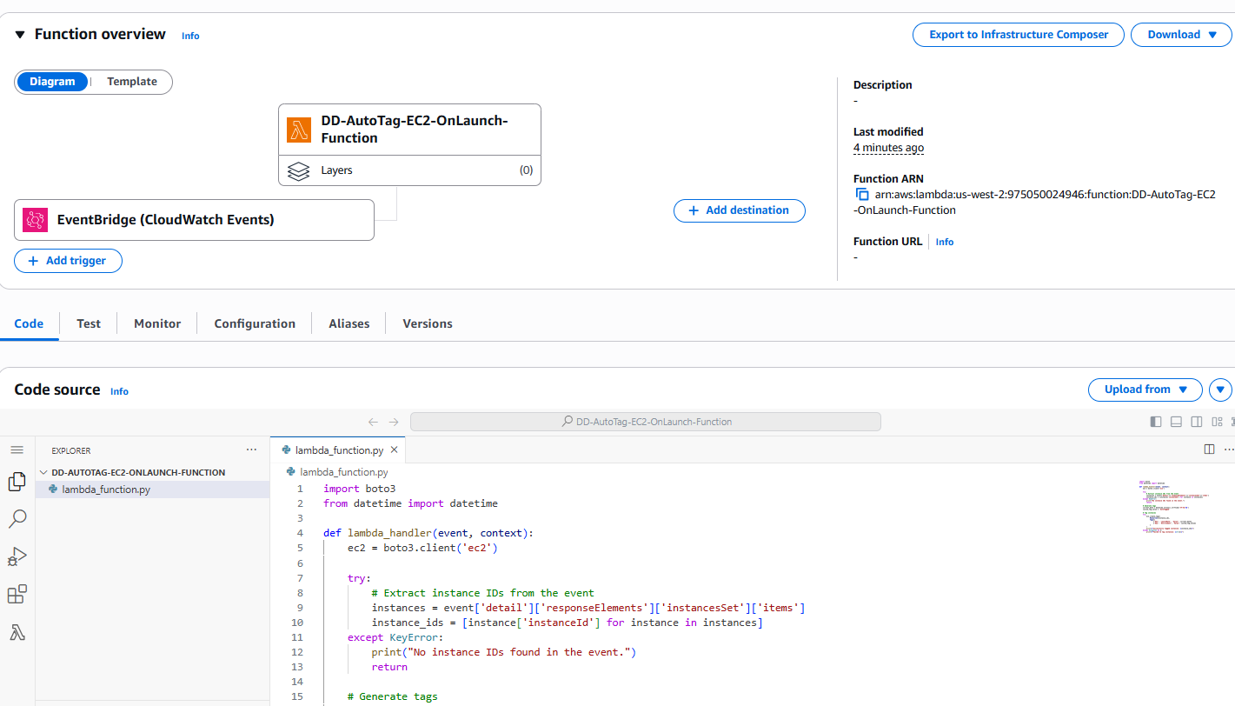

Creating Rule

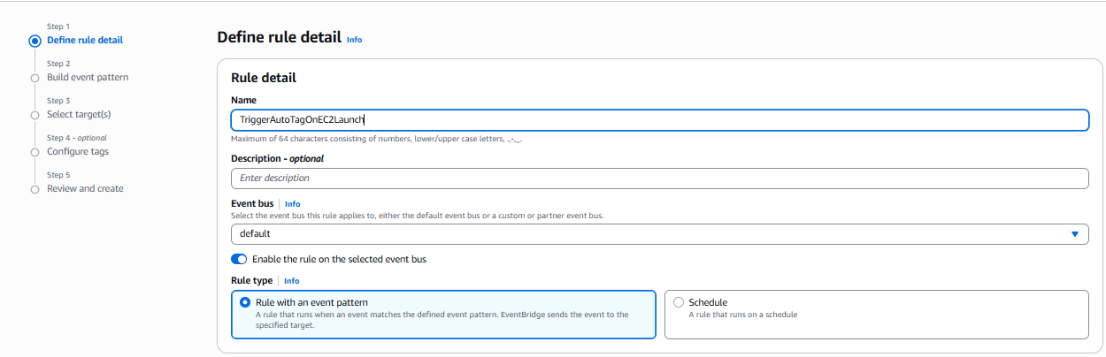

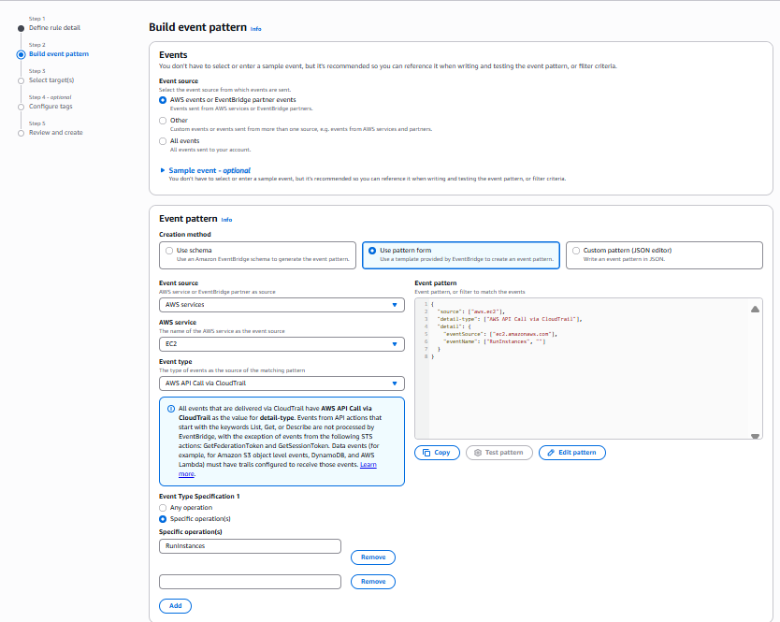

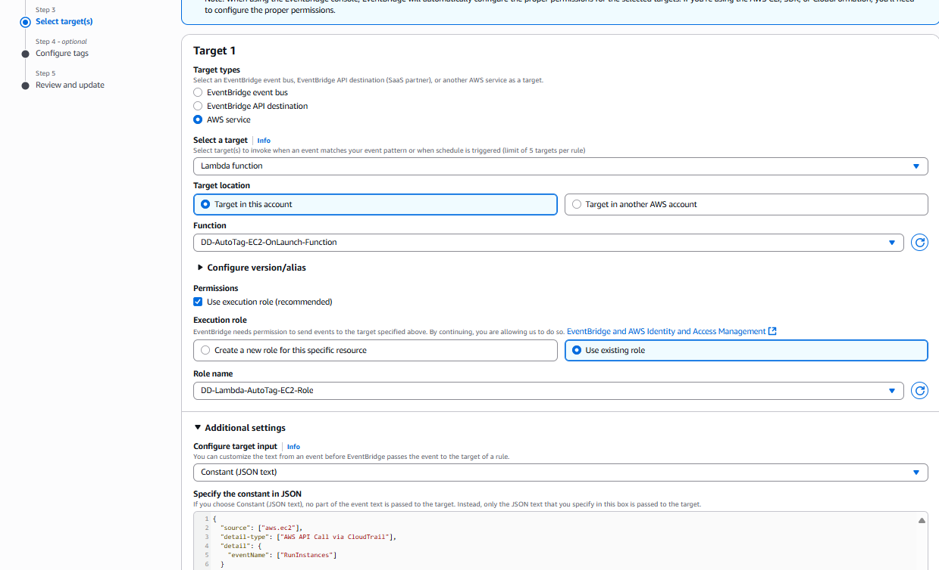

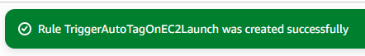

Performing the CloudWatch Activities

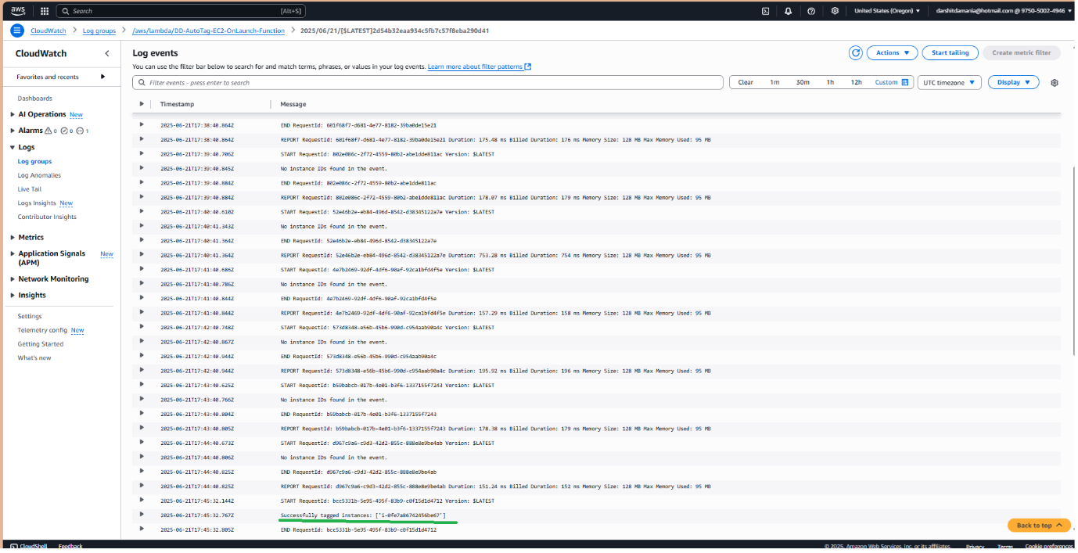

Verification of the Tag on the EC2 instances created

