

**SCHOOL OF COMPUTING**

**DEPARTMENT OF NETWORKING AND COMMUNICATION**

**Title:** Traffic sign recognition

**18CSC305J**

**Artificial Intelligence**

**Team Member:**

**1. RA1911030010092 – Shubh Govani**

**2. RA1911030010095 - Darshit Solia**

**3. RA1911030010102 – Ateev Lamba**

**Intoduction:**

There are several different types of traffic signs like speed limits, no entry, traffic signals, turn left or right, children crossing, no passing of heavy vehicles, etc. Traffic signs classification is the process of identifying which class a traffic sign belongs to.

What is Traffic Signs Recognition?

There are several different types of traffic signs like speed limits, no entry, traffic signals, turn left or right, children crossing, no passing of heavy vehicles, etc. Traffic signs classification is the process of identifying which class a traffic sign belongs to.

Traffic Signs Recognition – About the Python Project

In this Python project example, we will build a deep neural network model that can classify traffic signs present in the image into different categories. With this model, we are able to read and understand traffic signs which are a very important task for all autonomous vehicles.

**Hardware Specification:**

* Automotive Cameras
* High Radar Sensors
* Voice Alerting System
* Caution Display System
* ADAS (Advanced driver assistant system)

**Problem Statement:**

This Project is based on Autonomous Driver Assistant System. It helps in recognizing Traffic Sign Boards and display the purpose of the sign board.

**Source Code:**

**gui.py**

import tkinter as tk

from tkinter import filedialog

from tkinter import *

from PIL import ImageTk, Image

import numpy

#load the trained model to classify sign

from keras.models import load_model

model = load_model('traffic_classifier.h5')

#dictionary to label all traffic signs class.

classes = { 1:'Speed limit (20km/h)',

2:'Speed limit (30km/h)',

3:'Speed limit (50km/h)',

4:'Speed limit (60km/h)',

5:'Speed limit (70km/h)',

6:'Speed limit (80km/h)',

7:'End of speed limit (80km/h)',

8:'Speed limit (100km/h)',

9:'Speed limit (120km/h)',

10:'No passing',

11:'No passing veh over 3.5 tons',

12:'Right-of-way at intersection',

13:'Priority road',

14:'Yield',

15:'Stop',

16:'No vehicles',

17:'Veh > 3.5 tons prohibited',

18:'No entry',

19:'General caution',

20:'Dangerous curve left',

21:'Dangerous curve right',

22:'Double curve',

23:'Bumpy road',

24:'Slippery road',

25:'Road narrows on the right',

26:'Road work',

27:'Traffic signals',

28:'Pedestrians',

29:'Children crossing',

30:'Bicycles crossing',

31:'Beware of ice/snow',

32:'Wild animals crossing',

33:'End speed + passing limits',

34:'Turn right ahead',

35:'Turn left ahead',

36:'Ahead only',

37:'Go straight or right',

38:'Go straight or left',

39:'Keep right',

40:'Keep left',

41:'Roundabout mandatory',

42:'End of no passing',

43:'End no passing veh > 3.5 tons' }

#initialise GUI

top=tk.Tk()

top.geometry('800x600')

top.title('Traffic sign classification')

top.configure(background='#CDCDCD')

label=Label(top,background='#CDCDCD', font=('arial',15,'bold'))

sign_image = Label(top)

def classify(file_path):

global label_packed

image = Image.open(file_path)

image = image.resize((30,30))

image = numpy.expand_dims(image, axis=0)

image = numpy.array(image)

print(image.shape)

pred = model.predict_classes([image])[0]

sign = classes[pred+1]

print(sign)

label.configure(foreground='#011638', text=sign)

def show_classify_button(file_path):

classify_b=Button(top,text="Classify Image",command=lambda: classify(file_path),padx=10,pady=5)

classify_b.configure(background='#364156', foreground='white',font=('arial',10,'bold'))

classify_b.place(relx=0.79,rely=0.46)

def upload_image():

try:

file_path=filedialog.askopenfilename()

uploaded=Image.open(file_path)

uploaded.thumbnail(((top.winfo_width()/2.25),(top.winfo_height()/2.25)))

im=ImageTk.PhotoImage(uploaded)

sign_image.configure(image=im)

sign_image.image=im

label.configure(text='')

show_classify_button(file_path)

except:

pass

upload=Button(top,text="Upload an image",command=upload_image,padx=10,pady=5)

upload.configure(background='#364156', foreground='white',font=('arial',10,'bold'))

upload.pack(side=BOTTOM,pady=50)

sign_image.pack(side=BOTTOM,expand=True)

label.pack(side=BOTTOM,expand=True)

heading = Label(top, text="Know Your Traffic Sign",pady=20, font=('arial',20,'bold'))

heading.configure(background='#CDCDCD',foreground='#364156')

heading.pack()

top.mainloop()

**traffic_sign.py**

import numpy as np

import pandas as pd

import matplotlib.pyplot as plt

import cv2

import tensorflow as tf

from PIL import Image

import os

from sklearn.model_selection import train_test_split

from keras.utils import to_categorical

from keras.models import Sequential, load_model

from keras.layers import Conv2D, MaxPool2D, Dense, Flatten, Dropout

data = []

labels = []

classes = 43

cur_path = os.getcwd()

#Retrieving the images and their labels

for i in range(classes):

path = os.path.join(cur_path,'train',str(i))

images = os.listdir(path)

for a in images:

try:

image = Image.open(path + '\\'+ a)

image = image.resize((30,30))

image = np.array(image)

#sim = Image.fromarray(image)

data.append(image)

labels.append(i)

except:

print("Error loading image")

#Converting lists into numpy arrays

data = np.array(data)

labels = np.array(labels)

print(data.shape, labels.shape)

#Splitting training and testing dataset

X_train, X_test, y_train, y_test = train_test_split(data, labels, test_size=0.2, random_state=42)

print(X_train.shape, X_test.shape, y_train.shape, y_test.shape)

#Converting the labels into one hot encoding

y_train = to_categorical(y_train, 43)

y_test = to_categorical(y_test, 43)

#Building the model

model = Sequential()

model.add(Conv2D(filters=32, kernel_size=(5,5), activation='relu', input_shape=X_train.shape[1:]))

model.add(Conv2D(filters=32, kernel_size=(5,5), activation='relu'))

model.add(MaxPool2D(pool_size=(2, 2)))

model.add(Dropout(rate=0.25))

model.add(Conv2D(filters=64, kernel_size=(3, 3), activation='relu'))

model.add(Conv2D(filters=64, kernel_size=(3, 3), activation='relu'))

model.add(MaxPool2D(pool_size=(2, 2)))

model.add(Dropout(rate=0.25))

model.add(Flatten())

model.add(Dense(256, activation='relu'))

model.add(Dropout(rate=0.5))

model.add(Dense(43, activation='softmax'))

#Compilation of the model

model.compile(loss='categorical_crossentropy', optimizer='adam', metrics=['accuracy'])

epochs = 15

history = model.fit(X_train, y_train, batch_size=32, epochs=epochs, validation_data=(X_test, y_test))

model.save("my_model.h5")

#plotting graphs for accuracy

plt.figure(0)

plt.plot(history.history['accuracy'], label='training accuracy')

plt.plot(history.history['val_accuracy'], label='val accuracy')

plt.title('Accuracy')

plt.xlabel('epochs')

plt.ylabel('accuracy')

plt.legend()

plt.show()

plt.figure(1)

plt.plot(history.history['loss'], label='training loss')

plt.plot(history.history['val_loss'], label='val loss')

plt.title('Loss')

plt.xlabel('epochs')

plt.ylabel('loss')

plt.legend()

plt.show()

#testing accuracy on test dataset

from sklearn.metrics import accuracy_score

y_test = pd.read_csv('Test.csv')

labels = y_test["ClassId"].values

imgs = y_test["Path"].values

data=[]

for img in imgs:

image = Image.open(img)

image = image.resize((30,30))

data.append(np.array(image))

X_test=np.array(data)

pred = model.predict_classes(X_test)

#Accuracy with the test data

from sklearn.metrics import accuracy_score

print(accuracy_score(labels, pred))

**Output:**

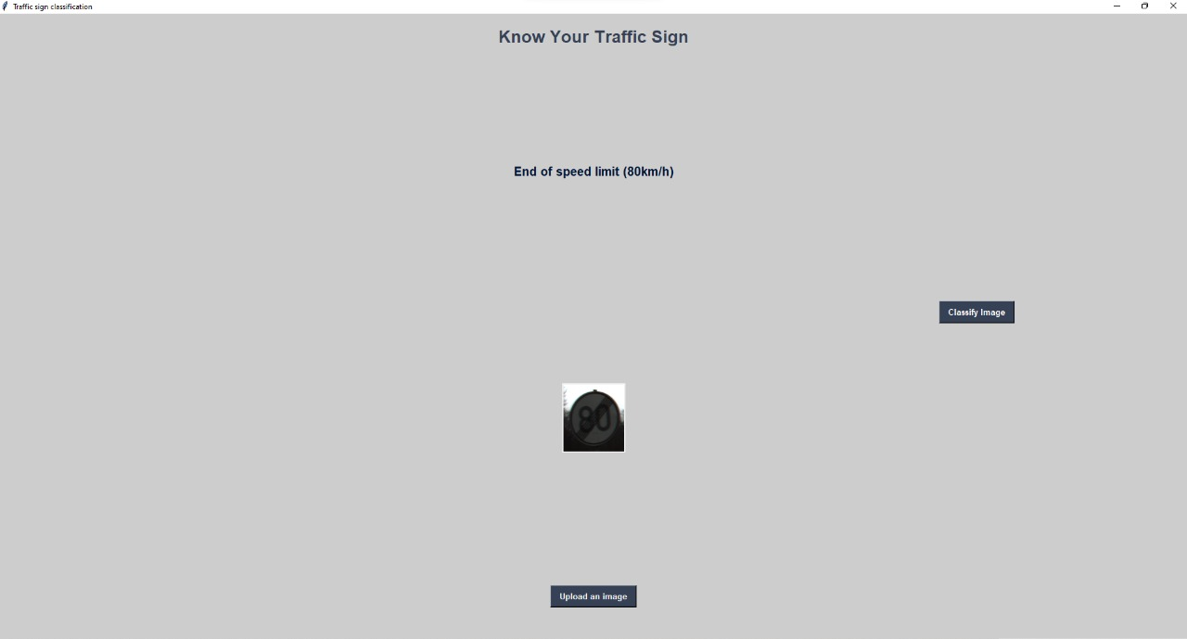

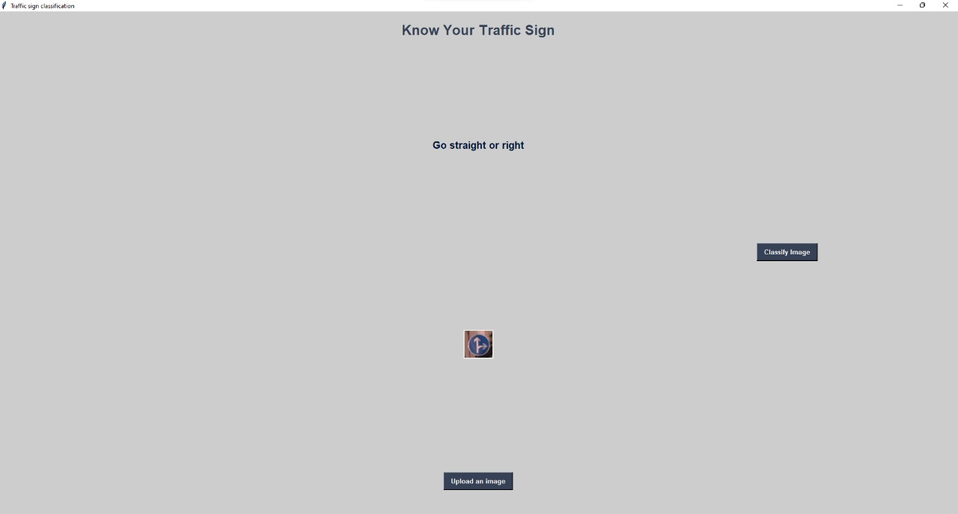

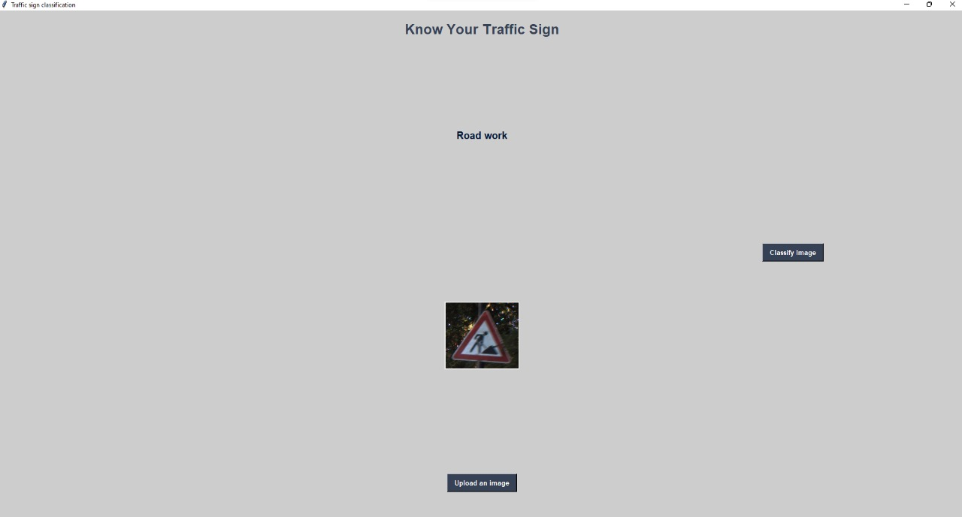

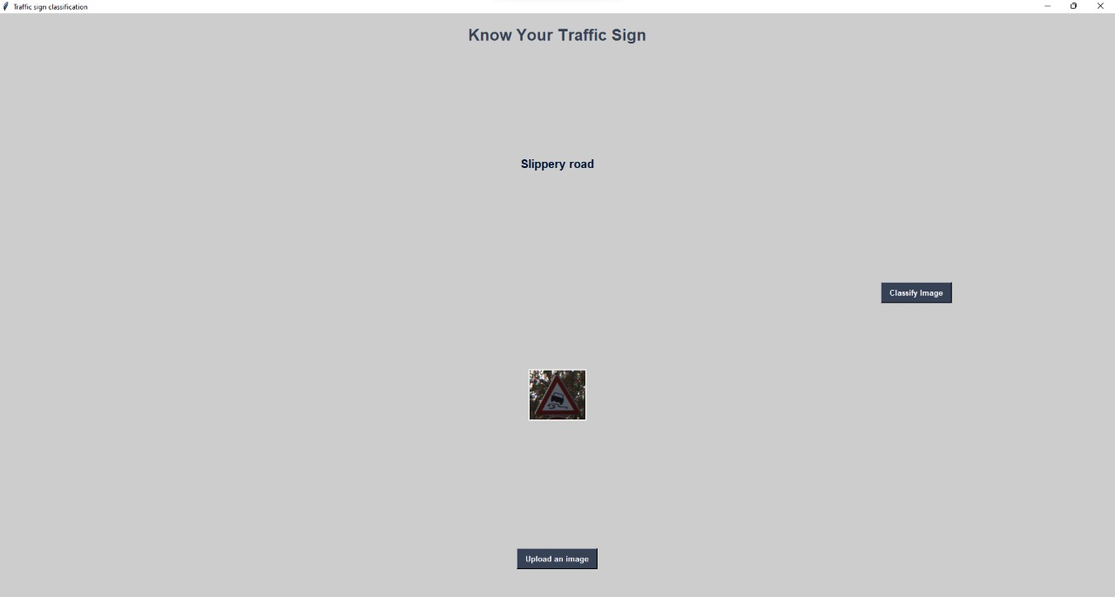

**Result:** Hence, the traffic sign board recognition is successfully tested.