**A**

**Project Report**

**On**

**“Job Manager”**

**Prepared by:**

Darshit Patel (16IT067)

Parth Navsariwala (16IT058)

**Under the supervision of**

Prof. Nirav Bhatt

A Report Submitted to

Charotar University of Science and Technology

for Partial Fulfillment of the Requirements for the

Degree of Bachelor of Technology

in Information Technology

IT345 Software Group Project-II (5th sem)

**Submitted at**



**DEPARTMENT OF INFORMATION TECHNOLOGY**

**Chandubhai S. Patel Institute of Technology**

**At: Changa, Dist: Anand – 388421**

**October 2018**



**CERTIFICATE**

This is to certify that the report entitled “Job Manager**"** is a bonafied work carried out by **Darshit Patel (16IT067) and Parth Navsariwala (16IT058)** under the guidance and supervision of **Prof. Nirav Bhatt** for the subject **Software Group Project-II (IT345)** of **5th**  Semester of Bachelor of Technology in **Information Technology** at Faculty of Technology & Engineering – CHARUSAT, Gujarat.

To the best of my knowledge and belief, this work embodies the work of candidate herself, has duly been completed, and fulfills the requirement of the ordinance relating to the B.Tech. Degree of the University and is up to the standard in respect of content, presentation and language for being referred to the examiner.

|  |
| --- |
| Under supervision of,  Prof. Nirav Bhatt  Assistant Professor  Dept. of Information Technology  CSPIT, Changa, Gujarat. |
| Prof. Parth Shah  Head & Associate Professor  Department of Information Technology  CSPIT, Changa, Gujarat. |

**Chandubhai S Patel Institute of Technology**

At: Changa, Ta. Petlad, Dist. Anand, PIN: 388 421. Gujarat

TABLE OF CONTENTS

* Acknowledgement 5
* Abstract 6
* Chapter 1 Introduction 7

1.1 Project Summary 7

1.2 Scope 7

1.3 Objective 7

* Chapter 2 System Requirements Study 9

2.1 User Characteristics 9

2.2 Tools & Technology Used 9

* Chapter 3 System Design 10

3.1 Project Flow 10

* Chapter 4 Implementation Planning 11

4.1 Implementation Environment (Single vs Multi user, GUI vs Non GUI) 11

4.2 Coding Standards 11

4.3 Snapshots of project 20

* Chapter 5 Limitations and Future Enhancement 22
* Chapter 6 Conclusion 23
* References 23

**ACKNOWLEDGEMENT**

Hereby thanking my torchbearers with an immense pleasure who have helped me and stood with me through this project.

My first and foremost thanking goes to my subject faculty Prof. Niarv Bhatt sir for giving me time to solve my problems and help me collecting the resources of my project.

Now I would like to forward my thanking to Prof.Parth Shah, Head of Information Technology Department, Charotar institute of Technology.

Darshit Patel (16IT067)

Parth Navsariwala (16IT058)

**ABSTRACT**

Website for the online Campus Recruitment which help student as well as company for selecting their employee easily and effectively. This site also used for see campus visited company and their post vacancy. Student also downloads their resume by filling some details. This site makes whole recruitment system very easy and fast.

**CHAPTER- 1: INTRODUCTION**

**1.1: Description**

We have mainly two user for this site

1.Student

2.Comapny

JOB CREATOR is used for the making whole recruitment system online. Which remove all pen paper process from the system during recruitment. It contains all information about college students. Student can also download their resume from this website. Site also contain whole information of the company which visit the campus annually. This site is very useful for student because it gives all information like as follow

Branch wise company

Number of vacancy in company

Comments on Company

Students Resume

Student also adds their skill and achievements on site for make their resume effective. Students can also get companies mail online whether they have selected or not.

Company have its separate login. Company side also have facility to put post, see detail of applied employee or etc… Company see all student in one PDF form. Company can easily send filter out eligible student for their company.

**1.2: Purpose:**

The purpose of this project is to help student and collage by making recruitment system easy and fast. Save student time by provides all functionality to student which is necessary during recruitment.

**1.3: Scope:**

This site provide all information about students like their skills, achievements etc… student also add their new skills and delete their old skills as per their wish. Student also see comments on company given by seniors or selected students.

In Company site they can add their post, see who have applied and post their events and company information.

**1.4: Objective:**

* Helps Student for recruitment.
* Help companies for selecting their employee.
* Make Recruitment System easy and fast.

**CHAPTER- 2: SYSTEM REQUIEMENTS**

**2.1: User characteristics:**

User must have their Collage ID and Password for accessing this site. User must have basic knowledge about this type of website. It is very user friendly site so any college student easily accesses this with help of ID and Password without query.

**2.2: Tools and languages used (For development):**

**Tools:**

1. XAMP
2. My Sql Database
3. Word press
4. Sublime Editor

**Languages:**

1. Jquery
2. HTML-5
3. BOOT STRAP
4. PHP-5
5. AJAX

**2.3: Assumptions and dependencies:**

We have assumed that user has the basic idea about the refer any website and have basic knowledge

About fill up the form and details online.

**CHAPTER-3: SYSTEM DESIGN**

**3.1: Project Flow:**

**Student Login**

**Home Profile Academic Projects & Resume**

**Achievement**

0

000

**Add Skills Add Projects Download**

**Add Achievement**

**Add Internship**

**Company Login**

**Home Profile Post Applied**

**CHAPTER- 4: IMPLEMENTATION PLANNING**

**4.1: Implementation environment:**

**Android single user.**

**4.2: Coding Standards**

**4.3: Snapshots of project**

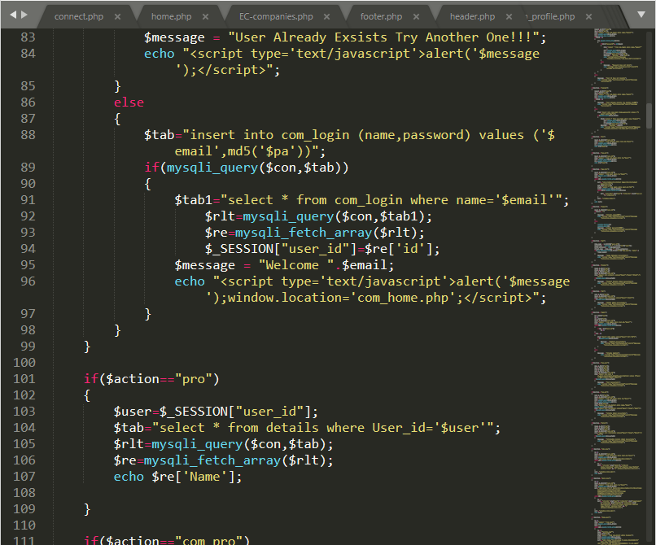

**Fig 1.1: Student Home Page**

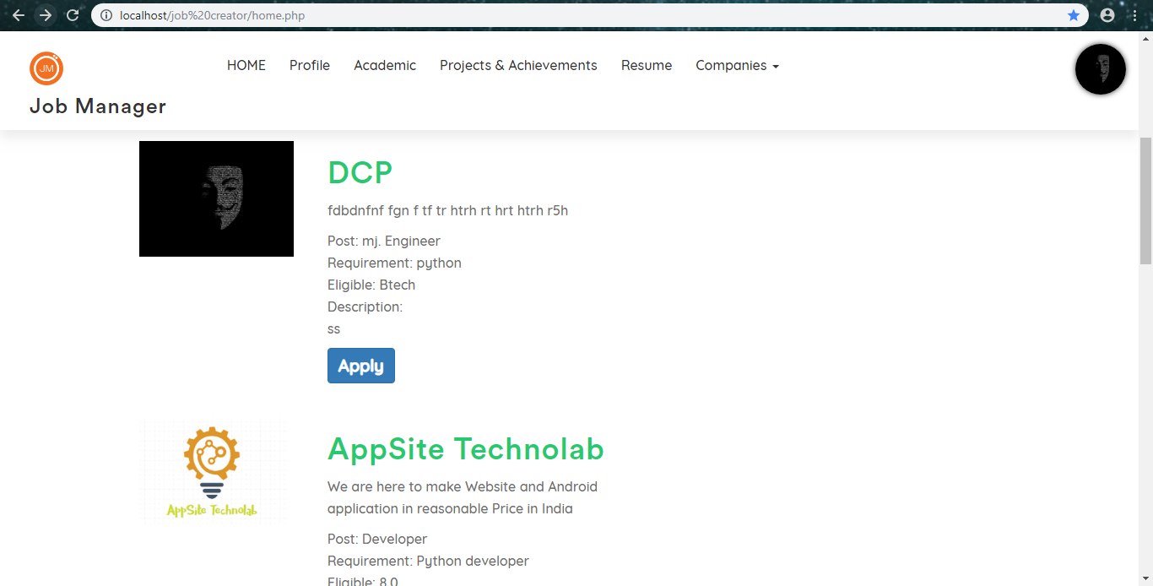

In this page student can view profile of various company and can apply for the job which company has posted by just clicking on Apply button bellow the post.

**Fig 1.2: Student Profile**

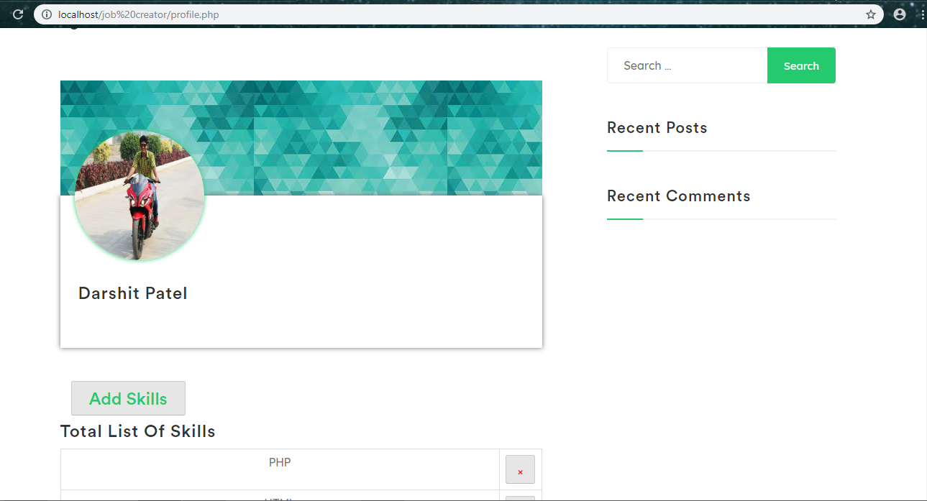

In this page student can easily view their profile and add their skills just by clicking on “Add Skills” button

Student can also change their profile image by clicking on image.

**Fig 1.3: Project & Achievements**

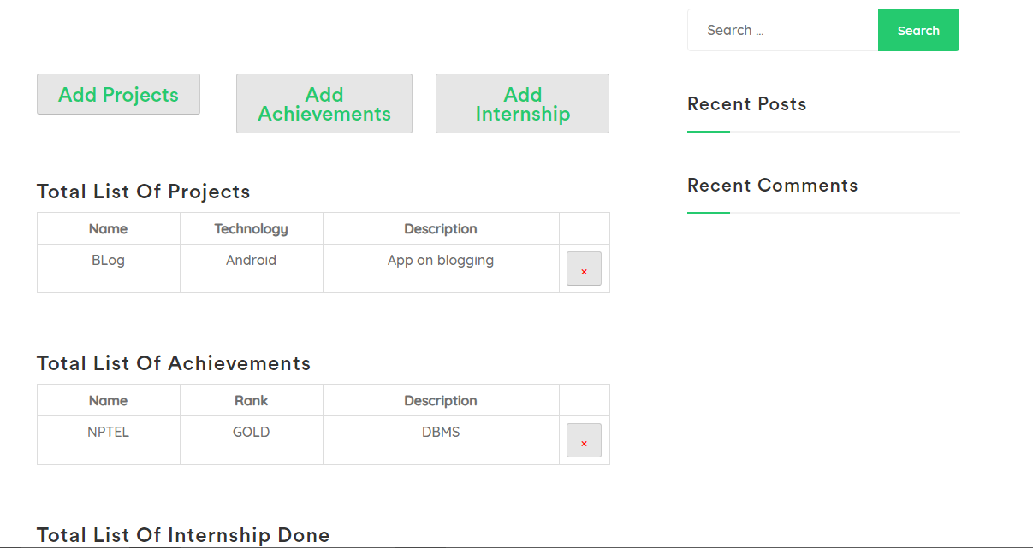

In this page student can add their Project details by clicking on “Add Projects” & view their projects. Student can also add their Achievements details & their Internship.

**Fig 1.4: Academic**

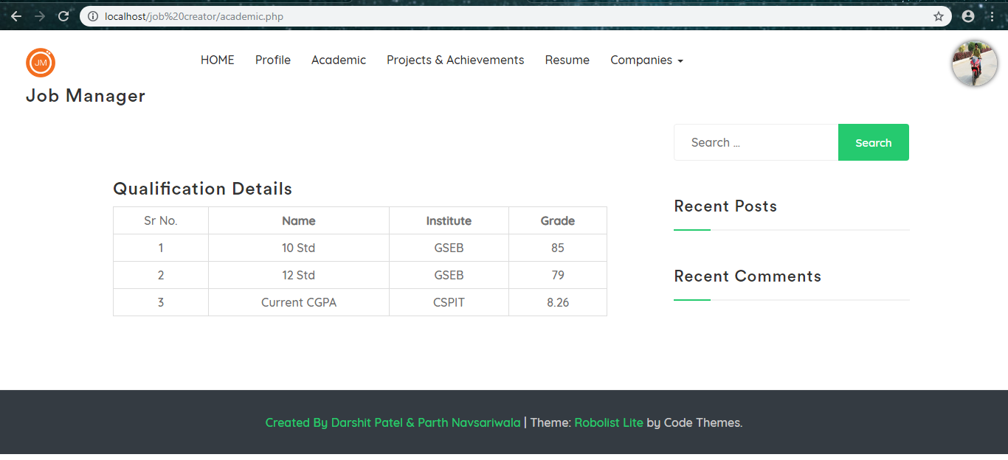

Here student can only view the information of their results they cannot edit it.

This information will further use for building their resume automatically.

After filling all above information student can directly download their resume form the site. Resume will be generated directly.

**Fig 1.5: Resume**

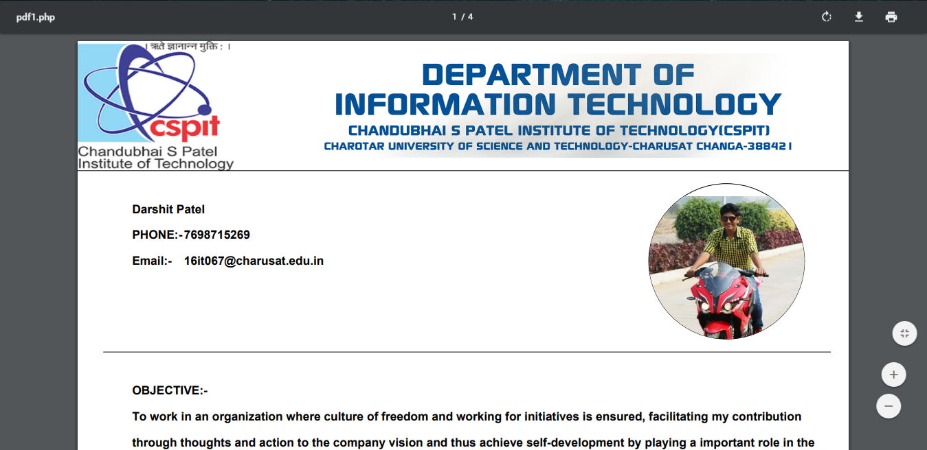

Here the resume of student is built and is ready to download. It contains all information like Projects Done, Internship Done, Achievements etc.

**Fig 1.6:Company home Page**

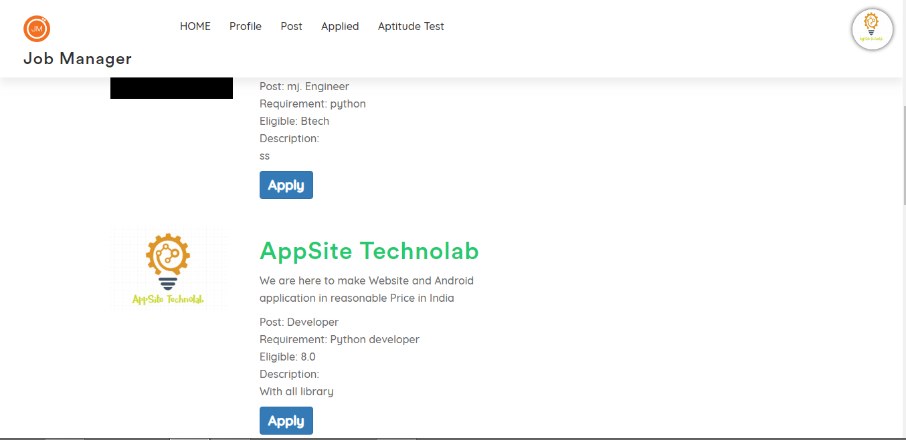

here is the home page of company

**Fig 1.7: Post**

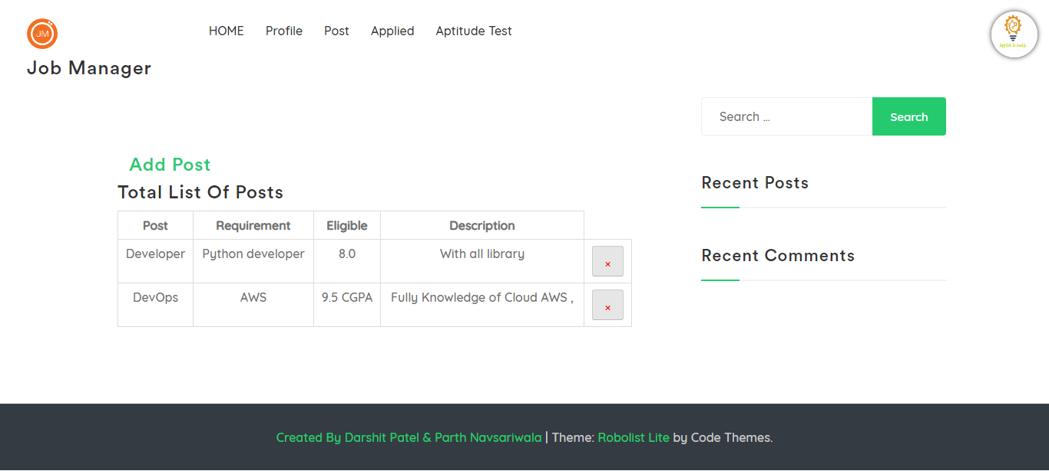

**Fig 1.8:Apllied Student List**

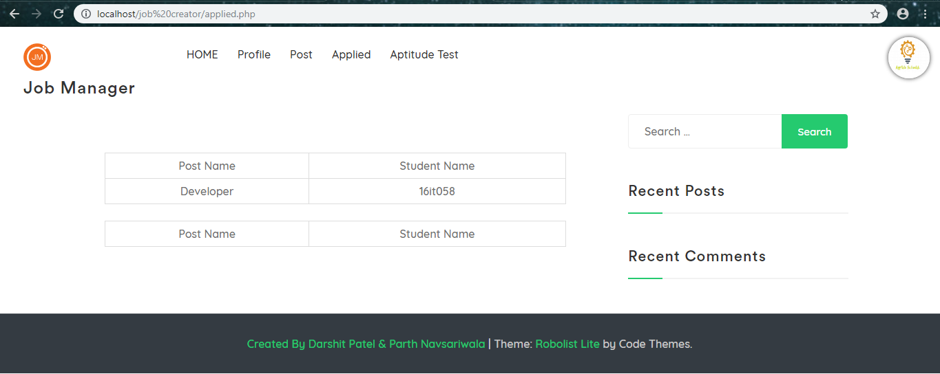

**Fig 1.9: Company Profile**

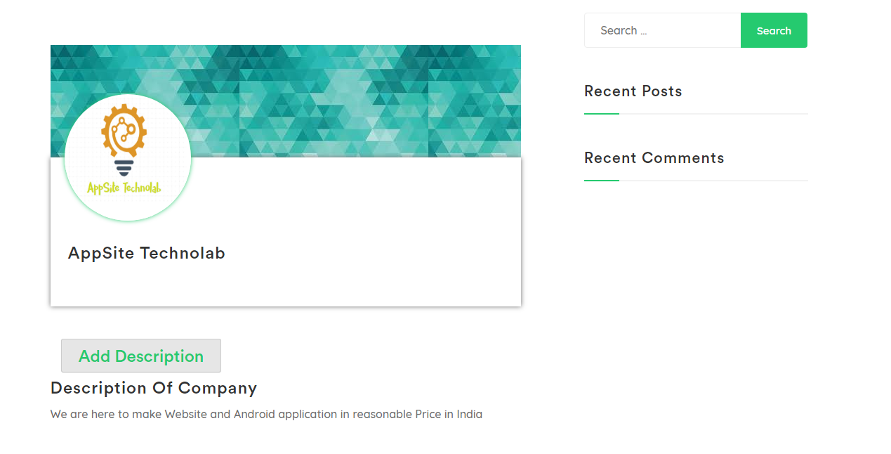

**CHAPTER-5: LIMITATIONS AND FUTURE ENHANCEMENT**

**5.1: Limitations**

* An only College student who has ID and Password can see events.
* It is operate only on local host this site is not online.
* Site has some little bit delay when number of user increase.
* It is not fully tested site so there may be issue related to data lick.

**5.2: Future Enhancements**

* **Security:**
* Make website more secure in terms of data security.
* **Reduce Time:**
* Reduce the site loading as number of user increase.
* **Online Score:**
* User can see their score in each round.

**CHAPTER 6 : CONCLUSION**

**6.1: Conclusion**

Hence I conclude that our site is helpful for students during campus interview they can easily add their skills and download their resume for company usage. From this site student also familiar with which company visit annually and prepare for it from starting. Student can also download their resume. This is also may used for company for put their post and make their selection process easy. Company easily short out selected student. It is also remove all pen paper method from the recruitment system.

**6.2: References**

1. [**http://www.fpdf.org/**](http://www.fpdf.org/)
2. [**https://getbootstrap.com/**](https://getbootstrap.com/)
3. [**https://www.w3schools.com/xml/ajax_intro.asp**](https://www.w3schools.com/xml/ajax_intro.asp)
4. [**https://www.mysql.com/**](https://www.mysql.com/)
5. [**https://www.wordpress.com/**](https://www.wordpress.com/)