**Practical - 1**

**Aim** **: Write C program to print all negative elements in an array.**

**Program** :

#include<stdio.h>

main()

{

int i, n;

printf("Enter elements of an Array : ");

scanf("%d", &n);

int a[n];

printf("\nEnter %d elements of an Array :\n",n);

for(i = 0 ; i < n ; i++)

{

printf("Element a[%d] = ", i);

scanf("%d", &a[i]);

}

printf("\nNegative elements of this Array are :\n");

for(i = 0 ; i < n ; i++)

{

if(a[i] < 0)

printf("%d\t", a[i]);

}

}

**Output :**

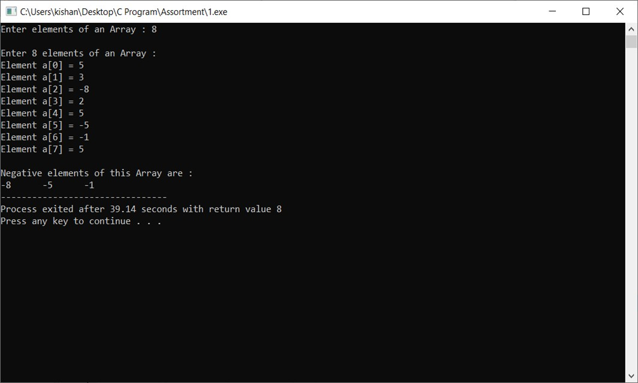

**Practical - 2**

**Aim** **:** **Write C program to find second largest number in array.**

**Program** :

#include <stdio.h>

#include <limits.h>

main()

{

int a[100], i, size;

int first, second;

printf("Enter the Number of elements in an array : ");

scanf("%d", &size);

printf("\nEnter %d elements of an Array \n", size);

for (i = 0; i < size; i++)

{

scanf("%d", &a[i]);

}

first = INT_MIN;

second = INT_MIN;

for (i = 0; i < size; i++)

{

if(a[i] > first)

{

second = first;

first = a[i];

}

else if(a[i] > second && a[i] < first)

{

second = a[i];

}

}

printf("\nThe Largest Number in this Array = %d", first);

printf("\nThe Second Largest Number in this Array = %d", second);

}

**Output :**

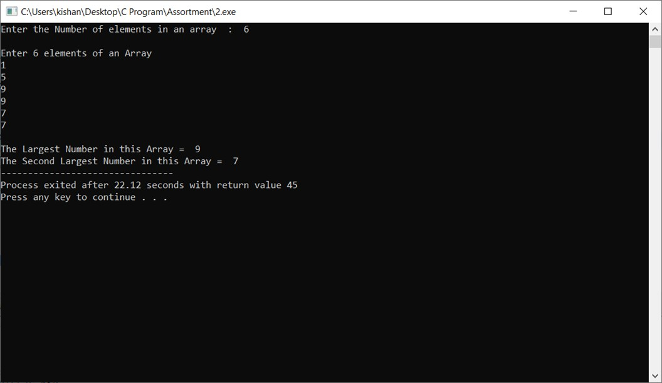

**Practical - 4**

**Aim** **:** **Write C program to Insert & Update operations the element into**

**Array.**

**Program** :

#include <stdio.h>

main()

{

int a[100];

int i, x, pos, n;

printf("Enter number of elements : ");

scanf("%d", &n);

for (i = 0; i < n; i++)

{

scanf("%d", &a[i]);

}

printf("\nElements of an Array are :\n");

for (i = 0 ; i < n ; i++)

{

printf("%d ", a[i]);

}

printf("\n\nEnter position : ");

scanf("%d", &pos);

printf("Enter value to be updated : ");

scanf("%d", &x);

n++;

for (i = n-1 ; i >= pos ; i--)

{

a[i] = a[i - 1];

}

a[pos - 1] = x;

printf("\nArray after updating :\n");

for (i = 0 ; i < n ; i++)

{

printf("%d ", a[i]);

}

}

**Output :**

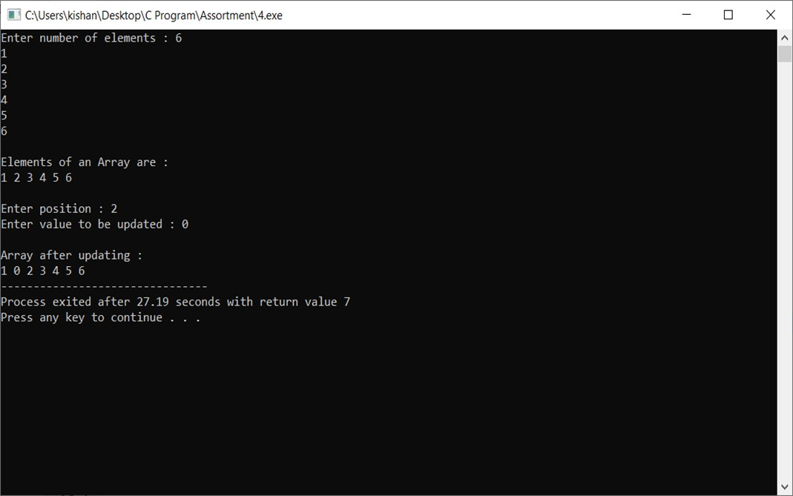

**Practical - 6**

**Aim** **: Write C program to addition of two matrices**

**Program** :

#include<stdio.h>

main()

{

int i, j, n;

printf("Enter rows and columns of an Array : ");

scanf("%d", &n);

int a[n][n], b[n][n], c[n][n];

printf("\nEnter %d elements of First Array :\n", n*n);

for(i = 0 ; i < n ; i++)

{

for(j = 0 ; j < n ; j++)

{

printf("a[%d][%d] = ", i, j);

scanf("%d", &a[i][j]);

}

}

printf("\nFirst Array :\n");

for(i = 0 ; i < n ; i++)

{

for(j = 0 ; j < n ; j++)

{

printf("%d\t", a[i][j]);

}

printf("\n");

}

printf("\nEnter %d elements of Second Array :\n", n*n);

for(i = 0 ; i < n ; i++)

{

for(j = 0 ; j < n ; j++)

{

printf("a[%d][%d] = ", i, j);

scanf("%d", &b[i][j]);

}

}

printf("\nSecond Array :\n");

for(i = 0 ; i < n ; i++)

{

for(j = 0 ; j < n ; j++)

{

printf("%d\t", b[i][j]);

}

printf("\n");

}

printf("\n\nAddition of 2 Array :\n");

for(i = 0 ; i < n ; i++)

{

for(j = 0 ; j < n ; j++)

{

c[i][j] = a[i][j] + b[i][j];

printf("%d\t", c[i][j]);

}

printf("\n");

}

}

**Output :**

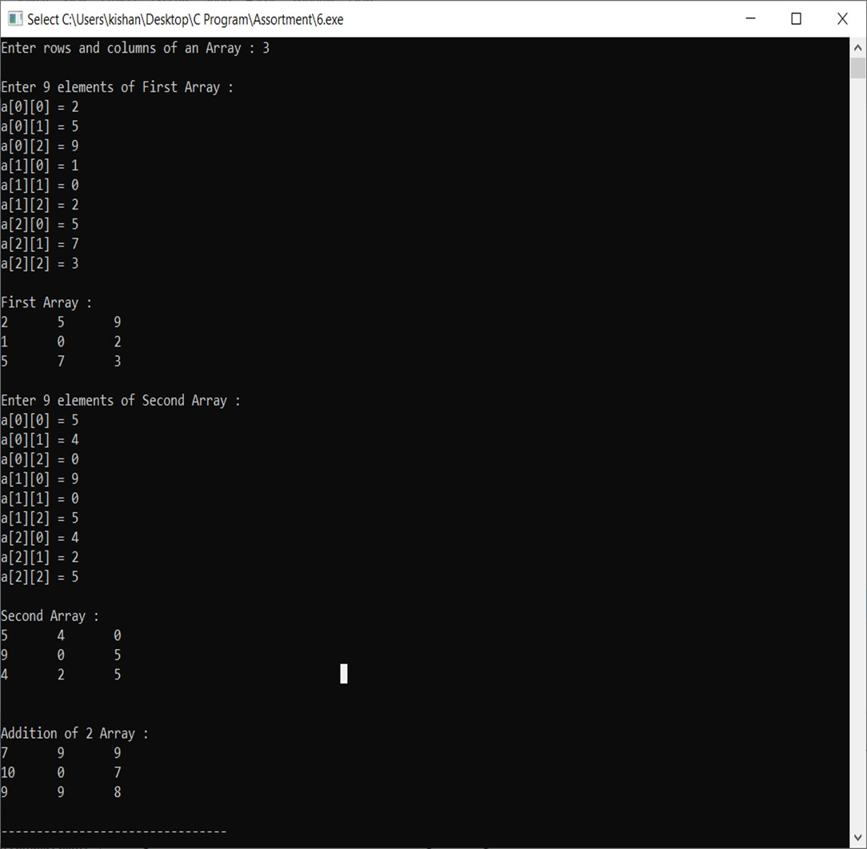

**Practical - 7**

**Aim** **:** **Write C program matrix convert into transpose matrix.**

**Program** :

#include<stdio.h>

main()

{

int i, j, n;

printf("Enter rows and columns of an Array :\n");

scanf("%d", &n);

int a[n][n], b[n][n];

printf("\nEnter elements of an Array :\n");

for(i = 0 ; i < n ; i++)

{

for(j = 0 ; j < n ; j++)

{

printf("a[%d][%d] = ", i, j);

scanf("%d", &a[i][j]);

}

}

printf("\nElements of this Array :\n");

for(i = 0 ; i < n ; i++)

{

for(j = 0 ; j < n ; j++)

{

printf("%d\t", a[i][j]);

b[j][i] = a[i][j];

}

printf("\n");

}

printf("\nAfter Transpose :\n");

for(i = 0 ; i < n ; i++)

{

for(j = 0 ; j < n ; j++)

{

printf("%d\t", b[i][j]);

}

printf("\n");

}

**Output :**

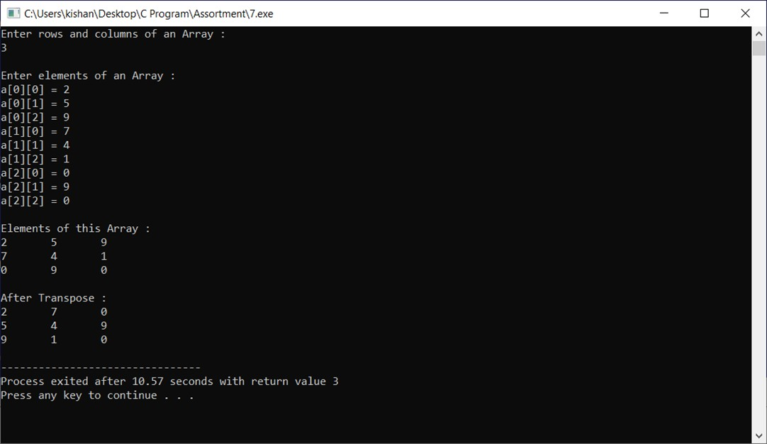

**Practical - 8**

**Aim** **: Write C program to find sum of diagonal elements of a matrix.**

**Program** :

#include<stdio.h>

main()

{

int i, j, n, sum=0;

printf("Enter the number of rows and columns for matrix :\n");

scanf("%d", &n);

int a[n][n];

printf("\nEnter the elements of the matrix :\n");

for(i = 0 ; i < n ; i++)

{

for(j = 0 ; j < n ; j++)

{

printf("Element of a[%d][%d] : ", i, j);

scanf("%d", &a[i][j]);

}

}

printf("\nThe array\n");

for(i = 0 ; i < n ; i++)

{

for(j = 0 ; j < n ; j++)

{

printf("%d\t", a[i][j]);

}

printf("\n");

}

for(i = 0 ; i < n ; i++)

{

for(j = 0 ; j < n ; j++)

{

if(i == j)

sum = sum + a[i][j];

}

}

printf("\nThe sum of diagonal elements of a square matrix = %d", sum);

}

**Output :**

