**Practical : 1**

**Aim : Write C program to print all alphabets from a to z. using do while loop.**

**Program :**

#include <stdio.h>

int main()

{

char ch = 'a';

printf("Alphabets from a - z are: \n");

do

{

printf("%c\n", ch);

ch++;

}

while(ch<='z');

return 0;

}

**Output :**

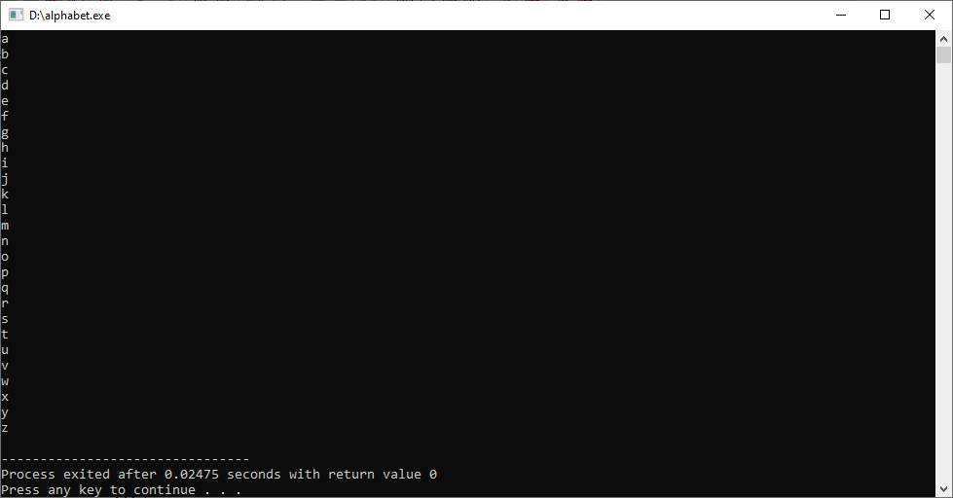

**Practical : 2**

**Aim : Write C program to print multiplication table of any number.**

**Program :**

#include <stdio.h>

int main()

{

int n, i;

printf("Enter an integer: ");

scanf("%d", &n);

for (i = 1; i <= 10; ++i)

{

printf("%d * %d = %d \n", n, i, n * i);

}

return 0;

}

**Output :**

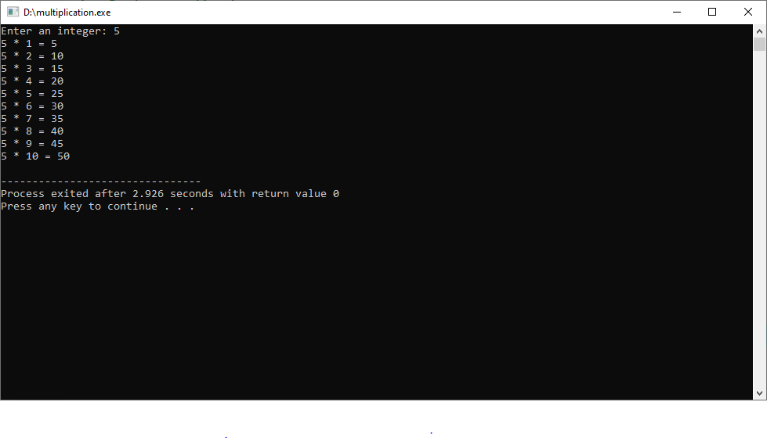

**Practical : 3**

**Aim : Write C program to count number of digits in a number.**

**Program :**

#include <stdio.h>

int main()

{

int n;

int count=0;

printf("Enter a number");

scanf("%d",&n);

while(n!=0)

{

n=n/10;

count++;

}

printf("\nThe number of digits in an integer is : %d",count);

}

**Output :**

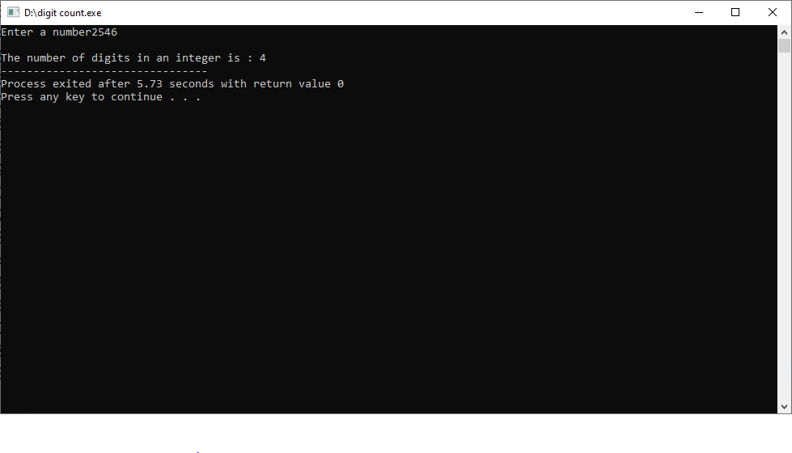

**Practical : 4**

**Aim : Write C program to find sum of first and last digit of a number.**

**Program :**

#include<stdio.h>

main()

{

int n, sum=0, f, l;

printf("Enter number to find sum of first and last digit = ");

scanf("%d", &n);

l = n % 10;

while(n >= 10)

{

n = n / 10;

}

f = n;

sum = f + l;

printf("Sum of first and last digit = %d", sum);

return 0;

}

**Output :**

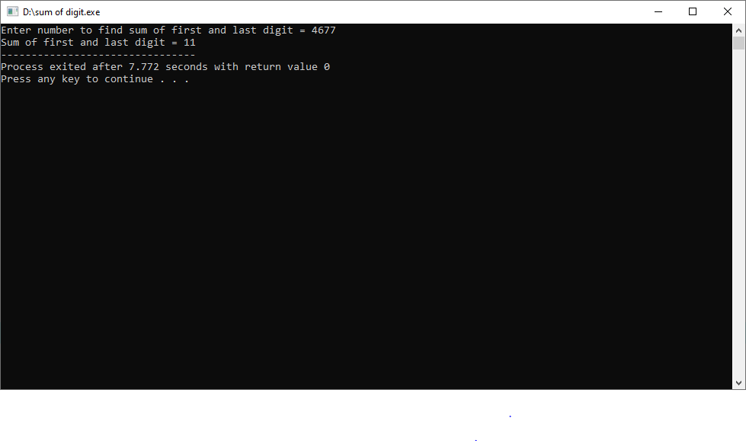

**Practical : 5**

**Aim : Write C program to enter a number and print its reverse & check weather num is palindrome or not?**

**Program :**

**#include<stdio.h>**

**int main()**

**{**

**int n,r,sum=0,temp;**

**printf("enter the number=");**

**scanf("%d",&n);**

**temp=n;**

**while(n>0)**

**{**

**r=n%10;**

**sum=(sum*10)+r;**

**n=n/10;**

**}**

**if(temp==sum)**

**printf("palindrome number ");**

**else**

**printf("not palindrome");**

**return 0;**

**}**

**Output :**

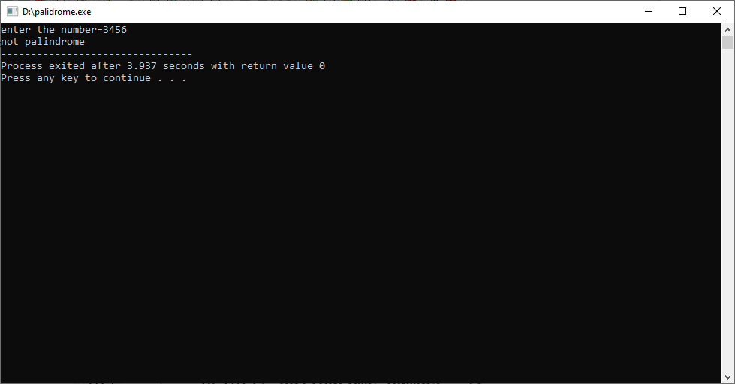

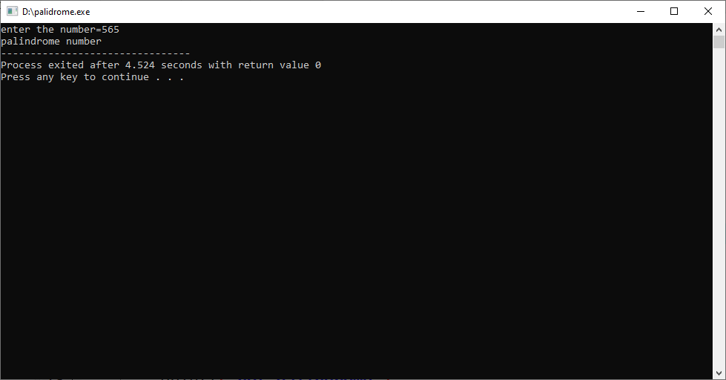

**Practical : 6**

**Aim : Write C program to calculate factorial of a number.**

**Program :**

**#include<stdio.h>**

int main()

{

int i,f=1,number;

printf("Enter a number: ");

scanf("%d",&number);

for(i=1;i<=number;i++)

{

f=f*i;

}

printf("Factorial of %d is: %d",number,f);

return 0;

}

**Output :**

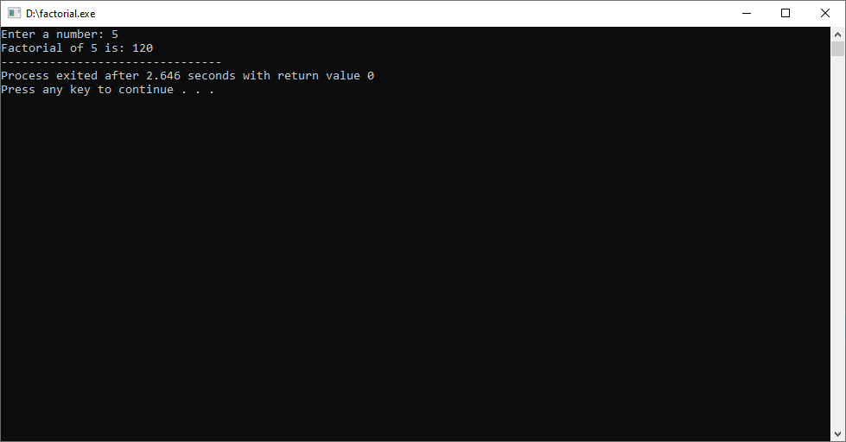

**Practical : 7**

**Aim : Write C program print out Fibonacci series. (0,1,1,2,3,5,8…)**

**Program :**

**#include <stdio.h>**

**int main()**

**{**

**int i, n;**

**int n1 = 0, n2 = 1;**

**int n3 = n1 + n2;**

**printf("Enter the number of terms: ");**

**scanf("%d", &n);**

**printf("Fibonacci Series: %d, %d, ", n1, n2);**

**for (i = 3; i <= n; ++i)**

**{**

**printf("%d, ", n3);**

**n1 = n2;**

**n2 = n3;**

**n3 = n1 + n2;**

**}**

**}**

**Output :**

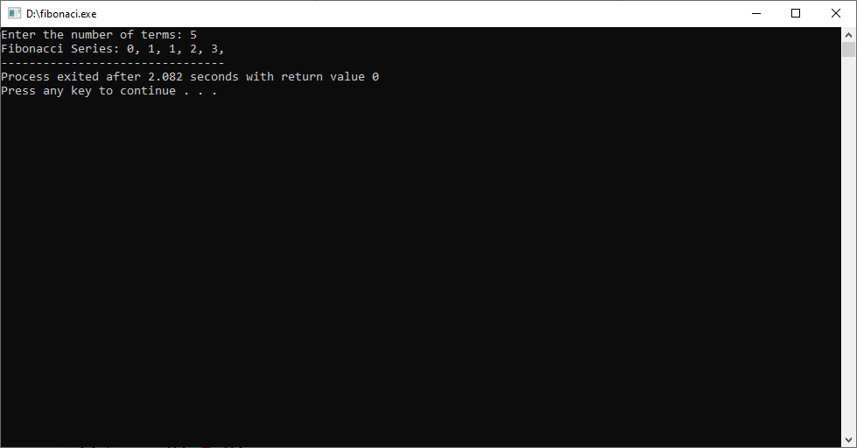

**Practical : 8**

**Aim : Program Check weather num is prime or not**

**Program :**

#include <stdio.h>

int main()

{

int n, i, f = 0;

printf("Enter a positive integer: ");

scanf("%d", &n);

if (n == 0 || n == 1)

f = 1;

for (i = 2; i <= n / 2; ++i)

{

if (n % i == 0)

{

f= 1;

break;

}

}

if (f == 0)

printf("%d is a prime number.", n);

else

printf("%d is not a prime number.", n);

}

**Output :**

