**Practical: 1**

**Aim: Write C Program to print below design using printf function with help of \t & \n escape sequence.**

**Program:**

#include<stdio.h>

#include<conio.h>

main()

{

clrscr();

printf("pattern-1\n");

printf("\t\t*\t\t*\n");

printf("\t*\t\t*\n");

printf("*\t\t*\n");

printf("\t*\t\t*\n");

printf("\t\t*\t\t*\n");

printf("\npattern-2\n");

printf("\t\t*\t*\t*\t*\t*\t*\t*\n\n\n");

printf("\t*\t*\t*\t*\t*\t*\t*\t*\n\n");

printf("\t*\t\t*\t\t\t\t\t*\n\n");

printf("\t*\t\t*\t\t*\t*\t*\t*\n\n");

printf("\t*\t\t*\t\t*\t\t*\t*\n\n");

printf("\t*\t*\t*\t*\t*\t*\t*\t*\n\n");

getch();

}

**Output:**

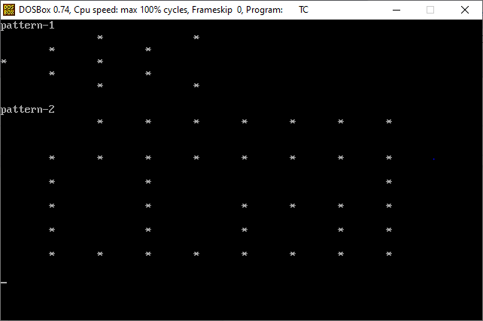

**Practical: 2**

**Aim:Write C Program to perform a swapping of two variables.**

**Program:**

#include<stdio.h>

#include<conio.h>

main()

{

int a,b;

clrscr();

printf("Enter value of a=");

scanf("%d",&a);

printf("Enter value of b=");

scanf("%d",&b);

a=a+b;

b=a-b;

a=a-b;

printf("\nafter swap=");

printf("\na=%d",a);

printf("\nb=%d",b);

getch();

}

**Output:**

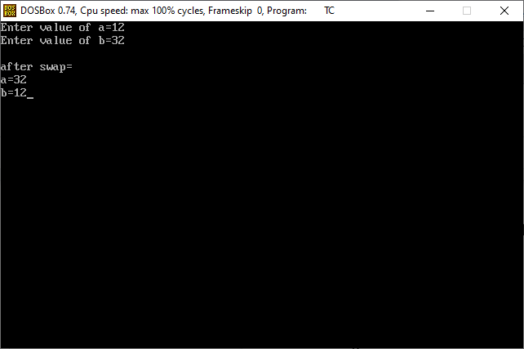

**Practical: 3**

**Aim: Write C program to convert temperature from degree Celsius to Fahrenheit.**

**Program:**

#include<stdio.h>

#include<conio.h>

main()

{

int a;

float t;

clrscr();

printf("enter value of a=");

scanf("%d",&a);

t=(a*1.8)+32;

printf("fahrenheit=%0.3f",t);

getch();

}

**Output:**

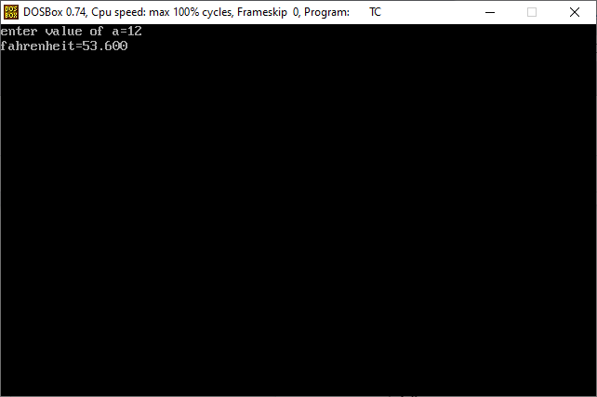

**Practical: 4**

**Aim:Write C Program to find gross salary.**

**Program:**

#include<stdio.h>

#include<conio.h>

main()

{

int a;

float H,D,T,ans;

clrscr();

printf("Enter base salary=");

scanf("%d",&a);

H=(a*10)/100;

D=(a*5) /100;

T=(a*8)/100;

ans=a+H+D+T;

printf("total salary=%f",ans);

getch();

}

**Output:**

