**8.INDICATOR**

**1. C program to swap two numbers using pointers**

**Program:**

#include <stdio.h>

void swap(int *x,int *y)

{

int t;

t = *x;

*x = *y;

*y = t;

}

int main()

{

int num1,num2;

printf("Enter value of num1: ");

scanf("%d",&num1);

printf("Enter value of num2: ");

scanf("%d",&num2);

printf("Before Swapping: num1 is: %d, num2 is: %d\n",num1,num2);

swap(&num1,&num2);

printf("After Swapping: num1 is: %d, num2 is: %d\n",num1,num2);

return 0;

}

**Output:**

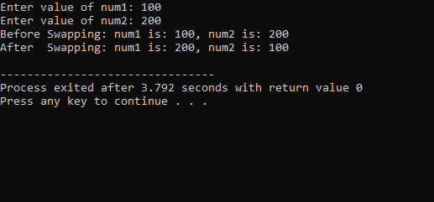

**2. C program to input and print array elements using pointers**

**Program:**

#include <stdio.h>

int main()

{

int data[5],i;

printf("Enter elements: ");

for (i = 0; i < 5; i++)

scanf("%d", data + i);

printf("You entered: \n");

for (i = 0; i < 5; i++)

printf("%d\n", *(data + i));

return 0;

}

**Output:**

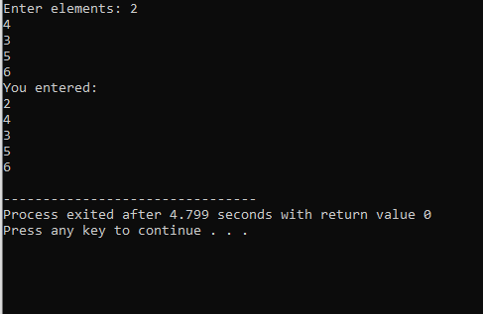

**3. C program to reverse an array using pointers**

**Program:**

#include<stdio.h>

#include<conio.h>

#define MAX 30

int main()

{

int size, i, arr[MAX];

int *ptr;

ptr = &arr[0];

printf("Enter the size of array :: ");

scanf("%d", &size);

printf("\nEnter %d integers into array:\n ", size);

for (i = 0; i < size; i++)

{

printf("\nEnter %d integer into array: ", i+1);

scanf("%d", ptr);

ptr++;

}

ptr = &arr[size - 1];

printf("\nElements of array in reverse order are :\n");

for (i = size - 1; i >= 0; i--)

{

printf("\n\nElement %d is %d ", i+1, *ptr);

ptr--;

}

return 0;

}

**Output:**

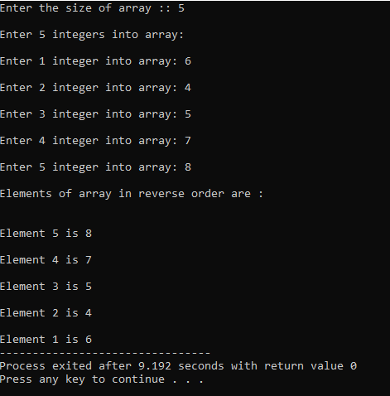

**4. Program to find length of string using pointer**

**Program:**

#include<stdio.h>

int string_ln(char*);

int main()

{

char str[20];

int length;

printf("Enter any string :: ");

scanf("%s",str);

length = string_ln(str);

printf("\nThe length of the given string [ %s ] is : %d\n", str, length);

return 0;

}

int string_ln(char*p)

{

int count = 0;

while (*p != '\0')

{

count++;

p++;

}

return count;

}

**Output:**

