**Practical - 1**

**Aim : Write C program to count frequency of each character in a string.**

**Program :**

#include<stdio.h>

main()

{

char s[1000];

int i,j,k,count=0,n;

printf(" enter the string :");

gets(s);

for(j=0 ; s[j] ; j++)

{

n=j;

}

printf("frequency count : ");

for(i=0 ; i<n ; i++)

{

count=1;

if(s[i])

{

for(j=i+1 ; j<n ;j++)

{

if(s[i]==s[j])

{

count++;

s[j] = '\0';

}

}

printf("%c = %d\n", s[i],count);

}

}

}

**Output :**

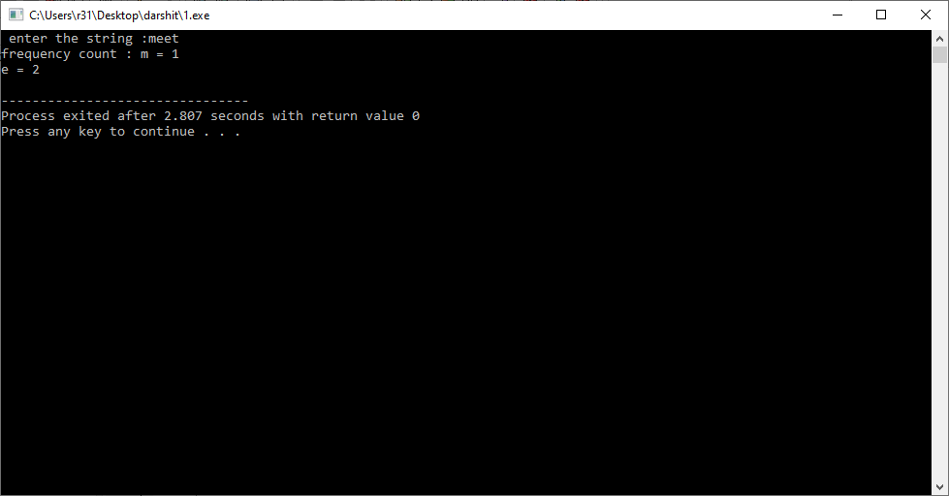

**Practical - 2**

**Aim : Write C program to check whether a string is palindrome or not.**

**Program :**

#include<stdio.h>

#include<string.h>

int main()

{

char str[20];

int i, len, temp=0;

int flag = 0;

printf("Enter a string:");

scanf("%s", str);

len = strlen(str);

for(i=0;i < len ;i++)

{

if(str[i] != str[len-i-1]){

temp = 1;

break;

}

}

if (temp==0) {

printf("String is a palindrome");

}

else {

printf("String is not a palindrome");

}

return 0;

}

**Output :**

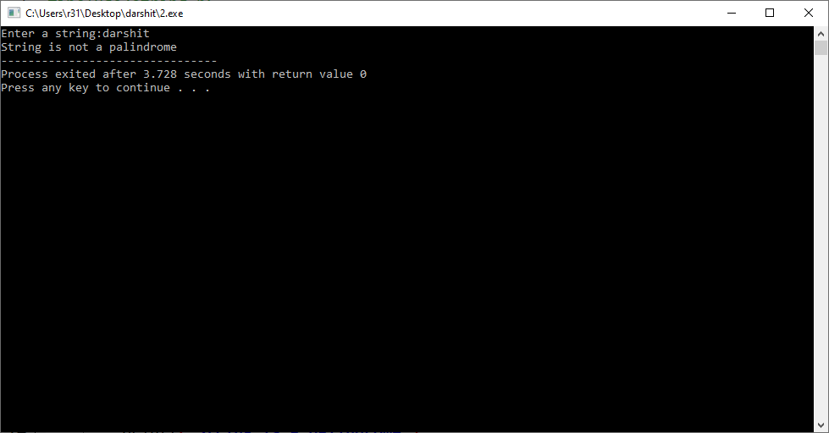

**Practical - 3**

**Aim : Write C program to remove spaces, blanks from a string.**

**Program :**

#include<stdio.h>

#include<string.h>

int main()

{

int i, len = 0,j;

char str[] = "Remove white spaces";

len = sizeof(str)/sizeof(str[0]);

for(i = 0; i < len; i++)

{

if(str[i] == ' ')

{

for(j=i;j<len;j++)

{

str[j]=str[j+1];

}

len--;

}

}

printf("String after removing all the white spaces : %s", str);

return 0;

}

**Output :**

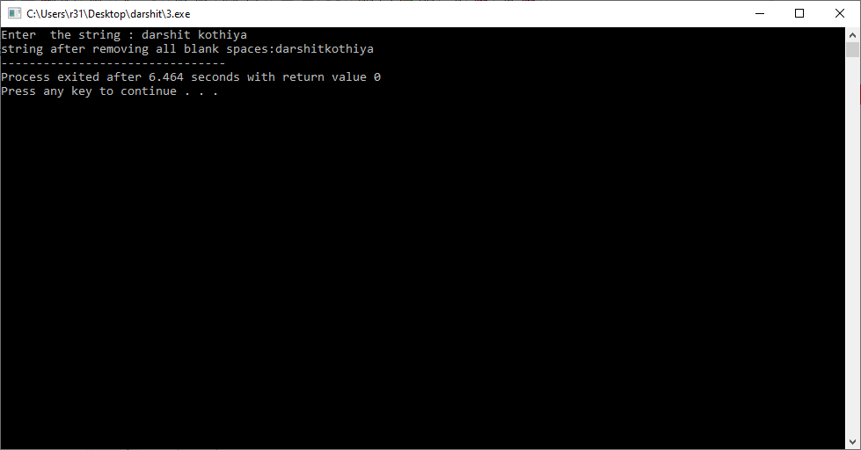

**Practical - 4**

**Aim : Write C program to remove all repeated characters in a string..**

**Program :**

#include <stdio.h>

#include <string.h>

int main()

{

char str[100];

int i, j, k;

printf("\n Please Enter any String : ");

gets(str);

for(i = 0; i < strlen(str); i++)

{

for(j = i + 1; str[j] != '\0'; j++)

{

if(str[j] == str[i])

{

for(k = j; str[k] != '\0'; k++)

{

str[k] = str[k + 1];

}

}

}

}

printf("\n The Final String after Removing All Duplicates = %s ", str);

return 0;

}

**Output :**

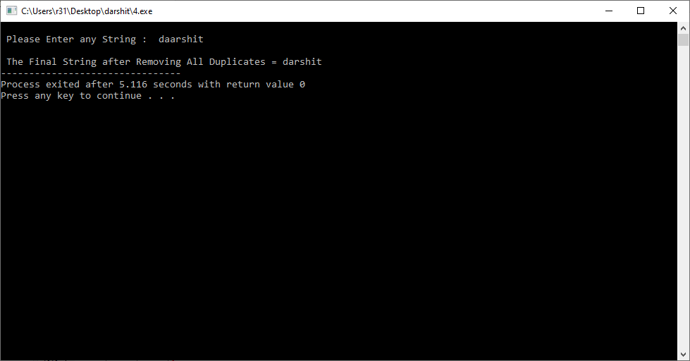

**Practical - 5**

**Aim : Write Count of number of given string in 2D character array.**

**Program :**

#include <stdio.h>

using namespace std;

#define ARRAY_SIZE(a) (sizeof(a) / sizeof(*a))

int internalSearch(string needle, int row,

int col, string hay[],

int row_max, int col_max, int xx)

{

int found = 0;

if (row >= 0 && row <= row_max && col >= 0 &&

col <= col_max && needle[xx] == hay[row][col])

{

char match = needle[xx];

xx += 1;

hay[row][col] = 0;

if (needle[xx] == 0)

{

found = 1;

}

else

{

found += internalSearch(needle, row,

col + 1, hay,

row_max, col_max,xx);

found += internalSearch(needle, row, col - 1,

hay, row_max, col_max,xx);

found += internalSearch(needle, row + 1, col,

hay, row_max, col_max,xx);

found += internalSearch(needle, row - 1, col,

hay, row_max, col_max,xx);

}

hay[row][col] = match;

}

return found;

}

**Output :**

