**Practical - 1**

**Aim : C program to find factorial of number using recursion.**

**Program :**

#include<stdio.h>

int fact(int x)

{

if(x <= 1)

{

return 1;

}

else

{

return x*fact(x-1);

}

}

main()

{

int n,ans;

printf("enter number :");

scanf("%d",&n);

ans=fact(n);

printf("factorial =%d",ans);

}

**Output :**

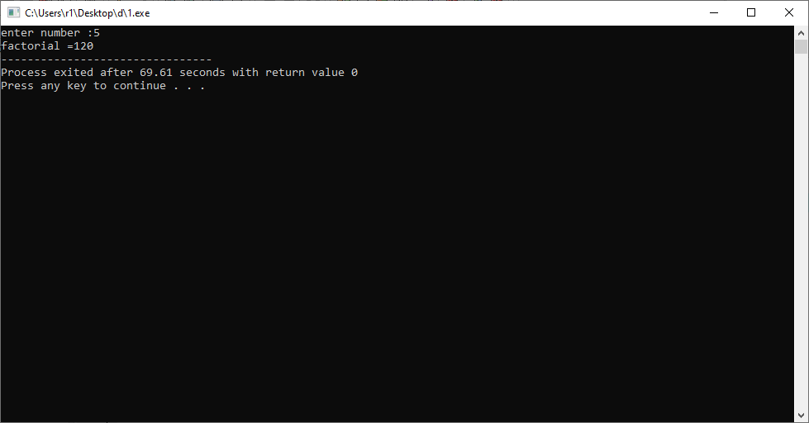

**Practical - 2**

**Aim : C program to find Sum of all Array Elements by passing array as an argument using User Define Functions.**

**Program :**

#include<stdio.h>

int sum(int b[],int x)

{

int i,sum=0;

for(i=0;i<x;i++)

{

sum=sum+b[i];

}

return sum;

}

main()

{

int i,n,a[100],ans;

printf("enter number :");

scanf("%d",&n);

for(i=0;i<n;i++)

{

printf("%d = ",i);

scanf("%d",&a[i]);

}

ans=sum(a,n);

printf("total sum =%d",ans);

}

**Output :**

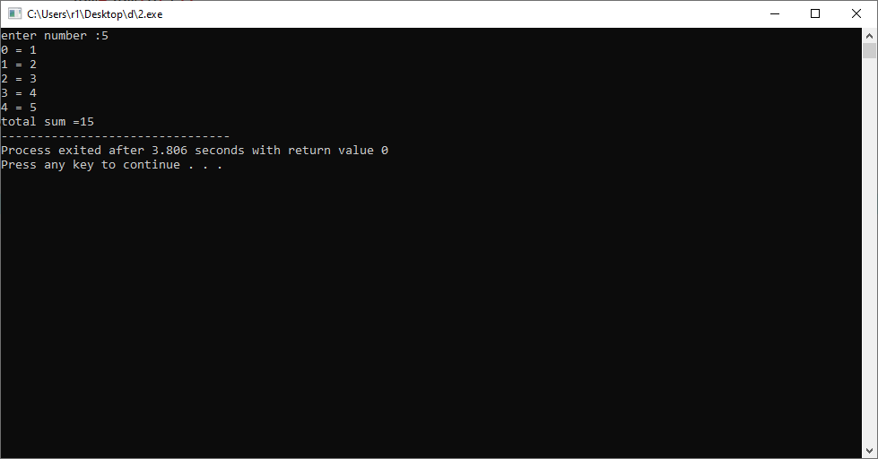

**Practical - 3**

**Aim : C program to find Length of the String by passing String/ Character Array as an Argument using User Define Functions.**

**Program :**

#include<stdio.h>

int len(char b[])

{

int i,len=0;

for(i=0;b[i]!=NULL;i++)

{

len++;

}

return len;

}

main()

{

char a[100];

int ans;

printf("enter name :");

gets(a);

len(a);

ans=len(a);

printf("len =%d",ans);

}

**Output :**

