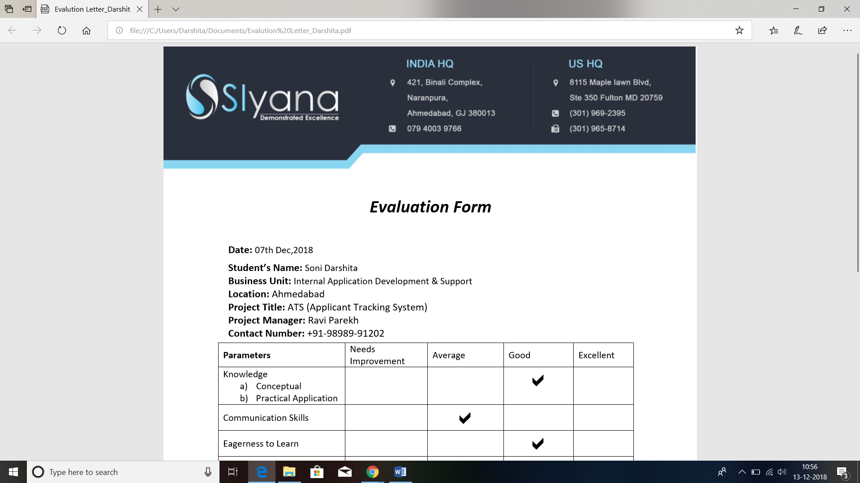

Date: 17th Sept, 2018

TO WHOM IT MAY CONCERN

This is to inform that Miss RENUKA THAKOR has successfully completed the project on ATS

(Applicant Tracking System) under me.This work is original and has not been submitted

elsewhere.

