**Project Title: APPLICANT TRACKING SYSTEM(ATS)**

**BY FIFTH SEMESTER OF THIRD YEAR OF MSC (CA&IT)**

**(2018-19)**

Group Id : 67

Student Name (Roll No) : Renuka Thakor (3246)

: Darshita Soni (3247)

Project Guide : Mr. Ravi Parekh

Name of Company : Siyana Info Solution

Date of Submission : 12th December 2018

Submitted to :



**K.S. School of Business Management & Research**

**Gujarat University Campus,**

**Ahmedabad.**

**Acknowledgement:**

The success and final outcome of this project required a lot of guidance and assistance from many people and we are extremely fortunate to have got this all for our project work. Whatever we have done is only due to such guidance and assistance and we would not forget to thank them.

We respect and thankful to K.S.S.B.M. for giving us an opportunity to do the project work and providing us all support and guidance which made us completes the project on time. We are extremely grateful to project guide for providing such a nice support and guidance though she had busy schedule.

We would like to express our gratitude towards Course coordinator Department and our project mentor for their kind co-operation and encouragement, which helped us in this project.

|  |  |  |
| --- | --- | --- |
| **Ch No:** | **Topic** | **Page No.** |
| **1** | **INTRODUCTION** | **5** |
|  | **1.1 Organisation Profile** | **6** |
|  | **1.2 System Detail** | **7** |
|  | **1.2.1 Existing System** | **7** |
|  | **1.2.2 Proposed System** | **7** |
|  | **1.3 Scope of System** | **8** |
|  | **1.4 Objectives** | **10** |
| **2** | **PROPOSED SYSTEM REQUIREMENT GATHERING** | **11** |
|  | **2.1 Stakeholders of System** | **11** |
|  | **2.2 Requirement Gathering Technique Used** | **13** |
|  | **2.3 Project Definition** | **17** |
| **3** | **SYSTEM MANAGEMENT AND PLANNING** | **18** |
|  | **3.1 Feasibility Study** | **18** |
|  | **3.1.1 Technical** | **18** |
|  | **3.1.2 Economic** | **18** |
|  | **3.1.3 Operational** | **19** |
|  | **3.2 Hardware- Software Requirement** | **20** |
|  | **3.3 System Planning** | **21** |
|  | **3.3.1 Work Breakdown Structure** | **21** |
|  | **3.3.2 Gantt Chart** | **22** |
|  | **3.4 Process Model** | **23** |

|  |  |  |
| --- | --- | --- |
| **4** | **SYSTEM ANALYSIS AND DESIGN** | **26** |
|  | **4.1 UML (Unified Modelling Language) /DFD** | **26** |
|  | **4.2 System Flow Diagram** | **36** |
|  | **4.3 Data Dictionary** | **37** |
|  | **4.4 User Interface** | **41** |
| **5** | **SUMMARY** | **48** |
|  | **5.1 Assumptions** | **48** |
|  | **5.2 Limitations** | **48** |
|  | **5.3 Conclusion** | **48** |
|  | **5.4 Future Scope** | **48** |

**CHAPTER: 1**

**INTRODUCTION**

The qualities of company’s hires are the single best predictor of its future success. This is widely understood but little acted upon. Hiring is still seen as frustrating and messy by the many business owners, HR Directors, hiring managers and recruiters who grapple with it. Now for the first time, better software is righting this wrong.

At the heart of all of this is the Applicant Tracking System (ATS).

**What is an ATS?**

What is an Applicant Tracking System?

The term “Applicant Tracking System” is in wide use and is considered part of a **“recruitment management system”.**

In its simplest form, its offers relief to these commonly acknowledged pain points in recruitments. The right Applicant Tracking software is a major step towards creating a repeatable, systematic hiring process.

It helps you manage the complete recruitment life-cycle from business development through finalizing a placement. It helps scheduling; issues notification alters and sends automated Emails to candidate.

**1.1 Organization Profile:**

**Name :**  Siyana Info Solution

**Address :** 421, Binali complex,

Naranpura, Ahmedabad,

GJ 380013.

**Contact :** 079 40039766

www.siyanainfo.com

**About :**



Siyana Info Solutions emerging global workforce solutions company for more than 100+ clients ranging from fortune 100 to start ups.

They consult, talk, train, tweet, blog, text, post, share, read and tete-a-tete about recruitment. They have been doing this for a few years now, working with many companies along the way. These companies range from small but growing companies fortune clients, right through federal agencies and state governments. Siyana Info Solutions is an equal employment opportunity employer. They operate across various verticals like information technology, defence, financial services, energy, utilities, internet and engineering. They have a global presence in four countries with a realistic roadmap to increase their footprints further.

**1.2 System Detail:**

Applicant Tracking System (ATS) offer numerous benefits to small and medium-sized business, making their recruitment and hiring tasks much more efficient. So , it comes as no surprise that ATS software has become increasingly popular, with more companies realizing just how easy hiring can became if the right system is put in place.

Does the ATS Integrate?

If you are going to deploy ATS recruitment, then near the top of your list of recruitments should be how well it integrates and what it integrates with. Most system integrates with job boards, but you want your system to go further than that.

**LinkedIn:**

Integration with LinkedIn is essential.

**1.2.1 Existing System:**

Currently no such system exists for Siyana Info Solution. Infect they do recruitment process manually and due to the manually process there are chances of lost or missing data. It also takes a much more time and creates a work load.

**1.2.2 Proposed System:**

Due to this manually process and to overcome this disadvantage we provide fully online recruitment process known as Applicant Tracking System.

Efficient resume parsing and system supported matches with each job description.

Evaluation includes not just technical screening but a job competency assessment, reliability, scorecard and social media profiting.

They bolster your employer brand with a robust profile that puts your mission and values front and center.

From end-to-end solutions to modular services that work seamlessly with your own internal process.

**1.3 Scope of System:**

1. Director
2. Recruiter
3. BD (Business Developer)
4. BDM (Business Developer Manager)

**Functionalities:**

Two main modules of ATS (Applicant Tracking System) are:

1. CRM (Client & Requirement Management)
2. ATS (Applicant Tracking System)

* **CRM has three sub-modules**

1. Lead Management:

In that company will find the lead that means which company need a staff. Then contact that company through the phone call and visit that company.

1. Client Management:

When we crack a deal with lead company then that company becomes our client.

1. Client Job Management:

We take detailed description from client about which type of candidate they need and add that information into client job management. Example: experience, special skills etc.

* **ATS has four sub-modules**

Company has a team of 10 recruiters and now all work is handled by the recruiter. Then assignments are given to per recruiter.

Then recruiter will find candidate from the social sites such as LinkedIn, monster, job boards, job portal etc.

1. Daily Call Log:

After finding some of the resumes from the above sites. Recruiter set daily call log of the specific candidate. So, the ATS remind them.

>> If any resume is confirmed by the recruiter then he will send this resume to the technicians of the company to conform that this resume is according to our client requirements or not.

1. Submission Sheet:

After the resume is approved by the technicians’. The basic interview is taken, then the submitted sheet is prepared of the selected candidates and that submission sheet is send to the client.

>> If client is agreed with our selected candidates. Then company will arrange interviews of the candidate and client.

1. Candidate Joining Sheet:

After all the phases of interview is completed by the client and if candidate is selected for their company, then our company get the message that candidate joins Client Company.

If any how the candidate is rejected by the client then also our company get the message.

1. Invoice:

Based on the how many candidates they can

Hire, our company will send invoice to the client.

**1.4 Objectives:**

The primary role of ATS (Applicant Tracking System) is that it will provide end-to-end service to our clients and also to candidates. Also, it works as a mediator between client and the candidates. You need to know the degree of flexibility that a potential Applicant Tracking System will offer when it comes to custom reporting and providing high-level visualization. A lot of ATS systems allow you to analyse areas such as candidate sources and candidate flow, exporting the data into excel spreadsheet.

Here there are some of the objectives as:

1. Cost Per Hire:

Most organizations will to know this, and some are outright obsessed with it. The problem with cost per hire is that it can be interpreted differently, so the more specific your ATS can be, the better.

1. Planning:

Time to fill is important and helps organization better organize their recruitment.

1. Candidate Sourcing:

For each hire, you want your ATS to tell you how many qualified candidates were in the mix.

1. Efficiency:

Driving an efficient recruitment strategy highly depends on the ability of a company to implement more streamlines and agile processes that enable recruiters to focus and spend more time on what matters the most.

**CHAPTER: 2**

**PROPOSED SYSTEM REQUIREMENT GATHERING**

Every software project goes through a phase called Requirement Gathering. A successful project begins with a difficult set of discussions on what should be done. It’s the major responsibility of IT Business Analyst to gather the Requirements from the clients. Getting the correct requirements from the client can often be one of the biggest hurdles in any software project. If Business Analyst gathers correct and complete requirements, the projects will yield richer crops.

**2.1 Stakeholder of System**:

Stakeholders of the system are:

1. Director
2. Recruiter
3. BD (Business Developer)
4. BDM (Business Developer Manager)

* Director:

A Director is a person who interacts with an ATS (Applicant Tracking System) in such a way that it can access the whole system and we can say that he/she will play a role of admin as well.

* System Admin:

A system Admin is a person who is responsible for reliable operation of computer system. He/she will provide the password and User ID to the user of the system and also manage the needs of the user.

* Recruiter:

The role of recruiter is that he/she will only find the candidate for the client company according to their requirements. There is a team of ten Recruiter.

So, BD (Business Developer) and BDM (Business Developer Manager) give the assignments to each recruiter and on the basis of this work. After completing their assignment, he/she will submit it to their BD and BDM.

* BD (Business Developer):

The role of BD is that will first find the lead company who are in requirement of a job position and developers. Then BD visits the lead company and makes deal with company that “our company can find candidate for your job positions”. If lead company agrees to this then that company becames the client of our company. Then after BD takes some of the requirements that which type of candidate the client company need. Based on the requirements given by client, BD gives assignments to the recruiter for finding the candidates. A BD can only see his own clients.

* BDM (Business Developer Manager):

BDM can see the clients of BD as well as his own clients. That is BDM can also find the lead company same as BD can do, and also convert it to client. According to the requirements of their clients BDM can also assign the assignments to recruiter. A BDM can check the assignments given by him to recruiter as well as he/she will check the assignment given by BD to recruiter.

**2.2 Requirement Gathering Technique Used:**

**Requirement Gathering Technique**

There are many techniques available for gathering the requirements. Each technique has value in certain scenario. Most of the time, it becames necessary for Business Analyst to use multiple techniques to gather complete and correct requirements from clients and stakeholders. Here are some of our favourite requirements gathering techniques:

1. One-on-one Interviews
2. Group interviews
3. Facilitated sessions
4. Joint application development(JAD)
5. Questionnaires
6. Following people around
7. Request for proposal(RPFs)
8. Brainstorming

**Brief Explanation of these techniques:**

1. One-on-one Interviews:

The most common technique for gathering requirements is to sit down with the clients and ask them what the need.

1. Group Interview:

Group interviews are similar to the one-on-one interview, except that more than one person is being interviewed usually two to four.

1. Facilitated sessions:

In a facilitated session, you bring a larger group (five or more) together for a common purpose. In this case you are trying to gather a set of common requirements from the group.

1. Joint application development (JAD):

JAD sessions are similar to general facilitated sessions. However, the group stay in session until the session objectives are completed. The participants stay in session until a complete set of requirements are documented and agreed to.

1. Questionnaires:

Questionnaires are much more formal and they are good tools to gather requirements from stakeholders in remote location or those who will have only minor input into overall requirements.

1. Following people around:

This technique is especially helpful when gathering information on current process. You may need to watch them perform their job before you can understand the entire picture.

1. Request for proposals (RFPs):

If you are a vendor, you may receive requirements through an RFP.

1. Brainstorming:

It is utilized in requirements elicitation to gather good number of ideas from a group of people.

For our system we have used **Questionnaires**:

* **The Question which were asked to Admin**:

1. Everyone can Login in your System?

(a)Yes

(b)No

b) How will you give User ID and password to the new user?

(a)Through Email

(b)Manually

* **The Question which were asked to team of Recruiter:**

1. How and from where you will find the candidates?

--------------------------------------------------------

--------------------------------------------------------

b)All the recruiter get an individual work?

(a)Yes

(b)No

c) How you contact with candidates?

(a)Phone Calls

(b) E-mail

(c) Arrange a Meeting

* **The Question which were asked to BD (Business Developer):**

1. On which basis you will give an Assignment to Recruiter?

-------------------------------------------------------------

-------------------------------------------------------------

1. How much time you give to the recruiter to complete any Assignment?

(a) 2 Days

(b) 1 Day

(c) Not Fixed

(d) On the basis of no. of candidate to find

c) How client company will provide information to you?

(a)Phone Call

(b) E-mail

(c) Courier

(d) At the time when you conform deal

**Another technique which we have used for our system is group Interview:**

* In Group Interview only three members are involved:

1)Director

2)System Admin

3)BDM (Business Developer Manager)

* **The Question which were asked in the Group Interview are:**

1. Why you are go for online applicant tracking system(ATS).
2. Which types of candidate your company will find for client?
3. How will you conform deal with the client company?
4. Who will prepare Invoice and who will send it to client?
5. How will you get message that candidate join the client company?

**2.3 Project Definition**:

An applicant tracking system (ATS) is a software application that enables the electronic handling of recruitment needs. An ATS can be implemented or accessed online on an enterprise or small business level, depending on the needs of the company. It manages the recruiting and hiring process, including job postings and applications. It conducts a preliminary analysis of the applicants to find the best fits for a job.

If you are going to deploy ATS recruitment, then near the top of your list of requirements should be how it integrates and what it integrates with. Most system integrates with job boards, but you want your system to go further than.

Applicant Tracking System(ATS) that helps you streamline your recruiting process and find your best hires more efficiently.

Background Checks:

There is full integration with reputable background check providers

Office Productivity:

ATS integrate with popular tools such as Zapier and slack, it will integrate with the productivity tool that you use

You want to be able to see a complete overview of your recruitment efforts, so it’s important to figure out if the ATS software has the necessary capabilities. Having the right tools is essential to get the most out of your recruitment efforts. All of the steps in your recruitment process need to be visible as well as repeatable.

**CHAPTER: 3**

**PROJECT MANAGEMENT & PLANNING**

**3.1 Feasibility study:**

A feasibility study is carried out to select the best system that meets performance requirements.

The main aim of the feasibility study activity is to determine whether it would be financially and technically feasible to develop the product. The feasibility study activity involves the analysis of the problem and collection of all relevant information relating to the product such as the different data items which would be input to the system, the processing required to be carried out on these data, the output data required to be produced by the system as well as various constraints on the behaviour of the system.

**3.1.1 Technical Feasibility:**

Technical feasibility analysis is an attempt to study the project basically from a technician’s angle. It is the complete study of the project in terms of input, processes, output, fields, programs and procedures. It is a very effective tool for long term planning and trouble shooting. Internet is required to use the system.

Our System is very much technically feasible such that it provides information to candidate and clients in a given time. It also remind recruiter about the call at a very accurate time and also send many emails to candidate and client on a time.

Our system consists of,

* The facility to produce outputs in a given time.
* Response time under certain conditions.
* Facility to communicate data to distant locations
* It just requires window operating system and normal browser to use our system.

**3.1.2 Economic Feasibility:**

Economic feasibility analysis is the most commonly used method for determining the efficiency of a new project. It is also known as cost analysis. It helps in identifying project against investment expected from a project. Cost and time are the most essential factors involves in the field of study.

Our System is not much costly to develop so we cannot take any of the charge from the end user, thus our system is very much Economically feasible. As anyone can use this system for free of cost.

There must be scopes for profit after the successful completion of project.

* Our system is not much costly to develop.
* It is easy to use and understand therefor there is no need to appoint any operator to use the system.
* Organisation is ready to invest in proposed system because it is being developed in latest technology and will be very fast for the users to transfer or send the information using the system.

**3.1.3 Operational Feasibility:**

Operational feasibility is a measure of how well a proposed system solves the problems, and takes advantage of the opportunities identified during scope definition and how well it satisfies the requirements identified in the requirements analysis phase of system development.

We can Develop our System in a such a manner that any person that is IT Or NON-IT can use our system easily without any kind of difficulty. No one has to take training for use our system. Its Functionality is designed in such a way that anyone can operate it easily. Thus, our system is operationally feasible.

**3.2 Hardware and Software Requirement**

**Software Requirements:**

For Using our System no special software is required to be purchased. It can be used in any browser. Such as: -

* + - * Google Chrome
      * Firefox
      * Internet Explorer

**Hardware Requirements:**

**3.3 System Planning:**

**3.3.1** Work Breakdown Structure:

Work breakdown structure(WBS) is a hierarchical tree structure that outlines your project and breaks it down into smaller, more manageable portion.

The Goal of WBS is to make a large project more manageable. Breaking it down into smaller chunks means work can be done simultaneously by different team members, leading to better team productivity and easier project management overall.

ATS

**(**fig 3.1 Project Breakdown Structure)

**3.3.2 Gantt Chart:**

|  |  |  |  |  |  |
| --- | --- | --- | --- | --- | --- |
| **No.** | **Chapter** | **Aug** | **Sept** | **Oct** | **Nov** |
| 1 | Introduction |  | | | |
| 2 | Proposed System Requirement Gathering |
| 3 | System management and planning |
| 4 | System Analysis & Design |
| 5 | Summary |

**3.4 System Model**

We would be following the *Incremental Model* because the nature of this system as the requirements are not concrete. Many features can be added after the development of the system that serves the main purpose.

**Incremental Model:**

* This model is more flexible – less costly to change scope and requirements.
* It is easier to test and debug during a smaller iteration.
* In this model customer can respond to each built.
* Lowers initial delivery cost.
* Easier to manage risk because risky pieces are identified and handled during it’d iteration.

Increment #n

Communication

Planning **Delivery of 3rd increment**

Modelling

Construction

Deployment

Increment #2

**Delivery of 2nd increment**

Increment #1

**Delivery of 1st increment**

Project Calendar Time

**(Fig 3.3 Incremental Model)**

**Why it is Suitable for our system?**

**1.** Requirement for the Complete System are clear.

**2.** There are chances that some details can be evolved with time.

**3.** There is need to get the project in market quickly.

**4.** New technology is being used.

**CHAPTER: 4**

**SYSTEM ANALYSIS AND DESIGN**

**4.1 UML Design**:

**Use Case:**



**(Use Case of Login)**



**(Use Case of Admin)**



**(Use Case of User)**



**(Use Case of Lead Management)**



**(Class Diagram)**

**Activity Diagram for Admin:**



**(Activity Diagram for Admin)**



**(Activity Diagram for User)**

**Sequence Login Diagram:**

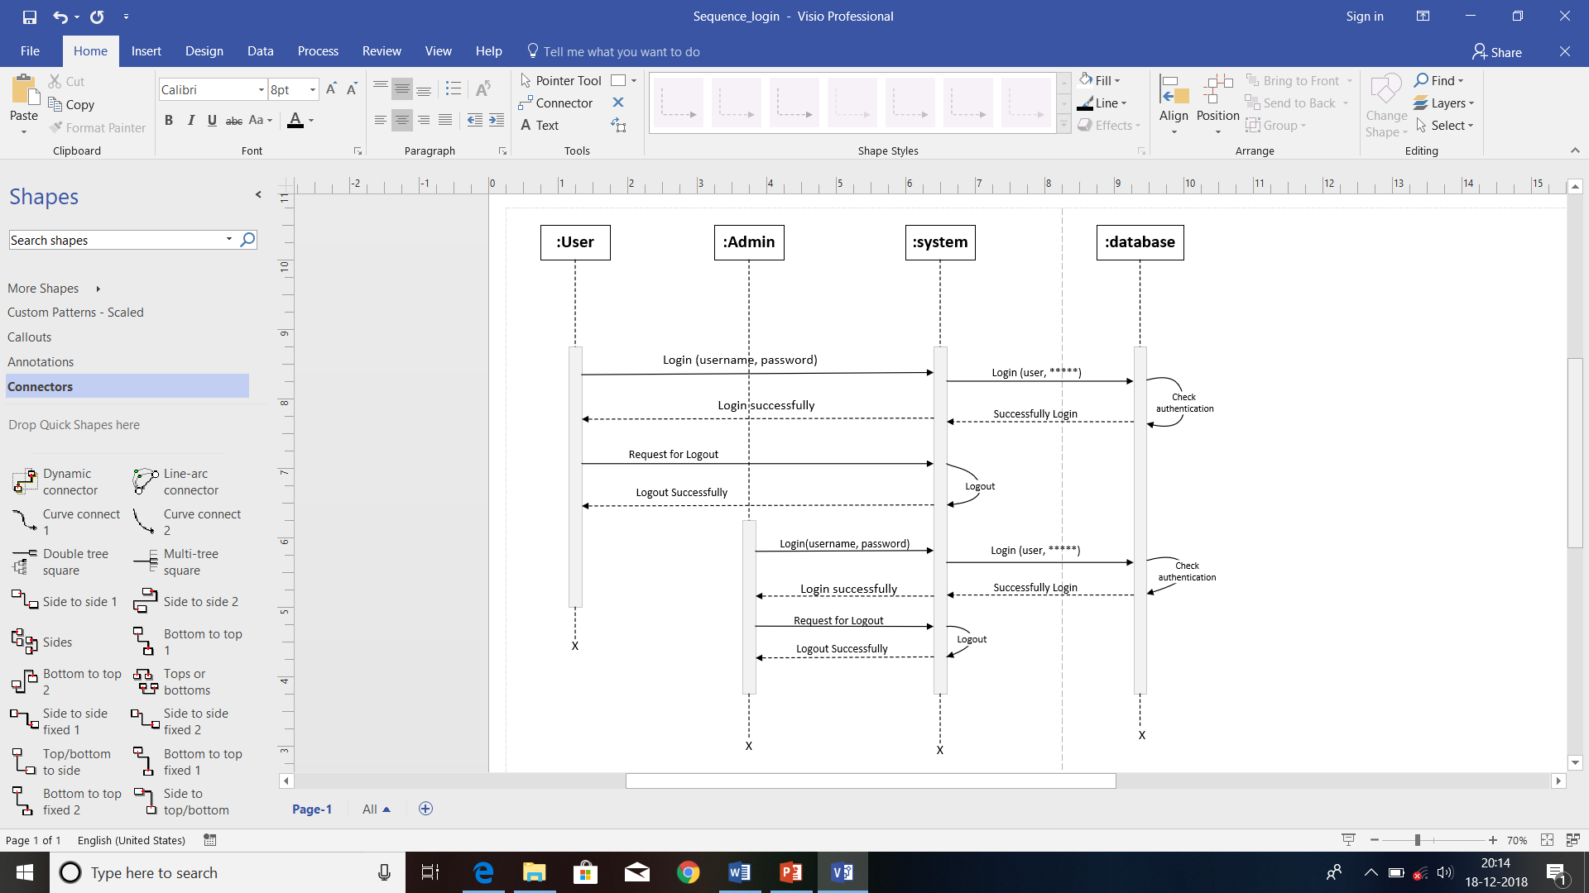

**(Sequence Diagram for Login)**

**Sequence Admin Diagram:**

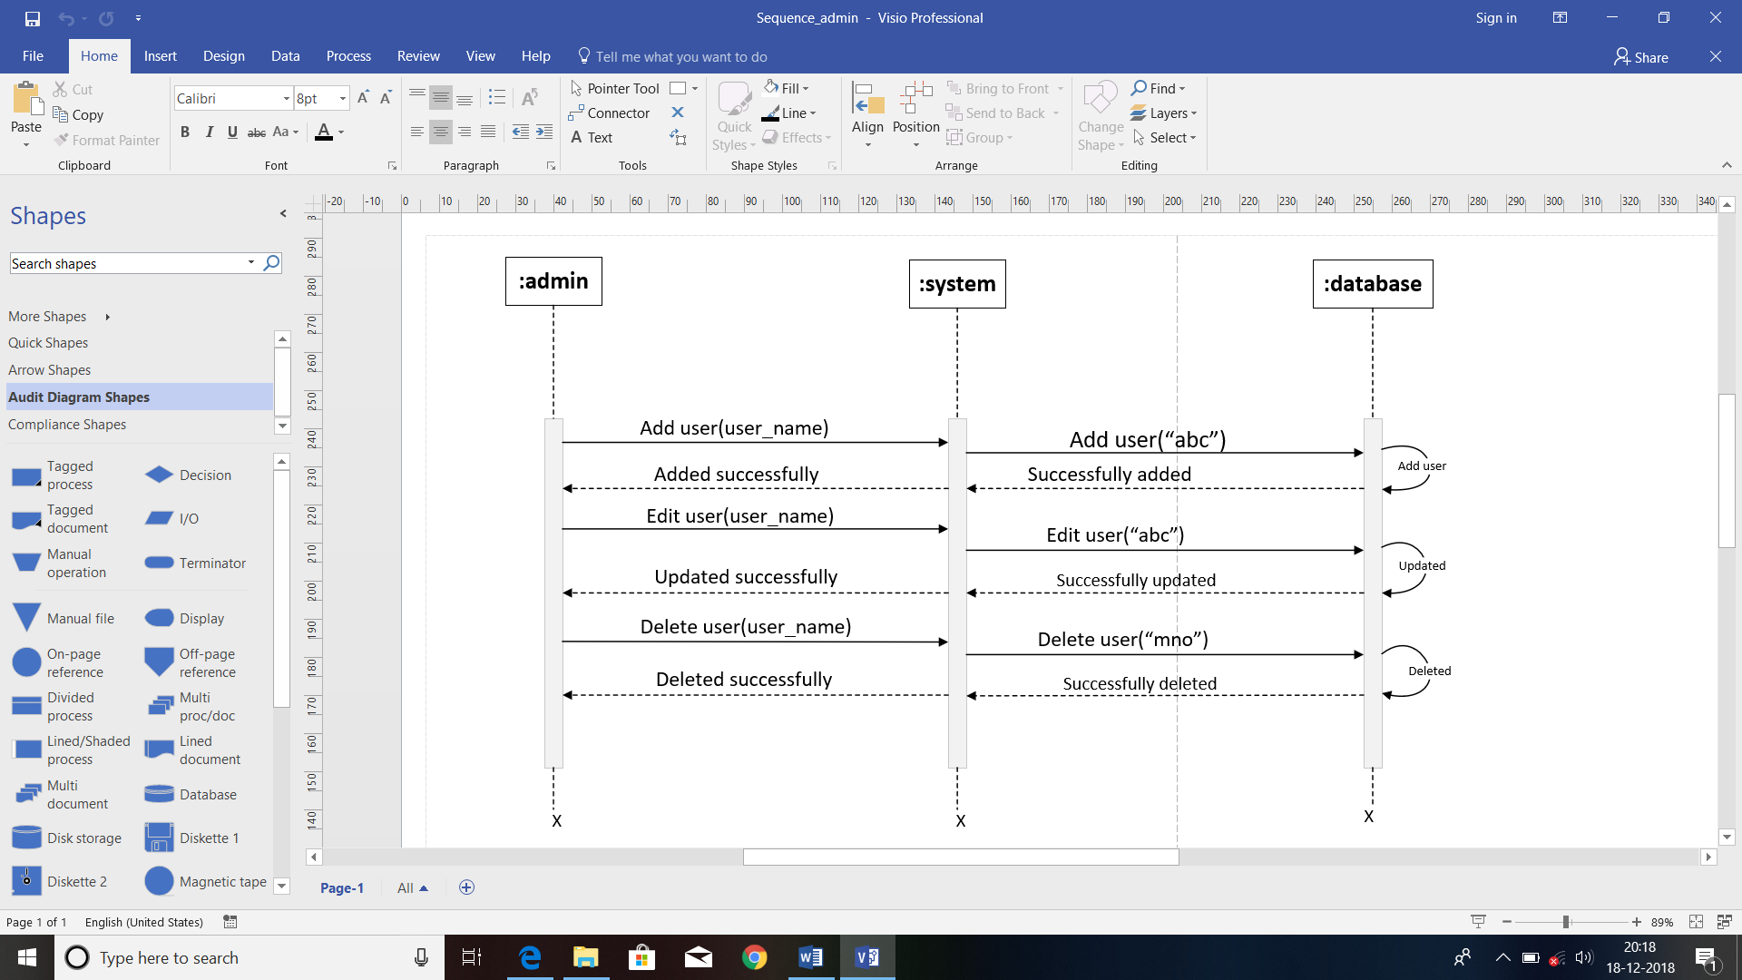

**(Sequence Diagram for Admin)**

**Sequence User Diagram:**

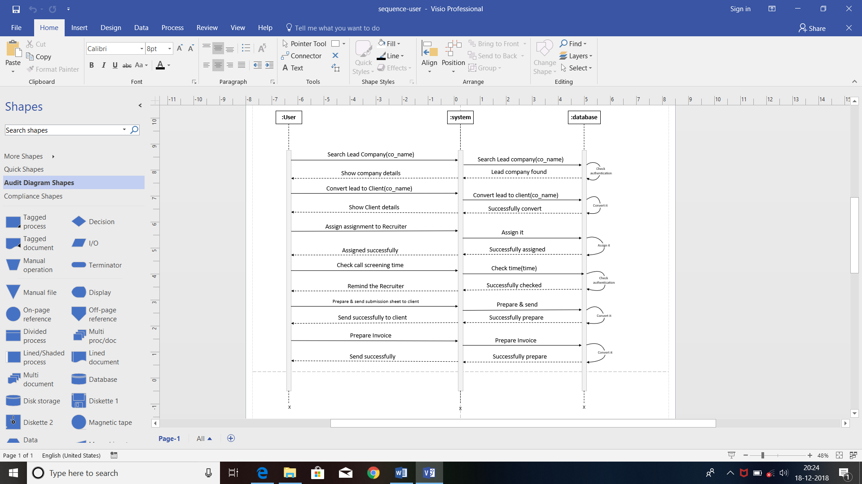

**(Sequence Diagram for User)**

**System flow Diagram:**



**4.3 Data Dictionary:**

**User**

|  |  |  |  |
| --- | --- | --- | --- |
| **Field** | **Data-Type** | **Constrains** | **Description** |
| Email_Id | Varchar (40) | Primary Key |  |
| Password | Varchar (10) | Not Null |  |
| User_name | Varchar (40) | Not Null |  |
| Gender | Varchar (6) | Not Null |  |
| Mobile no | integer (12) | Not Null |  |
| Address | Varchar (100) | Allow Null |  |
| Role | Varchar (10) | Not Null | User Role Ex:BD,BDM, BDM |
| Date_Of_Birth | Date | Allow Null |  |

**Company**

|  |  |  |  |
| --- | --- | --- | --- |
| **Field** | **Data-Type** | **Constrains** | **Description** |
| C_Id | integer | Primary Key |  |
| Co_Logo | Varchar (4000) | Not Null |  |
| Co_name | Varchar (100) | Not Null |  |
| Class_of_Co | Varchar (30) | Not Null | Private or public |
| Co_City | Varchar (30) | Not Null |  |
| Co_Address | Varchar (100) | Not Null |  |
| Co_Phone_no | Varchar (12) | Not Null |  |
| Co_Website | Varchar (50) | Not Null |  |
| Co_Email_Id | Varchar (100) | Not Null |  |

**Requirements**

|  |  |  |  |
| --- | --- | --- | --- |
| **Field** | **Data-Type** | **Constrains** | **Description** |
| Client_Job_Id | integer | Primary Key |  |
| C_Id | integer | Foreign Key | Company_tbl key |
| Job_type | Varchar (50) | Not Null |  |
| No_Of_Position | Varchar (50) | Not Null |  |
| Shift_time | date/time | Allow Null |  |
| Experience | Varchar (100) | Not Null |  |
| Salary_Package | double (100) | Not Null |  |
| Education | Varchar (100) | Not Null |  |
| Last_Used | Varchar (20) | Allow Null | In last when used |
| Technical_Skill | Varchar (500) | Not Null |  |
| Special_Skill | Varchar (100) | Allow Null |  |
| Job_Description | Varchar (200) | Allow Null |  |

**Candidate**

|  |  |  |  |
| --- | --- | --- | --- |
| **Field** | **Data-Type** | **Constrains** | **Description** |
| Candidate_Id | integer | Primary Key |  |
| Candidate name | Varchar (50) | Not Null |  |
| Resume | Varchar (4000) | Not Null |  |
| Call_date | date | Not Null |  |
| Call_time | time | Not Null |  |
| Call_status | Varchar (30) | Not Null |  |
| C_Id | integer | Foreign Key | Company_tbl Key |
| List_Submission_date | date | Not Null |  |
| Joining_status | Varchar (30) | Not Null |  |

**Invoice**

|  |  |  |  |
| --- | --- | --- | --- |
| **Field** | **Data-Type** | **Constrains** | **Description** |
| Invoice_Id | integer | Primary Key |  |
| Candidate_Id | integer | Foreign Key | Candidate_tbl Key |
| C_Id | integer | Foreign Key | Company_tbl Key |
| Amount | integer | Not Null |  |
| Date | Date | Allow Null |  |

**Assignment**

|  |  |  |  |
| --- | --- | --- | --- |
| **Field** | **Data-Type** | **Constrains** | **Description** |
| Recruiter_Id | Varchar (15) | Primary Key |  |
| Recruiter_name | Varchar (40) | Not Null |  |
| No_Of_Position | Integer | Not Null | How many candidate |
| Technical Skill | Varchar (50) | Not Null |  |
| Total_Exper | Varchar (10) | Not Null |  |
| Education | Varchar (25) | Not Null |  |
| Duration | Days | Not Null | Days |

|  |  |  |  |
| --- | --- | --- | --- |
| **Field** | **Data-Type** | **Constrains** | **Description** |
| Candidate-Id | Integer | Foreign Key | Candidate-table Key |
| C_Id | integer(30) | Foreign Key | Company-table Key |
| Candidate-Status | Varchar (5) | Not Null |  |

**Candidate Status**

**4.4 User Interface:**

**When User Do Login**

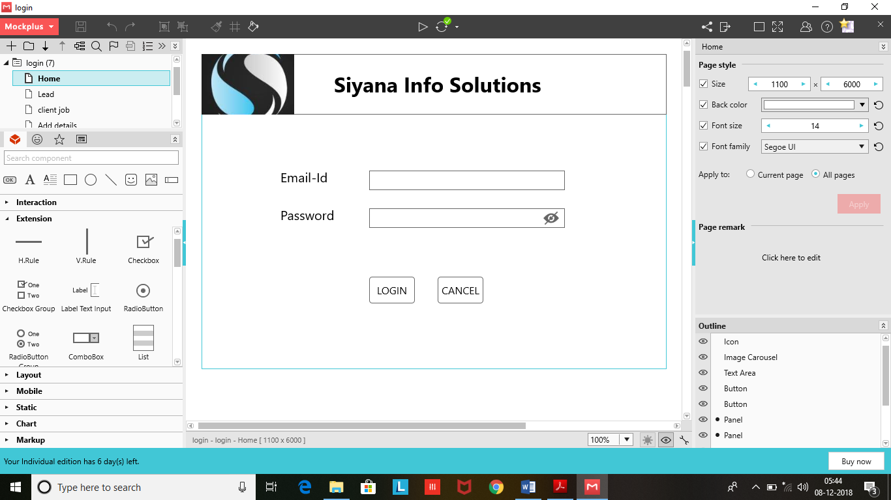

**When User Click on Lead Company**

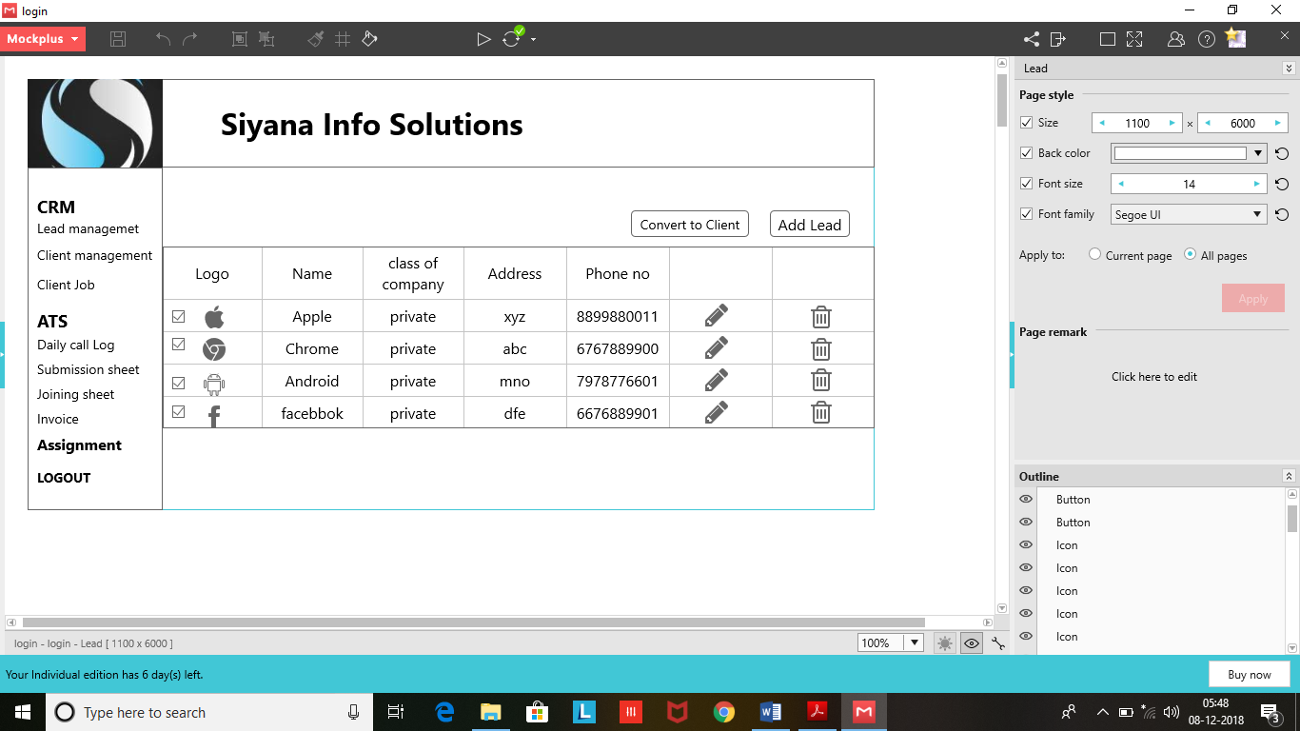

**When User Click on Client Job**

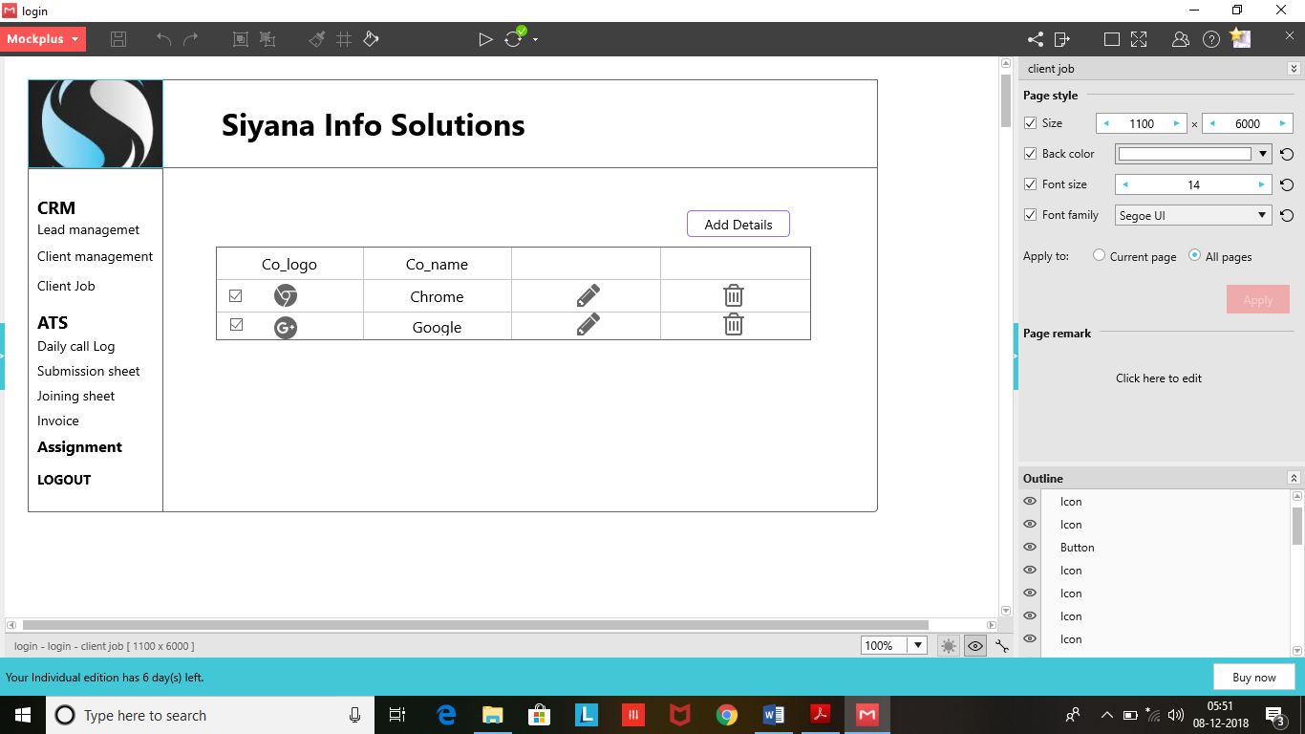

**When User Click on Add Details**

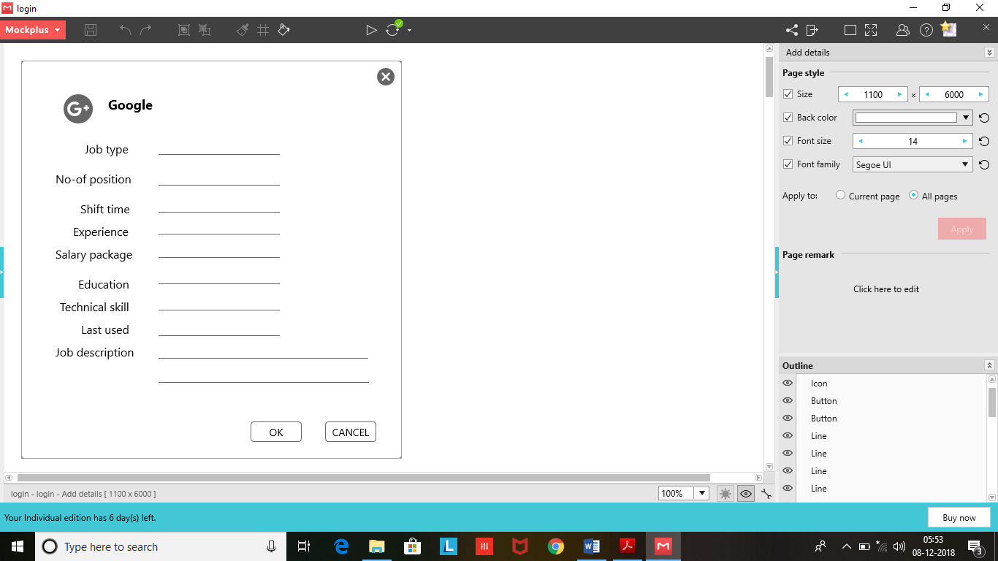

**When user Click on Assignment**

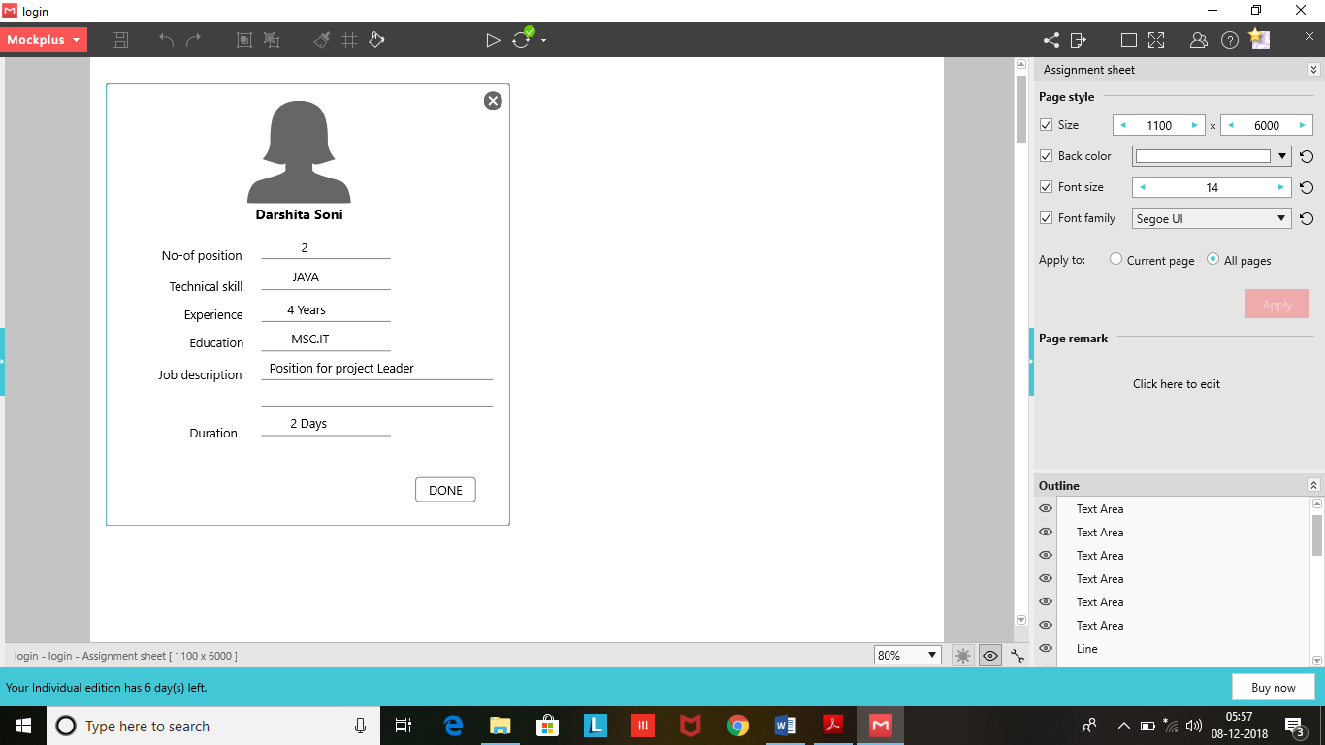

**When User Click on Daily Call Log**

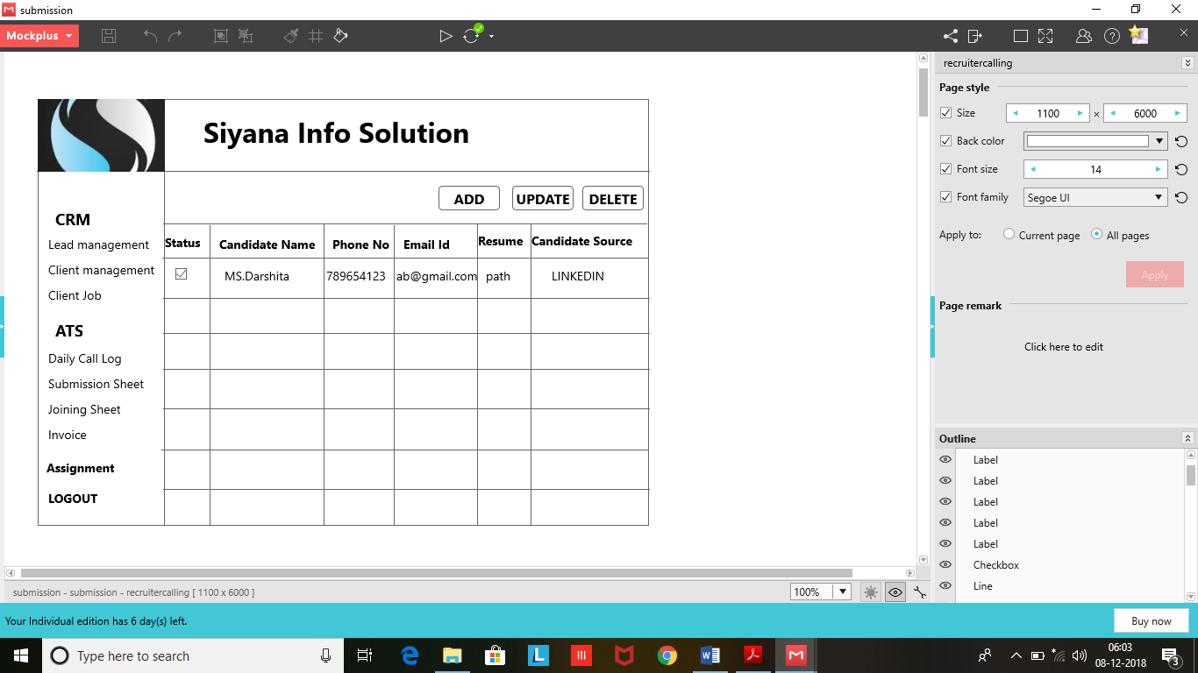

**Set the Screening of Call**

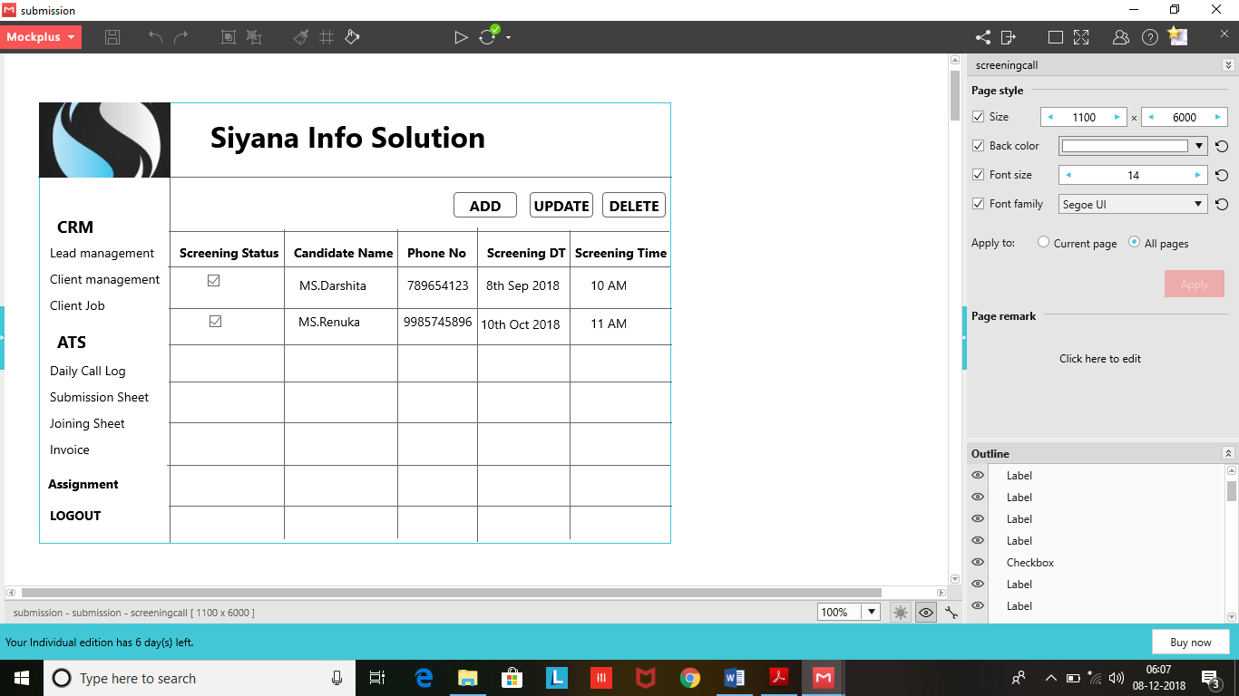

**When User Click on Set Call**

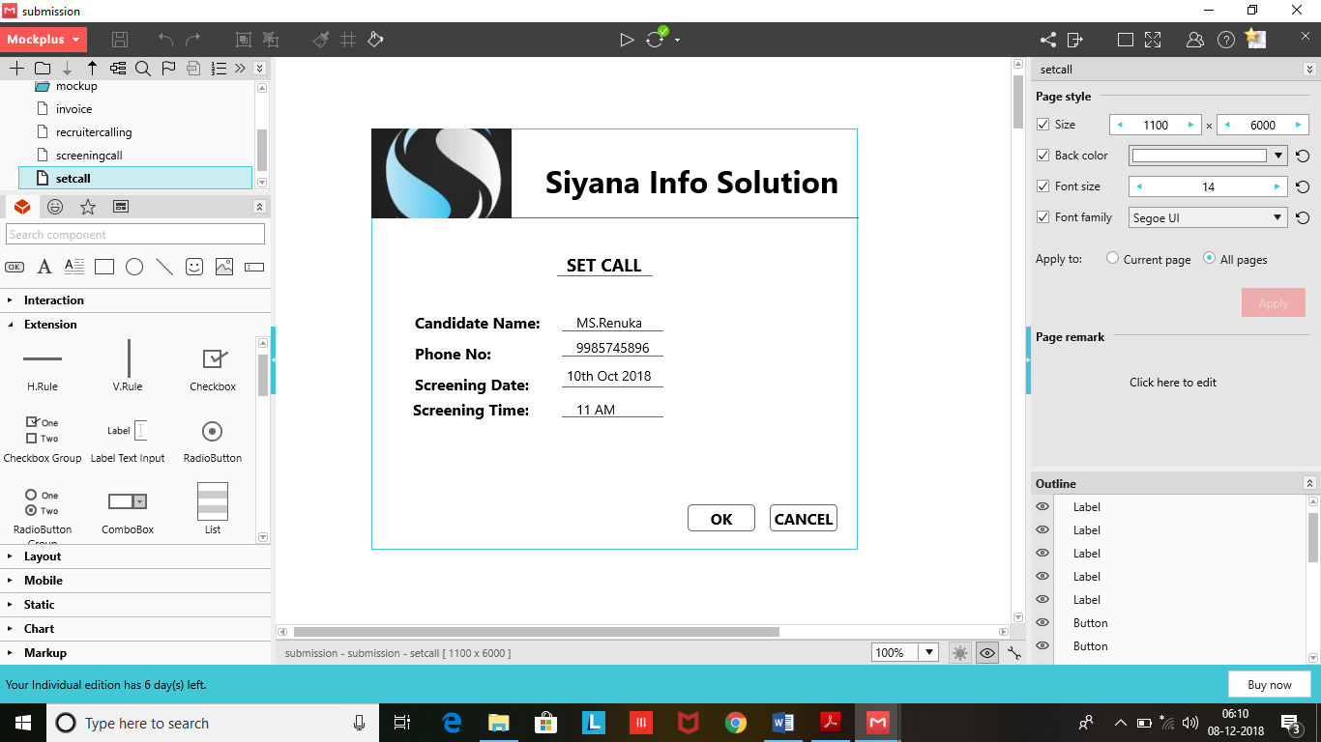

**List of Candidate:**

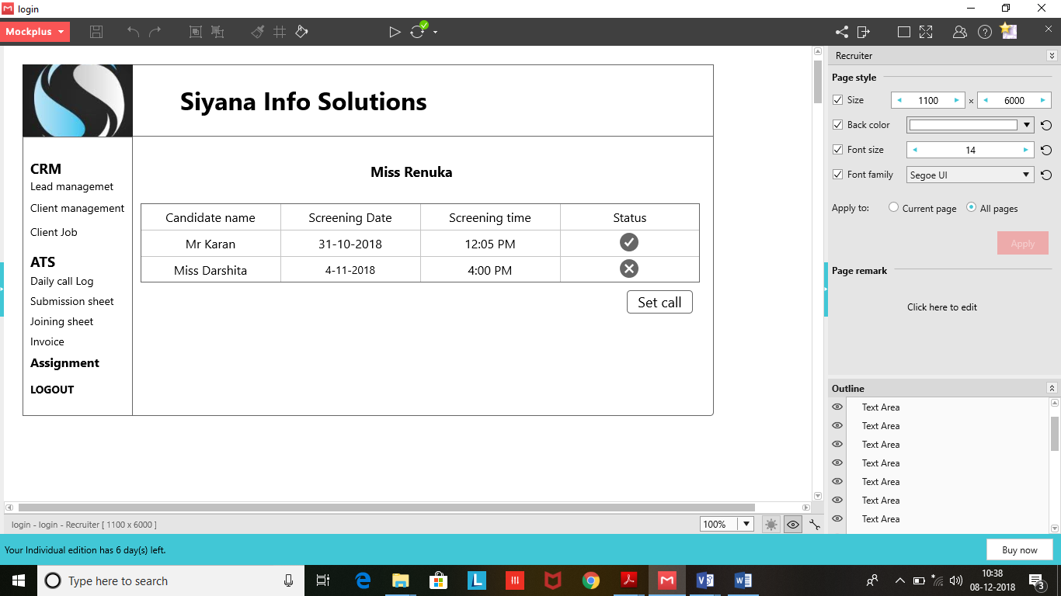

**When User Click on Submission Sheet**

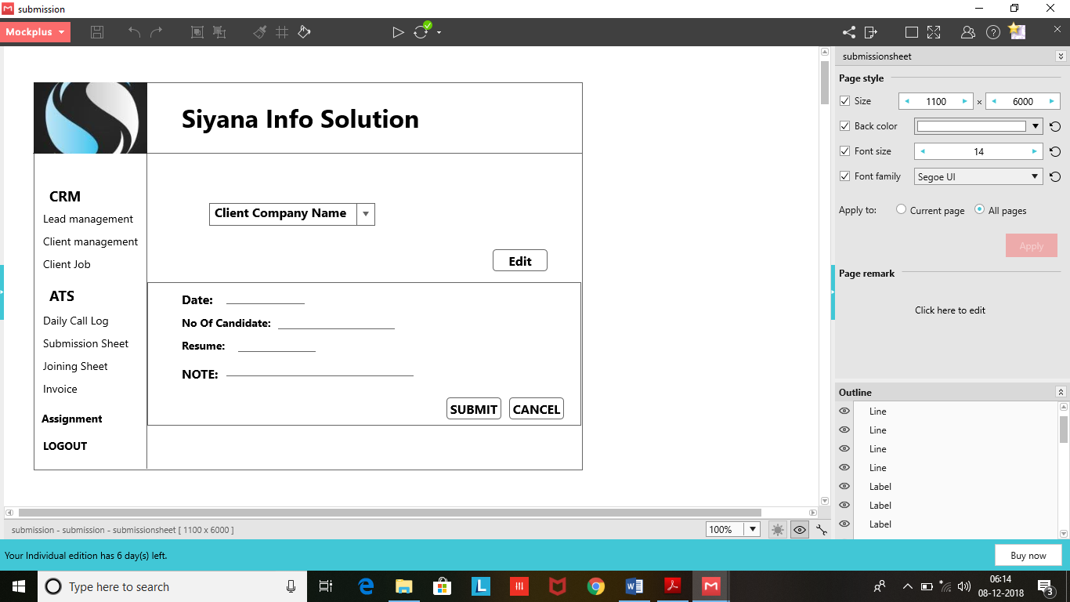

**When User Click on Joining Sheet**

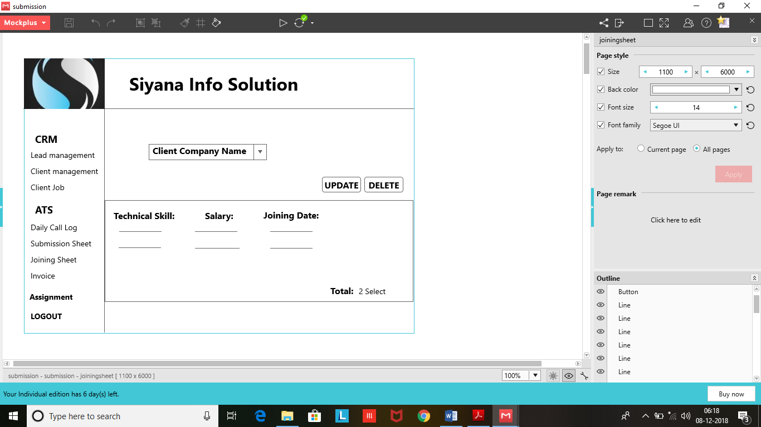

**When User Click on Invoice**

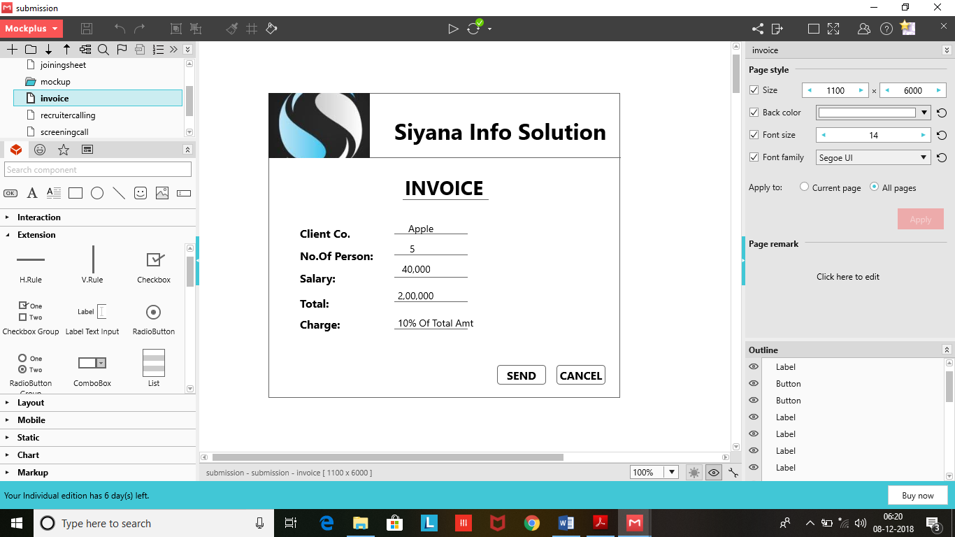

**CHAPTER: 5**

**SUMMARY**

**5.1 Assumption:**

* One should remember his ID & Password while login to the system.
* He has a primary knowledge of operating computer.
* He is able to run the system properly.
* He/she having Knowledge about What is Lead Company and What is Client Company.
* User is able to give any number of Assignment to the recruiter in a day.

**5.2 Limitations:**

* Client and candidate is not able to do login in our System.
* User of the System cannot generate Password and User Id by itself. They Have to register itself to the company to retrive password and User Id.

**5.3 Conclusion:**

It benefits to small and medium size business is making their requirements and hiring task much more efficient.

The System Will Save the time of those comapany’s who enough time doesn’t have to find proper candidate for their company.

This System is efficient for those candidates who are in search of good and Worthful job.

We know who might have made some mistake knowingly or unknowingly. But, All sthe suggestion regarding to the system are always welcome.

**5.4 Future Scope:**

System can be developed on higher skill such that it will provide facility of the interview slot for the client. It means that system will arrange interview for client. In future, we will try that our system will provide recruitment facility to other field area such as CA, CS etc…