Project Name:

Sales data Analysis of an E-commerce platform

Aim:

The primary goal is to provide actionable insights into the e-commerce landscape, pinpointing areas for enhancement and growth through comprehensive analysis.

Data:

Sales data:

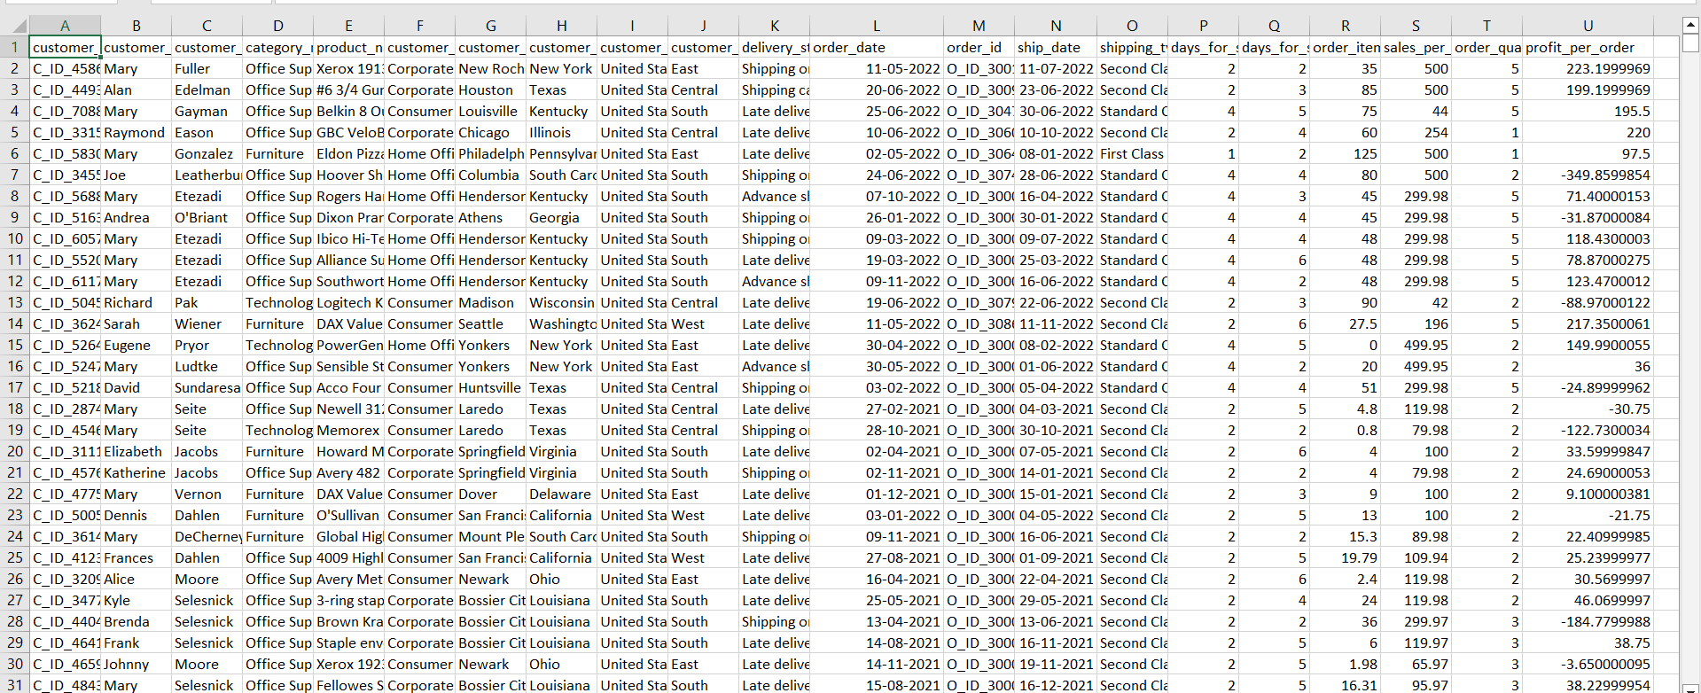

Region Data:

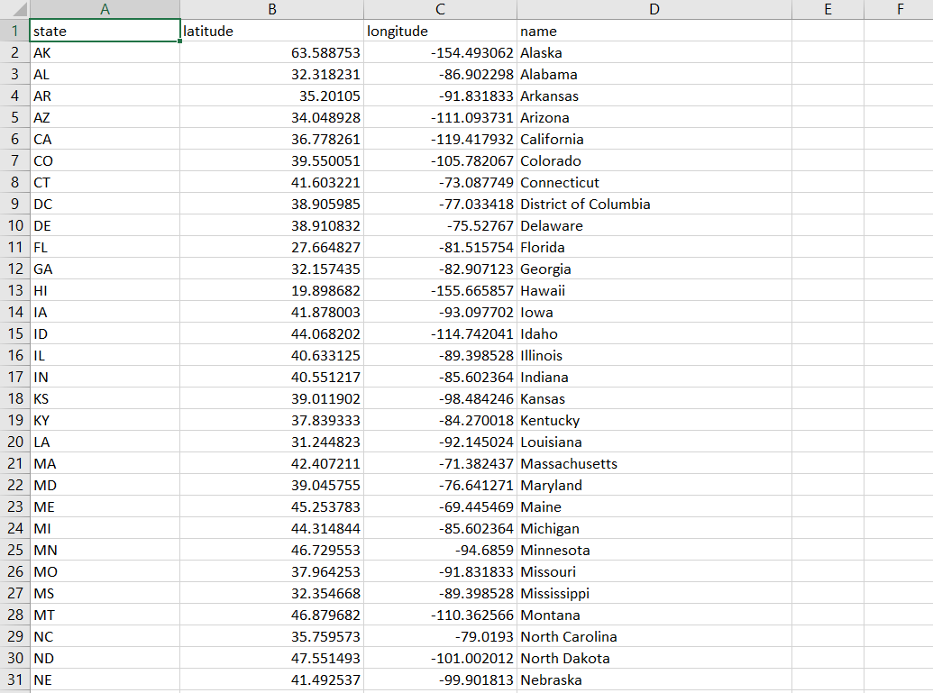

PowerBi Desktop:

