BUILD FOR BHARAT 2.0 · SAS CU HACKATHON
NEXUS DELTA
Evidence-based capability intelligence for the future workforce
Technical Approach Note

THE NUMBER THAT SHAPED THE DESIGN
0 — the number of employee IDs shared by the two people datasets (JDS ∩ SDS).
Any analysis that joins these files invents a link. NEXUS DELTA refuses to. It keeps every dataset separate and connects them through a versioned capability taxonomy, then asks three questions:
Know what to build. Which capability should an organisation develop next?
Know what to learn. Which capability should a student or professional develop next?
Know where you can thrive. Will the way a role works fit the way you work?

Team DSA · Chandigarh University
Anwesha Kar · Darshna Parihar · Saamyaraj Baidya
8 executed Python notebooks · SQL · SAS mirror · offline Streamlit application (171 automated checks)

Underlined orange text is clickable: section links jump within this document and notebook links open the executed code in the project repository. The QR code opens the same repository.


The 60-second version
The whole study on one page: what NEXUS DELTA found and why it can be trusted.
Table 1. The decision in one table (all values from results.json).
Capability | Internal evidence | Market evidence | Headroom | Decision
Maths & Statistics | δ 0.55 | OR 1.27 | 59% | PRIORITIZE
AI & ML | δ 0.36 | OR 1.38 | 51% | PRIORITIZE
Coding | δ 0.49 | OR 1.52 | 55% | PRIORITIZE
Dashboards & Storytelling | δ 0.59 | OR 0.75 | 42% | INVESTIGATE
Big Data | δ 0.12 | OR 1.09 | 82% | MAINTAIN

- Top priority: Maths & Statistics. Strong inside the company (Cliff's δ = 0.55), a market premium in all 6 models, 59% of juniors still below the ceiling, and the largest modelled gain. It beats the runner-up (AI & ML) in 95.7% of 1,000 bootstrap refits, ranks first among the four funded capabilities in 91.3% (NB08), and is first in all 9 sensitivity settings.
- The paradox: Storytelling. It is the strongest internal separator (δ = 0.59) yet carries a market discount (OR 0.69–0.80 in all six models). Splitting the keyword family shows the discount sits with MIS/reporting keywords (OR 0.66); visualisation keywords alone are neutral (OR 0.98). Verdict: INVESTIGATE (fund with reframe) — develop analytical communication, not report production.
- The trap: Big Data. The most headroom (82% of juniors below ceiling) but no significant univariate internal link (δ = 0.12, CI crosses 0), and its market premium disappears once experience is controlled. Headroom alone is not a reason to invest: MAINTAIN, and revisit with more data.
- For students: a posting's title and listed skills predict the exact salary band 44% of the time and land within one band 85% of the time (6 bands; majority-class baseline 24%) — so NEXUS DELTA shows a distribution, never an exact salary.
- For Bharat: Tier-2/3 cities account for 9.2% of all cleaned postings (6.7% of data-role postings), and only 29% of their data-role postings reach 10 LPA versus 51% in Tier-1.

Navigate this note
Section | What it answers
1. Problem definition | What decision is being made, by whom, and how success is measured
2. Approach | Why three separate signals, and why no row-level join
3. Data exploration | Every data issue found, its size, and the fix
4. Data analysis | Tests, models, validation and the Storytelling paradox
5. Results & conclusions | The decision, objectives met, hypotheses tested
6. Implications | What changes for each stakeholder, and the product
Appendix | Code, full tables, screenshots, SAS mirror, glossary

Contents
1. Problem Definition & Analytics Objective 4
1.1 Context 4
1.2 Problem statement 4
1.3 The workforce hierarchy 4
1.4 Analytics objectives 5
1.5 Hypotheses 5
1.6 Scope 6
2. Approach Description 6
2.1 The Zero Rule: why we do not join the datasets 6
2.2 Overall flow 6
2.3 Why three signals instead of one score 7
2.4 Decision rules 7
2.5 Method choices and the reason for each 8
2.6 Validation strategy 8
2.7 Technology 8
3. Data Exploration 9
3.1 Inventory 9
3.2 Data quality audit 9
3.3 Dataset profiles, outliers and inconsistencies 10
3.4 Descriptive statistics 11
3.5 Identifier audit 11
3.6 Derived variables 12
3.7 Consolidation and data reduction 12
3.8 What exploration showed 13
3.9 Bharat lens: the tier gap 13
4. Data Analysis 14
4.1 Internal evidence: what separates high-hike juniors 14
4.2 Is the internal signal real? (T1 model zoo) 15
4.3 Personality context (SDS) 15
4.4 Market evidence: what the market pays for 16
4.5 The Storytelling paradox — resolved 17
4.6 Reading a job description: the T2 scanner 17
4.7 Headroom and modelled gain 18
4.8 Career ladder and salary context 19
4.9 Evidence convergence: the decision 19
5. Results & Conclusions 20
5.1 The decision 20
5.2 Objectives met 21
5.3 Hypotheses 21
5.4 Conclusions 21
6. Implications 21
6.1 For each stakeholder 22
6.2 From analysis to product 22
6.3 Responsible use, built in 23
6.4 Limitations and next steps 23
6.5 Closing 24
Appendix 25

1. Problem Definition & Analytics Objective
IN ONE LINE
Capability investment decisions are usually made on opinion. NEXUS DELTA replaces the opinion with three independent pieces of evidence — and says so when they disagree.

1.1 Context
The SAS CU Hackathon brief frames the problem around data-science jobs, the skills of data scientists and their personality traits, with the objective “to bring out the best information out of available data”. Four files were supplied: Analytics Jobs (15,841 postings), Data Science Jobs (1,602 rows of company-level openings and salaries), JDS Skill Traits (139 junior data scientists, skills on a 1–5 scale and a high/low salary-hike outcome) and SDS Personality Traits (161 records, 152 unique IDs, of senior, customer-facing data scientists, with Big-Five traits and a high/low success outcome).
Several groups make expensive decisions from exactly this kind of information, usually by instinct: a learning-and-development head choosing which capability to fund, a student choosing what to learn, a candidate choosing which job to accept, and a university deciding what to teach. A wrong choice costs a training budget, a year of study, a resignation or a curriculum cycle.

1.2 Problem statement
PROBLEM STATEMENT
Which data-science capability should be developed next — and how confident can we be — when internal performance evidence, external market evidence and remaining headroom may point in different directions?

Table 2. Who decides, what it costs to be wrong.
Stakeholder | Decision they face | Cost of a wrong decision | What NEXUS DELTA gives them
L&D head / analytics leader | Which capability to fund for juniors | Budget spent on skills that do not move outcomes | PRIORITIZE / INVESTIGATE / MAINTAIN with evidence and confidence
Student / early professional | What to learn next for a target role | A year learning what the market discounts | Ranked development priorities for that role + salary-band distribution
Candidate / employee | Whether a role will fit how they work | Early attrition, friction, regret | Work-style fit, questions to ask, employee-reported culture
University placement cell | Which skills to add to the curriculum | Graduates trained for yesterday's roles | Capability demand by role and city tier

1.3 The workforce hierarchy
We organise the evidence as a hierarchy, borrowing the logic of Maslow's hierarchy of needs: a professional must first be employable, then grow, and only then can they choose where to thrive. Each level is answered by a different line of evidence, so the analysis never mixes them.
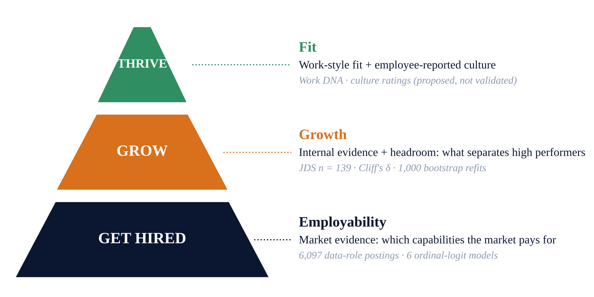
Figure 1. The NEXUS DELTA workforce hierarchy — a framing device, not a finding. Each level is answered by its own evidence line.

1.4 Analytics objectives
Table 3. Analytics objectives and success criteria.
# | Objective | Measurable success criterion | Answered in
O1 | Measure which capabilities separate high- and low-hike juniors | Effect size with 95% CI and multiple-testing correction | §4.1
O2 | Measure which capabilities the market pays for | Odds ratios stable across ≥ 6 model specifications | §4.4
O3 | Quantify remaining development headroom per capability | Share of juniors below ceiling + modelled gain with CI | §4.7
O4 | Turn three signals into one auditable decision | Printed rule; winner must beat runner-up in ≥ 80% of bootstraps | §4.7, §4.9
O5 | Help a student read any job description | Salary-band model beating baselines on grouped CV | §4.6
O6 | Show where Bharat's opportunity gap is | Capability and pay differences by city tier | §3.9

1.5 Hypotheses
- H1 — A capability that separates high performers internally is also paid a premium by the market.
- H2 — Big Data, widely promoted as a core data-science skill, separates high performers.
- H3 — The text of a job posting (title and listed skills) predicts its salary band beyond experience alone.
- H4 — Seniority carries a consistent pay premium across data roles.
- H5 — Personality traits separate successful senior, customer-facing data scientists.
AN OPEN QUESTION, ANSWERED IN §4.5
If H1 is true, every strong internal skill should be a market premium. One of them is not. Which one — and why — turned out to be the most useful finding in this study (§4.5).

1.6 Scope
In scope: the five technical capabilities measured in JDS (Big Data, Maths & Statistics, Coding, AI & ML, Dashboards & Storytelling), the Indian analytics job market as described in the brief (postings from 2024–25), and a decision rule an organisation can audit. Out of scope: causal claims (all evidence is associational), individual salary prediction from JDS (one company, n = 139), and any hiring or rejection decision about a person.

2. Approach Description
IN ONE LINE
Three signals, kept apart and combined by written rules. Agreement → PRIORITIZE. Disagreement → INVESTIGATE. A weak internal link → MAINTAIN.

2.1 The Zero Rule: why we do not join the datasets
The obvious first step — merging the four files — is invalid. Our identifier audit (§3.5) found 0 IDs shared between JDS and SDS; the overlaps that do exist (for example 1,460 between DS Jobs reference numbers and Analytics Jobs serial numbers, and 137 and 152 between Analytics serial numbers and JDS/SDS IDs) are coincidental number ranges, not shared entities. The files also describe different grains: a posting, a company opening, a junior employee, a senior employee. Joining them would fabricate relationships.
Instead, NEXUS DELTA connects the datasets through a versioned capability taxonomy (cap-tax-v2.0): the same five capabilities are measured as scores in JDS and detected as keyword (regex) flags in posting text. Each dataset answers the question it can actually answer.
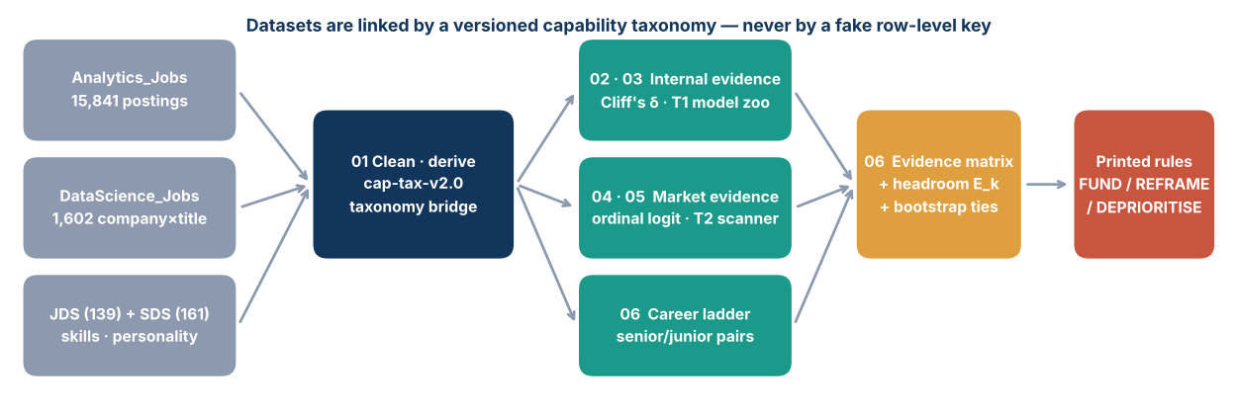
Figure 2. The NEXUS DELTA pipeline: data → evidence → insight → decision → action. Datasets meet only at the capability level. Notebook verdicts FUND / FUND WITH REFRAME / DEPRIORITISE appear in the product as PRIORITIZE / INVESTIGATE / MAINTAIN.

2.2 Overall flow
Table 4. Pipeline stages. Notebook links open the executed code.
Stage | Notebook | Input | Output | Why this stage exists
1 Explore & clean | NB01 | 4 raw files | analytics_clean.csv, taxonomy.json | Fix duplicates, parse fields, flag bad rows, prove no join
2 Internal evidence | NB02 | JDS, SDS | Cliff's δ + CI + Holm | What separates high performers inside one company
3 Predictive check | NB03 | JDS | 7-model zoo, permutation test | Is the internal signal real or noise?
4 Market evidence | NB04 | Analytics Jobs | Ordinal-logit odds ratios × 6 specs | What the market pays for, with controls
5 JD scanner | NB05 | Analytics Jobs | T2 model zoo, selected model | Read any job description for a student
6 Headroom & decision | NB06 | Outputs of stages 2–5, DS Jobs | E_k what-if, bootstrap ranking, ladder, SQLite database | Combine signals into one auditable decision
7 Role profiles | NB07 | Analytics Jobs | Role demand, band shares | Feed the student lens of the app
8 Supplementary checks | NB08 | JDS, SDS, Analytics Jobs | Ranking detail, cut-point check, tier ratios, descriptives | Robustness and traceability for every number quoted

2.3 Why three signals instead of one score
A weighted average would hide the most important information: disagreement. Storytelling scores HIGH internally and LOW in the market; averaged, it looks medium — and an organisation could fund report production that the market discounts. NEXUS DELTA therefore keeps the signals separate and makes the conflict visible (see the Evidence Convergence figure, §4.9).
Table 5. The three signals and how each is graded.
Signal | Source | Statistic | HIGH when
Internal evidence | JDS (n = 139) | Cliff's δ, Mann–Whitney U, 2,000-bootstrap CI, Holm | δ ≥ 0.33 and 95% CI above 0 (LOW: Holm p ≥ 0.05 or δ < 0.147)
Market evidence | Analytics Jobs: 6,097 data-role postings (10,338 in the wide check) | Proportional-odds ratio for a higher salary band | Premium (CI > 1) in both primary (S5) and wide (S6) models; LOW = discount in both
Headroom | JDS | % of juniors below 5.0; E_k = modelled gain per +0.5 step | ≥ 60% (MEDIUM 45–60%, LOW < 45%); E_k ranks funded capabilities

2.4 Decision rules
Table 6. The decision rule (NB06). Thresholds follow Romano et al. for Cliff's δ (0.147 small, 0.33 medium, 0.474 large); ‘strong’ therefore means at least a medium effect with a confidence interval above zero.
Condition | Verdict | Product label
Strong internal + market premium or neutral | FUND | PRIORITIZE
Strong internal + market discount in both taxonomies | FUND WITH REFRAME | INVESTIGATE
Moderate internal + robust premium | MONITOR | INVESTIGATE
Weak internal (Holm p ≥ 0.05 or δ < 0.147), or moderate without a premium | DEPRIORITISE | MAINTAIN
Among funded: winner must beat runner-up in ≥ 80% of 1,000 paired bootstraps | else TIED | INVESTIGATE (human choice logged)

2.5 Method choices and the reason for each
Table 7. Methods and justification.
Method | Used for | Why this, not the alternative
Mann–Whitney U + Cliff's δ | JDS/SDS group differences | Scores are bounded 1–5 and ceiling-heavy; δ is distribution-free and interpretable, t-tests assume normality
Holm correction | 5 simultaneous tests per family (JDS, SDS) | Controls family-wise error and is uniformly more powerful than Bonferroni
L2 logistic + StratifiedGroupKFold | T1 high-hike model | Duplicate employee profiles exist; grouping prevents the same profile in train and test
Permutation test (300 shuffles for T1, 40 for T2) | T1 and T2 validity | Shows the scores are not achievable by chance
Ordinal logit (statsmodels OrderedModel) | Market evidence | Salary bands are ordered; ordinal logit uses the order, multinomial throws it away
6 nested specifications | Robustness | A skill only counts as a premium if it survives experience, seniority, location, role and data-quality controls
TF-IDF (title + listed skills) + structured logistic | T2 JD scanner | Best of 7 models on grouped CV; linear, fast, explainable, runs offline
Paired bootstrap ranking | Final decision | Turns ‘which is first?’ into a probability; declares ties instead of hiding them

Key formulas
Cliff's δ (internal evidence), for high-hike scores xᵢ and low-hike scores yⱼ:
δ = [ #(xᵢ > yⱼ) − #(xᵢ < yⱼ) ] / (n_high · n_low) = 2U / (n_high · n_low) − 1, −1 ≤ δ ≤ 1
Proportional-odds ordinal logit (market evidence), for salary band Y ∈ {0,…,5}, capability flags Sₖ and controls Z:
logit P(Y ≥ j) = αⱼ + Σₖ βₖ·Sₖ + γ·Z, ORₖ = exp(βₖ) (ORₖ > 1: higher bands more likely)
Modelled gain Eₖ (headroom), using the fitted T1 logistic model p(·) on all 139 juniors (juniors already at 5.0 contribute zero):
Eₖ = 100 · mean over juniors [ p(x with xₖ → min(xₖ + 0.5, 5)) − p(x) ] (percentage points)
Decision confidence, from B = 1,000 paired bootstrap refits:
P(beat) = (1/B) · Σ_b 1[ E_lead^(b) > E_next^(b) ], TIED if P(beat) < 0.80

2.6 Validation strategy
- Leakage control: grouped cross-validation on duplicate profiles for T1; normalised job-title groups for T2 (6,741 groups across 10,338 postings).
- Chance control: permutation tests for T1 and T2; Holm correction for multiple tests.
- Robustness: six market specifications, two taxonomies, a subset without lead/manager/head titles, a subset without promotional titles, and a proportional-odds check by cut-point.
- Calibration: predicted vs observed probabilities for T1 and T2.
- Software: 171 automated checks on the app, including edge cases (missing model, corrupt results, empty input).

2.7 Technology
Python (pandas, scipy, statsmodels, scikit-learn) in eight Colab-ready notebooks with a fixed random seed (42); SQL queries on a SQLite database of the cleaned tables and the evidence matrix; a SAS mirror of the core steps for SAS VFL (a template, not executed); and a Streamlit application that runs fully offline. Everything is in the public repository.

3. Data Exploration
IN ONE LINE
87% of skill fields were truncated, 1,001 postings were duplicates, and 25 junior profiles contradicted each other. Every problem was measured and treated before modelling.

3.1 Inventory
Table 8. Datasets supplied in the brief.
File | Rows | Grain | Key fields | Role in the study
Analytics_Jobs.csv | 15,841 | One posting | designation, key_skills, description, experience, salary band, location | Market evidence; JD scanner
DataScience_Jobs.csv | 1,602 | Company × title opening | company, title, min experience, avg/min/max salary, num_of_jobs | Career ladder; salary context
JDS_Skill_Traits.xlsx | 139 | Junior employee | 5 skill scores (1–5), high/low hike | Internal evidence; headroom
SDS_Personality_Traits.xlsx | 161 | Senior employee | Big-Five traits (normalised), high/low success | Personality context

3.2 Data quality audit
Table 9. Data-quality issues, their size and the treatment. ‘Raw’ = 15,841 supplied rows; ‘clean’ = 14,840 after de-duplication.
Dataset | Issue found | Evidence | Impact if ignored | Treatment
Analytics Jobs | Exact duplicate postings | 1,001 raw rows (6.3%) | Inflated counts, leakage in CV | Dropped; job-title groups in CV
Analytics Jobs | Skills field truncated (‘…’) | 13,806 raw rows (87.2%); 87.0% after de-duplication | Missed skills → biased toward null | Truncation flag as control; description text parsed in the wide taxonomy (S6)
Analytics Jobs | Job type missing | 11,567 clean rows (77.9%) | Unusable as feature | Missingness flag as control only
Analytics Jobs | Description missing | 3,508 raw rows (3,371 clean) | Fewer text cues | Kept; title and skills fields used
Analytics Jobs | Promotional titles (‘urgent’, ‘walk-in’, ₹) | 1,722 clean rows (586 in data roles) | Noise in role mix | Flagged; robustness run without them (max |ΔOR| 0.066)
Analytics Jobs | Salary given only as 6 bands | all rows | No exact salary exists | Ordinal models; distributions, never exact pay
Analytics Jobs | Free-text locations | all rows | City inconsistency | Tier-1 / Tier-2-3 / International by regex
JDS | Duplicate skill profiles | 29 groups, 62 rows | Same profile in train and test | StratifiedGroupKFold; de-duplicated re-check
JDS | Identical profiles, opposite outcomes | 12 groups, 25 rows | Ceiling on accuracy | Reported; caps achievable AUC
JDS | Ceiling at 5.0 | 58% of juniors at 5.0 in Storytelling | Little room left to grow | Measured as ‘headroom’
SDS | Repeated IDs | 161 rows, 152 unique IDs | Double counting | Grouped CV for the model; rank tests use all rows (9 repeats, 5.6%)
All | No shared identifiers | JDS ∩ SDS = 0 | Invalid joins | Taxonomy bridge (the Zero Rule)

3.3 Dataset profiles, outliers and inconsistencies
Table 10. Profiling every file: outliers, inconsistencies and what we did.
Dataset | Check | Finding | Decision
Analytics Jobs | Category inconsistency | job_type has 5 spellings of one value (Analytics 2,971 · analytics 746 · ANALYTICS 64 · analytic 30 · Analytic 19); 12,011 raw rows blank | Normalised to lower-case ‘analytics’; missingness kept as a flag
Analytics Jobs | Location text | 1,355 distinct location strings; 2,553 postings list several cities; 313 distinct spellings contain Bangalore/Bengaluru | Regex tiering on the full string (Tier-1 if any Tier-1 city appears)
Analytics Jobs | Experience range | Ranges up to 30 years; spans up to 10 years; 0 unparseable | Kept; span used as a control
Analytics Jobs | Salary distribution | 6 bands; after de-duplication the mode is 10–15 LPA (3,503) and 25–50 LPA holds 992 (1,245 raw — a fifth of top-band rows were duplicates) | Ordinal target; no imputation of exact pay
DS Jobs | Text-typed numbers | Salaries stored as text (‘7.8L’) | Parsed to numeric LPA
DS Jobs | Outliers | 39 average salaries above the IQR fence (Q1 7.6, Q3 17.2, max 82 LPA); 10 rows with > 1,000 openings | Kept — real senior roles; ladder uses medians and paired ratios, which are robust
DS Jobs | Consistency | min ≤ avg ≤ max holds in all 1,602 rows; 134 reference numbers reused across 276 rows; 10 titles × 642 companies | Company × title pairs used for the ladder
JDS | Column names | ‘maths-stats_skills’ uses a hyphen; outcome stored as 0/1 | Renamed to snake_case keys
JDS | Range & ceiling | All scores within 1–5; 18–58% of juniors already at 5.0 per capability; 2 repeated IDs | Ceiling measured as headroom; grouped CV
SDS | Column names | Leading space in ‘ extraversion’; ‘success_ classification_ high_low’ has embedded spaces | Stripped and renamed
SDS | Repeated IDs | 9 repeated IDs (161 rows, 152 unique) | Grouped analysis

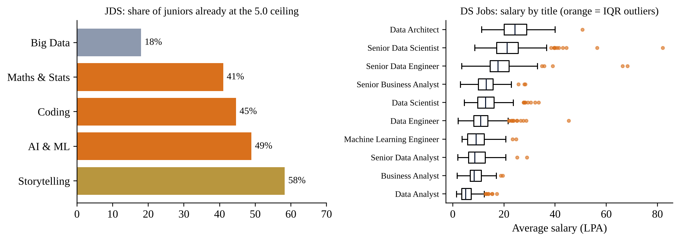
Figure 3. Two exploration findings that shaped the analysis: the JDS ceiling effect (left) and salary outliers by title in DS Jobs (right).

3.4 Descriptive statistics
Table 11. JDS skill scores, n = 139. High-hike share 52.5% (balanced outcome).
JDS capability (1–5) | Mean | SD | Min | Median | Max | Skew | % at 5.0
Big Data | 3.85 | 0.85 | 2.3 | 3.8 | 5.0 | −0.08 | 18.0%
Maths & Statistics | 4.29 | 0.84 | 2.2 | 4.6 | 5.0 | −0.97 | 41.0%
Coding | 4.27 | 0.89 | 2.2 | 4.6 | 5.0 | −0.89 | 44.6%
AI & ML | 4.57 | 0.67 | 2.2 | 4.9 | 5.0 | −1.70 | 48.9%
Dashboards & Storytelling | 4.36 | 0.93 | 2.3 | 5.0 | 5.0 | −1.08 | 58.3%

Four of the five skills are strongly left-skewed with medians at or near the 5.0 ceiling; only Big Data is symmetric. This has three consequences for the analysis: (1) mean-based tests would be distorted, so we use rank-based Mann–Whitney U and Cliff's δ; (2) the 18 AI & ML scores flagged by the IQR rule are low scorers in a ceiling-compressed distribution, not errors, so they are kept; (3) the share already at 5.0 is itself a finding — it limits how much a capability can still improve, which we measure as headroom.
Table 12. SDS trait scores, n = 161. Success share 52.8%. Five agreeableness values fall outside the IQR fence and are kept (plausible range).
SDS trait (normalised) | Mean | SD | Min | Median | Max
Neuroticism | 36.2 | 11.3 | 17 | 34 | 68
Extraversion | 43.2 | 12.1 | 17 | 45 | 67
Openness | 41.3 | 11.3 | 18 | 44 | 65
Agreeableness | 44.6 | 11.3 | 17 | 46 | 68
Conscientiousness | 45.2 | 13.2 | 18 | 49 | 66

Correlation between skills
Table 13. Rank correlations between JDS skills. Variance inflation factors are 1.04–1.45.
Spearman ρ | Big Data | Maths & Stats | Coding | AI & ML | Storytelling
Big Data | 1.00 | −0.18 | 0.05 | −0.17 | 0.05
Maths & Statistics | −0.18 | 1.00 | 0.40 | 0.44 | 0.36
Coding | 0.05 | 0.40 | 1.00 | 0.16 | 0.47
AI & ML | −0.17 | 0.44 | 0.16 | 1.00 | 0.27
Dashboards & Storytelling | 0.05 | 0.36 | 0.47 | 0.27 | 1.00

The skills are moderately correlated at most (largest ρ = 0.47, Coding with Storytelling) and every variance inflation factor is below 1.5, so the multivariable T1 model can separate their contributions without collinearity problems. Big Data is nearly uncorrelated with everything else — consistent with it behaving as a separate, weakly related skill rather than part of the analytical core.

3.5 Identifier audit
Table 14. Identifier overlap across files (NB01).
ID comparison | Overlap | Interpretation
DS.reference_no ∩ A.s_no | 1,460 | coincidental row numbers — different grains
DS.reference_no ∩ JDS.id | 21 | coincidental row numbers — different grains
DS.reference_no ∩ SDS.id | 33 | coincidental row numbers — different grains
A.s_no ∩ JDS.id | 137 | coincidental row numbers — different grains
A.s_no ∩ SDS.id | 152 | coincidental row numbers — different grains
JDS.id ∩ SDS.id | 0 | no shared entities

3.6 Derived variables
Table 15. Derivations (NB01, NB06).
Derived field | Rule | Example | Used in
salary_ord | 6 ordered bands: 0–3, 3–6, 6–10, 10–15, 15–25, 25–50 LPA | ‘10to15’ → 3 | Market model, JD scanner
exp_min / exp_max / exp_span | Regex on ‘x–y yrs’ (0 parse failures) | ‘5-10 yrs’ → 5, 10, 5 | Controls, scanner
seniority | First match: head > lead/manager > senior > junior > mid | ‘Sr Data Scientist’ → senior | Controls, ladder
role_family | DS/ML, DE, BA, DA/BI, other | ‘Big Data Engineer’ → DE | Controls, role profiles
loc_tier | Tier-1 city list / foreign list / else Tier-2-3 | ‘Indore’ → Tier2_3 | Bharat analysis
Capability flags × 7 | cap-tax-v2.0 regex: primary = title + listed skills; wide = also the description | ‘python, scikit-learn’ → coding, ai_ml | Market model
trunc_skills, jobtype_missing, spam_title | Data-quality flags | — | Controls, robustness
headroom_k | Share of juniors with score < 5.0 for capability k | Big Data 82% | Decision

3.7 Consolidation and data reduction
Table 16. Cleaning log, Analytics Jobs.
Step | Rows
raw rows | 15,841
after exact-duplicate drop | 14,840
experience parse failures | 0
after dropping unparseable experience | 14,840
Primary data-role population (is_ds_p) | 6,097
Wide population (is_ds_w) | 10,338

Data reduction. Rows: 15,841 → 14,840 after duplicates → 6,097 primary data roles for the main market model, with the 10,338-posting wide population kept as a robustness check. Features: free-text skills and descriptions are reduced to 7 capability flags; free-text locations to 3 tiers; designations to 5 seniority levels and 5 role families; salary to 6 ordered bands. Each reduction is a published rule in taxonomy.json, so it can be audited and re-run.
The cleaned postings, JDS, DS Jobs and the capability evidence matrix are written to one SQLite database (out/nexus_delta.db) and queried with standard SQL; the same tables can be loaded into SAS VFL. The capability prevalence in primary data roles is: Coding 29.4%, Maths & Statistics 17.2%, Storytelling 16.5%, AI & ML 14.4%, MIS 13.0%, Big Data 9.5%, Visualisation 5.4%.
Excerpt — NB01 cleaning
a = A_RAW.drop_duplicates(subset=key_cols, keep="first").copy() # -1,001 rows
a["trunc_skills"] = a.key_skills.fillna("").str.rstrip().str.endswith("...") # ~87%
m = a.experience.str.extract(r"(\d+)\s*-\s*(\d+)").astype(float) # '5-10 yrs' -> 5, 10
a["salary_ord"] = a.salary.map({b: i for i, b in enumerate(BANDS)}).astype(int)
a["loc_tier"] = np.where(loc.str.contains(T1), "Tier1",
np.where(loc.str.contains(FOREIGN), "International", "Tier2_3"))

3.8 What exploration showed
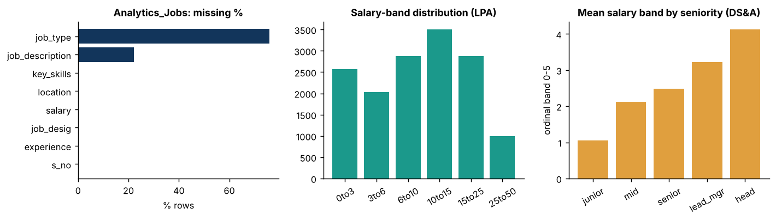
Figure 4. Exploration overview (NB01): missing-value rate by column, salary-band distribution, and mean salary band by seniority.

3.9 Bharat lens: the tier gap
Table 17. Opportunity by city tier, primary data-role postings (n = 6,097).
City tier | Postings | % at ≥ 10 LPA | AI & ML % | Coding % | Maths %
Tier1 | 5,627 | 51.0% | 15.0 | 30.6 | 17.8
Tier2_3 | 407 | 29.0% | 6.9 | 16.0 | 9.8
International | 63 | 79.4% | 4.8 | 7.9 | 9.5

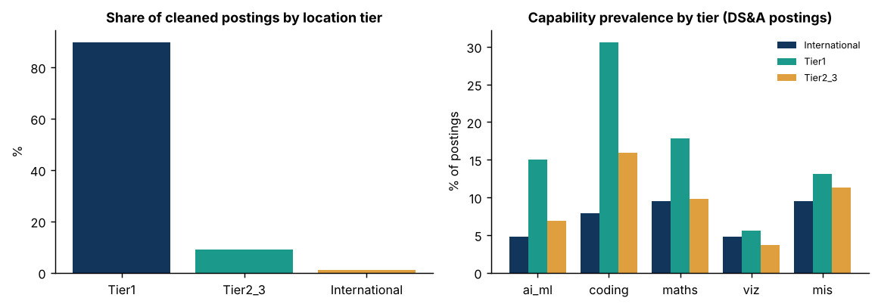
Figure 5. Share of postings by city tier (left) and capability prevalence by tier (right). In Tier-2/3 cities, 29% of data-role postings reach 10 LPA, about half the Tier-1 rate.
Table 18. Capability prevalence by tier, primary data-role postings (NB08).
Capability keywords | Tier-1 % | Tier-2/3 % | Tier-2/3 ÷ Tier-1
Big Data | 9.8 | 6.1 | 0.63×
Maths & Statistics | 17.8 | 9.8 | 0.55×
Coding | 30.6 | 16.0 | 0.52×
AI & ML | 15.0 | 6.9 | 0.46×
Storytelling (family) | 16.7 | 14.7 | 0.88×
Visualisation | 5.6 | 3.7 | 0.66×
MIS / reporting | 13.1 | 11.3 | 0.86×
MIS only | 11.2 | 11.1 | 0.99×

The skill mix differs by tier. Tier-2/3 postings mention Maths & Statistics, Coding and AI & ML only about half as often as Tier-1 postings (0.55×, 0.52×, 0.46×), while MIS/reporting keywords are almost as common (0.86×; MIS-only 0.99×). Tier-2/3 data roles therefore lean toward the reporting work that the market prices lower (§4.5) — part of why only 29% of them reach 10 LPA.

4. Data Analysis
IN ONE LINE
Maths & Statistics clears all three tests and has the largest modelled gain. Storytelling is strongest inside the company but discounted outside — and the analysis shows where the discount comes from.

4.1 Internal evidence: what separates high-hike juniors
Table 19. JDS, n = 139, 52.5% high hike. Mann–Whitney U, 2,000-bootstrap CI, Holm-corrected.
Capability | Mean (low hike) | Mean (high hike) | Cliff's δ | 95% CI | Holm p
Dashboards & Storytelling | 3.81 | 4.85 | 0.59 | [0.44, 0.72] | 1.2e-10
Maths & Statistics | 3.83 | 4.71 | 0.55 | [0.40, 0.70] | 2.7e-08
Coding | 3.85 | 4.64 | 0.49 | [0.31, 0.64] | 6.1e-07
AI & ML | 4.28 | 4.82 | 0.36 | [0.19, 0.52] | 1.7e-04
Big Data | 3.75 | 3.94 | 0.12 | [-0.09, 0.32] | 0.22

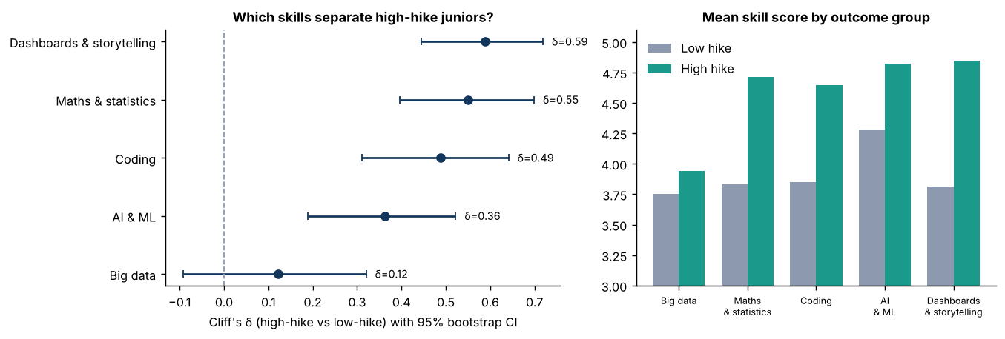
Figure 6. Internal effect sizes with 95% bootstrap intervals. Big Data's interval crosses zero.
Four of five capabilities separate high- and low-hike juniors with medium-to-large effects. H2 is not supported: Big Data does not separate them on its own (δ = 0.12, CI −0.09 to 0.32, Holm p = 0.22). Note that in the multivariable T1 model (§4.2) Big Data does carry a positive coefficient once the other four skills are held fixed: it is slightly negatively correlated with Maths & Statistics and AI & ML (ρ ≈ −0.18), which masks its effect in the univariate test (a suppression effect). Its univariate null result should be revisited with more data.

4.2 Is the internal signal real? (T1 model zoo)
Table 20. T1: predicting high hike from the five skills (NB03).
Model | AUC (grouped CV) | Brier | Accuracy
Prevalence baseline | 0.491 ± 0.000 | 0.249 | 0.525
Storytelling-only LR | 0.772 ± 0.008 | 0.169 | 0.763
kNN (k=15) | 0.875 ± 0.006 | 0.147 | 0.800
Random forest | 0.893 ± 0.006 | 0.127 | 0.847
Gradient boosting | 0.880 ± 0.009 | 0.130 | 0.829
RBF-SVM | 0.886 ± 0.011 | 0.119 | 0.853
NEXUS L2 logistic (C=1) | 0.902 ± 0.005 | 0.116 | 0.863

The regularised logistic model (AUC 0.90) beats random forest, boosting, SVM and kNN, and is the most interpretable. After removing duplicate profiles the AUC is still 0.88 (n = 118). A permutation test gives p ≤ 0.0033 (the smallest attainable with 300 shuffles): the best shuffled run reached only 0.66. The learning curve rises from 0.876 at n = 40 to 0.901 at n = 100 and only 0.904 at n = 139, so more data from the same company would add little.
Table 21. What drives the T1 model.
Capability | Coefficient (std.) | Permutation importance (AUC drop)
Maths & Statistics | 1.28 | 0.110
Dashboards & Storytelling | 1.12 | 0.095
AI & ML | 0.76 | 0.037
Big Data | 0.68 | 0.028
Coding | 0.53 | 0.015

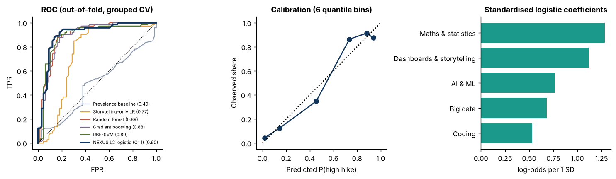
Figure 7. T1 model comparison, calibration and drivers.

4.3 Personality context (SDS)
Table 22. SDS, n = 161 rows (152 unique IDs). Cross-validated AUC 0.96.
Trait | Mean (low success) | Mean (high success) | Cliff's δ | Holm p
Openness | 33.3 | 48.5 | 0.77 | <0.001
Conscientiousness | 35.7 | 53.7 | 0.76 | <0.001
Extraversion | 36.9 | 48.9 | 0.57 | <0.001
Agreeableness | 41.1 | 47.7 | 0.30 | 0.002
Neuroticism | 36.3 | 36.1 | 0.07 | 0.454

H5 is supported: openness (δ 0.77), conscientiousness (0.76) and extraversion (0.57) separate successful senior, customer-facing data scientists; neuroticism does not. Rank tests use all 161 rows; the 9 repeated IDs (5.6%) are handled by grouping in the cross-validated model. We use this only as context. SDS has no link to JDS (the Zero Rule), and normalised trait scores are not an emotional-intelligence measure, so NEXUS DELTA never scores individuals on personality.

4.4 Market evidence: what the market pays for
Table 23. Proportional-odds ratio for a higher salary band, six ordinal-logit specifications on 6,097 data-role postings (S6: 10,338) (NB04). S1 flags only · S2 +experience · S3 +seniority · S4 +location · S5 all controls · S6 wide taxonomy & population.
Capability | S1 | S2 | S3 | S4 | S5 | S6
Maths & Statistics | 1.60 | 1.41 | 1.31 | 1.30 | 1.27 | 1.42
AI & ML | 1.93 | 2.08 | 2.13 | 2.13 | 1.38 | 1.25
Coding | 1.54 | 1.52 | 1.53 | 1.53 | 1.52 | 1.55
Dashboards & Storytelling | 0.69 | 0.75 | 0.74 | 0.74 | 0.75 | 0.80
Big Data | 1.77 | 1.16 | 1.16 | 1.16 | 1.09 | 1.15

Maths & Statistics, Coding and AI & ML are significant premiums in 6 of 6 specifications. AI & ML's premium falls from 2.13 to 1.38 once role family and data-quality controls are added (S5) — part of it is carried by job titles. Big Data's premium (1.77 unadjusted) attenuates to 1.16 and loses significance (CI 0.99–1.37) once experience is added, consistent with an experience proxy rather than a skill premium. Excluding lead/manager/head titles (n = 4,816) gives the same picture (Maths 1.37, Coding 1.62, AI & ML 1.61, Storytelling 0.74), and dropping 586 promotional titles changes no odds ratio by more than 0.066.
Table 24. Proportional-odds check: odds ratios from separate binary logits at each band cut-point, S5 controls (NB08). Bold = 95% CI excludes 1.
Capability | ≥ 3 LPA | ≥ 6 LPA | ≥ 10 LPA | ≥ 15 LPA | ≥ 25 LPA
Maths & Statistics | 1.80 | 1.77 | 1.21 | 1.17 | 0.97
AI & ML | 22.83 | 1.57 | 1.15 | 1.52 | 1.69
Coding | 2.44 | 1.76 | 1.43 | 1.28 | 1.15
Dashboards & Storytelling | 0.76 | 0.66 | 0.74 | 0.77 | 0.83
Big Data | 2.55 | 1.67 | 1.04 | 0.86 | 1.07

Proportional-odds check. The single odds ratios in §4.4 assume one effect across the whole pay range, so we re-estimated each capability at every cut-point. Storytelling stays below 1 at every cut (significant at the first four) and Coding stays above 1 at every cut (significant up to 15 LPA). Maths & Statistics is a significant premium through the 10 LPA cut, weaker at 15 LPA (CI crosses 1) and neutral at 25 LPA. AI & ML is above 1 at every cut but not significant at the 10 LPA cut; its ≥ 3 LPA estimate (22.8) rests on only 10 postings in the lowest band and is unstable. Big Data is significant only at the 6 LPA cut. The pooled odds ratios are therefore averages across the pay range, and we read them that way.
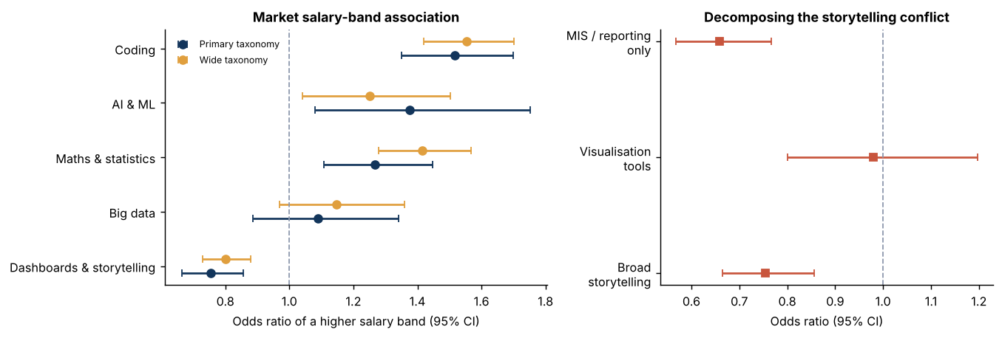
Figure 8. Market odds ratios with 95% CIs in the primary (S5) and wide (S6) models (left), and the Storytelling decomposition (right).

4.5 The Storytelling paradox — resolved
Storytelling is the strongest internal separator (δ 0.59) and a market discount in every specification (OR 0.69–0.80). H1 does not hold for Storytelling. As an exploratory follow-up, we split the storytelling keyword family into its two sub-taxonomies and re-fitted the S5 model on the 6,097 data-role postings:
Table 25. Decomposing the Storytelling discount.
Sub-family | Example keywords | Odds ratio | 95% CI | p
Visualisation | Tableau, Power BI, dashboards, storytelling | 0.98 | [0.80, 1.20] | 0.84
MIS / reporting only | MIS, Excel reporting, report generation | 0.66 | [0.57, 0.77] | 5.7e-08

THE ANSWER TO THE OPEN QUESTION
The discount is not attached to communication as such. Postings with visualisation keywords are priced neutrally (OR 0.98, p = 0.84); postings with MIS/reporting-only keywords are associated with lower bands (OR 0.66). So the decision is neither ‘fund’ nor ‘cut’: INVESTIGATE — fund with reframe: develop analytical storytelling, not report production. An averaged score would have hidden this.

This result depends on how the taxonomy defines storytelling. With visualisation keywords alone the market signal is neutral in the primary model (although its interval, 0.80–1.20, cannot rule out a modest discount); the discount comes mainly from the MIS/reporting keywords. That is why the verdict is to reframe the capability rather than to cut it.

4.6 Reading a job description: the T2 scanner
Table 26. T2: salary band from a job posting; grouped CV on 10,338 postings in 6,741 job-title groups (NB05).
Model | Exact band | Within 1 band | Quadratic κ | MAE (bands)
B0 majority | 23.9% | 63.9% | 0.000 | 1.28
B1 experience-only LR | 38.3% | 81.1% | 0.655 | 0.85
M0 structured LR (no flags) | 41.4% | 82.0% | 0.677 | 0.82
M1 structured LR (+flags) | 42.3% | 82.6% | 0.688 | 0.81
M2 TF-IDF + structured LR | 44.4% | 85.1% | 0.719 | 0.75
M3 random forest | 41.9% | 81.5% | 0.672 | 0.83
M4 hist-gradient boosting | 42.0% | 81.5% | 0.672 | 0.83

H3 is supported. The text of the posting (TF-IDF on title and listed skills, plus structured fields) beats the experience-only model on every metric: quadratic κ 0.719 vs 0.655, exact band 44.4% vs 38.3%, within one band 85.1% vs 81.1%. Adding the capability flags to the structured fields alone raises κ by 0.011 (95% bootstrap CI 0.006–0.016), and a label-permutation test of that model never exceeded κ 0.008 (observed 0.688). Because 56% of exact-band predictions are still wrong, the product shows the full probability distribution and never an exact salary.
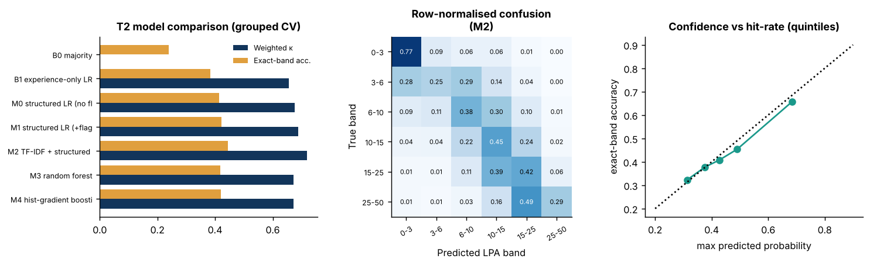
Figure 9. T2 model comparison, normalised confusion matrix of the selected model, and confidence versus hit rate (calibration).

4.7 Headroom and modelled gain
Table 27. E_k = modelled rise in P(high hike) if every junior improved by up to 0.5 points in capability k (capped at 5.0), averaged over all 139 juniors (what-if, not causal).
Capability | Headroom | E_k (pp per +0.5 step) | 95% CI | P(top)
Big Data | 82% | 3.47 | [1.04, 6.06] | 14.5%
Maths & Statistics | 59% | 5.15 | [2.96, 7.47] | 79.5%
Coding | 55% | 1.98 | [0.13, 3.92] | 2.0%
AI & ML | 51% | 2.77 | [0.78, 4.59] | 2.2%
Dashboards & Storytelling | 42% | 2.75 | [1.49, 4.11] | 1.8%

Maths & Statistics has the largest modelled gain (+5.1 pp, CI 3.0–7.5). Across 1,000 bootstrap refits it beats the runner-up among funded capabilities (AI & ML) in 95.7%, ranks first among the four funded capabilities in 91.3%, and ranks first among all five in 79.5% (NB06, NB08). Big Data has the second-largest E_k (3.5 pp, CI 1.0–6.1) but is not eligible: its univariate internal signal is not significant, so the rule (§2.4) sets it to MAINTAIN. The ranking was re-run over 9 settings (step size 0.25/0.5/1.0 × regularisation C = 0.1/1/10): Maths & Statistics is first in all 9. E_k is computed in-sample on 139 juniors and is a what-if, not a causal effect.
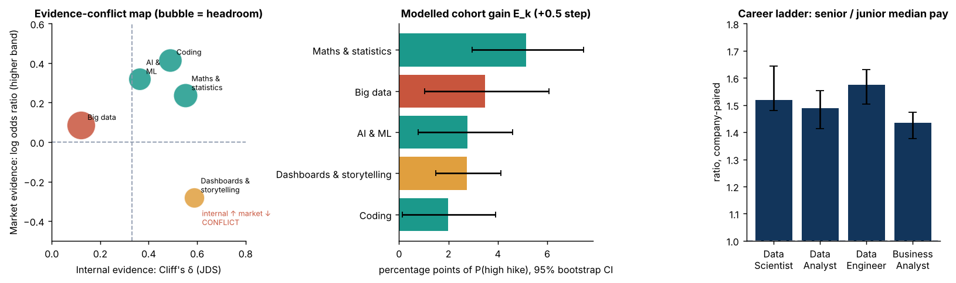
Figure 10. Evidence-conflict map (bubble = headroom), modelled gain E_k with 95% bootstrap CIs, and the career ladder (§4.8).

4.8 Career ladder and salary context
Table 28. Paired company-level comparison, Data Science Jobs (NB06).
Role family | Senior ÷ junior median salary | 95% CI | Pairs | Senior higher | Wilcoxon p
Data Scientist | 1.52× | [1.48, 1.64] | 105 | 96% | 4e-19
Data Analyst | 1.49× | [1.41, 1.55] | 111 | 96% | 1e-19
Data Engineer | 1.58× | [1.50, 1.63] | 112 | 97% | 3e-20
Business Analyst | 1.43× | [1.38, 1.47] | 124 | 95% | 1e-21

H4 is supported: within the same company, senior roles pay about 1.4–1.6× junior roles, in 95–97% of pairs. Salary models on this file reach R² 0.59 (gradient boosting, MAE 3.5 LPA), with title and experience explaining most of it — further reason not to promise individuals an exact number.

4.9 Evidence convergence: the decision
The three signals for each capability, side by side. Green is HIGH, gold MEDIUM, red LOW, graded as in §2.3 (Table 5). The arrow is the decision rule, not an average.
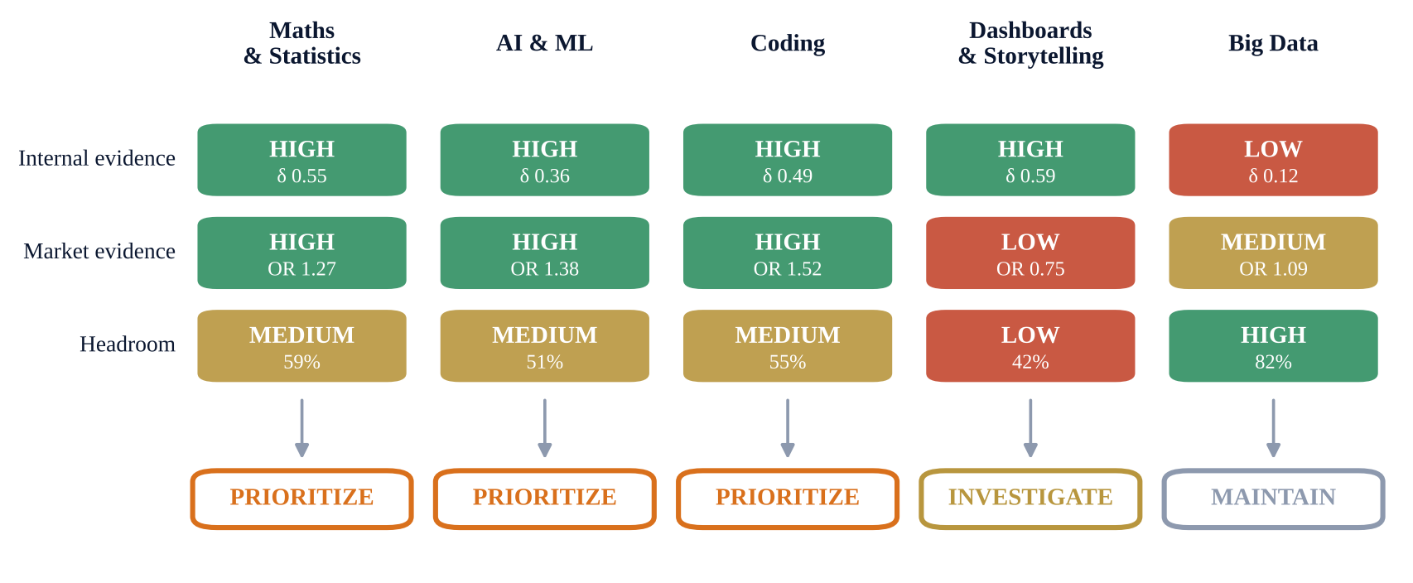
Figure 11. Evidence Convergence. Maths & Statistics, AI & ML and Coding converge; Storytelling conflicts; Big Data has headroom but weak evidence.
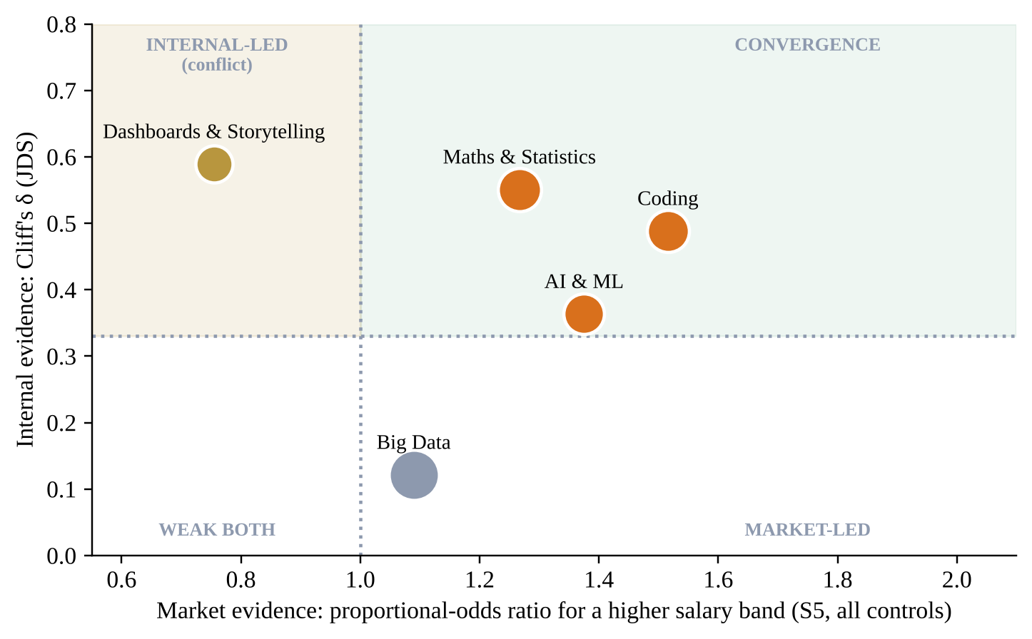
Figure 12. Evidence conflict matrix. Bubble size = headroom; colour = decision. Storytelling sits alone in the conflict quadrant. Big Data's odds ratio (1.09, CI 0.89–1.34) is not significant, so it is treated as neutral despite sitting right of 1.

5. Results & Conclusions
IN ONE LINE
Maths & Statistics is the best-supported next investment (first among funded capabilities in 91.3% of refits). Reframe Storytelling. Do not chase Big Data just because there is room.

5.1 The decision
Table 29. NEXUS DECISION.
# | Capability | Decision | Why
1 | Maths & Statistics | PRIORITIZE | Strong internal (δ 0.55) + premium in 6/6 models + 59% headroom + largest modelled gain; beats AI & ML in 95.7% of refits
2 | AI & ML | PRIORITIZE | Strong internal (δ 0.36, CI 0.19–0.52) + premium in 6/6 models; part of the premium is carried by job titles
3 | Coding | PRIORITIZE | Strong internal (δ 0.49) + the largest controlled premium (OR 1.52); smaller modelled gain
4 | Dashboards & Storytelling | INVESTIGATE | Strongest internal (δ 0.59) but market discount, concentrated in MIS/reporting keywords; reframe as analytical communication
5 | Big Data | MAINTAIN | No significant univariate internal link (δ 0.12); market premium vanishes with experience controls; 82% headroom is not enough on its own

5.2 Objectives met
Table 30. Objectives and results.
# | Objective | Result
O1 | Internal separation | 4 of 5 capabilities separate high/low hike; Big Data does not (§4.1)
O2 | Market value | 3 premiums and 1 discount significant in all 6 specs; Big Data significant only unadjusted (1 of 6) (§4.4)
O3 | Headroom | Measured per capability; E_k with bootstrap CI (§4.7)
O4 | Auditable decision | Written rules; winner beats runner-up in 95.7% of refits (threshold 80%); first among funded in 91.3%; 9/9 settings agree
O5 | Read any posting | 44% exact / 85% within-one band; better than experience-only on all metrics
O6 | Bharat gap | Tier-2/3: 6.7% of data-role postings; 29% vs 51% reach 10 LPA

5.3 Hypotheses
Table 31. Hypotheses and outcomes.
Hypothesis | Outcome | Evidence
H1 Internal strength = market premium | Partly supported | True for Maths, Coding, AI & ML; not for Storytelling (OR 0.75)
H2 Big Data separates performers | Not supported | δ 0.12, CI crosses 0, Holm p 0.22 (positive only conditionally, in T1)
H3 Posting text predicts salary band | Supported | κ 0.719 vs 0.655 (experience-only); exact 44.4% vs 38.3%
H4 Seniority premium is consistent | Supported | 1.43–1.58× in 95–97% of paired comparisons
H5 Personality separates senior success | Supported | Openness δ 0.77, conscientiousness 0.76; AUC 0.96

5.4 Conclusions
- Evidence beats intuition, and disagreement is information. The single most useful finding — the Storytelling paradox — exists only because the signals were not averaged.
- Maths & Statistics is the best-supported investment for junior data scientists: strong internally, a premium in every market model, the largest modelled gain, and first under every sensitivity setting we tried.
- Unadjusted signals mislead. Big Data looks valuable in raw postings (OR 1.77) but the premium loses significance once experience is controlled, and it does not separate performers on its own.
- Students should be shown distributions, not promises. A posting's title and skills predict its salary band usefully but imperfectly.
- Opportunity is unevenly distributed across Bharat: Tier-2/3 data-role postings reach 10 LPA about half as often as Tier-1 postings, and lean toward MIS/reporting work rather than statistics, coding and AI & ML.

6. Implications
IN ONE LINE
The same evidence engine serves the organisation that funds skills, the student who learns them and the employee who lives with the job.

6.1 For each stakeholder
Table 32. Implications for each stakeholder.
Stakeholder | Implication | Action this week
L&D head | Make Maths & Statistics the first candidate for the next training budget, and measure the result; redesign Storytelling training around analytical narrative, not MIS reports | Run NEXUS DECISION on your own skills data; review any ties with the team
Student | Learn statistics first; build real AI & ML and coding skill rather than chasing titles (part of the AI & ML premium is carried by job titles); be cautious about MIS-only roles if pay matters | Scan three target job descriptions; follow the priority tiers
University placement cell | Add applied statistics and communication-of-analysis to the curriculum | Map courses to the five capabilities; track by role
Hiring manager | Write job descriptions that match the real work; the market already prices titles | Use Work DNA questions in interviews — as discussion, never as a filter
Employee | Rate how the work really is, anonymously, so the next candidate knows | Join with an invite code; nothing is shown until 5 responses exist
Bharat / policy | 29% of Tier-2/3 data-role postings reach 10 LPA vs 51% in Tier-1 | Expand applied statistics and coding programmes outside metros

6.2 From analysis to product
NEXUS DELTA is not a report that ends here. The analysis drives a working, offline Streamlit application (source) with three lenses: Organisation (Evidence Convergence and NEXUS DECISION), Student (career priorities and a JD scanner) and Fit (Work DNA and employee-reported culture — proposed instruments, not yet validated). Every number in the app carries a provenance badge — source file, notebook, method and limitation.
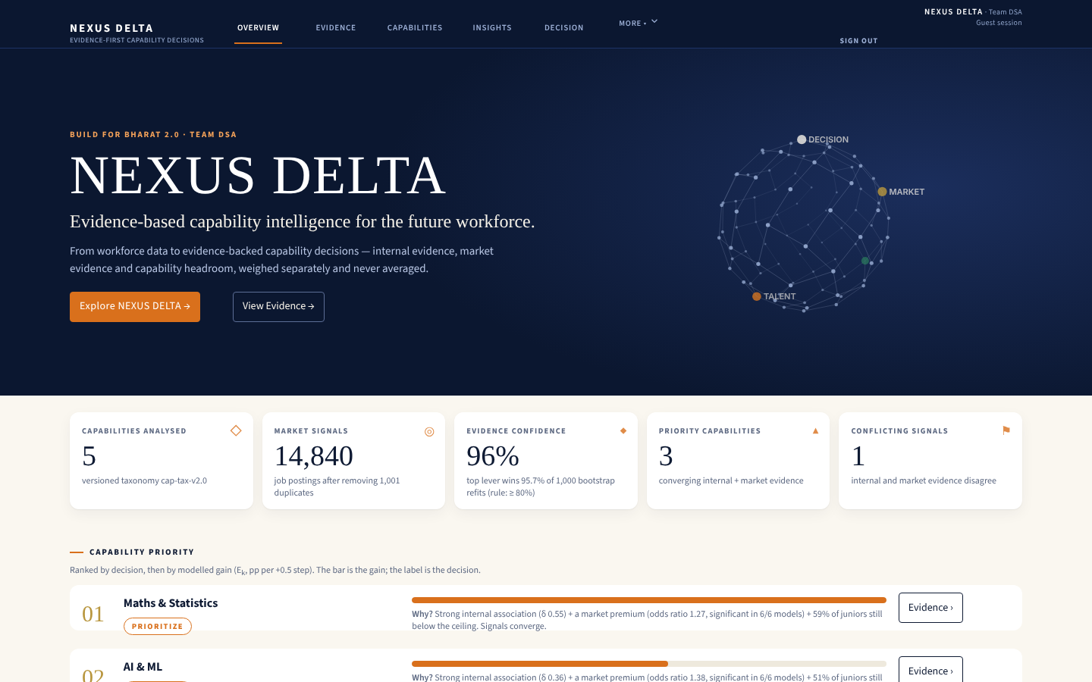
Figure 13. NEXUS DELTA — overview: decision ranking with a ‘Why?’ for every capability.
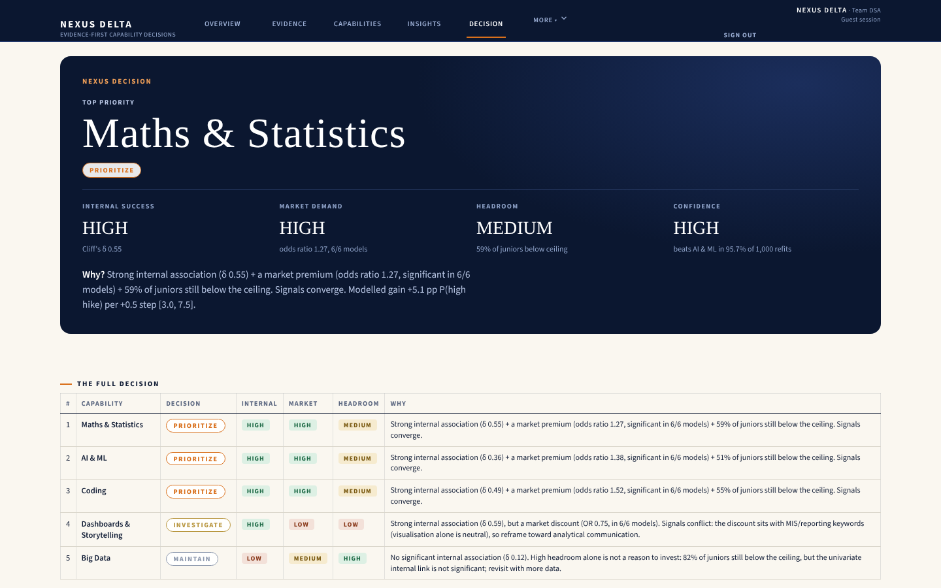
Figure 14. NEXUS DECISION screen — the same result as §5.1, with evidence levels and confidence.

6.3 Responsible use, built in
- No fake joins, no fake salaries, no fake companies. Simulated demo data is labelled SIMULATED on every screen.
- Every output carries a label: OBSERVED, DERIVED, INFERRED, PROPOSED or SIMULATED.
- No automatic hiring or rejection. Organisation views are discussion prompts; a human decides.
- Privacy by design: passwords hashed with scrypt; records encrypted with AES-256-GCM; employee culture answers stored without any user ID and shown only after 5 responses (a minimum group size).
- Optional means optional: the emotional-intelligence questionnaire can be skipped and never enters any score.

6.4 Limitations and next steps
Table 33. Limitations and next steps.
Limitation | Effect | Next step
JDS is one company, n = 139 | Internal evidence may not generalise | Multi-company skills data; re-run NB02–03
All evidence is associational | Cannot claim a skill causes a hike | Pilot training cohort with a comparison group
87% of skills fields truncated | Under-detects skills | Full-text postings; hand-audited taxonomy sample
Salary only in bands | No exact pay modelling | Band distributions retained in product
Work DNA and culture survey not validated | Fit scores are indicative | Validate against retention with a partner employer
E_k computed in-sample | Optimistic gain estimates | Out-of-sample estimation with a larger cohort
Six specifications not jointly corrected | Some risk of selective reading | The rule needs a premium in both S5 and S6; all three premiums are in fact significant in all six
SAS mirror not executed | SAS results not shown | Run in SAS VFL; compare with Python outputs

6.5 Closing
EVIDENCE, NOT OPINION
We started with a zero: no shared IDs, so no shortcuts.
We end with one decision, stated with its confidence: Maths & Statistics — PRIORITIZE — first among funded capabilities in 91.3% of refits.
Know what to build. Know what to learn. Know where you can thrive.

Appendix

A. Code excerpts
A.1 Internal evidence (NB02)
def cliffs_delta(hi, lo):
U, p = mannwhitneyu(hi, lo, alternative="two-sided")
return 2*U/(len(hi)*len(lo)) - 1, p

for k in SK:
hi = JDS.loc[JDS.high_hike == 1, k].values
lo = JDS.loc[JDS.high_hike == 0, k].values
d, p = cliffs_delta(hi, lo)
boots = [cliffs_delta(rng.choice(hi, len(hi)), rng.choice(lo, len(lo)))[0]
for _ in range(2000)]
rows.append(dict(skill=k, delta=d, p_raw=p,
ci_lo=np.percentile(boots, 2.5), ci_hi=np.percentile(boots, 97.5)))
eff["p_holm"] = multipletests(eff.p_raw, method="holm")[1]

A.2 Market evidence (NB04)
from statsmodels.miscmodels.ordinal_model import OrderedModel

def fit_or(df, suffix, spec, flags=FL):
X = design(df, suffix, spec, flags) # flags + nested controls S1..S5
y = df.salary_ord.values # 6 ordered salary bands
m = OrderedModel(y, X.values, distr="logit").fit(method="bfgs", maxiter=800, disp=False)
ci = m.conf_int()[:len(flags)]
return {f: dict(OR=np.exp(m.params[i]), lo=np.exp(ci[i, 0]), hi=np.exp(ci[i, 1]))
for i, f in enumerate(flags)}

prem = {f: sum(out[s][f]["lo"] > 1 for s in out) for f in FL} # specs with a premium

A.3 Decision rule (NB06, condensed)
if d >= 0.33 and lo > 0: internal = "Strong"
elif p_holm >= 0.05 or d < 0.147: internal = "Weak"
else: internal = "Moderate"

if internal == "Strong" and market in ("Premium", "Neutral"): verdict = "FUND"
elif internal == "Strong" and market == "Discount": verdict = "FUND WITH REFRAME"
elif internal == "Moderate" and market == "Premium": verdict = "MONITOR"
else: verdict = "DEPRIORITISE"

p_beat = float((B[:, lead] > B[:, runner_up]).mean()) # 0.957 over 1,000 refits
tie = p_beat < 0.80

A.4 Privacy gate (application, culture.py)
def aggregate(org_id, cyc=None):
n = count(org_id, cyc)
if n < K_MIN: # nothing is shown below 5 responses
return dict(suppressed=True, n=n, need=K_MIN, cycle=cyc)
rs = _load(org_id, cyc) # AES-256-GCM decrypt; rows carry no user id

B. Full market table (odds ratio [95% CI])
Table 34. Proportional-odds ratios for a higher salary band, all specifications (NB04).
Spec | Maths & Statistics | AI & ML | Coding | Dashboards & Storytelling | Big Data
S1 flags only | 1.60 [1.42, 1.80] | 1.93 [1.69, 2.21] | 1.54 [1.38, 1.71] | 0.69 [0.61, 0.78] | 1.77 [1.51, 2.07]
S2 +experience | 1.41 [1.24, 1.60] | 2.08 [1.80, 2.40] | 1.52 [1.36, 1.71] | 0.75 [0.66, 0.85] | 1.16 [0.99, 1.37]
S3 +seniority | 1.31 [1.16, 1.49] | 2.13 [1.85, 2.46] | 1.53 [1.37, 1.71] | 0.74 [0.65, 0.84] | 1.16 [0.98, 1.36]
S4 +location | 1.30 [1.14, 1.48] | 2.13 [1.84, 2.45] | 1.53 [1.36, 1.71] | 0.74 [0.65, 0.83] | 1.16 [0.98, 1.37]
S5 +all controls (primary tax.) | 1.27 [1.11, 1.45] | 1.38 [1.08, 1.75] | 1.52 [1.35, 1.70] | 0.75 [0.67, 0.86] | 1.09 [0.89, 1.34]
S6 all controls (wide tax. & population) | 1.42 [1.28, 1.57] | 1.25 [1.04, 1.50] | 1.55 [1.42, 1.70] | 0.80 [0.73, 0.88] | 1.15 [0.97, 1.36]

C. Application screens
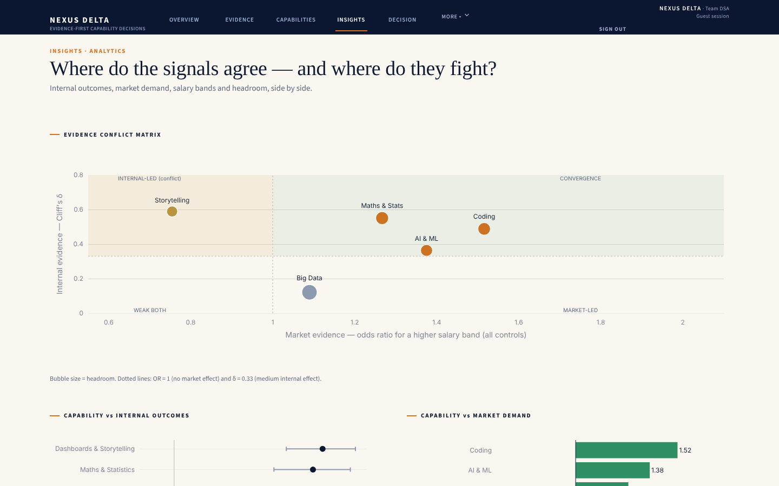
Figure 15. Insights page: the live conflict matrix.
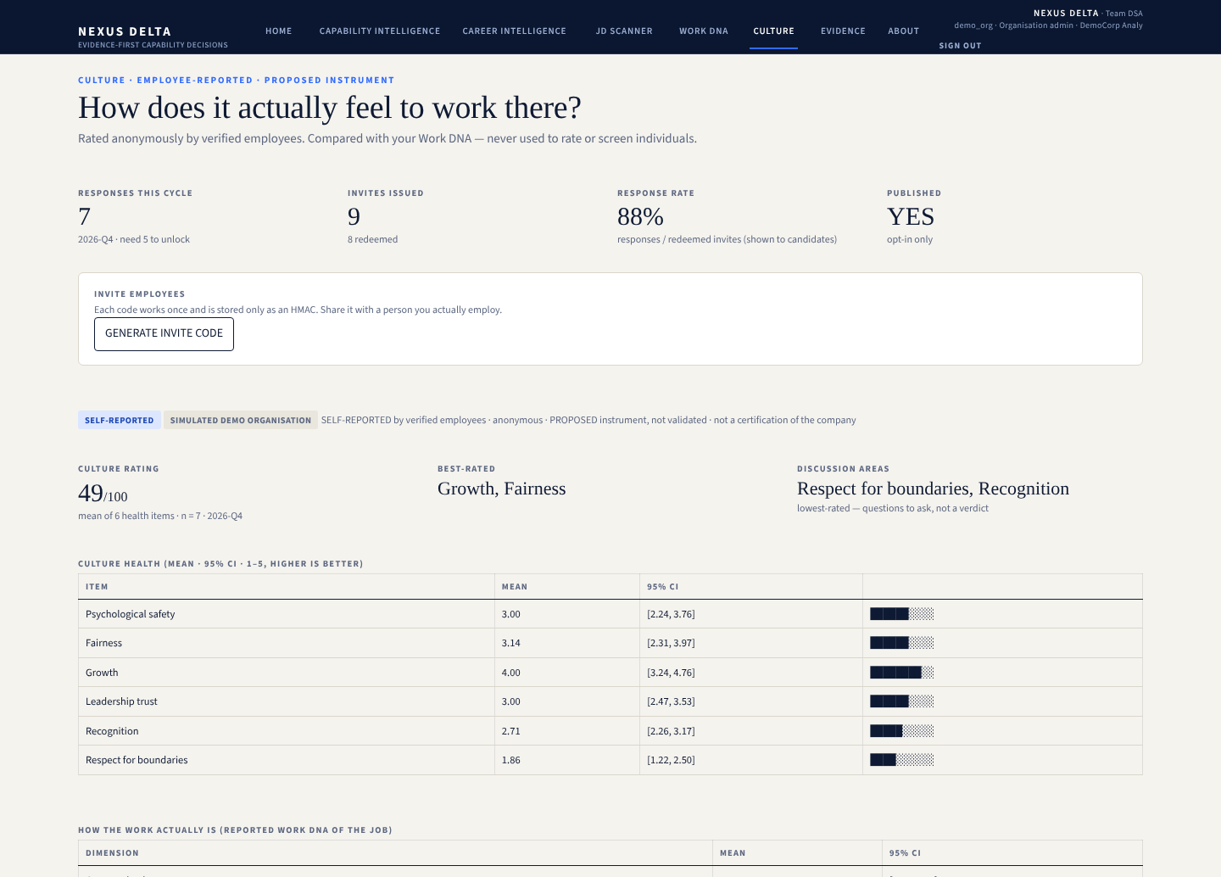
Figure 16. Culture page (organisation view, SIMULATED demo organisation): response count, invite codes and the scorecard, which appears only after 5 anonymous responses.

D. SAS mirror (excerpt, ready for SAS VFL; not executed)
nexus_delta_sas_mirror.sas (sections 1–3)
/* NEXUS DELTA - SAS mirror of the key analytical steps (Team DSA, Build For Bharat 2.0)
STATUS: translation of the Python pipeline for SAS Viya / SAS VFL /
SAS OnDemand for Academics.
Not executed in the authoring environment: re-run in SAS before quoting
any SAS-side number.
Numbers in the Approach Note come from the executed Python notebooks 01-08. */
options validvarname=v7; /* 'maths-stats_skills' -> maths_stats_skills */
/* folder holding the organiser files and the exported out/analytics_clean.csv */
libname nd "/home/&sysuserid/nexus_delta";

proc import datafile="/home/&sysuserid/nexus_delta/JDS_Skill_Traits.xlsx"
out=nd.jds dbms=xlsx replace; run;
proc import datafile="/home/&sysuserid/nexus_delta/out/analytics_clean.csv"
out=nd.analytics_raw dbms=csv replace;
guessingrows=max; run;

/* three flags are exported as the text True/False; capability flags are already 0/1 */
data nd.analytics;
set nd.analytics_raw;
array t{*} $ is_ds_p jobtype_missing trunc_skills;
array n{*} is_ds_p_n jobtype_missing_n trunc_skills_n;
do i = 1 to dim(t); n{i} = (strip(t{i}) = 'True'); end;
drop i;
run;

/* 1. Internal evidence: Mann-Whitney U (Wilcoxon rank-sum) per skill, high vs low hike */
%let skills = big_data_skills maths_stats_skills coding_skills ai_and_ml_skills
dashboard_and_storytelling_skills;
proc npar1way data=nd.jds wilcoxon;
class salary_hike_high_or_low;
var &skills;
ods output WilcoxonTest=nd.wtest WilcoxonScores=nd.wscores;
run;
/* two-sided p-values -> Holm adjustment (multtest needs a variable named raw_p) */
data nd.pvals;
set nd.wtest; where Name1 = 'P2_WIL'; /* normal approx., continuity-corrected */
raw_p = nValue1; keep Variable raw_p;
run;
proc multtest inpvalues=nd.pvals holm out=nd.holm_out; run;
/* Cliff's delta = 2U/(n1*n0) - 1, with U = rank sum of the high group - n1(n1+1)/2 */
proc sort data=nd.wscores; by Variable; run;
data nd.cliffs;
merge nd.wscores(where=(Class='1') rename=(N=n1 SumOfScores=S1))
nd.wscores(where=(Class='0') keep=Variable Class N rename=(N=n0));
by Variable;
U = S1 - n1*(n1+1)/2; cliffs_delta = 2*U/(n1*n0) - 1;
run;

/* 2. T1: logistic model on standardised skills + ROC */
proc stdize data=nd.jds out=nd.jds_z method=std; var &skills; run;
proc logistic data=nd.jds_z plots(only)=roc;
model salary_hike_high_or_low(event='1') = &skills / ctable;
run;

/* 3. Market: cumulative-logit (proportional-odds) model of the 6 salary bands.
DESCENDING models P(Y >= j), so exp(beta) > 1 means higher bands. The score test
for the proportional-odds assumption is printed by default. */
proc logistic data=nd.analytics(where=(is_ds_p_n=1)) descending;
class seniority(ref='mid') loc_tier(ref='Tier1') role_family(ref='other') / param=ref;
model salary_ord = big_data_p maths_stats_p coding_p ai_ml_p story_p
exp_min exp_span jobtype_missing_n trunc_skills_n
seniority loc_tier role_family / link=clogit;
ods output OddsRatios=nd.market_or;
run;

E. Reproduce everything
Notebook | Open
01_data_exploration_cleaning | view on GitHub
02_internal_evidence_JDS_SDS | view on GitHub
03_T1_high_hike_model | view on GitHub
04_market_salary_band_model | view on GitHub
05_T2_JD_scanner_salary_band | view on GitHub
06_headroom_career_decision_engine | view on GitHub
07_app_role_profiles | view on GitHub
08_supplementary_checks | view on GitHub
Application | streamlit run app.py (offline) — repository

F. Glossary
Term | Meaning
Cliff's δ | Probability a high-group score exceeds a low-group score minus the reverse; −1 to 1
Odds ratio (OR) | Multiplicative change in the odds of a higher salary band when a capability is present; 1 = no effect
Headroom | Share of juniors below the 5.0 ceiling in a capability
E_k | Modelled change in P(high hike) for a +0.5 improvement in capability k (what-if)
Quadratic κ | Agreement for ordered categories; penalises far misses more
Minimum group size (K = 5) | No group statistic shown until at least 5 people contributed
PRIORITIZE / INVESTIGATE / MAINTAIN | Product labels for the notebook verdicts FUND / FUND WITH REFRAME, MONITOR or TIED / DEPRIORITISE

