**ODBC**

**(Open DataBase Connection)**

ODBC is a low-level, high-performance interface that is designed specifically for relational data stores.

**Steps .**

1. Search ODBC in windows
2. 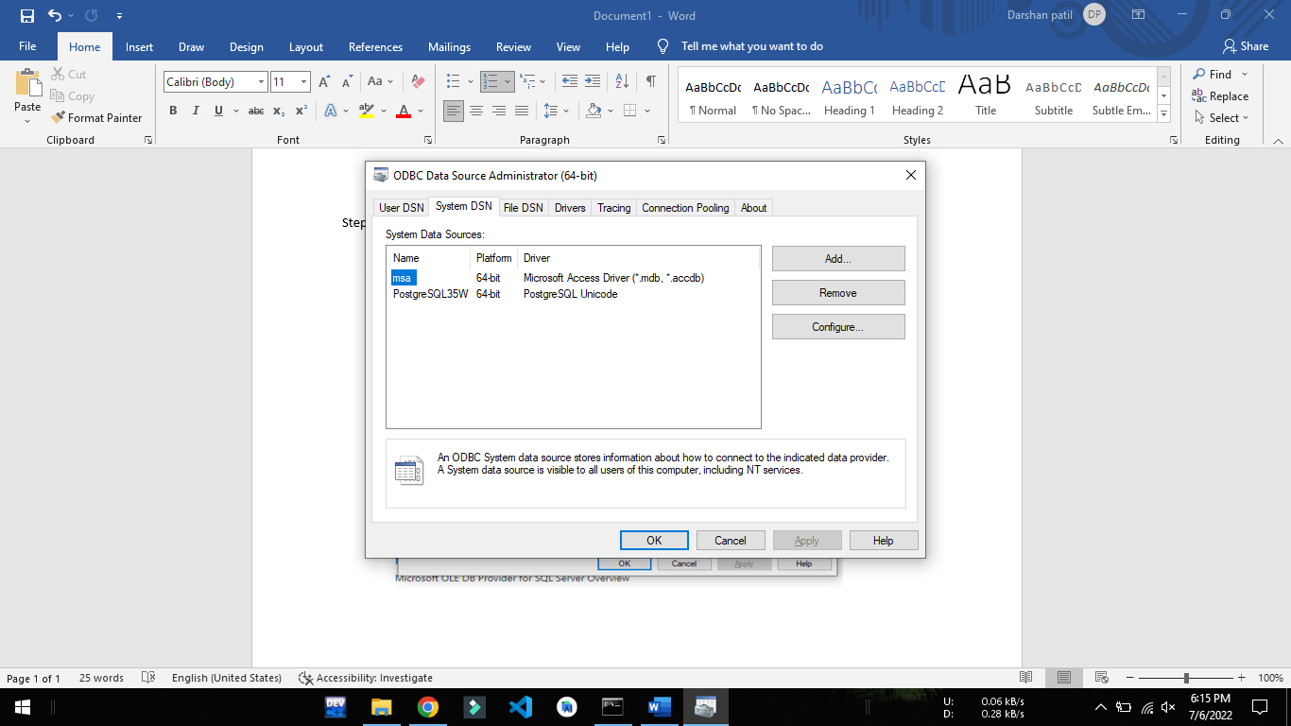Goto System DSN

1. Click on add
2. 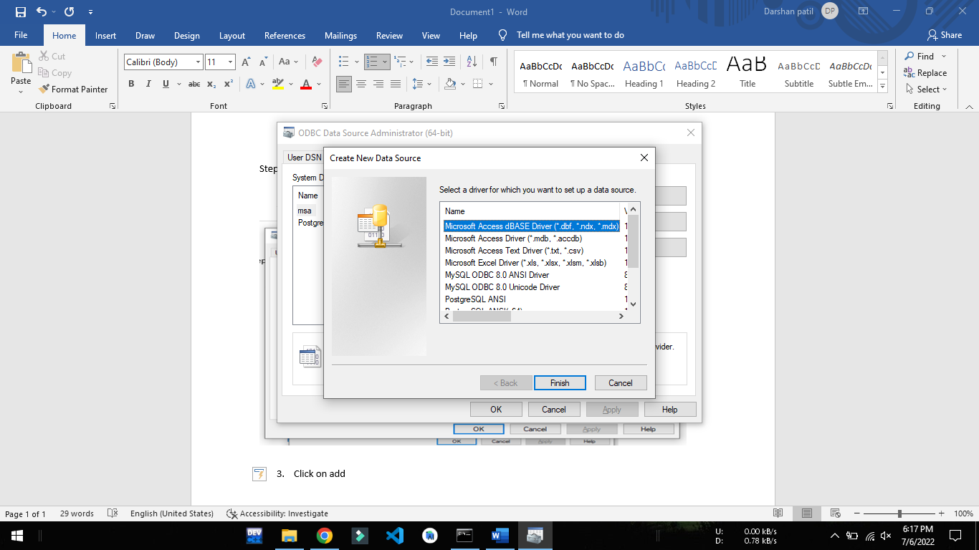Select the required drivers for the database.

Links to download the ODBC drivers for the databases

Links:

* Postgre

[https://www.enterprisedb.com/downloads/postgres-postgresql-downloads](%20https://www.enterprisedb.com/downloads/postgres-postgresql-downloads)

* MySQL

<https://dev.mysql.com/downloads/connector/odbc/>

* DynamoDB

<https://www.cdata.com/drivers/dynamodb/download/odbc/>

**ODBC Connection for PostgreSQL**

1. 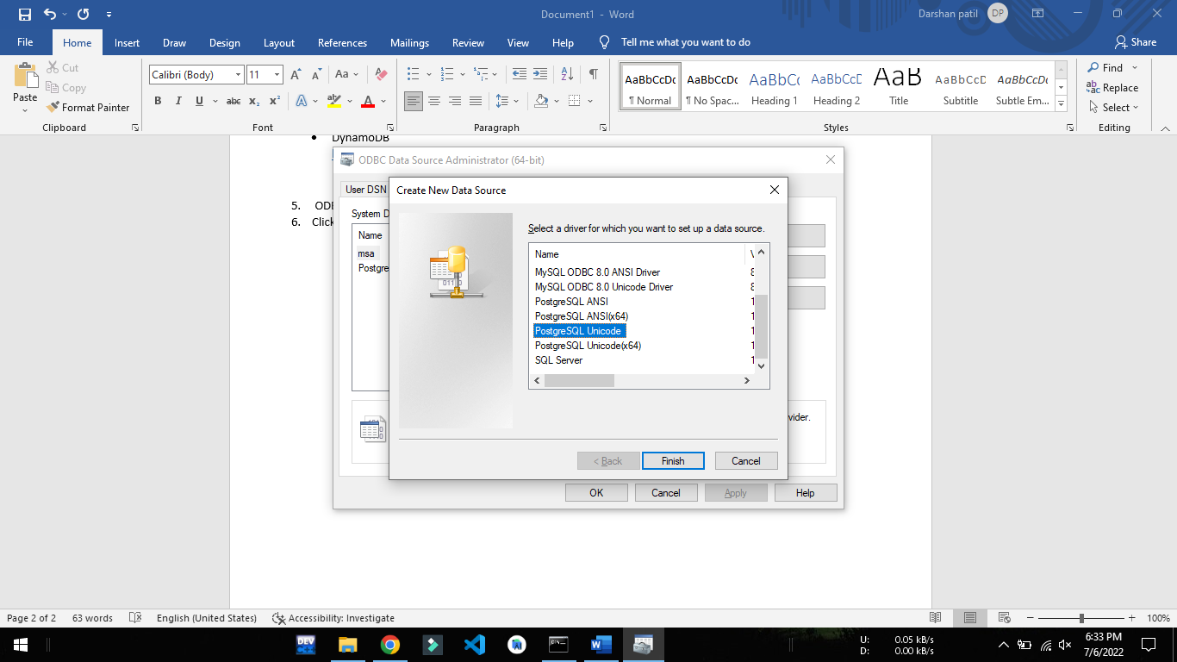Click on PostgreSql Unicode
2. 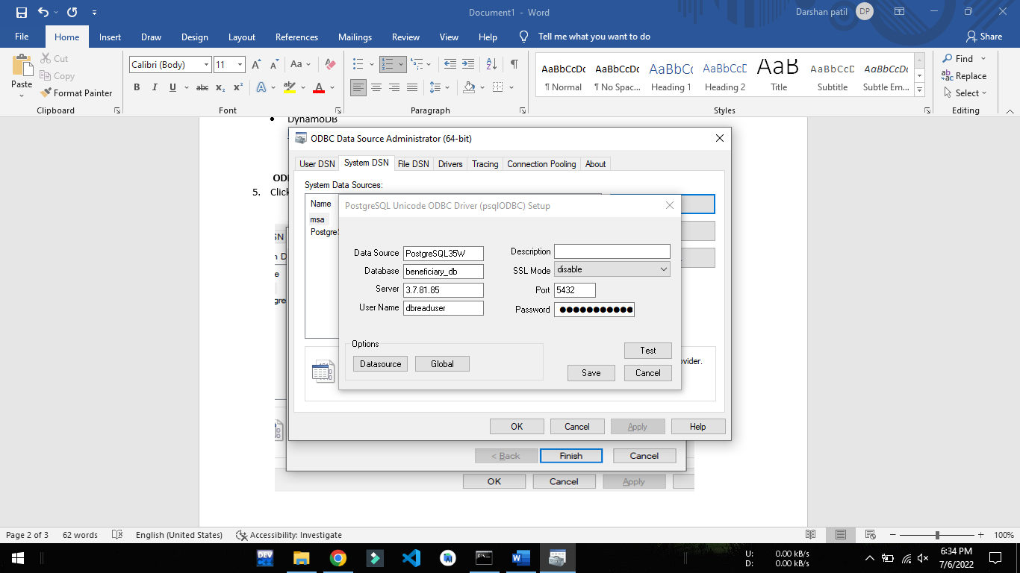Enter the required details

Note: 1. Data Source will be the name used for connection

2.Click on Test to check if the connection is successful or not

3. If connection is not succesful, wrong data may have entered in the fields

1. Click apply and exit.

**Code**:

1. Read data from Postgre using odbc Drivers.

## import psycopg2 as pg

## import pandas as pd

## import pyodbc

//print all the drivers in system

## for driver in pyodbc.drivers():

## print(driver)

//Used the name Provided in the DataSource

## cnxn = pyodbc.connect("DSN=*PostgreSQL35W*")

## query="select * from beneficiaries limit 1"

//convert the Output into a DataFrame

## df=pd.io.sql.read_sql(query, cnxn)

## df

Output

| **id** | | **active** | **created_at** | **created_by** | | | **deleted** | **last_modified_by** | | | | **modified_at** | | **age** | **annual_household_income** | | |
| --- | --- | --- | --- | --- | --- | --- | --- | --- | --- | --- | --- | --- | --- | --- | --- | --- | --- |
| **0** | 8a8b803a7d56fe4c017d6095f06e7cf7 | | | | 1 | 1638002978926 | | | be88415b-029b-4696-a192-4e6ab8edb278 | 0 | be88415b-029b-4696-a192-4e6ab8edb278 | | 1649075136406 | | | None | None |

1. Connect ODBC drivers with providing own values.

(( For Mysql Connection ))

### import pyodbc

### import pandas as pd

// Enter the details of the connection

### server = '127.0.0.1'

### database = 'nb3'

### username = 'root'

### password = ''

### // Enter the name of the Driver of the required Database

### connSqlServer=pyodbc.connect('DRIVER={***MySQL ODBC 8.0 ANSI Driver*};**SERVER='+server+';DATABASE='+database+';UID='+username+';Trusted_Connection=yes')

### query="select * from xyz"

### df=pd.io.sql.read_sql(query, connSqlServer)

### df