**OLEDB**

**OLE DB** (*Object Linking and Embedding, Database*, sometimes written as **OLEDB** or **OLE-DB**), an [API](https://en.wikipedia.org/wiki/Application_programming_interface) designed by [Microsoft](https://en.wikipedia.org/wiki/Microsoft), allows accessing [data](https://en.wikipedia.org/wiki/Data) from a variety of sources in a uniform manner. The API provides a set of interfaces implemented using the [Component Object Model](https://en.wikipedia.org/wiki/Component_Object_Model) (COM); it is otherwise unrelated to [OLE](https://en.wikipedia.org/wiki/Object_Linking_and_Embedding). Microsoft originally intended OLE DB as a higher-level replacement for, and successor to, [ODBC](https://en.wikipedia.org/wiki/ODBC), extending its feature set to support a wider variety of non-[relational databases](https://en.wikipedia.org/wiki/Relational_database), such as [object databases](https://en.wikipedia.org/wiki/Object_database) and [spreadsheets](https://en.wikipedia.org/wiki/Spreadsheet) that do not necessarily implement.

Steps:

1. Create a MS Access file with some sample

**Code**

## **import** pandas **as** pd

## **import** numpy **as** np

## **//**location of the acces file

## databasename **=** 'C:/Users/Shinchan/Desktop/w.mdb'

## constr **=** 'Provider=Microsoft.ACE.OLEDB.12.0;Data Source=%s' **%** databasename

## db **=** ado**.**connect(constr)

## cursor**=**db**.**cursor()

## query**=**'select * from Table1'

## **//**transform data to dataframe

## **def** get_df(data):

## ar **=** np**.**array(data**.**ado_results) *# turn ado results into a numpy array*

## df **=** pd**.**DataFrame(ar)**.**transpose() *# create a dataframe from the array*

## df**.**columns **=** data**.**columnNames**.**keys() *# set column names*

## **return** df

## **with** db**.**cursor() **as** cur:

## cur**.**execute(query)

## data **=** cur**.**fetchall()

## df **=** get_df(data)

## df

## 

Extra.

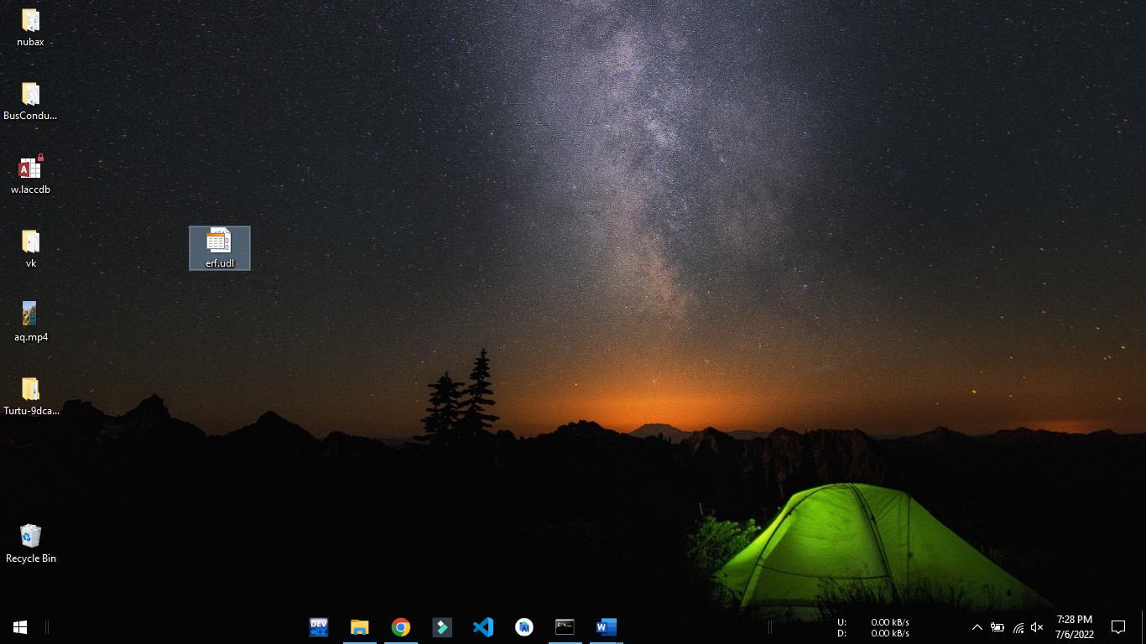1.Create a txt file and give the extension as UDL.

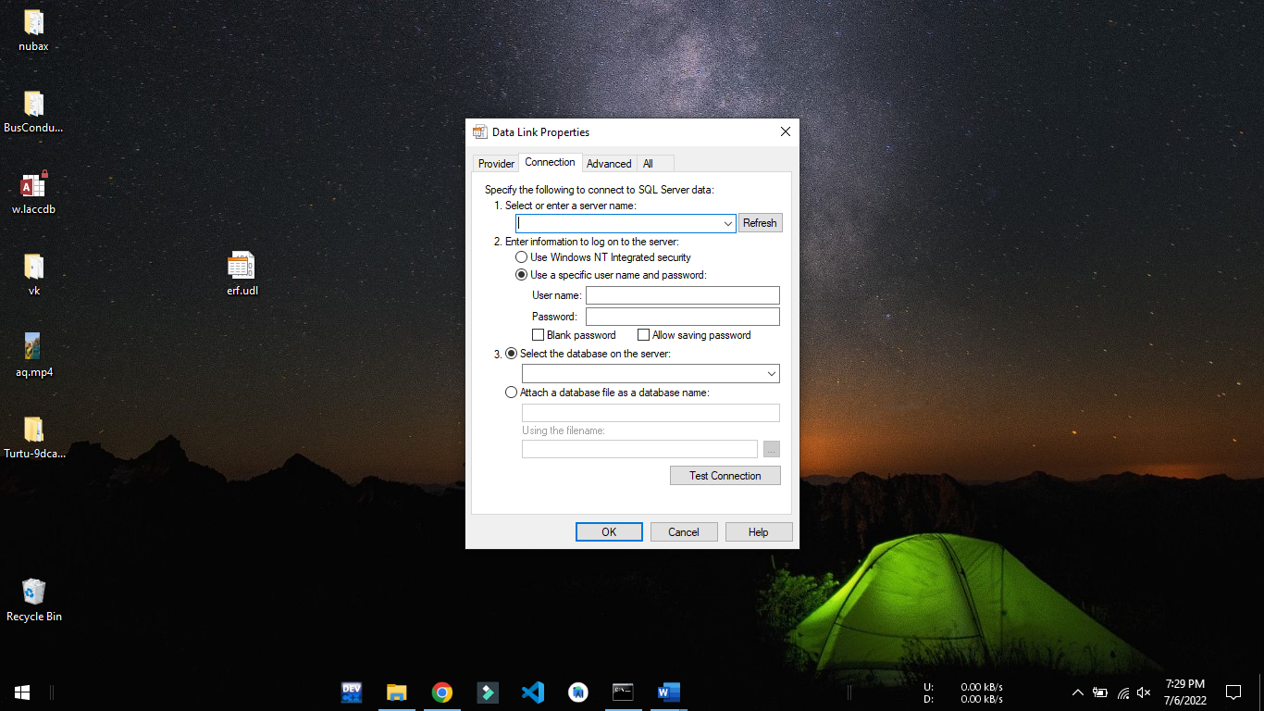2.Open It

3.In the provider menu you can select the required oledb drivers and follow the necessary steps