# Learning About CI Pipeline in GitLab

I have read documentation of GitLab CI (Continuous Integration) pipeline which I will use to update CDM stored in GitLab periodically. The pipeline will scrap data from the stored links & then process the data using a process script which I will make to process it to standard columns. Then the pipeline will push the changes to the GitLab Repository.

I have created a pipeline [**here**](https://gitlab.com/Darshpreet2000/scraphospitalcdm/-/blob/master/.gitlab-ci.yml)

I need to make changes in it to also process the data. I will read documentation of it carefully

<https://docs.gitlab.com/ee/ci/pipelines/>

## Changed UI of Home screen & Search Screen of App

I have changed only home screen & search screen UI . Now, I have used flutter gradient in home screen toolbar.

I have also forked the repo from LibreHealth GitLab Repository

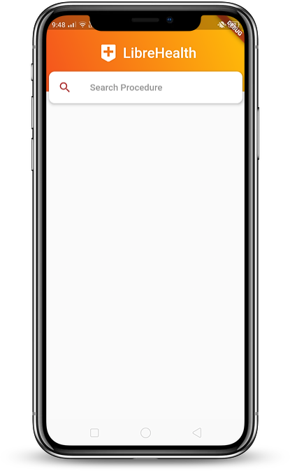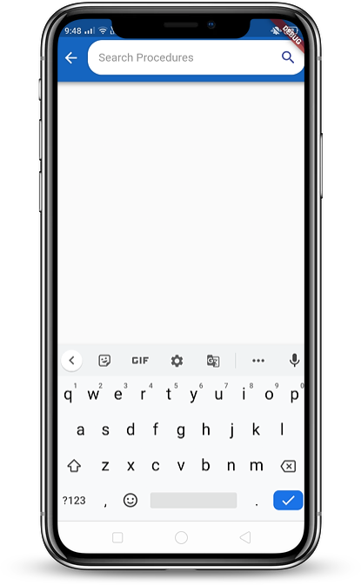

I have scrapped data of few hospitals & tried to use CI Pipeline to update them & the pipeline is working correctly.

I have searched the web for US govt data which contain all hospitals of state. I got New York & California Hospitals CDM ,for rest of state I manually have to save links.

## What do I plan to do next week?

* I will give my mentors Detailed project plan with Milestones for my coding period.
* Analyzing CDM of hospitals & reading documentation for flutter Sqflite package
* Preparing up the development environment for start of coding session.

### Discussion

My Entire discussion with mentors can be seen here

<https://forums.librehealth.io/t/project-develop-an-android-mobile-application-to-show-patient-friendly-costs-of-care/3685/25>