**CSC4100/CSC5100 – Midterm Exam**

**Watch below videos before starting to write the program**

[**https://www.youtube.com/watch?v=ldJ8WGZVXZk**](https://www.youtube.com/watch?v=ldJ8WGZVXZk)

[**https://www.youtube.com/watch?v=raLCgPK-Igc**](https://www.youtube.com/watch?v=raLCgPK-Igc)

**Reference** [**http://www.csc.villanova.edu/~mdamian/threads/posixthreads.html**](http://www.csc.villanova.edu/~mdamian/threads/posixthreads.html)

**Thread (linux only)**

* **Add #include <pthread.h>**
* **Initialize a thread**

pthread_t thread1

* Create a new thread

pthread_create(pthread_t *thread, const pthread_attr_t *attr,

void *(*start_routine)(void*), void *arg)

* Join thread – Allows child to complete before main thread ends

pthread_join(tid, NULL);

* Exit

exit(0);

* Run program for sum

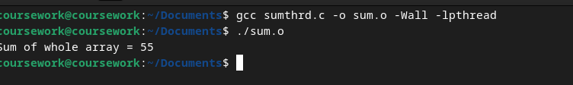

**See attachment for code examples**

1. **Create a C program that performs the below** 
   1. **Create five threads**
   2. **Calculate sum of numbers from 1 – 100**
   3. **Thread 1 – sum from 1 – 20**

**Thread 2 – sum from 21 – 40**

**Thread 3 – sum from 41 – 60**

**Thread 4 – sum from 61 – 80**

**Thread 5 – sum from 81 – 100**

* 1. **Calculate the total sum from all the threads and print**