Crowd Emporium

Crowd Emporium is an event space that caters to singers and artists so that they may host a concert for their fans. It’s a rather small event space but still is divided into sections with seats that that are priced based on reserved, VIP, and general admission.

## Requirements

To keep the math simple the event space has 10 sections each with 5 rows per section and 10 seats per row, so 500 seats in the Emporium.

When an event is scheduled for a date, all 500 seats will be up for purchase. As seats are reserved/purchased, this will remove the seat from inventory so other fans cannot purchase these seats.

### Ticket Sales

The system should have the ability to sell at the box office, but in the future, it will need to accommodate mobile sales so that fans can purchase tickets online. This will require a responsive design.

The system should keep track of the number of tickets available for each event and notify administrators when tickets are running low.

The system should also be able to handle cancellations.

The cost of the tickets depends on the base price of the event. For example, if the base price of a Taylor Swift concert is $150. The event can raise the rates for VIP Seats and Reserved seating based on that event. The database will need to be able to have percentages from the base price the ticket will be sold at. So, if Taylor gets $150 for GA, then she might sell the VIP for 75% more or $262.50.

Consider the following event space section.

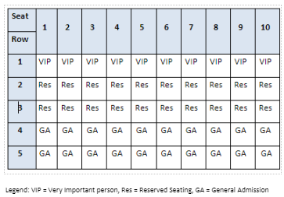

User Interface

The system should be optimized for mobile devices to provide a seamless experience for fans to purchase tickets from their smartphones or tablets.

Data Analytics

The system should provide reports on ticket sales, revenue, and other metrics. This can help administrators make informed decisions about pricing, marketing, and other aspects of the event.

System Monitoring and Observability

* When 60% of the tickets have sold, raise the base price of the tickets by 15%.
* When 80% of the tickets have sold, raise the base price of the tickets by 25%
* The system should have reporting capabilities that provide valuable insights into fan purchases.
* Which events sell the best, singers or monster trucks? This can help businesses make informed decisions and improve their services.

The system should be able to handle a large volume of ticket sales without crashing or experiencing performance issues.

Some questions to get you thinking.

* What is the minimum viable product that you can deliver to begin to show the functionality to CE?
* What type of database tables and relationships can you discover in this system?
* Are there requirements that you can satisfy now to minimize the risk of the system?
* What questions do you have about the current requirements that you need to go back to the Product Owner to get clarification?
* Are there requirements that you can do now and ones that would be nice to have for the future?
* What growth can you plan for the system so that it may scale?
* What type of users do you have for your system? How does this affect table relationships.
* What functionality do you think would be good for the system that maybe the product owner or client hasn’t considered?