**What is Bitcoin?**

– Bitcoin is a new form of decentralized wealth

that nobody controls and it is developed as an

open collaborative project.

- A purely peer-to-peer version of electronic cash would allow online settlements directly from one party to another without going through a financial institution.

- Bitcoin is sovereign and free from all state controll.

**Bitcoins energy expenditure is key to a provably fair and secure network**

All money needs to be provably scarce and difficult to counterfeit. Bitcoins power usage allows people anywhere on earth to legitimately participate in the bitcoin network without censorship. Mining gives incentives for the cheapest power; currently the cheapest power on earth is renewables and stranded energy.

If you own Bitcoin **YOU OWN THE ENERGY OF YOUR LABOR IN THE FORM OF THE HARDEST MONEY EVER KNOWN**

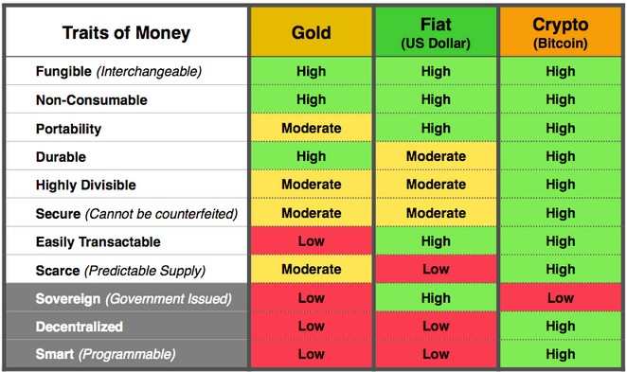

**WHO USES BITCOIN?**

- btc can settle payments P2P (person to person)

- bitcoin can cutout the middleman of banks and rent seeking. Banks can charge to hold, send, and receive and much more. Their legacy business model is predicated on debt bondage.

- bitcoin is a peaceful way to opt-out of the government surveillance panopticon. It allows any sovereign individual the optionality of not funding government violence.

- bitcoin is a wealth transferer mechanisms to future generations, free from the leaching and insidious nature of taxes from overburdensome regimes.

- bitcoin is not some get rich quick scheme; bitcoin is a not get poor slowly tool.

**"If you're not paying for it, You become the product"**

- Bitcoin has fees to use and secure the network. These fees act as finical incentive to include one transaction over another. Fees directly tie to the underwriting of bitcoins security. They guarantee a robust future market, allowing miners to further invest more capital into bitcoins security.

- bitcoin forces the shedding of excess overhead traditionally associated with traditional government fiat issuance.

- bitcoin acts as a check against banking cartels and despot governments.

**- We use BTC because FUCK the banks!**

**Bitcoin key aspects:**

***PERMISSIONLESS***

You don’t need anybody’s permission to use it

***OPEN SOURCE***

Anybody can participate in developing the code

***UNCONFISCATABLE***

Nobody can take it without your permission

***CENSORSHIP RESISTANT***

Nobody can stop, ban, filter your addresses

***LIMITED SUPPLY***

It will be ONLY 21M BTC, ever, forever

***BORDERLESS***

Worldwide accepted, cross-border payments

***ALWAYS AVAILABLE***

The nodes and miners NEVER stop working

***IT’S YOUR PROPERTY***

Is not an IOU, is not somebody else money

***IT’S YOUR VOICE***

It is free speech, by using it, you are heard

***YOUR KEYS = YOUR BITCOINS***

So keep them in private and in your possesion

***BE YOUR OWN BANK***

Act accordingly, think like a bank

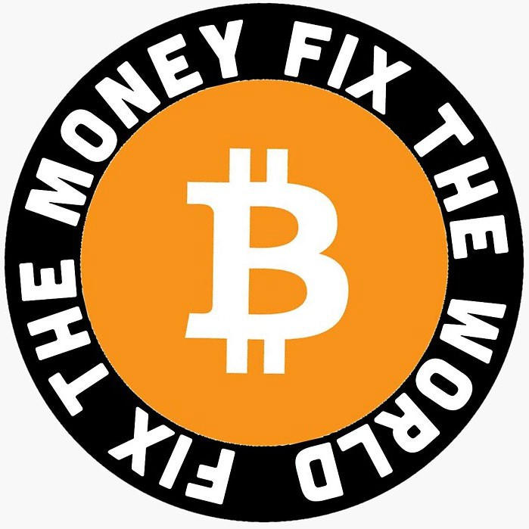

Average no-coiner



Fiat money saver

Michael Saylor

CEO Microstrategy

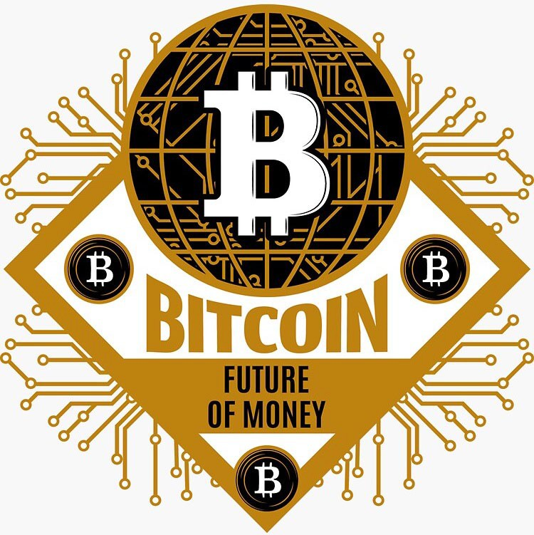

Hope.com

NC: It’s not backed by anything!

MS: Wall of encrypted energy and cyber hornets

NC: It’s not controlled by anyone!

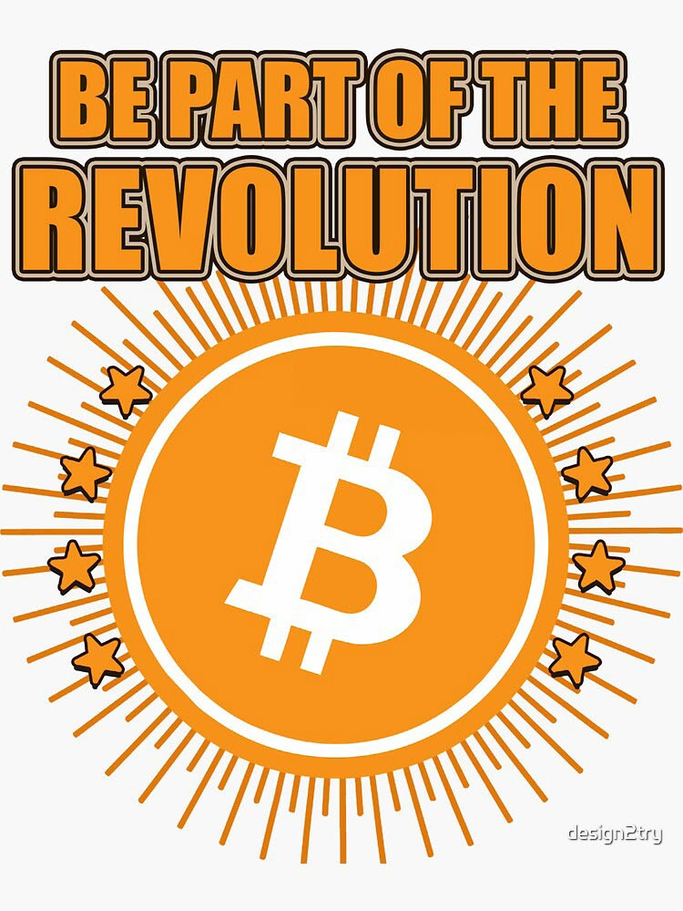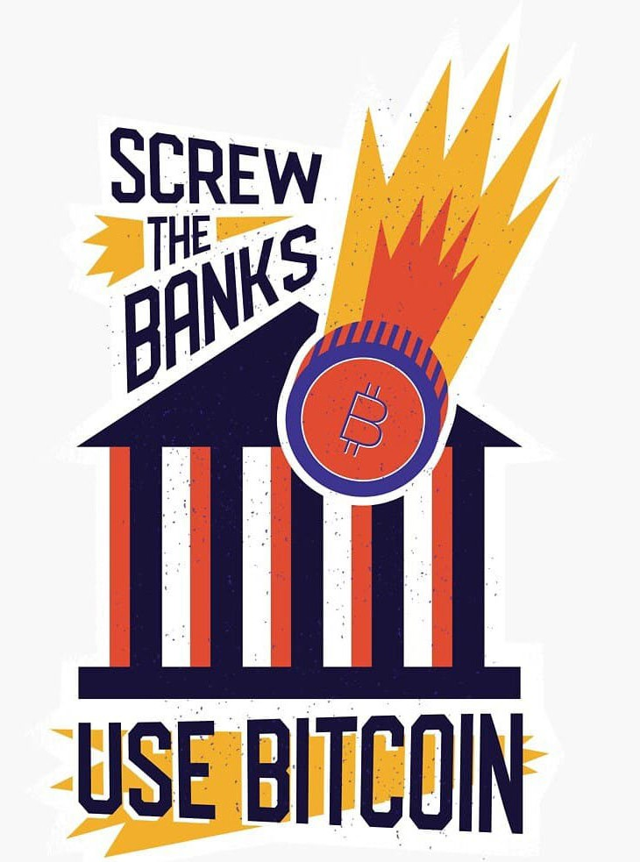

MS: That’s exactly why it works and what makes it better

than legacy networks.

NC: Gold si better. 5000 years!

MS: Gold is only relatively scarce, Bitcoin is absolutely

scarce. Also more durable, divisible, portable and recogniz-

able.

NC: Too volatile!

MS: Equities have been more volatile this year, especially

given Bitcoin’s size

NC: Governments will ban it! MS: Geographic arbitrage

NC: Criminals use it!

MS: It’s not anonymous, it’s a public ledger

NC: Uses too much energy!

MS: Legacy finance uses orders of magnitude more

NC: Quantum computers!

MS: Nuclear launch codes and Nasdaq will go down before

Bitcoin

NC: It’s not anonymous!

MS: It was never anonymous, it’s a public ledger

RESOURCES:

- **Bitcoin.org** - Official page

- **Bitcoin.page** - Resources about Bitcoin

- **Bitcoiner.guide** - Guides and tutorials

- **Lightning.how** - Lightning Network Resources

- **Hope.com** - Bitcoin Resources & Course

- Bitcoin.directory - all sorts of info

**WHERE TO BUY BITCOIN:**

hodlhodl.com - P2P no KYC

kraken.com - KYC centralized

azte.co - vouchers LN

nicehash.com - LN support

binance.com - KYC centralized

relai.ch - no-KYC

coinfloor.co.uk - simple to use

luno.com - simple mobile app

**BITCOIN WALLETS:**

bluewallet.io samouraiwallet.com

phoenix.acinq.co electrum.org

breez.technology wasabiwallet.io

**HARDWARE WALLETS**

colcardwallet.com trezor.io ledger.com