A CALL OF CTHULHU ONE-SHOT
The Blooming
Keeper's Reference
30 SEPTEMBER 1921 · DUNWICH, MASSACHUSETTS

3–5 investigators · ~4 hours · one sitting
Four horticulturists answer an invitation to watch a rare orchid bloom.
There is no orchid society. The bloom is a clock.

KEEPER-ONLY DOSSIER · dndnight.org

AT-A-GLANCE RUN SHEET

Run the Night in One Page
Keep this page open. The five acts below darken as they go — do not spend your best horror early. Dread meters (●●●○○) pace your descriptions.
ACT | WHERE | BEAT | DREAD
I | Dunwich, dusk | A rotting town; Zebulon rushes them up Sentinel Hill. Cozy, then three quiet wrongnesses. | ●●○○○
II | The Chateau · Study | Reginald greets them. Books on Bloody Mary, the crystal, the two grimoires. Wait for midnight. | ●●●○○
III | Ground floor | Blood drains east. The calendar puzzle. The orchid blooms; Reginald locks them in. | ●●●●○
IV | Master Suite | Mother — the birthing vessel. The genre changes at the table. | ●●●●●
V | Deck · Dungeon | Family portraits. The Communicator. The Name. The Soul Organ. | ●●●●●
END | The grounds | Reginald, naked beneath the maelstrom: “Welcome to a new birth.” Cut to black. | ●●●●●

THE ONE THING TO REMEMBER
The premise is banal on purpose. Your players are hobbyists lured by a flower — not soldiers. Play the first hour almost cozy so the wrongness arrives in a room they thought was safe.

OPEN THE SESSION WITH THREE LINES (OUT OF CHARACTER)
“This is not D&D. Bravery can get you killed. And by the end of tonight, at least one of you will not be entirely yourself.”
Then explain Sanity once (table below) and never explain it again.

KEEPER ONLY · BEHIND THE CURTAIN

The Secret Truth
Everything the investigators will spend four hours failing to understand.
WHO IS Y’GOLONAC
A Great Old One in the shape of a naked, headless body — palms opening into hungering mouths. God of the depraved and the buried. He cannot walk the world in his own form; he needs a vessel of the correct bloodline, opened at the correct hour.

THE BLOODY MARY CONSPIRACY
In 1553, on 30 September, Mary I became England’s first crowned queen — through sacrifice to Y’golonac. Her reign of blood was tribute. He had arranged Lady Jane Grey’s beheading to make Mary his vessel, but Mary’s death in 1558 cheated him of the birth. Enraged, he swore to burst from his stone tomb on the third first-of-October under a new moon and consume all of Mary’s line.

MOTHER, AND THE 1845 EVENT
Y’golonac last emerged in 1845, possessing the Lady of this estate. Forced out, what remained was Mother — no longer a person, a semi-lucid husk kept alive to birth Dark Ones. She is strapped to a bed in the Master Suite, still whispering. The Household has tended the bloodline and the calendar ever since.

THE INVESTIGATORS ARE THE POINT
They were not invited for a flower. Each is a distant descendant of Mary’s line — that is how the Household knew their names. The orchid is a countdown. The house is the womb. Reginald is the midwife.

▮ The calendar puzzle — untangled
Players find scattered lunar notes and get confused. That is intended. Here is the version you never lose:
DATE / YEAR | WHAT IT MEANS
30 Sept | Anniversary of Mary’s coronation — the god’s “birthday.”
1 Oct, new moon | The only night the seal can break. Y’golonac’s vow was sworn against this date. **This is tonight.**
31 Oct | A red herring the cult itself chased. Halloween is a human invention; the god does not keep it.
1845 | Last successful emergence — produced Mother.
1902 | New moon fell on both 1 Oct and 31 Oct, yet “no event” — the bloodline wasn’t present.
1959 | The next alignment after tonight. Stop this one and the Household simply waits.

ACT I · EARLY EVENING, 30 SEPTEMBER 1921

Arrival at Dunwich
Each investigator makes their own way to Dunwich. However they arrive, the town greets them the same: a dilapidated center, buildings barely held together by rot and vines, the bones of a place surrendering to the forest. An air of destitution. Let a player ask the question the town begs — why is anyone still here? — and give no answer.
COZY, THEN WRONG
Play Act I gentle. Let the horticulturists geek out, compare invitations, discover their shared obsession. Seed three quiet wrongnesses and never underline them:
① nobody in town will meet their eyes; ② the estate is only ever called “up there,” never by name; ③ the invitations are all in the same hand, though received separately.

▮ Zebulon Whately — the guide
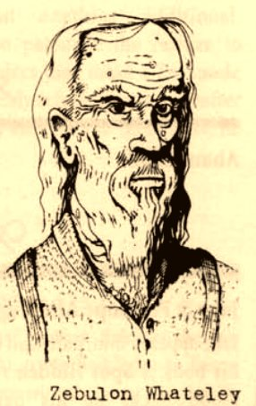
ZEBULON WHATELY · WILL NOT WALK THEM UP THE HILL
The investigators assemble at Osborn’s General Store as the sun goes down. Zebulon gives directions up to the chateau, deep in the forest atop Old Sentinel Hill. He is not talkative. He wants these people up and out of his town as fast as possible. Every answer is vague to the point of uselessness. He will not walk them up. He does not expect them to come back down.
IF PLAYERS PUSH ZEBULON
“Folk who go up for the flower don’t come down. Company’s been going up longer’n the town’s been dyin’. You want my advice? Miss it.”
Then he closes the store.

ACT II · THE HOUSE RECEIVES THEM · THE WAIT FOR MIDNIGHT

The Chateau & the Study
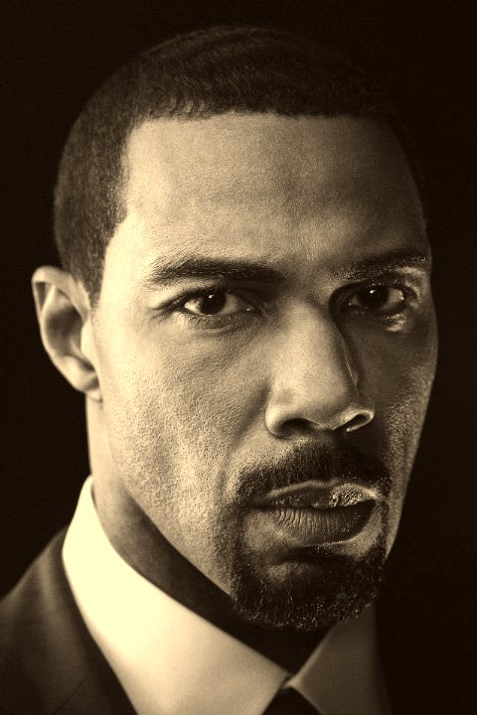
REGINALD · THE BUTLER / THE MIDWIFE

▮ Reginald greets them
At the door stands Reginald — stoic, exacting, respectful. He ushers each arrival to the Study and withdraws; near midnight he returns to collect them. Play him as a man doing a job he only half understands. He does not know who owns the house. His instructions simply appear: once a week a schedule is left on a board in the Laundry, from a source he has never seen and will not discuss.
REGINALD’S ARC — PLANT IT NOW
He seems the one sane fixture in the house. That is the setup. His warmth is real and his ignorance is real — which makes his final turn land like a trapdoor. Give the players a reason to trust him tonight so it costs them later.

▮ The Study — read aloud
Three walls are lined floor to ceiling with bookshelves: periodicals, dusty tomes, some bound in a leather you would not care to name. The fourth wall — nearest the Master Bedroom — is different. Accent lights converge from every angle on a single small white crystal, and to either side a reading table displays one book each, positioned to be found.
THE ROOM IS A SOFT LOCK
Later the investigators are shut in here and must find the way out. The exit into the Master Suite opens only when the Zanthu Tablets are lifted from their table — a hidden mechanism engages. Anyone with SPOT 15+ hears it click.

▮ On the shelves — the Mary thread
- Volumes on Mary I: her life, her death, and — in lurid detail — how she tortured those she named heretics.
- Dark-arts texts claiming her death “foretold the coming of a great beast.”
- Marginalia puzzling over why 1 October and 30 September matter, and why 31 October “doesn’t make sense.”
- Tucked in one book: a half-disintegrated photo of a Civil War soldier, dated 31 October 1865. On the back: “ceremony — did it take?”
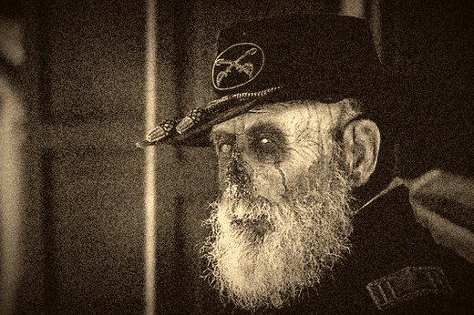
FOUND PRESSED IN A TOME · 31 OCT 1865

▮ The Crystal of the Elders
A shining white crystal swirling with contained power. Examination: 0/1 Sanity. Picking it up “activates” it: 1d2/5d4 ability-score damage, randomized across abilities by 1d4 each. On being lifted it disintegrates into white spores — one random investigator drops unconscious for 1d10 minutes.
USE THE UNCONSCIOUSNESS
The spore-sleep is a gift to pacing. Drop a player under right before a scare, and let them wake to something already wrong — the others gone quiet, a door now open, Reginald standing too close.

▮ The Tomes — grimoires in disguise
The two displayed books, and others found by searching, are functional grimoires. Reading them is dangerous; casting from them is worse. Full spell mechanics are in the Reference tables at the back.
TOME | SANITY (EXAMINE / READ) | WHAT IT HOLDS
Zanthu Tablets  carvings dredged from the Pacific | 0/1d3 · then 1/1d6 | Triggers the Master-Suite lock. Holds Eye of Light & Darkness, Dominate Soul.
Pnakotic Manuscript  prehistoric, possibly pre-human | 1d4 · then 1d8 | Holds Create Time Gate, Contact Y’golonac.

ACT III · EXPLORING THE GROUND FLOOR · THE WRONGNESS SURFACES

The House Wakes
If the investigators wander before midnight — or after they escape the Study — the chateau opens room by room. Each space adds one piece of the truth. The house is confident it will keep them.

▮ The Grand Room
Faint blood-stains, scrubbed many times, nearly invisible against dark wood. Not decoration — directional.
TO NOTICE | SEARCH (ACTIVE) | SPOT (PASSIVE)
The stains at all | 18+ | 23+
They “drain” toward the EAST wall | 20+ | 25+
THE EAST WALL IS A PROMISE
Everything flows east and down — toward the Master Suite, the Deck, the dungeon beneath. When a player traces the blood east, let them feel the pull of the architecture. The house has a stomach, and it’s downhill.

▮ Sitting Room & Conservatory
- Sitting Room — the door to the Master Suite is locked until the Zanthu Tablets are lifted in the Study.
- Conservatory — the calendar puzzle room. A sandstone stand set deliberately just off-center. Around its center, in an unbroken ring, runs the script below.
HANDOUT · SANDSTONE SCRIPT
31ˢᵗ Octobers bring forth the final seal — from sky He comes and the end He brings

Lunar charts paper every surface. Among the notes: “New moon.” · “next halloween with new moon: 1959.” · “1902: no event.” · “Explain 1845??”
LET THEM SOLVE THE WRONG PUZZLE
The sandstone and the 1959/Halloween notes point at 31 October — the trail the cult itself burned years on. Clever players will fixate on it. It is a dead end. The real date is tonight, 1 October, new moon. While they decode the wrong Halloween, midnight comes for the right one.

▮ The Fountain & the Orchid
At the heart of the grounds, the Rothschild’s orchid stands wrapped in strange light. When it blooms at midnight, the sky splits into a slow maelstrom of purple and red. The instant it opens, Reginald appears to escort the group “back to the Study for the viewing” — where he locks them in. The night has begun.

ACT IV · THE MASTER SUITE · THE FIRST TRUE HORROR

Mother
Having escaped the Study through the mechanism, the investigators step into the Master Suite and find what the house has been feeding. This is the hinge of the night. Everything before was atmosphere.
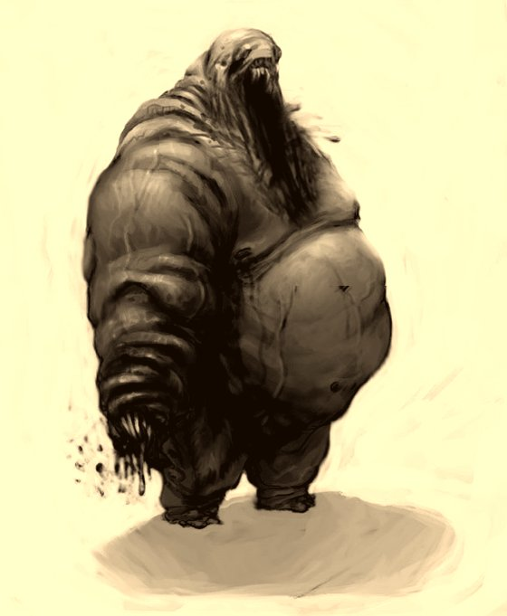
SUBJECT: “MOTHER” · DO NOT APPROACH
Strapped to the bed is a grotesque female form — an indistinct mass of sinew and fluid, headless, with mouths where hands should be. The bed is a swamp of gore. She births foul, half-formed things and repeats one shrieked line:
MOTHER SPEAKS
“Care for the brood! CARE FOR THE BROOD!”
Sanity on sight: 1d4 / 2d4.

RESTRAINT IS THE HORROR
Describe Mother in three precise strokes, then stop. The pause after “mouths where her hands should be” is worse than any fourth sentence. Body-horror lands hardest when it is specific and brief. Watch the table — if someone’s rattled, that’s the effect working, not a reason to pile on.

The same directional stains reappear — this time easy to spot, dragging toward the northern wall and the Deck beyond. The house is still pointing downhill.

ACT V · THE NORTHERN DECK · THE TRAPDOOR · THE DUNGEON

Beneath the House

▮ The Northern Deck
Hidden in the deck boards is a trapdoor down into the dungeon.
ACTION | THRESHOLD
SPOT the door | 20+
SEARCH (active) | 17+
Force it (STR) | 20+
Read the runes (Occult) | Knowledge 15+
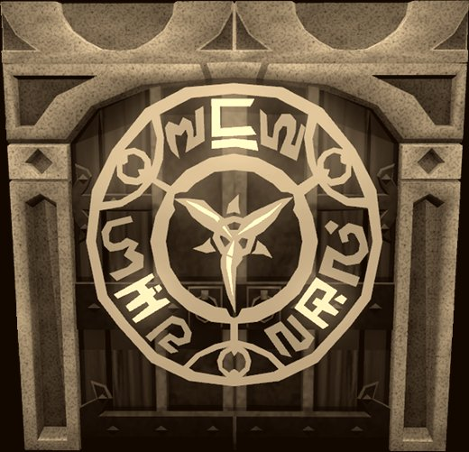
TRAPDOOR GLYPHS · THE OPENING RITE
The runes describe an ancient power mankind has tried, again and again, to enslave — and how every time it is the power that ends up owning the men. By now the investigators can name what this house is: a cult, and an old one.

▮ The Dungeon
Walls lined with runes telling the story of the coming dark. Everything algae-slick, cobwebbed, filthy — and hot. Unnaturally, wrongly hot. Read the rooms slow; let the players feel the temperature climb.
THE CONFERENCE ROOM — THE GUT-PUNCH
Just left of the entry: portraits dating to the founding of the colonies, early 1600s onward. Among the old faces the investigators find their own families — a grandparent here, a parent there. This is where a smart table realizes they were bred for tonight. Let it dawn in silence. The portraits are the explanation.

▮ The Temporal Communicator
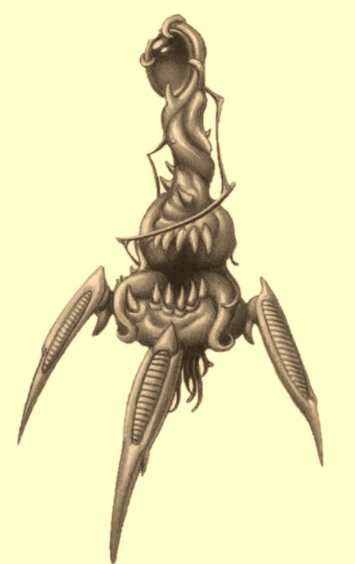
THE TEMPORAL COMMUNICATOR
An intricate brass device topped with a red jewel attuned to Y’golonac. Touch the jewel and it wakes; after 1d4 minutes a hologram of the god projects from the stone. To see Y’golonac’s true form costs 1d20 Sanity outright. Reading the surrounding runes: 0/1d4. They name the horror — a name so vulgar that hearing it costs 1/1d6 more:
THE NAME
Y’GOLONAC
Once the name is known, every investigator gains +5 Mythos. There is no unknowing it.

▮ The Soul Organ
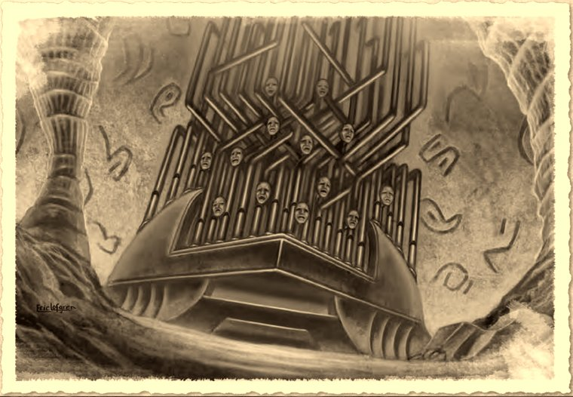
THE SOUL ORGAN · THE FATE OF EVERY GUEST BEFORE THEM
In the last room waits the Soul Organ. Looking at it: 1/1d6 Sanity. It writhes in agony; a mass of faces, each turning to glare into every investigator’s eyes. They know English. They can converse. And everything they say is broken past sense.
HANDOUT · THE FACES SPEAK
“We are sorrow… you’ll feel it too.”
“He knows what makes you cry.”
“Fly with the voids of darkness and hear the whispers.”
“Your soul smells delectable.”
“Devour. DEVOUR.”
DELIVER THE WHISPERS WRONG ON PURPOSE
Read these out of order. Overlap them. Assign each line to a different face and let them talk over one another. The horror isn’t the words — it’s that the faces want to communicate and can’t, and one of them, if the investigators linger, starts to sound like someone they recognize.

THE END · HOW THE NIGHT CLOSES

A New Birth
While the investigators were locked in the Study, they heard Reginald outside, murmuring to someone unseen. Then screaming. Then a wet, heavy sploosh, and blood seeping under the door (0/1 Sanity). They assumed the worst had happened to him. It hadn’t. It happened through him.
THE FINAL IMAGE
When the investigators reach the exit from the dungeon, they emerge to find Reginald standing naked beneath the vast maelstrom, gazing up in rapture. He hears them, turns, and — with a wide, gentle, genuinely welcoming smile — says the last words of the night:
“Welcome… to a new birth.”
Cut to black there. Do not narrate what comes next. The investigators arrived exactly on schedule, and the house has what it invited. This is how the scenario ends.

ESCALATING THE FINALE (OPTIONAL)
If your table wants a fight: let them try to stop it and fail meaningfully. The Eye of Light and Darkness spell weakens every Mythos creature within a mile and blocks Domination — cast four hours before moonrise, it could have unmade the ritual. By the time they understand, it’s minutes to midnight. Give them the tool too late. Tragedy beats a boss fight here.

APPENDIX · PULLED OUT SO THE ACTS STAY CLEAN

Reference Tables

▮ The four spells
SPELL | COST | EFFECT
Eye of Light & Darkness  Zanthu · #1 | 2 CON (perm) · 1d8 San to all in range | Cast 4 hrs before moonrise; needs blood of an innocent (0 Mythos). Weakens all Mythos creatures within 1 mile; blocks Dominate. The one thing that could stop tonight.
Dominate Soul  Zanthu · #2 | 2 WIS · 1d6 San | Target resists with WIS 17+. On success, control the soul for 1 day/level (~3 days).
Create Time Gate  Pnakotic · #3 | 1 STR + 1 San per rank | Opens a gate through time. Distance scales ×10 per STR drained — see table.
Contact Y’golonac  Pnakotic | 1 WIS (perm) · 1d10 San · +1d20 on waking | Opens a channel to the god. Caster collapses 1d10 min into horrifying visions. You do not want this to succeed.

▮ Create Time Gate — distance by STR drained
STR | YEARS | STR | YEARS
1 | 100 | 8 | 1 billion
2 | 1,000 | 9 | 10 billion
3 | 10,000 | 10 | 100 billion
4 | 100,000 | 11 | 1 trillion
5 | 1 million | 12 | 10 trillion
6 | 10 million | 13 | 100 trillion
7 | 100 million | 14–15 | 1–10 quadrillion
Every rank is ×10. Reaching 1553 would gut an investigator — which is the point. The past is reachable, and it costs your body to touch it.

▮ Sanity toll — quick tally
ENCOUNTER | SANITY (FAIL / SUCCESS OR EXAMINE / COMPLETE)
Crystal of the Elders (examine) | 0/1
Zanthu Tablets | 0/1d3 · then 1/1d6
Pnakotic Manuscript | 1d4 · then 1d8
Mother, on sight | 1d4 / 2d4
Reginald’s “death” (blood under the door) | 0/1
Dungeon runes / the Name | 0/1d4 · then 1/1d6
Soul Organ | 1/1d6
Y’golonac’s true form (Communicator) | 1d20

▮ Cast of the house
- Reginald — the butler. Sincere, exacting, ignorant by design. The house’s hands. Opens the way at midnight and welcomes the dawn of “a new birth.”
- Mother — the 1845 vessel, hollowed out and kept alive to birth Dark Ones. Says only: “Care for the brood.”
- Zebulon Whately — Dunwich guide. Knows exactly what the hill is; gets them there fast. Will not follow.
- Y’golonac — Great Old One. Headless body, mouths in the palms. Wants in through Mary’s blood on the new moon of 1 October.
- The Household — never seen, possibly never real. Reginald’s schedule appears from nowhere. The true master is the god below.

TABLE REFERENCE
For random unsettling phenomena as the night escalates, roll on Strange Events — Table 7-1, p.122 (PDF) / p.120 (print) of the core rulebook.

The Blooming · Keeper’s Reference · dndnight.org

