Spark Assignment 3

1-4:

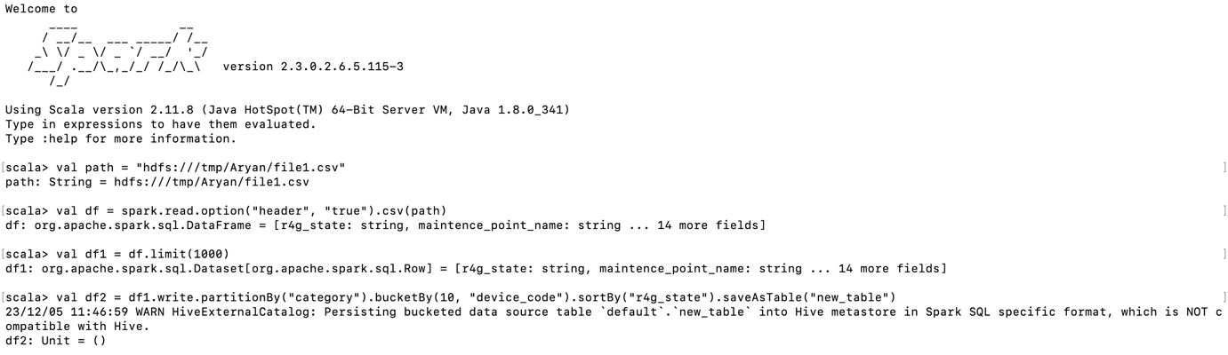

5:

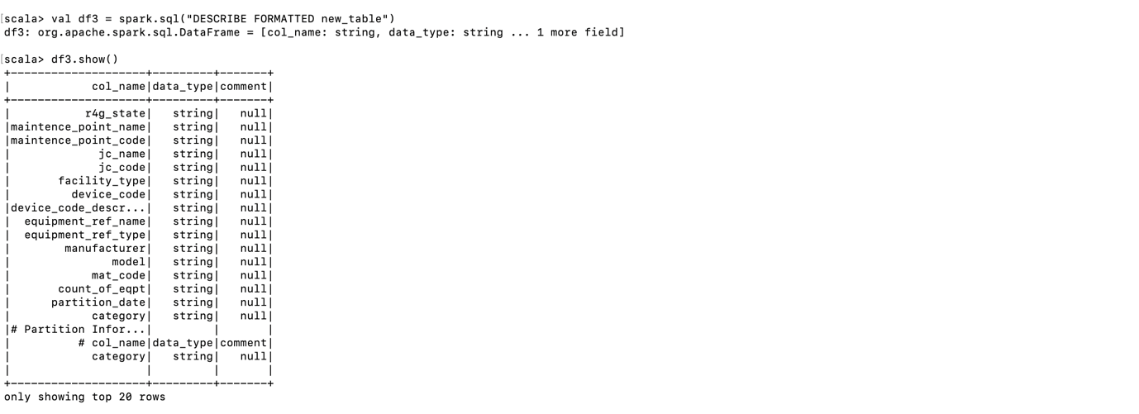

6:

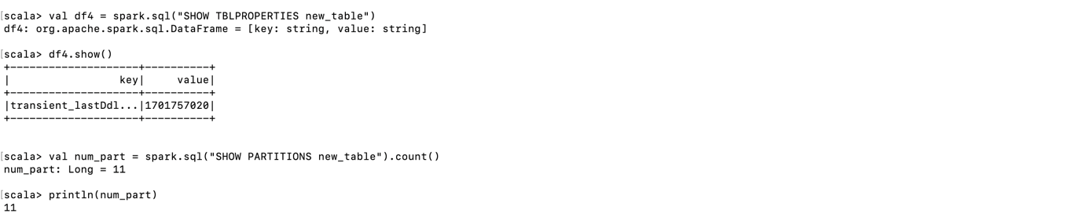

Aryan.Sahoo