Spark Assignment 5

1-7:

Local:

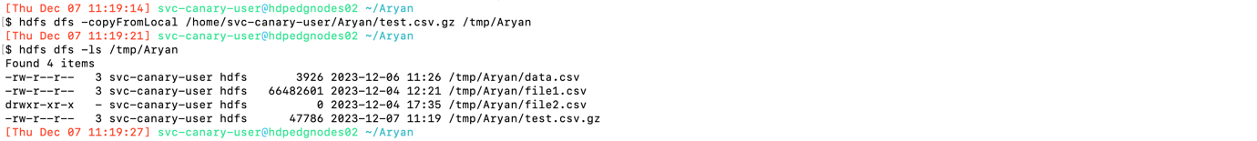

Spark-shell:

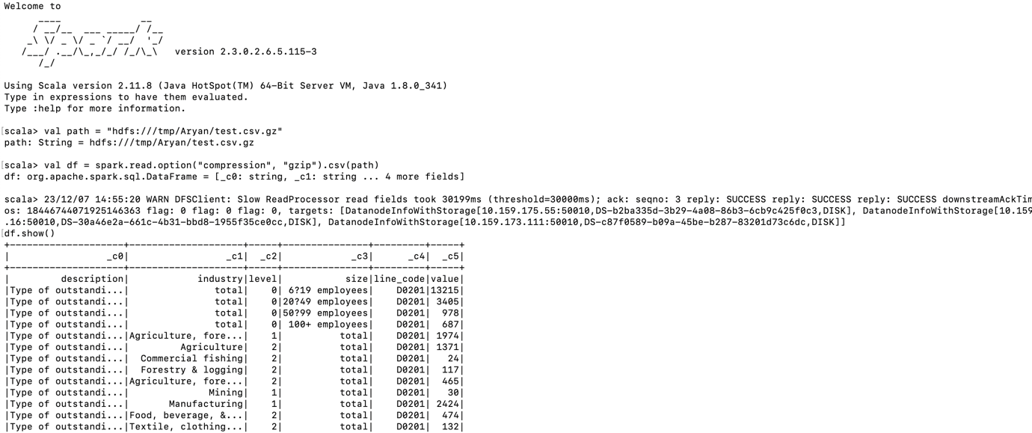

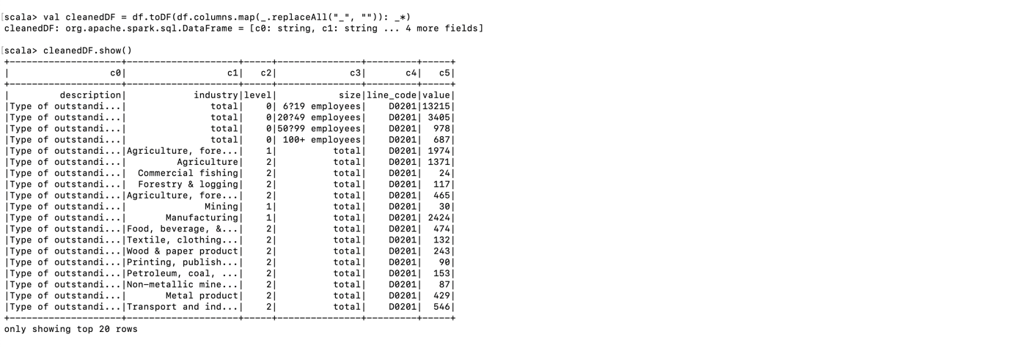

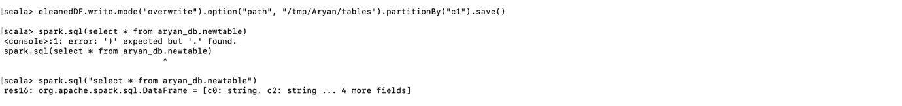

Beeline:



Local:

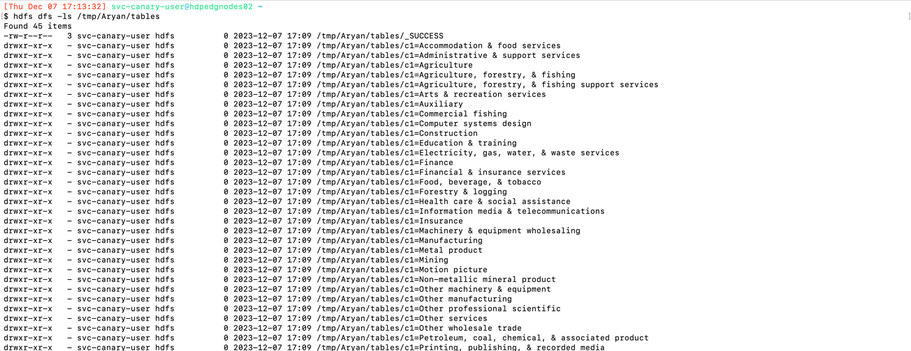

Aryan.Sahoo