|  |  |
| --- | --- |
| **Gerb-BMSTU_01** | **Министерство науки и высшего образования Российской Федерации**  **Федеральное государственное бюджетное образовательное учреждение**  **высшего образования**  **«Московский государственный технический университет**  **имени Н.Э. Баумана**  **(национальный исследовательский университет)»**  **(МГТУ им. Н.Э. Баумана)** |

ФАКУЛЬТЕТ «Информатика и системы управления» (ИУ)

КАФЕДРА «Информационная безопасность» (ИУ8)

Отчёт

по рубежному контролю № 3

по дисциплине «Методы оптимизации»

**Тема:** **« Исследование генетических алгоритмов в задачах поиска экстремумов »**

Вариант 10

Выполнил: Митрофанов Д.А.,

студент группы ИУ8-33

Проверил: Коннова Н. С.,

доцент каф. ИУ8

г. Москва,

2019 г.

## Цель работы

*Изучить основные принципы действия генетических алгоритмов на примере решения задач оптимизации функций двух переменных.*

## Постановка задачи

*Найти максимум функции f(x,y) в области D с помощью простого (классического) генетического алгоритма. За исходную популяцию принять 4 случайных точки. Хромосома каждой особи состоит из двух генов: значений координат x, y. В качестве потомков следует выбирать результат скрещивания лучшего решения со вторым и третьим в порядке убывания значений функции приспособленности с последующей случайной мутацией обоих генов. В качестве критерия остановки эволюционного процесса задаться номером конечной популяции (N~101...102). Визуализировать результаты расчетов.*

## Условие варианта

|  |  |
| --- | --- |
| **Вид функции** *f(x,y)* | **Область допустимых значений** *D* |
|  |  |

1. **Расчёт с помощью программы**

10 generations:

|genereation|prefix | X | Y | FIT |max element | average |

------------------------------------------------------------------------------------

| 0 | p | 0.4018 | -0.0001607 | 0.1317 | | |

| 0 | p | 0.9955 | 1.223 | 0.2019 | | |

| 0 | p | 1.445 | 0.9934 | 0.2416 | | |

| 0 | p | 1.283 | -0.08465 | 0.3465 | 0.3465 | 0.2304 |

------------------------------------------------------------------------------------

------------------------------------------------------------------------------------

| 1 | p | 1.283 | -0.08465 | 0.3465 | | |

| 1 | p | 1.283 | -0.0001607 | 0.3474 | | |

| 1 | p | 0.9955 | -0.08465 | 0.3523 | | |

| 1 | p | 0.9955 | -0.0001607 | 0.3536 | 0.3536 | 0.3499 |

------------------------------------------------------------------------------------

------------------------------------------------------------------------------------

| 1 | ig | 1.283 | -0.08465 | 0.3465 | | |

| 1 | ig | 1.283 | -0.08465 | 0.3465 | | |

| 1 | ig | 1.283 | -0.08465 | 0.3465 | | |

| 1 | ig | 1.283 | -0.0001607 | 0.3474 | | |

| 1 | ig | 1.283 | -0.0001607 | 0.3474 | | |

| 1 | ig | 1.283 | -0.0001607 | 0.3474 | | |

| 1 | ig | 0.9955 | -0.08465 | 0.3523 | | |

| 1 | ig | 0.9955 | -0.08465 | 0.3523 | | |

| 1 | ig | 0.9955 | -0.08465 | 0.3523 | | |

| 1 | ig | 0.9955 | -0.0001607 | 0.3536 | | |

| 1 | ig | 0.9955 | -0.0001607 | 0.3536 | | |

| 1 | ig | 0.9955 | -0.0001607 | 0.3536 | 0.3536 | 0.3499 |

------------------------------------------------------------------------------------

------------------------------------------------------------------------------------

| 2 | p | 0.9955 | -0.0001607 | 0.3536 | | |

| 2 | p | 0.9955 | -0.0001607 | 0.3536 | | |

| 2 | p | 0.9955 | -0.0001607 | 0.3536 | | |

| 2 | p | 0.9955 | -0.0001607 | 0.3536 | 0.3536 | 0.3536 |

------------------------------------------------------------------------------------

------------------------------------------------------------------------------------

| 2 | ig | 0.9955 | -0.0001607 | 0.3536 | | |

| 2 | ig | 0.9955 | -0.0001607 | 0.3536 | | |

| 2 | ig | 0.9955 | -0.0001607 | 0.3536 | | |

| 2 | ig | 0.9955 | -0.0001607 | 0.3536 | | |

| 2 | ig | 0.9955 | -0.0001607 | 0.3536 | | |

| 2 | ig | 0.9955 | -0.0001607 | 0.3536 | | |

| 2 | ig | 0.9955 | -0.0001607 | 0.3536 | | |

| 2 | ig | 0.9955 | -0.0001607 | 0.3536 | | |

| 2 | ig | 0.9955 | -0.0001607 | 0.3536 | | |

| 2 | ig | 0.9955 | -0.0001607 | 0.3536 | | |

| 2 | ig | 0.9955 | -0.0001607 | 0.3536 | | |

| 2 | ig | 0.9955 | -0.0001607 | 0.3536 | 0.3536 | 0.3536 |

------------------------------------------------------------------------------------

------------------------------------------------------------------------------------

| 3 | p | 0.9955 | -0.0001607 | 0.3536 | | |

| 3 | p | 0.9955 | -0.0001607 | 0.3536 | | |

| 3 | p | 0.9955 | -0.0001607 | 0.3536 | | |

| 3 | p | 0.9955 | -0.0001607 | 0.3536 | 0.3536 | 0.3536 |

------------------------------------------------------------------------------------

------------------------------------------------------------------------------------

| 3 | ig | 0.9955 | -0.0001607 | 0.3536 | | |

| 3 | ig | 0.9955 | -0.0001607 | 0.3536 | | |

| 3 | ig | 0.9955 | -0.0001607 | 0.3536 | | |

| 3 | ig | 0.9955 | -0.0001607 | 0.3536 | | |

| 3 | ig | 0.9955 | -0.0001607 | 0.3536 | | |

| 3 | ig | 0.9955 | -0.0001607 | 0.3536 | | |

| 3 | ig | 0.9955 | -0.0001607 | 0.3536 | | |

| 3 | ig | 0.9955 | -0.0001607 | 0.3536 | | |

| 3 | ig | 0.9955 | -0.0001607 | 0.3536 | | |

| 3 | ig | 0.9955 | -0.0001607 | 0.3536 | | |

| 3 | ig | 0.9955 | -0.0001607 | 0.3536 | | |

| 3 | ig | 0.9955 | -0.0001607 | 0.3536 | 0.3536 | 0.3536 |

------------------------------------------------------------------------------------

------------------------------------------------------------------------------------

| 4 | p | 0.9955 | -0.0001607 | 0.3536 | | |

| 4 | p | 0.9955 | -0.0001607 | 0.3536 | | |

| 4 | p | 0.9955 | -0.0001607 | 0.3536 | | |

| 4 | p | 0.9955 | -0.0001607 | 0.3536 | 0.3536 | 0.3536 |

------------------------------------------------------------------------------------

------------------------------------------------------------------------------------

| 4 | ig | 0.9955 | -0.0001607 | 0.3536 | | |

| 4 | ig | 0.9955 | -0.0001607 | 0.3536 | | |

| 4 | ig | 0.9955 | -0.0001607 | 0.3536 | | |

| 4 | ig | 0.9955 | -0.0001607 | 0.3536 | | |

| 4 | ig | 0.9955 | -0.0001607 | 0.3536 | | |

| 4 | ig | 0.9955 | -0.0001607 | 0.3536 | | |

| 4 | ig | 0.9955 | -0.0001607 | 0.3536 | | |

| 4 | ig | 0.9955 | -0.0001607 | 0.3536 | | |

| 4 | ig | 0.9955 | -0.0001607 | 0.3536 | | |

| 4 | ig | 0.9955 | -0.0001607 | 0.3536 | | |

| 4 | ig | 0.9955 | -0.0001607 | 0.3536 | | |

| 4 | ig | 0.9955 | -0.0001607 | 0.3536 | 0.3536 | 0.3536 |

------------------------------------------------------------------------------------

------------------------------------------------------------------------------------

| 5 | p | 0.9955 | -0.0001607 | 0.3536 | | |

| 5 | p | 0.9955 | -0.0001607 | 0.3536 | | |

| 5 | p | 0.9955 | -0.0001607 | 0.3536 | | |

| 5 | p | 0.9955 | -0.0001607 | 0.3536 | 0.3536 | 0.3536 |

------------------------------------------------------------------------------------

------------------------------------------------------------------------------------

| 5 | ig | 0.9955 | -0.0001607 | 0.3536 | | |

| 5 | ig | 0.9955 | -0.0001607 | 0.3536 | | |

| 5 | ig | 0.9955 | -0.0001607 | 0.3536 | | |

| 5 | ig | 0.9955 | -0.0001607 | 0.3536 | | |

| 5 | ig | 0.9955 | -0.0001607 | 0.3536 | | |

| 5 | ig | 0.9955 | -0.0001607 | 0.3536 | | |

| 5 | ig | 0.9955 | -0.0001607 | 0.3536 | | |

| 5 | ig | 0.9955 | -0.0001607 | 0.3536 | | |

| 5 | ig | 0.9955 | -0.0001607 | 0.3536 | | |

| 5 | ig | 0.9955 | -0.0001607 | 0.3536 | | |

| 5 | ig | 0.9955 | -0.0001607 | 0.3536 | | |

| 5 | ig | 0.9955 | -0.0001607 | 0.3536 | 0.3536 | 0.3536 |

------------------------------------------------------------------------------------

------------------------------------------------------------------------------------

| 6 | p | 0.9955 | -0.0001607 | 0.3536 | | |

| 6 | p | 0.9955 | -0.0001607 | 0.3536 | | |

| 6 | p | 0.9955 | -0.0001607 | 0.3536 | | |

| 6 | p | 0.9955 | -0.0001607 | 0.3536 | 0.3536 | 0.3536 |

------------------------------------------------------------------------------------

------------------------------------------------------------------------------------

| 6 | ig | 0.9955 | -0.0001607 | 0.3536 | | |

| 6 | ig | 0.9955 | -0.0001607 | 0.3536 | | |

| 6 | ig | 0.9955 | -0.0001607 | 0.3536 | | |

| 6 | ig | 0.9955 | -0.0001607 | 0.3536 | | |

| 6 | ig | 0.9955 | -0.0001607 | 0.3536 | | |

| 6 | ig | 0.9955 | -0.0001607 | 0.3536 | | |

| 6 | ig | 0.9955 | -0.0001607 | 0.3536 | | |

| 6 | ig | 0.9955 | -0.0001607 | 0.3536 | | |

| 6 | ig | 0.9955 | -0.0001607 | 0.3536 | | |

| 6 | ig | 0.9955 | -0.0001607 | 0.3536 | | |

| 6 | ig | 0.9955 | -0.0001607 | 0.3536 | | |

| 6 | ig | 0.9955 | -0.0001607 | 0.3536 | 0.3536 | 0.3536 |

------------------------------------------------------------------------------------

------------------------------------------------------------------------------------

| 7 | p | 0.9955 | -0.0001607 | 0.3536 | | |

| 7 | p | 0.9955 | -0.0001607 | 0.3536 | | |

| 7 | p | 0.9955 | -0.0001607 | 0.3536 | | |

| 7 | p | 0.9955 | -0.0001607 | 0.3536 | 0.3536 | 0.3536 |

------------------------------------------------------------------------------------

------------------------------------------------------------------------------------

| 7 | ig | 0.9955 | -0.0001607 | 0.3536 | | |

| 7 | ig | 0.9955 | -0.0001607 | 0.3536 | | |

| 7 | ig | 0.9955 | -0.0001607 | 0.3536 | | |

| 7 | ig | 0.9955 | -0.0001607 | 0.3536 | | |

| 7 | ig | 0.9955 | -0.0001607 | 0.3536 | | |

| 7 | ig | 0.9955 | -0.0001607 | 0.3536 | | |

| 7 | ig | 0.9955 | -0.0001607 | 0.3536 | | |

| 7 | ig | 0.9955 | -0.0001607 | 0.3536 | | |

| 7 | ig | 0.9955 | -0.0001607 | 0.3536 | | |

| 7 | ig | 0.9955 | -0.0001607 | 0.3536 | | |

| 7 | ig | 0.9955 | -0.0001607 | 0.3536 | | |

| 7 | ig | 0.9955 | -0.0001607 | 0.3536 | 0.3536 | 0.3536 |

------------------------------------------------------------------------------------

------------------------------------------------------------------------------------

| 8 | p | 0.9955 | -0.0001607 | 0.3536 | | |

| 8 | p | 0.9955 | -0.0001607 | 0.3536 | | |

| 8 | p | 0.9955 | -0.0001607 | 0.3536 | | |

| 8 | p | 0.9955 | -0.0001607 | 0.3536 | 0.3536 | 0.3536 |

------------------------------------------------------------------------------------

------------------------------------------------------------------------------------

| 8 | ig | 0.9955 | -0.0001607 | 0.3536 | | |

| 8 | ig | 0.9955 | -0.0001607 | 0.3536 | | |

| 8 | ig | 0.9955 | -0.0001607 | 0.3536 | | |

| 8 | ig | 0.9955 | -0.0001607 | 0.3536 | | |

| 8 | ig | 0.9955 | -0.0001607 | 0.3536 | | |

| 8 | ig | 0.9955 | -0.0001607 | 0.3536 | | |

| 8 | ig | 0.9955 | -0.0001607 | 0.3536 | | |

| 8 | ig | 0.9955 | -0.0001607 | 0.3536 | | |

| 8 | ig | 0.9955 | -0.0001607 | 0.3536 | | |

| 8 | ig | 0.9955 | -0.0001607 | 0.3536 | | |

| 8 | ig | 0.9955 | -0.0001607 | 0.3536 | | |

| 8 | ig | 0.9955 | -0.0001607 | 0.3536 | 0.3536 | 0.3536 |

------------------------------------------------------------------------------------

------------------------------------------------------------------------------------

| 9 | p | 0.9955 | -0.0001607 | 0.3536 | | |

| 9 | p | 0.9955 | -0.0001607 | 0.3536 | | |

| 9 | p | 0.9955 | -0.0001607 | 0.3536 | | |

| 9 | p | 0.9955 | -0.0001607 | 0.3536 | 0.3536 | 0.3536 |

------------------------------------------------------------------------------------

------------------------------------------------------------------------------------

| 9 | ig | 0.9955 | -0.0001607 | 0.3536 | | |

| 9 | ig | 0.9955 | -0.0001607 | 0.3536 | | |

| 9 | ig | 0.9955 | -0.0001607 | 0.3536 | | |

| 9 | ig | 0.9955 | -0.0001607 | 0.3536 | | |

| 9 | ig | 0.9955 | -0.0001607 | 0.3536 | | |

| 9 | ig | 0.9955 | -0.0001607 | 0.3536 | | |

| 9 | ig | 0.9955 | -0.0001607 | 0.3536 | | |

| 9 | ig | 0.9955 | -0.0001607 | 0.3536 | | |

| 9 | ig | 0.9955 | -0.0001607 | 0.3536 | | |

| 9 | ig | 0.9955 | -0.0001607 | 0.3536 | | |

| 9 | ig | 0.9955 | -0.0001607 | 0.3536 | | |

| 9 | ig | 0.9955 | -0.0001607 | 0.3536 | 0.3536 | 0.3536 |

------------------------------------------------------------------------------------

------------------------------------------------------------------------------------

| 10 | result | 0.9955 | -0.0001607 | 0.3536 | | |

| 10 | result | 0.9955 | -0.0001607 | 0.3536 | | |

| 10 | result | 0.9955 | -0.0001607 | 0.3536 | | |

| 10 | result | 0.9955 | -0.0001607 | 0.3536 | 0.3536 | 0.3536 |

------------------------------------------------------------------------------------

100 generations:

|genereation|prefix | X | Y | FIT |max element | average |

------------------------------------------------------------------------------------

| 0 | p | 0.4897 | -1.732 | 0.05218 | | |

| 0 | p | 1.51 | -1.321 | 0.1983 | | |

| 0 | p | 0.9145 | -0.5381 | 0.2953 | | |

| 0 | p | 1.384 | 0.178 | 0.3276 | 0.3276 | 0.2183 |

------------------------------------------------------------------------------------

------------------------------------------------------------------------------------

| 1 | p | 1.51 | 0.178 | 0.3009 | | |

| 1 | p | 1.384 | -0.5381 | 0.3013 | | |

| 1 | p | 1.384 | 0.178 | 0.3276 | | |

| 1 | p | 0.9145 | 0.178 | 0.336 | 0.336 | 0.3165 |

------------------------------------------------------------------------------------

------------------------------------------------------------------------------------

| 1 | ig | 1.51 | -0.5381 | 0.2792 | | |

| 1 | ig | 0.9145 | -0.5381 | 0.2953 | | |

| 1 | ig | 1.51 | 0.178 | 0.3009 | | |

| 1 | ig | 1.51 | 0.178 | 0.3009 | | |

| 1 | ig | 1.384 | -0.5381 | 0.3013 | | |

| 1 | ig | 1.384 | 0.178 | 0.3276 | | |

| 1 | ig | 1.384 | 0.178 | 0.3276 | | |

| 1 | ig | 1.384 | 0.178 | 0.3276 | | |

| 1 | ig | 1.384 | 0.178 | 0.3276 | | |

| 1 | ig | 1.384 | 0.178 | 0.3276 | | |

| 1 | ig | 0.9145 | 0.178 | 0.336 | | |

| 1 | ig | 0.9145 | 0.178 | 0.336 | 0.336 | 0.3156 |

------------------------------------------------------------------------------------

------------------------------------------------------------------------------------

| 2 | p | 1.384 | 0.178 | 0.3276 | | |

| 2 | p | 0.9145 | 0.178 | 0.336 | | |

| 2 | p | 0.9145 | 0.178 | 0.336 | | |

| 2 | p | 0.9145 | 0.178 | 0.336 | 0.336 | 0.3339 |

------------------------------------------------------------------------------------

------------------------------------------------------------------------------------

| 2 | ig | 1.384 | 0.178 | 0.3276 | | |

| 2 | ig | 1.384 | 0.178 | 0.3276 | | |

| 2 | ig | 1.384 | 0.178 | 0.3276 | | |

| 2 | ig | 0.9145 | 0.178 | 0.336 | | |

| 2 | ig | 0.9145 | 0.178 | 0.336 | | |

| 2 | ig | 0.9145 | 0.178 | 0.336 | | |

| 2 | ig | 0.9145 | 0.178 | 0.336 | | |

| 2 | ig | 0.9145 | 0.178 | 0.336 | | |

| 2 | ig | 0.9145 | 0.178 | 0.336 | | |

| 2 | ig | 0.9145 | 0.178 | 0.336 | | |

| 2 | ig | 0.9145 | 0.178 | 0.336 | | |

| 2 | ig | 0.9145 | 0.178 | 0.336 | 0.336 | 0.3339 |

------------------------------------------------------------------------------------

------------------------------------------------------------------------------------

| 3 | p | 0.9145 | 0.178 | 0.336 | | |

| 3 | p | 0.9145 | 0.178 | 0.336 | | |

| 3 | p | 0.9145 | 0.178 | 0.336 | | |

| 3 | p | 0.9145 | 0.178 | 0.336 | 0.336 | 0.336 |

------------------------------------------------------------------------------------

------------------------------------------------------------------------------------

| 3 | ig | 0.9145 | 0.178 | 0.336 | | |

| 3 | ig | 0.9145 | 0.178 | 0.336 | | |

| 3 | ig | 0.9145 | 0.178 | 0.336 | | |

| 3 | ig | 0.9145 | 0.178 | 0.336 | | |

| 3 | ig | 0.9145 | 0.178 | 0.336 | | |

| 3 | ig | 0.9145 | 0.178 | 0.336 | | |

| 3 | ig | 0.9145 | 0.178 | 0.336 | | |

| 3 | ig | 0.9145 | 0.178 | 0.336 | | |

| 3 | ig | 0.9145 | 0.178 | 0.336 | | |

| 3 | ig | 0.9145 | 0.178 | 0.336 | | |

| 3 | ig | 0.9145 | 0.178 | 0.336 | | |

| 3 | ig | 0.9145 | 0.178 | 0.336 | 0.336 | 0.336 |

------------------------------------------------------------------------------------

------------------------------------------------------------------------------------

| 4 | p | 0.9145 | 0.178 | 0.336 | | |

| 4 | p | 0.9145 | 0.178 | 0.336 | | |

| 4 | p | 0.9145 | 0.178 | 0.336 | | |

| 4 | p | 0.9145 | 0.178 | 0.336 | 0.336 | 0.336 |

------------------------------------------------------------------------------------

------------------------------------------------------------------------------------

| 4 | ig | 0.9145 | 0.178 | 0.336 | | |

| 4 | ig | 0.9145 | 0.178 | 0.336 | | |

| 4 | ig | 0.9145 | 0.178 | 0.336 | | |

| 4 | ig | 0.9145 | 0.178 | 0.336 | | |

| 4 | ig | 0.9145 | 0.178 | 0.336 | | |

| 4 | ig | 0.9145 | 0.178 | 0.336 | | |

| 4 | ig | 0.9145 | 0.178 | 0.336 | | |

| 4 | ig | 0.9145 | 0.178 | 0.336 | | |

| 4 | ig | 0.9145 | 0.178 | 0.336 | | |

| 4 | ig | 0.9145 | 0.178 | 0.336 | | |

| 4 | ig | 0.9145 | 0.178 | 0.336 | | |

| 4 | ig | 0.9145 | 0.178 | 0.336 | 0.336 | 0.336 |

------------------------------------------------------------------------------------

------------------------------------------------------------------------------------

| 5 | p | 0.9145 | 0.178 | 0.336 | | |

| 5 | p | 0.9145 | 0.178 | 0.336 | | |

| 5 | p | 0.9145 | 0.178 | 0.336 | | |

| 5 | p | 0.9145 | 0.178 | 0.336 | 0.336 | 0.336 |

------------------------------------------------------------------------------------

------------------------------------------------------------------------------------

| 5 | ig | 0.9145 | 0.178 | 0.336 | | |

| 5 | ig | 0.9145 | 0.178 | 0.336 | | |

| 5 | ig | 0.9145 | 0.178 | 0.336 | | |

| 5 | ig | 0.9145 | 0.178 | 0.336 | | |

| 5 | ig | 0.9145 | 0.178 | 0.336 | | |

| 5 | ig | 0.9145 | 0.178 | 0.336 | | |

| 5 | ig | 0.9145 | 0.178 | 0.336 | | |

| 5 | ig | 0.9145 | 0.178 | 0.336 | | |

| 5 | ig | 0.9145 | 0.178 | 0.336 | | |

| 5 | ig | 0.9145 | 0.178 | 0.336 | | |

| 5 | ig | 0.9145 | 0.178 | 0.336 | | |

| 5 | ig | 0.9145 | 0.178 | 0.336 | 0.336 | 0.336 |

------------------------------------------------------------------------------------

------------------------------------------------------------------------------------

| 6 | p | 0.9145 | 0.178 | 0.336 | | |

| 6 | p | 0.9145 | 0.178 | 0.336 | | |

| 6 | p | 0.9145 | 0.178 | 0.336 | | |

| 6 | p | 0.9145 | 0.178 | 0.336 | 0.336 | 0.336 |

------------------------------------------------------------------------------------

------------------------------------------------------------------------------------

| 6 | ig | 0.9145 | 0.178 | 0.336 | | |

| 6 | ig | 0.9145 | 0.178 | 0.336 | | |

| 6 | ig | 0.9145 | 0.178 | 0.336 | | |

| 6 | ig | 0.9145 | 0.178 | 0.336 | | |

| 6 | ig | 0.9145 | 0.178 | 0.336 | | |

| 6 | ig | 0.9145 | 0.178 | 0.336 | | |

| 6 | ig | 0.9145 | 0.178 | 0.336 | | |

| 6 | ig | 0.9145 | 0.178 | 0.336 | | |

| 6 | ig | 0.9145 | 0.178 | 0.336 | | |

| 6 | ig | 0.9145 | 0.178 | 0.336 | | |

| 6 | ig | 0.9145 | 0.178 | 0.336 | | |

| 6 | ig | 0.9145 | 0.178 | 0.336 | 0.336 | 0.336 |

------------------------------------------------------------------------------------

------------------------------------------------------------------------------------

| 7 | p | 0.9145 | 0.178 | 0.336 | | |

| 7 | p | 0.9145 | 0.178 | 0.336 | | |

| 7 | p | 0.9145 | 0.178 | 0.336 | | |

| 7 | p | 0.9145 | 0.178 | 0.336 | 0.336 | 0.336 |

------------------------------------------------------------------------------------

------------------------------------------------------------------------------------

| 7 | ig | 0.9145 | 0.178 | 0.336 | | |

| 7 | ig | 0.9145 | 0.178 | 0.336 | | |

| 7 | ig | 0.9145 | 0.178 | 0.336 | | |

| 7 | ig | 0.9145 | 0.178 | 0.336 | | |

| 7 | ig | 0.9145 | 0.178 | 0.336 | | |

| 7 | ig | 0.9145 | 0.178 | 0.336 | | |

| 7 | ig | 0.9145 | 0.178 | 0.336 | | |

| 7 | ig | 0.9145 | 0.178 | 0.336 | | |

| 7 | ig | 0.9145 | 0.178 | 0.336 | | |

| 7 | ig | 0.9145 | 0.178 | 0.336 | | |

| 7 | ig | 0.9145 | 0.178 | 0.336 | | |

| 7 | ig | 0.9145 | 0.178 | 0.336 | 0.336 | 0.336 |

------------------------------------------------------------------------------------

------------------------------------------------------------------------------------

| 8 | p | 0.9145 | 0.178 | 0.336 | | |

| 8 | p | 0.9145 | 0.178 | 0.336 | | |

| 8 | p | 0.9145 | 0.178 | 0.336 | | |

| 8 | p | 0.9145 | 0.178 | 0.336 | 0.336 | 0.336 |

------------------------------------------------------------------------------------

------------------------------------------------------------------------------------

| 8 | ig | 0.9145 | 0.178 | 0.336 | | |

| 8 | ig | 0.9145 | 0.178 | 0.336 | | |

| 8 | ig | 0.9145 | 0.178 | 0.336 | | |

| 8 | ig | 0.9145 | 0.178 | 0.336 | | |

| 8 | ig | 0.9145 | 0.178 | 0.336 | | |

| 8 | ig | 0.9145 | 0.178 | 0.336 | | |

| 8 | ig | 0.9145 | 0.178 | 0.336 | | |

| 8 | ig | 0.9145 | 0.178 | 0.336 | | |

| 8 | ig | 0.9145 | 0.178 | 0.336 | | |

| 8 | ig | 0.9145 | 0.178 | 0.336 | | |

| 8 | ig | 0.9145 | 0.178 | 0.336 | | |

| 8 | ig | 0.9145 | 0.178 | 0.336 | 0.336 | 0.336 |

------------------------------------------------------------------------------------

------------------------------------------------------------------------------------

| 9 | p | 0.9145 | 0.178 | 0.336 | | |

| 9 | p | 0.9145 | 0.178 | 0.336 | | |

| 9 | p | 0.9145 | 0.178 | 0.336 | | |

| 9 | p | 0.9145 | 0.178 | 0.336 | 0.336 | 0.336 |

------------------------------------------------------------------------------------

------------------------------------------------------------------------------------

| 9 | ig | 0.9145 | 0.178 | 0.336 | | |

| 9 | ig | 0.9145 | 0.178 | 0.336 | | |

| 9 | ig | 0.9145 | 0.178 | 0.336 | | |

| 9 | ig | 0.9145 | 0.178 | 0.336 | | |

| 9 | ig | 0.9145 | 0.178 | 0.336 | | |

| 9 | ig | 0.9145 | 0.178 | 0.336 | | |

| 9 | ig | 0.9145 | 0.178 | 0.336 | | |

| 9 | ig | 0.9145 | 0.178 | 0.336 | | |

| 9 | ig | 0.9145 | 0.178 | 0.336 | | |

| 9 | ig | 0.9145 | 0.178 | 0.336 | | |

| 9 | ig | 0.9145 | 0.178 | 0.336 | | |

| 9 | ig | 0.9145 | 0.178 | 0.336 | 0.336 | 0.336 |

------------------------------------------------------------------------------------

------------------------------------------------------------------------------------

| 10 | p | 0.9145 | 0.178 | 0.336 | | |

| 10 | p | 0.9145 | 0.178 | 0.336 | | |

| 10 | p | 0.9145 | 0.178 | 0.336 | | |

| 10 | p | 0.9145 | 0.178 | 0.336 | 0.336 | 0.336 |

------------------------------------------------------------------------------------

------------------------------------------------------------------------------------

| 10 | ig | 0.9145 | 0.178 | 0.336 | | |

| 10 | ig | 0.9145 | 0.178 | 0.336 | | |

| 10 | ig | 0.9145 | 0.178 | 0.336 | | |

| 10 | ig | 0.9145 | 0.178 | 0.336 | | |

| 10 | ig | 0.9145 | 0.178 | 0.336 | | |

| 10 | ig | 0.9145 | 0.178 | 0.336 | | |

| 10 | ig | 0.9145 | 0.178 | 0.336 | | |

| 10 | ig | 0.9145 | 0.178 | 0.336 | | |

| 10 | ig | 0.9145 | 0.178 | 0.336 | | |

| 10 | ig | 0.9145 | 0.178 | 0.336 | | |

| 10 | ig | 0.9145 | 0.178 | 0.336 | | |

| 10 | ig | 0.9145 | 0.178 | 0.336 | 0.336 | 0.336 |

------------------------------------------------------------------------------------

------------------------------------------------------------------------------------

| 11 | p | 0.9145 | 0.178 | 0.336 | | |

| 11 | p | 0.9145 | 0.178 | 0.336 | | |

| 11 | p | 0.9145 | 0.178 | 0.336 | | |

| 11 | p | 0.9145 | 0.178 | 0.336 | 0.336 | 0.336 |

------------------------------------------------------------------------------------

------------------------------------------------------------------------------------

| 11 | ig | 0.9145 | 0.178 | 0.336 | | |

| 11 | ig | 0.9145 | 0.178 | 0.336 | | |

| 11 | ig | 0.9145 | 0.178 | 0.336 | | |

| 11 | ig | 0.9145 | 0.178 | 0.336 | | |

| 11 | ig | 0.9145 | 0.178 | 0.336 | | |

| 11 | ig | 0.9145 | 0.178 | 0.336 | | |

| 11 | ig | 0.9145 | 0.178 | 0.336 | | |

| 11 | ig | 0.9145 | 0.178 | 0.336 | | |

| 11 | ig | 0.9145 | 0.178 | 0.336 | | |

| 11 | ig | 0.9145 | 0.178 | 0.336 | | |

| 11 | ig | 0.9145 | 0.178 | 0.336 | | |

| 11 | ig | 0.9145 | 0.178 | 0.336 | 0.336 | 0.336 |

------------------------------------------------------------------------------------

------------------------------------------------------------------------------------

| 12 | p | 0.8731 | 0.3743 | 0.3087 | | |

| 12 | p | 0.8499 | 0.2147 | 0.3191 | | |

| 12 | p | 0.9721 | 0.2458 | 0.3403 | | |

| 12 | p | 1.085 | 0.2404 | 0.3499 | 0.3499 | 0.3295 |

------------------------------------------------------------------------------------

------------------------------------------------------------------------------------

| 12 | ig | 0.6459 | 0.08588 | 0.2543 | | |

| 12 | ig | 0.6916 | 0.3437 | 0.2548 | | |

| 12 | ig | 0.8682 | 0.1139 | 0.3297 | | |

| 12 | ig | 1.015 | 0.377 | 0.3322 | | |

| 12 | ig | 1.199 | 0.3364 | 0.3403 | | |

| 12 | ig | 0.9327 | -0.01976 | 0.3449 | | |

| 12 | ig | 0.942 | -0.05961 | 0.3459 | | |

| 12 | ig | 0.9686 | 0.00882 | 0.3504 | | |

| 12 | ig | 1.201 | 0.1403 | 0.3531 | | |

| 12 | ig | 1.14 | 0.1633 | 0.3549 | | |

| 12 | ig | 1.1 | 0.1489 | 0.3558 | | |

| 12 | ig | 1.146 | 0.02796 | 0.3587 | 0.3587 | 0.3312 |

------------------------------------------------------------------------------------

------------------------------------------------------------------------------------

| 13 | p | 1.201 | 0.1403 | 0.3531 | | |

| 13 | p | 1.14 | 0.1633 | 0.3549 | | |

| 13 | p | 1.1 | 0.1489 | 0.3558 | | |

| 13 | p | 1.146 | 0.02796 | 0.3587 | 0.3587 | 0.3556 |

------------------------------------------------------------------------------------

------------------------------------------------------------------------------------

| 13 | ig | 1.201 | 0.1633 | 0.3521 | | |

| 13 | ig | 1.201 | 0.1489 | 0.3527 | | |

| 13 | ig | 1.146 | 0.1633 | 0.3548 | | |

| 13 | ig | 1.1 | 0.1633 | 0.3551 | | |

| 13 | ig | 1.146 | 0.1489 | 0.3554 | | |

| 13 | ig | 1.14 | 0.1489 | 0.3556 | | |

| 13 | ig | 1.201 | 0.02796 | 0.3558 | | |

| 13 | ig | 1.146 | 0.1403 | 0.3558 | | |

| 13 | ig | 1.14 | 0.1403 | 0.356 | | |

| 13 | ig | 1.1 | 0.1403 | 0.3562 | | |

| 13 | ig | 1.14 | 0.02796 | 0.3589 | | |

| 13 | ig | 1.1 | 0.02796 | 0.3593 | 0.3593 | 0.3556 |

------------------------------------------------------------------------------------

------------------------------------------------------------------------------------

| 14 | p | 1.1 | 0.1403 | 0.3562 | | |

| 14 | p | 1.146 | 0.02796 | 0.3587 | | |

| 14 | p | 1.14 | 0.02796 | 0.3589 | | |

| 14 | p | 1.1 | 0.02796 | 0.3593 | 0.3593 | 0.3583 |

------------------------------------------------------------------------------------

------------------------------------------------------------------------------------

| 14 | ig | 1.146 | 0.1403 | 0.3558 | | |

| 14 | ig | 1.14 | 0.1403 | 0.356 | | |

| 14 | ig | 1.1 | 0.1403 | 0.3562 | | |

| 14 | ig | 1.146 | 0.02796 | 0.3587 | | |

| 14 | ig | 1.146 | 0.02796 | 0.3587 | | |

| 14 | ig | 1.14 | 0.02796 | 0.3589 | | |

| 14 | ig | 1.14 | 0.02796 | 0.3589 | | |

| 14 | ig | 1.1 | 0.02796 | 0.3593 | | |

| 14 | ig | 1.1 | 0.02796 | 0.3593 | | |

| 14 | ig | 1.1 | 0.02796 | 0.3593 | | |

| 14 | ig | 1.1 | 0.02796 | 0.3593 | | |

| 14 | ig | 1.1 | 0.02796 | 0.3593 | 0.3593 | 0.3583 |

------------------------------------------------------------------------------------

------------------------------------------------------------------------------------

| 15 | p | 1.1 | 0.02796 | 0.3593 | | |

| 15 | p | 1.1 | 0.02796 | 0.3593 | | |

| 15 | p | 1.1 | 0.02796 | 0.3593 | | |

| 15 | p | 1.1 | 0.02796 | 0.3593 | 0.3593 | 0.3593 |

------------------------------------------------------------------------------------

------------------------------------------------------------------------------------

| 15 | ig | 1.1 | 0.02796 | 0.3593 | | |

| 15 | ig | 1.1 | 0.02796 | 0.3593 | | |

| 15 | ig | 1.1 | 0.02796 | 0.3593 | | |

| 15 | ig | 1.1 | 0.02796 | 0.3593 | | |

| 15 | ig | 1.1 | 0.02796 | 0.3593 | | |

| 15 | ig | 1.1 | 0.02796 | 0.3593 | | |

| 15 | ig | 1.1 | 0.02796 | 0.3593 | | |

| 15 | ig | 1.1 | 0.02796 | 0.3593 | | |

| 15 | ig | 1.1 | 0.02796 | 0.3593 | | |

| 15 | ig | 1.1 | 0.02796 | 0.3593 | | |

| 15 | ig | 1.1 | 0.02796 | 0.3593 | | |

| 15 | ig | 1.1 | 0.02796 | 0.3593 | 0.3593 | 0.3593 |

------------------------------------------------------------------------------------

------------------------------------------------------------------------------------

| 16 | p | 1.1 | 0.02796 | 0.3593 | | |

| 16 | p | 1.1 | 0.02796 | 0.3593 | | |

| 16 | p | 1.1 | 0.02796 | 0.3593 | | |

| 16 | p | 1.1 | 0.02796 | 0.3593 | 0.3593 | 0.3593 |

------------------------------------------------------------------------------------

------------------------------------------------------------------------------------

| 16 | ig | 1.1 | 0.02796 | 0.3593 | | |

| 16 | ig | 1.1 | 0.02796 | 0.3593 | | |

| 16 | ig | 1.1 | 0.02796 | 0.3593 | | |

| 16 | ig | 1.1 | 0.02796 | 0.3593 | | |

| 16 | ig | 1.1 | 0.02796 | 0.3593 | | |

| 16 | ig | 1.1 | 0.02796 | 0.3593 | | |

| 16 | ig | 1.1 | 0.02796 | 0.3593 | | |

| 16 | ig | 1.1 | 0.02796 | 0.3593 | | |

| 16 | ig | 1.1 | 0.02796 | 0.3593 | | |

| 16 | ig | 1.1 | 0.02796 | 0.3593 | | |

| 16 | ig | 1.1 | 0.02796 | 0.3593 | | |

| 16 | ig | 1.1 | 0.02796 | 0.3593 | 0.3593 | 0.3593 |

------------------------------------------------------------------------------------

------------------------------------------------------------------------------------

| 17 | p | 1.1 | 0.02796 | 0.3593 | | |

| 17 | p | 1.1 | 0.02796 | 0.3593 | | |

| 17 | p | 1.1 | 0.02796 | 0.3593 | | |

| 17 | p | 1.1 | 0.02796 | 0.3593 | 0.3593 | 0.3593 |

------------------------------------------------------------------------------------

------------------------------------------------------------------------------------

| 17 | ig | 1.1 | 0.02796 | 0.3593 | | |

| 17 | ig | 1.1 | 0.02796 | 0.3593 | | |

| 17 | ig | 1.1 | 0.02796 | 0.3593 | | |

| 17 | ig | 1.1 | 0.02796 | 0.3593 | | |

| 17 | ig | 1.1 | 0.02796 | 0.3593 | | |

| 17 | ig | 1.1 | 0.02796 | 0.3593 | | |

| 17 | ig | 1.1 | 0.02796 | 0.3593 | | |

| 17 | ig | 1.1 | 0.02796 | 0.3593 | | |

| 17 | ig | 1.1 | 0.02796 | 0.3593 | | |

| 17 | ig | 1.1 | 0.02796 | 0.3593 | | |

| 17 | ig | 1.1 | 0.02796 | 0.3593 | | |

| 17 | ig | 1.1 | 0.02796 | 0.3593 | 0.3593 | 0.3593 |

------------------------------------------------------------------------------------

------------------------------------------------------------------------------------

| 18 | p | 1.1 | 0.02796 | 0.3593 | | |

| 18 | p | 1.1 | 0.02796 | 0.3593 | | |

| 18 | p | 1.1 | 0.02796 | 0.3593 | | |

| 18 | p | 1.1 | 0.02796 | 0.3593 | 0.3593 | 0.3593 |

------------------------------------------------------------------------------------

------------------------------------------------------------------------------------

| 18 | ig | 1.1 | 0.02796 | 0.3593 | | |

| 18 | ig | 1.1 | 0.02796 | 0.3593 | | |

| 18 | ig | 1.1 | 0.02796 | 0.3593 | | |

| 18 | ig | 1.1 | 0.02796 | 0.3593 | | |

| 18 | ig | 1.1 | 0.02796 | 0.3593 | | |

| 18 | ig | 1.1 | 0.02796 | 0.3593 | | |

| 18 | ig | 1.1 | 0.02796 | 0.3593 | | |

| 18 | ig | 1.1 | 0.02796 | 0.3593 | | |

| 18 | ig | 1.1 | 0.02796 | 0.3593 | | |

| 18 | ig | 1.1 | 0.02796 | 0.3593 | | |

| 18 | ig | 1.1 | 0.02796 | 0.3593 | | |

| 18 | ig | 1.1 | 0.02796 | 0.3593 | 0.3593 | 0.3593 |

------------------------------------------------------------------------------------

------------------------------------------------------------------------------------

| 19 | p | 1.1 | 0.02796 | 0.3593 | | |

| 19 | p | 1.1 | 0.02796 | 0.3593 | | |

| 19 | p | 1.1 | 0.02796 | 0.3593 | | |

| 19 | p | 1.1 | 0.02796 | 0.3593 | 0.3593 | 0.3593 |

------------------------------------------------------------------------------------

------------------------------------------------------------------------------------

| 19 | ig | 1.1 | 0.02796 | 0.3593 | | |

| 19 | ig | 1.1 | 0.02796 | 0.3593 | | |

| 19 | ig | 1.1 | 0.02796 | 0.3593 | | |

| 19 | ig | 1.1 | 0.02796 | 0.3593 | | |

| 19 | ig | 1.1 | 0.02796 | 0.3593 | | |

| 19 | ig | 1.1 | 0.02796 | 0.3593 | | |

| 19 | ig | 1.1 | 0.02796 | 0.3593 | | |

| 19 | ig | 1.1 | 0.02796 | 0.3593 | | |

| 19 | ig | 1.1 | 0.02796 | 0.3593 | | |

| 19 | ig | 1.1 | 0.02796 | 0.3593 | | |

| 19 | ig | 1.1 | 0.02796 | 0.3593 | | |

| 19 | ig | 1.1 | 0.02796 | 0.3593 | 0.3593 | 0.3593 |

------------------------------------------------------------------------------------

------------------------------------------------------------------------------------

| 20 | p | 1.1 | 0.02796 | 0.3593 | | |

| 20 | p | 1.1 | 0.02796 | 0.3593 | | |

| 20 | p | 1.1 | 0.02796 | 0.3593 | | |

| 20 | p | 1.1 | 0.02796 | 0.3593 | 0.3593 | 0.3593 |

------------------------------------------------------------------------------------

------------------------------------------------------------------------------------

| 20 | ig | 1.1 | 0.02796 | 0.3593 | | |

| 20 | ig | 1.1 | 0.02796 | 0.3593 | | |

| 20 | ig | 1.1 | 0.02796 | 0.3593 | | |

| 20 | ig | 1.1 | 0.02796 | 0.3593 | | |

| 20 | ig | 1.1 | 0.02796 | 0.3593 | | |

| 20 | ig | 1.1 | 0.02796 | 0.3593 | | |

| 20 | ig | 1.1 | 0.02796 | 0.3593 | | |

| 20 | ig | 1.1 | 0.02796 | 0.3593 | | |

| 20 | ig | 1.1 | 0.02796 | 0.3593 | | |

| 20 | ig | 1.1 | 0.02796 | 0.3593 | | |

| 20 | ig | 1.1 | 0.02796 | 0.3593 | | |

| 20 | ig | 1.1 | 0.02796 | 0.3593 | 0.3593 | 0.3593 |

------------------------------------------------------------------------------------

------------------------------------------------------------------------------------

| 21 | p | 1.1 | 0.02796 | 0.3593 | | |

| 21 | p | 1.1 | 0.02796 | 0.3593 | | |

| 21 | p | 1.1 | 0.02796 | 0.3593 | | |

| 21 | p | 1.1 | 0.02796 | 0.3593 | 0.3593 | 0.3593 |

------------------------------------------------------------------------------------

------------------------------------------------------------------------------------

| 21 | ig | 1.1 | 0.02796 | 0.3593 | | |

| 21 | ig | 1.1 | 0.02796 | 0.3593 | | |

| 21 | ig | 1.1 | 0.02796 | 0.3593 | | |

| 21 | ig | 1.1 | 0.02796 | 0.3593 | | |

| 21 | ig | 1.1 | 0.02796 | 0.3593 | | |

| 21 | ig | 1.1 | 0.02796 | 0.3593 | | |

| 21 | ig | 1.1 | 0.02796 | 0.3593 | | |

| 21 | ig | 1.1 | 0.02796 | 0.3593 | | |

| 21 | ig | 1.1 | 0.02796 | 0.3593 | | |

| 21 | ig | 1.1 | 0.02796 | 0.3593 | | |

| 21 | ig | 1.1 | 0.02796 | 0.3593 | | |

| 21 | ig | 1.1 | 0.02796 | 0.3593 | 0.3593 | 0.3593 |

------------------------------------------------------------------------------------

------------------------------------------------------------------------------------

| 22 | p | 0.9433 | 0.3001 | 0.331 | | |

| 22 | p | 0.8888 | -0.1718 | 0.3312 | | |

| 22 | p | 0.9305 | 0.1513 | 0.3405 | | |

| 22 | p | 1.203 | 0.09021 | 0.3546 | 0.3546 | 0.3393 |

------------------------------------------------------------------------------------

------------------------------------------------------------------------------------

| 22 | ig | 0.817 | -0.2483 | 0.3074 | | |

| 22 | ig | 1.37 | 0.3149 | 0.3227 | | |

| 22 | ig | 0.8956 | -0.2085 | 0.3301 | | |

| 22 | ig | 1.301 | 0.2975 | 0.3341 | | |

| 22 | ig | 0.9813 | 0.3238 | 0.3341 | | |

| 22 | ig | 1.159 | 0.3108 | 0.3442 | | |

| 22 | ig | 1.283 | 0.153 | 0.3444 | | |

| 22 | ig | 1.047 | -0.2175 | 0.3498 | | |

| 22 | ig | 1.073 | -0.1934 | 0.3527 | | |

| 22 | ig | 1.169 | 0.1587 | 0.3541 | | |

| 22 | ig | 1.11 | 0.1109 | 0.3575 | | |

| 22 | ig | 1.153 | -0.03746 | 0.3584 | 0.3584 | 0.3408 |

------------------------------------------------------------------------------------

------------------------------------------------------------------------------------

| 23 | p | 1.169 | 0.1587 | 0.3541 | | |

| 23 | p | 1.203 | 0.09021 | 0.3546 | | |

| 23 | p | 1.11 | 0.1109 | 0.3575 | | |

| 23 | p | 1.153 | -0.03746 | 0.3584 | 0.3584 | 0.3562 |

------------------------------------------------------------------------------------

------------------------------------------------------------------------------------

| 23 | ig | 1.203 | 0.1587 | 0.3522 | | |

| 23 | ig | 1.203 | 0.1109 | 0.354 | | |

| 23 | ig | 1.153 | 0.1587 | 0.3548 | | |

| 23 | ig | 1.11 | 0.1587 | 0.3554 | | |

| 23 | ig | 1.203 | -0.03746 | 0.3556 | | |

| 23 | ig | 1.169 | 0.1109 | 0.3561 | | |

| 23 | ig | 1.169 | 0.09021 | 0.3567 | | |

| 23 | ig | 1.153 | 0.1109 | 0.3567 | | |

| 23 | ig | 1.153 | 0.09021 | 0.3574 | | |

| 23 | ig | 1.169 | -0.03746 | 0.3577 | | |

| 23 | ig | 1.11 | 0.09021 | 0.3581 | | |

| 23 | ig | 1.11 | -0.03746 | 0.3592 | 0.3592 | 0.3562 |

------------------------------------------------------------------------------------

------------------------------------------------------------------------------------

| 24 | p | 1.169 | -0.03746 | 0.3577 | | |

| 24 | p | 1.11 | 0.09021 | 0.3581 | | |

| 24 | p | 1.153 | -0.03746 | 0.3584 | | |

| 24 | p | 1.11 | -0.03746 | 0.3592 | 0.3592 | 0.3584 |

------------------------------------------------------------------------------------

------------------------------------------------------------------------------------

| 24 | ig | 1.169 | 0.09021 | 0.3567 | | |

| 24 | ig | 1.153 | 0.09021 | 0.3574 | | |

| 24 | ig | 1.169 | -0.03746 | 0.3577 | | |

| 24 | ig | 1.169 | -0.03746 | 0.3577 | | |

| 24 | ig | 1.11 | 0.09021 | 0.3581 | | |

| 24 | ig | 1.153 | -0.03746 | 0.3584 | | |

| 24 | ig | 1.153 | -0.03746 | 0.3584 | | |

| 24 | ig | 1.11 | -0.03746 | 0.3592 | | |

| 24 | ig | 1.11 | -0.03746 | 0.3592 | | |

| 24 | ig | 1.11 | -0.03746 | 0.3592 | | |

| 24 | ig | 1.11 | -0.03746 | 0.3592 | | |

| 24 | ig | 1.11 | -0.03746 | 0.3592 | 0.3592 | 0.3584 |

------------------------------------------------------------------------------------

------------------------------------------------------------------------------------

| 25 | p | 1.11 | -0.03746 | 0.3592 | | |

| 25 | p | 1.11 | -0.03746 | 0.3592 | | |

| 25 | p | 1.11 | -0.03746 | 0.3592 | | |

| 25 | p | 1.11 | -0.03746 | 0.3592 | 0.3592 | 0.3592 |

------------------------------------------------------------------------------------

------------------------------------------------------------------------------------

| 25 | ig | 1.11 | -0.03746 | 0.3592 | | |

| 25 | ig | 1.11 | -0.03746 | 0.3592 | | |

| 25 | ig | 1.11 | -0.03746 | 0.3592 | | |

| 25 | ig | 1.11 | -0.03746 | 0.3592 | | |

| 25 | ig | 1.11 | -0.03746 | 0.3592 | | |

| 25 | ig | 1.11 | -0.03746 | 0.3592 | | |

| 25 | ig | 1.11 | -0.03746 | 0.3592 | | |

| 25 | ig | 1.11 | -0.03746 | 0.3592 | | |

| 25 | ig | 1.11 | -0.03746 | 0.3592 | | |

| 25 | ig | 1.11 | -0.03746 | 0.3592 | | |

| 25 | ig | 1.11 | -0.03746 | 0.3592 | | |

| 25 | ig | 1.11 | -0.03746 | 0.3592 | 0.3592 | 0.3592 |

------------------------------------------------------------------------------------

------------------------------------------------------------------------------------

| 26 | p | 1.11 | -0.03746 | 0.3592 | | |

| 26 | p | 1.11 | -0.03746 | 0.3592 | | |

| 26 | p | 1.11 | -0.03746 | 0.3592 | | |

| 26 | p | 1.11 | -0.03746 | 0.3592 | 0.3592 | 0.3592 |

------------------------------------------------------------------------------------

------------------------------------------------------------------------------------

| 26 | ig | 1.11 | -0.03746 | 0.3592 | | |

| 26 | ig | 1.11 | -0.03746 | 0.3592 | | |

| 26 | ig | 1.11 | -0.03746 | 0.3592 | | |

| 26 | ig | 1.11 | -0.03746 | 0.3592 | | |

| 26 | ig | 1.11 | -0.03746 | 0.3592 | | |

| 26 | ig | 1.11 | -0.03746 | 0.3592 | | |

| 26 | ig | 1.11 | -0.03746 | 0.3592 | | |

| 26 | ig | 1.11 | -0.03746 | 0.3592 | | |

| 26 | ig | 1.11 | -0.03746 | 0.3592 | | |

| 26 | ig | 1.11 | -0.03746 | 0.3592 | | |

| 26 | ig | 1.11 | -0.03746 | 0.3592 | | |

| 26 | ig | 1.11 | -0.03746 | 0.3592 | 0.3592 | 0.3592 |

------------------------------------------------------------------------------------

------------------------------------------------------------------------------------

| 27 | p | 1.11 | -0.03746 | 0.3592 | | |

| 27 | p | 1.11 | -0.03746 | 0.3592 | | |

| 27 | p | 1.11 | -0.03746 | 0.3592 | | |

| 27 | p | 1.11 | -0.03746 | 0.3592 | 0.3592 | 0.3592 |

------------------------------------------------------------------------------------

------------------------------------------------------------------------------------

| 27 | ig | 1.11 | -0.03746 | 0.3592 | | |

| 27 | ig | 1.11 | -0.03746 | 0.3592 | | |

| 27 | ig | 1.11 | -0.03746 | 0.3592 | | |

| 27 | ig | 1.11 | -0.03746 | 0.3592 | | |

| 27 | ig | 1.11 | -0.03746 | 0.3592 | | |

| 27 | ig | 1.11 | -0.03746 | 0.3592 | | |

| 27 | ig | 1.11 | -0.03746 | 0.3592 | | |

| 27 | ig | 1.11 | -0.03746 | 0.3592 | | |

| 27 | ig | 1.11 | -0.03746 | 0.3592 | | |

| 27 | ig | 1.11 | -0.03746 | 0.3592 | | |

| 27 | ig | 1.11 | -0.03746 | 0.3592 | | |

| 27 | ig | 1.11 | -0.03746 | 0.3592 | 0.3592 | 0.3592 |

------------------------------------------------------------------------------------

------------------------------------------------------------------------------------

| 28 | p | 1.11 | -0.03746 | 0.3592 | | |

| 28 | p | 1.11 | -0.03746 | 0.3592 | | |

| 28 | p | 1.11 | -0.03746 | 0.3592 | | |

| 28 | p | 1.11 | -0.03746 | 0.3592 | 0.3592 | 0.3592 |

------------------------------------------------------------------------------------

------------------------------------------------------------------------------------

| 28 | ig | 1.11 | -0.03746 | 0.3592 | | |

| 28 | ig | 1.11 | -0.03746 | 0.3592 | | |

| 28 | ig | 1.11 | -0.03746 | 0.3592 | | |

| 28 | ig | 1.11 | -0.03746 | 0.3592 | | |

| 28 | ig | 1.11 | -0.03746 | 0.3592 | | |

| 28 | ig | 1.11 | -0.03746 | 0.3592 | | |

| 28 | ig | 1.11 | -0.03746 | 0.3592 | | |

| 28 | ig | 1.11 | -0.03746 | 0.3592 | | |

| 28 | ig | 1.11 | -0.03746 | 0.3592 | | |

| 28 | ig | 1.11 | -0.03746 | 0.3592 | | |

| 28 | ig | 1.11 | -0.03746 | 0.3592 | | |

| 28 | ig | 1.11 | -0.03746 | 0.3592 | 0.3592 | 0.3592 |

------------------------------------------------------------------------------------

------------------------------------------------------------------------------------

| 29 | p | 1.11 | -0.03746 | 0.3592 | | |

| 29 | p | 1.11 | -0.03746 | 0.3592 | | |

| 29 | p | 1.11 | -0.03746 | 0.3592 | | |

| 29 | p | 1.11 | -0.03746 | 0.3592 | 0.3592 | 0.3592 |

------------------------------------------------------------------------------------

------------------------------------------------------------------------------------

| 29 | ig | 1.11 | -0.03746 | 0.3592 | | |

| 29 | ig | 1.11 | -0.03746 | 0.3592 | | |

| 29 | ig | 1.11 | -0.03746 | 0.3592 | | |

| 29 | ig | 1.11 | -0.03746 | 0.3592 | | |

| 29 | ig | 1.11 | -0.03746 | 0.3592 | | |

| 29 | ig | 1.11 | -0.03746 | 0.3592 | | |

| 29 | ig | 1.11 | -0.03746 | 0.3592 | | |

| 29 | ig | 1.11 | -0.03746 | 0.3592 | | |

| 29 | ig | 1.11 | -0.03746 | 0.3592 | | |

| 29 | ig | 1.11 | -0.03746 | 0.3592 | | |

| 29 | ig | 1.11 | -0.03746 | 0.3592 | | |

| 29 | ig | 1.11 | -0.03746 | 0.3592 | 0.3592 | 0.3592 |

------------------------------------------------------------------------------------

------------------------------------------------------------------------------------

| 30 | p | 0.8837 | -0.2737 | 0.322 | | |

| 30 | p | 0.8537 | 0.09882 | 0.3268 | | |

| 30 | p | 1.253 | -0.08731 | 0.3501 | | |

| 30 | p | 1.206 | -0.1019 | 0.3541 | 0.3541 | 0.3382 |

------------------------------------------------------------------------------------

------------------------------------------------------------------------------------

| 30 | ig | 0.8248 | -0.07941 | 0.3198 | | |

| 30 | ig | 0.8459 | 0.07566 | 0.3256 | | |

| 30 | ig | 0.8962 | 0.2599 | 0.326 | | |

| 30 | ig | 1.401 | -0.03646 | 0.3277 | | |

| 30 | ig | 0.9161 | 0.2483 | 0.331 | | |

| 30 | ig | 1.362 | 0.1316 | 0.3332 | | |

| 30 | ig | 1.328 | -0.2447 | 0.3337 | | |

| 30 | ig | 1.19 | -0.2904 | 0.3447 | | |

| 30 | ig | 1.29 | -0.004256 | 0.3466 | | |

| 30 | ig | 1.257 | 0.1736 | 0.3466 | | |

| 30 | ig | 1.157 | 0.1034 | 0.3568 | | |

| 30 | ig | 1.174 | -0.01883 | 0.3576 | 0.3576 | 0.3374 |

------------------------------------------------------------------------------------

------------------------------------------------------------------------------------

| 31 | p | 1.253 | -0.08731 | 0.3501 | | |

| 31 | p | 1.206 | -0.1019 | 0.3541 | | |

| 31 | p | 1.157 | 0.1034 | 0.3568 | | |

| 31 | p | 1.174 | -0.01883 | 0.3576 | 0.3576 | 0.3547 |

------------------------------------------------------------------------------------

------------------------------------------------------------------------------------

| 31 | ig | 1.253 | 0.1034 | 0.3497 | | |

| 31 | ig | 1.253 | -0.1019 | 0.3497 | | |

| 31 | ig | 1.253 | -0.01883 | 0.3511 | | |

| 31 | ig | 1.206 | 0.1034 | 0.3541 | | |

| 31 | ig | 1.206 | -0.08731 | 0.3545 | | |

| 31 | ig | 1.206 | -0.01883 | 0.3556 | | |

| 31 | ig | 1.174 | 0.1034 | 0.3561 | | |

| 31 | ig | 1.174 | -0.1019 | 0.3561 | | |

| 31 | ig | 1.174 | -0.08731 | 0.3565 | | |

| 31 | ig | 1.157 | -0.1019 | 0.3569 | | |

| 31 | ig | 1.157 | -0.08731 | 0.3573 | | |

| 31 | ig | 1.157 | -0.01883 | 0.3584 | 0.3584 | 0.3547 |

------------------------------------------------------------------------------------

------------------------------------------------------------------------------------

| 32 | p | 1.157 | -0.1019 | 0.3569 | | |

| 32 | p | 1.157 | -0.08731 | 0.3573 | | |

| 32 | p | 1.174 | -0.01883 | 0.3576 | | |

| 32 | p | 1.157 | -0.01883 | 0.3584 | 0.3584 | 0.3576 |

------------------------------------------------------------------------------------

------------------------------------------------------------------------------------

| 32 | ig | 1.174 | -0.1019 | 0.3561 | | |

| 32 | ig | 1.174 | -0.08731 | 0.3565 | | |

| 32 | ig | 1.157 | -0.1019 | 0.3569 | | |

| 32 | ig | 1.157 | -0.1019 | 0.3569 | | |

| 32 | ig | 1.157 | -0.08731 | 0.3573 | | |

| 32 | ig | 1.157 | -0.08731 | 0.3573 | | |

| 32 | ig | 1.174 | -0.01883 | 0.3576 | | |

| 32 | ig | 1.157 | -0.01883 | 0.3584 | | |

| 32 | ig | 1.157 | -0.01883 | 0.3584 | | |

| 32 | ig | 1.157 | -0.01883 | 0.3584 | | |

| 32 | ig | 1.157 | -0.01883 | 0.3584 | | |

| 32 | ig | 1.157 | -0.01883 | 0.3584 | 0.3584 | 0.3576 |

------------------------------------------------------------------------------------

------------------------------------------------------------------------------------

| 33 | p | 1.157 | -0.01883 | 0.3584 | | |

| 33 | p | 1.157 | -0.01883 | 0.3584 | | |

| 33 | p | 1.157 | -0.01883 | 0.3584 | | |

| 33 | p | 1.157 | -0.01883 | 0.3584 | 0.3584 | 0.3584 |

------------------------------------------------------------------------------------

------------------------------------------------------------------------------------

| 33 | ig | 1.157 | -0.01883 | 0.3584 | | |

| 33 | ig | 1.157 | -0.01883 | 0.3584 | | |

| 33 | ig | 1.157 | -0.01883 | 0.3584 | | |

| 33 | ig | 1.157 | -0.01883 | 0.3584 | | |

| 33 | ig | 1.157 | -0.01883 | 0.3584 | | |

| 33 | ig | 1.157 | -0.01883 | 0.3584 | | |

| 33 | ig | 1.157 | -0.01883 | 0.3584 | | |

| 33 | ig | 1.157 | -0.01883 | 0.3584 | | |

| 33 | ig | 1.157 | -0.01883 | 0.3584 | | |

| 33 | ig | 1.157 | -0.01883 | 0.3584 | | |

| 33 | ig | 1.157 | -0.01883 | 0.3584 | | |

| 33 | ig | 1.157 | -0.01883 | 0.3584 | 0.3584 | 0.3584 |

------------------------------------------------------------------------------------

------------------------------------------------------------------------------------

| 34 | p | 1.157 | -0.01883 | 0.3584 | | |

| 34 | p | 1.157 | -0.01883 | 0.3584 | | |

| 34 | p | 1.157 | -0.01883 | 0.3584 | | |

| 34 | p | 1.157 | -0.01883 | 0.3584 | 0.3584 | 0.3584 |

------------------------------------------------------------------------------------

------------------------------------------------------------------------------------

| 34 | ig | 1.157 | -0.01883 | 0.3584 | | |

| 34 | ig | 1.157 | -0.01883 | 0.3584 | | |

| 34 | ig | 1.157 | -0.01883 | 0.3584 | | |

| 34 | ig | 1.157 | -0.01883 | 0.3584 | | |

| 34 | ig | 1.157 | -0.01883 | 0.3584 | | |

| 34 | ig | 1.157 | -0.01883 | 0.3584 | | |

| 34 | ig | 1.157 | -0.01883 | 0.3584 | | |

| 34 | ig | 1.157 | -0.01883 | 0.3584 | | |

| 34 | ig | 1.157 | -0.01883 | 0.3584 | | |

| 34 | ig | 1.157 | -0.01883 | 0.3584 | | |

| 34 | ig | 1.157 | -0.01883 | 0.3584 | | |

| 34 | ig | 1.157 | -0.01883 | 0.3584 | 0.3584 | 0.3584 |

------------------------------------------------------------------------------------

------------------------------------------------------------------------------------

| 35 | p | 1.157 | -0.01883 | 0.3584 | | |

| 35 | p | 1.157 | -0.01883 | 0.3584 | | |

| 35 | p | 1.157 | -0.01883 | 0.3584 | | |

| 35 | p | 1.157 | -0.01883 | 0.3584 | 0.3584 | 0.3584 |

------------------------------------------------------------------------------------

------------------------------------------------------------------------------------

| 35 | ig | 1.157 | -0.01883 | 0.3584 | | |

| 35 | ig | 1.157 | -0.01883 | 0.3584 | | |

| 35 | ig | 1.157 | -0.01883 | 0.3584 | | |

| 35 | ig | 1.157 | -0.01883 | 0.3584 | | |

| 35 | ig | 1.157 | -0.01883 | 0.3584 | | |

| 35 | ig | 1.157 | -0.01883 | 0.3584 | | |

| 35 | ig | 1.157 | -0.01883 | 0.3584 | | |

| 35 | ig | 1.157 | -0.01883 | 0.3584 | | |

| 35 | ig | 1.157 | -0.01883 | 0.3584 | | |

| 35 | ig | 1.157 | -0.01883 | 0.3584 | | |

| 35 | ig | 1.157 | -0.01883 | 0.3584 | | |

| 35 | ig | 1.157 | -0.01883 | 0.3584 | 0.3584 | 0.3584 |

------------------------------------------------------------------------------------

------------------------------------------------------------------------------------

| 36 | p | 1.157 | -0.01883 | 0.3584 | | |

| 36 | p | 1.157 | -0.01883 | 0.3584 | | |

| 36 | p | 1.157 | -0.01883 | 0.3584 | | |

| 36 | p | 1.157 | -0.01883 | 0.3584 | 0.3584 | 0.3584 |

------------------------------------------------------------------------------------

------------------------------------------------------------------------------------

| 36 | ig | 1.157 | -0.01883 | 0.3584 | | |

| 36 | ig | 1.157 | -0.01883 | 0.3584 | | |

| 36 | ig | 1.157 | -0.01883 | 0.3584 | | |

| 36 | ig | 1.157 | -0.01883 | 0.3584 | | |

| 36 | ig | 1.157 | -0.01883 | 0.3584 | | |

| 36 | ig | 1.157 | -0.01883 | 0.3584 | | |

| 36 | ig | 1.157 | -0.01883 | 0.3584 | | |

| 36 | ig | 1.157 | -0.01883 | 0.3584 | | |

| 36 | ig | 1.157 | -0.01883 | 0.3584 | | |

| 36 | ig | 1.157 | -0.01883 | 0.3584 | | |

| 36 | ig | 1.157 | -0.01883 | 0.3584 | | |

| 36 | ig | 1.157 | -0.01883 | 0.3584 | 0.3584 | 0.3584 |

------------------------------------------------------------------------------------

------------------------------------------------------------------------------------

| 37 | p | 1.157 | -0.01883 | 0.3584 | | |

| 37 | p | 1.157 | -0.01883 | 0.3584 | | |

| 37 | p | 1.157 | -0.01883 | 0.3584 | | |

| 37 | p | 1.157 | -0.01883 | 0.3584 | 0.3584 | 0.3584 |

------------------------------------------------------------------------------------

------------------------------------------------------------------------------------

| 37 | ig | 1.157 | -0.01883 | 0.3584 | | |

| 37 | ig | 1.157 | -0.01883 | 0.3584 | | |

| 37 | ig | 1.157 | -0.01883 | 0.3584 | | |

| 37 | ig | 1.157 | -0.01883 | 0.3584 | | |

| 37 | ig | 1.157 | -0.01883 | 0.3584 | | |

| 37 | ig | 1.157 | -0.01883 | 0.3584 | | |

| 37 | ig | 1.157 | -0.01883 | 0.3584 | | |

| 37 | ig | 1.157 | -0.01883 | 0.3584 | | |

| 37 | ig | 1.157 | -0.01883 | 0.3584 | | |

| 37 | ig | 1.157 | -0.01883 | 0.3584 | | |

| 37 | ig | 1.157 | -0.01883 | 0.3584 | | |

| 37 | ig | 1.157 | -0.01883 | 0.3584 | 0.3584 | 0.3584 |

------------------------------------------------------------------------------------

------------------------------------------------------------------------------------

| 38 | p | 1.157 | -0.01883 | 0.3584 | | |

| 38 | p | 1.157 | -0.01883 | 0.3584 | | |

| 38 | p | 1.157 | -0.01883 | 0.3584 | | |

| 38 | p | 1.157 | -0.01883 | 0.3584 | 0.3584 | 0.3584 |

------------------------------------------------------------------------------------

------------------------------------------------------------------------------------

| 38 | ig | 1.157 | -0.01883 | 0.3584 | | |

| 38 | ig | 1.157 | -0.01883 | 0.3584 | | |

| 38 | ig | 1.157 | -0.01883 | 0.3584 | | |

| 38 | ig | 1.157 | -0.01883 | 0.3584 | | |

| 38 | ig | 1.157 | -0.01883 | 0.3584 | | |

| 38 | ig | 1.157 | -0.01883 | 0.3584 | | |

| 38 | ig | 1.157 | -0.01883 | 0.3584 | | |

| 38 | ig | 1.157 | -0.01883 | 0.3584 | | |

| 38 | ig | 1.157 | -0.01883 | 0.3584 | | |

| 38 | ig | 1.157 | -0.01883 | 0.3584 | | |

| 38 | ig | 1.157 | -0.01883 | 0.3584 | | |

| 38 | ig | 1.157 | -0.01883 | 0.3584 | 0.3584 | 0.3584 |

------------------------------------------------------------------------------------

------------------------------------------------------------------------------------

| 39 | p | 1.157 | -0.01883 | 0.3584 | | |

| 39 | p | 1.157 | -0.01883 | 0.3584 | | |

| 39 | p | 1.157 | -0.01883 | 0.3584 | | |

| 39 | p | 1.157 | -0.01883 | 0.3584 | 0.3584 | 0.3584 |

------------------------------------------------------------------------------------

------------------------------------------------------------------------------------

| 39 | ig | 1.157 | -0.01883 | 0.3584 | | |

| 39 | ig | 1.157 | -0.01883 | 0.3584 | | |

| 39 | ig | 1.157 | -0.01883 | 0.3584 | | |

| 39 | ig | 1.157 | -0.01883 | 0.3584 | | |

| 39 | ig | 1.157 | -0.01883 | 0.3584 | | |

| 39 | ig | 1.157 | -0.01883 | 0.3584 | | |

| 39 | ig | 1.157 | -0.01883 | 0.3584 | | |

| 39 | ig | 1.157 | -0.01883 | 0.3584 | | |

| 39 | ig | 1.157 | -0.01883 | 0.3584 | | |

| 39 | ig | 1.157 | -0.01883 | 0.3584 | | |

| 39 | ig | 1.157 | -0.01883 | 0.3584 | | |

| 39 | ig | 1.157 | -0.01883 | 0.3584 | 0.3584 | 0.3584 |

------------------------------------------------------------------------------------

------------------------------------------------------------------------------------

| 40 | p | 1.327 | -0.115 | 0.3394 | | |

| 40 | p | 1.23 | 0.1582 | 0.35 | | |

| 40 | p | 1.121 | 0.2042 | 0.3528 | | |

| 40 | p | 1.191 | -0.04289 | 0.3564 | 0.3564 | 0.3497 |

------------------------------------------------------------------------------------

------------------------------------------------------------------------------------

| 40 | ig | 1.402 | -0.2806 | 0.3191 | | |

| 40 | ig | 1.41 | 0.08513 | 0.3252 | | |

| 40 | ig | 0.8953 | 0.2481 | 0.3269 | | |

| 40 | ig | 0.8597 | 0.03431 | 0.3299 | | |

| 40 | ig | 1.357 | -0.08288 | 0.3354 | | |

| 40 | ig | 0.9937 | 0.2356 | 0.3438 | | |

| 40 | ig | 0.9722 | 0.06636 | 0.3501 | | |

| 40 | ig | 1.134 | -0.2435 | 0.3501 | | |

| 40 | ig | 0.9857 | 0.1141 | 0.3502 | | |

| 40 | ig | 1.247 | -0.1055 | 0.3502 | | |

| 40 | ig | 1.003 | 0.01384 | 0.3543 | | |

| 40 | ig | 1.207 | -0.03463 | 0.3553 | 0.3553 | 0.3409 |

------------------------------------------------------------------------------------

------------------------------------------------------------------------------------

| 41 | p | 1.121 | 0.2042 | 0.3528 | | |

| 41 | p | 1.003 | 0.01384 | 0.3543 | | |

| 41 | p | 1.207 | -0.03463 | 0.3553 | | |

| 41 | p | 1.191 | -0.04289 | 0.3564 | 0.3564 | 0.3547 |

------------------------------------------------------------------------------------

------------------------------------------------------------------------------------

| 41 | ig | 1.003 | 0.2042 | 0.3471 | | |

| 41 | ig | 1.207 | 0.2042 | 0.3495 | | |

| 41 | ig | 1.191 | 0.2042 | 0.3506 | | |

| 41 | ig | 1.003 | -0.04289 | 0.354 | | |

| 41 | ig | 1.003 | -0.03463 | 0.3541 | | |

| 41 | ig | 1.207 | -0.04289 | 0.3552 | | |

| 41 | ig | 1.207 | 0.01384 | 0.3554 | | |

| 41 | ig | 1.191 | -0.03463 | 0.3565 | | |

| 41 | ig | 1.191 | 0.01384 | 0.3566 | | |

| 41 | ig | 1.121 | -0.04289 | 0.3591 | | |

| 41 | ig | 1.121 | -0.03463 | 0.3592 | | |

| 41 | ig | 1.121 | 0.01384 | 0.3593 | 0.3593 | 0.3547 |

------------------------------------------------------------------------------------

------------------------------------------------------------------------------------

| 42 | p | 1.191 | 0.01384 | 0.3566 | | |

| 42 | p | 1.121 | -0.04289 | 0.3591 | | |

| 42 | p | 1.121 | -0.03463 | 0.3592 | | |

| 42 | p | 1.121 | 0.01384 | 0.3593 | 0.3593 | 0.3586 |

------------------------------------------------------------------------------------

------------------------------------------------------------------------------------

| 42 | ig | 1.191 | -0.04289 | 0.3564 | | |

| 42 | ig | 1.191 | -0.03463 | 0.3565 | | |

| 42 | ig | 1.191 | 0.01384 | 0.3566 | | |

| 42 | ig | 1.121 | -0.04289 | 0.3591 | | |

| 42 | ig | 1.121 | -0.04289 | 0.3591 | | |

| 42 | ig | 1.121 | -0.03463 | 0.3592 | | |

| 42 | ig | 1.121 | -0.03463 | 0.3592 | | |

| 42 | ig | 1.121 | 0.01384 | 0.3593 | | |

| 42 | ig | 1.121 | 0.01384 | 0.3593 | | |

| 42 | ig | 1.121 | 0.01384 | 0.3593 | | |

| 42 | ig | 1.121 | 0.01384 | 0.3593 | | |

| 42 | ig | 1.121 | 0.01384 | 0.3593 | 0.3593 | 0.3586 |

------------------------------------------------------------------------------------

------------------------------------------------------------------------------------

| 43 | p | 1.121 | 0.01384 | 0.3593 | | |

| 43 | p | 1.121 | 0.01384 | 0.3593 | | |

| 43 | p | 1.121 | 0.01384 | 0.3593 | | |

| 43 | p | 1.121 | 0.01384 | 0.3593 | 0.3593 | 0.3593 |

------------------------------------------------------------------------------------

------------------------------------------------------------------------------------

| 43 | ig | 1.121 | 0.01384 | 0.3593 | | |

| 43 | ig | 1.121 | 0.01384 | 0.3593 | | |

| 43 | ig | 1.121 | 0.01384 | 0.3593 | | |

| 43 | ig | 1.121 | 0.01384 | 0.3593 | | |

| 43 | ig | 1.121 | 0.01384 | 0.3593 | | |

| 43 | ig | 1.121 | 0.01384 | 0.3593 | | |

| 43 | ig | 1.121 | 0.01384 | 0.3593 | | |

| 43 | ig | 1.121 | 0.01384 | 0.3593 | | |

| 43 | ig | 1.121 | 0.01384 | 0.3593 | | |

| 43 | ig | 1.121 | 0.01384 | 0.3593 | | |

| 43 | ig | 1.121 | 0.01384 | 0.3593 | | |

| 43 | ig | 1.121 | 0.01384 | 0.3593 | 0.3593 | 0.3593 |

------------------------------------------------------------------------------------

------------------------------------------------------------------------------------

| 44 | p | 1.121 | 0.01384 | 0.3593 | | |

| 44 | p | 1.121 | 0.01384 | 0.3593 | | |

| 44 | p | 1.121 | 0.01384 | 0.3593 | | |

| 44 | p | 1.121 | 0.01384 | 0.3593 | 0.3593 | 0.3593 |

------------------------------------------------------------------------------------

------------------------------------------------------------------------------------

| 44 | ig | 1.121 | 0.01384 | 0.3593 | | |

| 44 | ig | 1.121 | 0.01384 | 0.3593 | | |

| 44 | ig | 1.121 | 0.01384 | 0.3593 | | |

| 44 | ig | 1.121 | 0.01384 | 0.3593 | | |

| 44 | ig | 1.121 | 0.01384 | 0.3593 | | |

| 44 | ig | 1.121 | 0.01384 | 0.3593 | | |

| 44 | ig | 1.121 | 0.01384 | 0.3593 | | |

| 44 | ig | 1.121 | 0.01384 | 0.3593 | | |

| 44 | ig | 1.121 | 0.01384 | 0.3593 | | |

| 44 | ig | 1.121 | 0.01384 | 0.3593 | | |

| 44 | ig | 1.121 | 0.01384 | 0.3593 | | |

| 44 | ig | 1.121 | 0.01384 | 0.3593 | 0.3593 | 0.3593 |

------------------------------------------------------------------------------------

------------------------------------------------------------------------------------

| 45 | p | 1.121 | 0.01384 | 0.3593 | | |

| 45 | p | 1.121 | 0.01384 | 0.3593 | | |

| 45 | p | 1.121 | 0.01384 | 0.3593 | | |

| 45 | p | 1.121 | 0.01384 | 0.3593 | 0.3593 | 0.3593 |

------------------------------------------------------------------------------------

------------------------------------------------------------------------------------

| 45 | ig | 1.121 | 0.01384 | 0.3593 | | |

| 45 | ig | 1.121 | 0.01384 | 0.3593 | | |

| 45 | ig | 1.121 | 0.01384 | 0.3593 | | |

| 45 | ig | 1.121 | 0.01384 | 0.3593 | | |

| 45 | ig | 1.121 | 0.01384 | 0.3593 | | |

| 45 | ig | 1.121 | 0.01384 | 0.3593 | | |

| 45 | ig | 1.121 | 0.01384 | 0.3593 | | |

| 45 | ig | 1.121 | 0.01384 | 0.3593 | | |

| 45 | ig | 1.121 | 0.01384 | 0.3593 | | |

| 45 | ig | 1.121 | 0.01384 | 0.3593 | | |

| 45 | ig | 1.121 | 0.01384 | 0.3593 | | |

| 45 | ig | 1.121 | 0.01384 | 0.3593 | 0.3593 | 0.3593 |

------------------------------------------------------------------------------------

------------------------------------------------------------------------------------

| 46 | p | 1.121 | 0.01384 | 0.3593 | | |

| 46 | p | 1.121 | 0.01384 | 0.3593 | | |

| 46 | p | 1.121 | 0.01384 | 0.3593 | | |

| 46 | p | 1.121 | 0.01384 | 0.3593 | 0.3593 | 0.3593 |

------------------------------------------------------------------------------------

------------------------------------------------------------------------------------

| 46 | ig | 1.121 | 0.01384 | 0.3593 | | |

| 46 | ig | 1.121 | 0.01384 | 0.3593 | | |

| 46 | ig | 1.121 | 0.01384 | 0.3593 | | |

| 46 | ig | 1.121 | 0.01384 | 0.3593 | | |

| 46 | ig | 1.121 | 0.01384 | 0.3593 | | |

| 46 | ig | 1.121 | 0.01384 | 0.3593 | | |

| 46 | ig | 1.121 | 0.01384 | 0.3593 | | |

| 46 | ig | 1.121 | 0.01384 | 0.3593 | | |

| 46 | ig | 1.121 | 0.01384 | 0.3593 | | |

| 46 | ig | 1.121 | 0.01384 | 0.3593 | | |

| 46 | ig | 1.121 | 0.01384 | 0.3593 | | |

| 46 | ig | 1.121 | 0.01384 | 0.3593 | 0.3593 | 0.3593 |

------------------------------------------------------------------------------------

------------------------------------------------------------------------------------

| 47 | p | 1.121 | 0.01384 | 0.3593 | | |

| 47 | p | 1.121 | 0.01384 | 0.3593 | | |

| 47 | p | 1.121 | 0.01384 | 0.3593 | | |

| 47 | p | 1.121 | 0.01384 | 0.3593 | 0.3593 | 0.3593 |

------------------------------------------------------------------------------------

------------------------------------------------------------------------------------

| 47 | ig | 1.121 | 0.01384 | 0.3593 | | |

| 47 | ig | 1.121 | 0.01384 | 0.3593 | | |

| 47 | ig | 1.121 | 0.01384 | 0.3593 | | |

| 47 | ig | 1.121 | 0.01384 | 0.3593 | | |

| 47 | ig | 1.121 | 0.01384 | 0.3593 | | |

| 47 | ig | 1.121 | 0.01384 | 0.3593 | | |

| 47 | ig | 1.121 | 0.01384 | 0.3593 | | |

| 47 | ig | 1.121 | 0.01384 | 0.3593 | | |

| 47 | ig | 1.121 | 0.01384 | 0.3593 | | |

| 47 | ig | 1.121 | 0.01384 | 0.3593 | | |

| 47 | ig | 1.121 | 0.01384 | 0.3593 | | |

| 47 | ig | 1.121 | 0.01384 | 0.3593 | 0.3593 | 0.3593 |

------------------------------------------------------------------------------------

------------------------------------------------------------------------------------

| 48 | p | 1.121 | 0.01384 | 0.3593 | | |

| 48 | p | 1.121 | 0.01384 | 0.3593 | | |

| 48 | p | 1.121 | 0.01384 | 0.3593 | | |

| 48 | p | 1.121 | 0.01384 | 0.3593 | 0.3593 | 0.3593 |

------------------------------------------------------------------------------------

------------------------------------------------------------------------------------

| 48 | ig | 1.121 | 0.01384 | 0.3593 | | |

| 48 | ig | 1.121 | 0.01384 | 0.3593 | | |

| 48 | ig | 1.121 | 0.01384 | 0.3593 | | |

| 48 | ig | 1.121 | 0.01384 | 0.3593 | | |

| 48 | ig | 1.121 | 0.01384 | 0.3593 | | |

| 48 | ig | 1.121 | 0.01384 | 0.3593 | | |

| 48 | ig | 1.121 | 0.01384 | 0.3593 | | |

| 48 | ig | 1.121 | 0.01384 | 0.3593 | | |

| 48 | ig | 1.121 | 0.01384 | 0.3593 | | |

| 48 | ig | 1.121 | 0.01384 | 0.3593 | | |

| 48 | ig | 1.121 | 0.01384 | 0.3593 | | |

| 48 | ig | 1.121 | 0.01384 | 0.3593 | 0.3593 | 0.3593 |

------------------------------------------------------------------------------------

------------------------------------------------------------------------------------

| 49 | p | 1.121 | 0.01384 | 0.3593 | | |

| 49 | p | 1.121 | 0.01384 | 0.3593 | | |

| 49 | p | 1.121 | 0.01384 | 0.3593 | | |

| 49 | p | 1.121 | 0.01384 | 0.3593 | 0.3593 | 0.3593 |

------------------------------------------------------------------------------------

------------------------------------------------------------------------------------

| 49 | ig | 1.121 | 0.01384 | 0.3593 | | |

| 49 | ig | 1.121 | 0.01384 | 0.3593 | | |

| 49 | ig | 1.121 | 0.01384 | 0.3593 | | |

| 49 | ig | 1.121 | 0.01384 | 0.3593 | | |

| 49 | ig | 1.121 | 0.01384 | 0.3593 | | |

| 49 | ig | 1.121 | 0.01384 | 0.3593 | | |

| 49 | ig | 1.121 | 0.01384 | 0.3593 | | |

| 49 | ig | 1.121 | 0.01384 | 0.3593 | | |

| 49 | ig | 1.121 | 0.01384 | 0.3593 | | |

| 49 | ig | 1.121 | 0.01384 | 0.3593 | | |

| 49 | ig | 1.121 | 0.01384 | 0.3593 | | |

| 49 | ig | 1.121 | 0.01384 | 0.3593 | 0.3593 | 0.3593 |

------------------------------------------------------------------------------------

------------------------------------------------------------------------------------

| 50 | p | 1.121 | 0.01384 | 0.3593 | | |

| 50 | p | 1.121 | 0.01384 | 0.3593 | | |

| 50 | p | 1.121 | 0.01384 | 0.3593 | | |

| 50 | p | 1.121 | 0.01384 | 0.3593 | 0.3593 | 0.3593 |

------------------------------------------------------------------------------------

------------------------------------------------------------------------------------

| 50 | ig | 1.121 | 0.01384 | 0.3593 | | |

| 50 | ig | 1.121 | 0.01384 | 0.3593 | | |

| 50 | ig | 1.121 | 0.01384 | 0.3593 | | |

| 50 | ig | 1.121 | 0.01384 | 0.3593 | | |

| 50 | ig | 1.121 | 0.01384 | 0.3593 | | |

| 50 | ig | 1.121 | 0.01384 | 0.3593 | | |

| 50 | ig | 1.121 | 0.01384 | 0.3593 | | |

| 50 | ig | 1.121 | 0.01384 | 0.3593 | | |

| 50 | ig | 1.121 | 0.01384 | 0.3593 | | |

| 50 | ig | 1.121 | 0.01384 | 0.3593 | | |

| 50 | ig | 1.121 | 0.01384 | 0.3593 | | |

| 50 | ig | 1.121 | 0.01384 | 0.3593 | 0.3593 | 0.3593 |

------------------------------------------------------------------------------------

------------------------------------------------------------------------------------

| 51 | p | 0.8859 | 0.2745 | 0.3225 | | |

| 51 | p | 1.348 | -0.1815 | 0.3338 | | |

| 51 | p | 0.8975 | -0.126 | 0.3356 | | |

| 51 | p | 1.17 | 0.07722 | 0.357 | 0.357 | 0.3372 |

------------------------------------------------------------------------------------

------------------------------------------------------------------------------------

| 51 | ig | 1.378 | 0.2998 | 0.3223 | | |

| 51 | ig | 1.395 | -0.137 | 0.327 | | |

| 51 | ig | 0.9798 | 0.2878 | 0.3375 | | |

| 51 | ig | 1.22 | -0.2815 | 0.3435 | | |

| 51 | ig | 1.306 | -0.03513 | 0.3441 | | |

| 51 | ig | 1.296 | 0.08919 | 0.3446 | | |

| 51 | ig | 1.242 | 0.2213 | 0.3456 | | |

| 51 | ig | 1.01 | -0.2201 | 0.3466 | | |

| 51 | ig | 1.24 | 0.1364 | 0.35 | | |

| 51 | ig | 1.212 | -0.04924 | 0.3548 | | |

| 51 | ig | 1.049 | -0.1271 | 0.3551 | | |

| 51 | ig | 1.094 | -0.124 | 0.3568 | 0.3568 | 0.344 |

------------------------------------------------------------------------------------

------------------------------------------------------------------------------------

| 52 | p | 1.212 | -0.04924 | 0.3548 | | |

| 52 | p | 1.049 | -0.1271 | 0.3551 | | |

| 52 | p | 1.094 | -0.124 | 0.3568 | | |

| 52 | p | 1.17 | 0.07722 | 0.357 | 0.357 | 0.3559 |

------------------------------------------------------------------------------------

------------------------------------------------------------------------------------

| 52 | ig | 1.212 | -0.1271 | 0.3528 | | |

| 52 | ig | 1.212 | -0.124 | 0.3529 | | |

| 52 | ig | 1.212 | 0.07722 | 0.3543 | | |

| 52 | ig | 1.049 | -0.124 | 0.3552 | | |

| 52 | ig | 1.17 | -0.1271 | 0.3554 | | |

| 52 | ig | 1.17 | -0.124 | 0.3556 | | |

| 52 | ig | 1.094 | -0.1271 | 0.3567 | | |

| 52 | ig | 1.049 | 0.07722 | 0.3568 | | |

| 52 | ig | 1.049 | -0.04924 | 0.3574 | | |

| 52 | ig | 1.17 | -0.04924 | 0.3575 | | |

| 52 | ig | 1.094 | 0.07722 | 0.3584 | | |

| 52 | ig | 1.094 | -0.04924 | 0.3589 | 0.3589 | 0.356 |

------------------------------------------------------------------------------------

------------------------------------------------------------------------------------

| 53 | p | 1.049 | -0.04924 | 0.3574 | | |

| 53 | p | 1.17 | -0.04924 | 0.3575 | | |

| 53 | p | 1.094 | 0.07722 | 0.3584 | | |

| 53 | p | 1.094 | -0.04924 | 0.3589 | 0.3589 | 0.358 |

------------------------------------------------------------------------------------

------------------------------------------------------------------------------------

| 53 | ig | 1.049 | 0.07722 | 0.3568 | | |

| 53 | ig | 1.17 | 0.07722 | 0.357 | | |

| 53 | ig | 1.049 | -0.04924 | 0.3574 | | |

| 53 | ig | 1.049 | -0.04924 | 0.3574 | | |

| 53 | ig | 1.17 | -0.04924 | 0.3575 | | |

| 53 | ig | 1.17 | -0.04924 | 0.3575 | | |

| 53 | ig | 1.094 | 0.07722 | 0.3584 | | |

| 53 | ig | 1.094 | -0.04924 | 0.3589 | | |

| 53 | ig | 1.094 | -0.04924 | 0.3589 | | |

| 53 | ig | 1.094 | -0.04924 | 0.3589 | | |

| 53 | ig | 1.094 | -0.04924 | 0.3589 | | |

| 53 | ig | 1.094 | -0.04924 | 0.3589 | 0.3589 | 0.358 |

------------------------------------------------------------------------------------

------------------------------------------------------------------------------------

| 54 | p | 1.094 | -0.04924 | 0.3589 | | |

| 54 | p | 1.094 | -0.04924 | 0.3589 | | |

| 54 | p | 1.094 | -0.04924 | 0.3589 | | |

| 54 | p | 1.094 | -0.04924 | 0.3589 | 0.3589 | 0.3589 |

------------------------------------------------------------------------------------

------------------------------------------------------------------------------------

| 54 | ig | 1.094 | -0.04924 | 0.3589 | | |

| 54 | ig | 1.094 | -0.04924 | 0.3589 | | |

| 54 | ig | 1.094 | -0.04924 | 0.3589 | | |

| 54 | ig | 1.094 | -0.04924 | 0.3589 | | |

| 54 | ig | 1.094 | -0.04924 | 0.3589 | | |

| 54 | ig | 1.094 | -0.04924 | 0.3589 | | |

| 54 | ig | 1.094 | -0.04924 | 0.3589 | | |

| 54 | ig | 1.094 | -0.04924 | 0.3589 | | |

| 54 | ig | 1.094 | -0.04924 | 0.3589 | | |

| 54 | ig | 1.094 | -0.04924 | 0.3589 | | |

| 54 | ig | 1.094 | -0.04924 | 0.3589 | | |

| 54 | ig | 1.094 | -0.04924 | 0.3589 | 0.3589 | 0.3589 |

------------------------------------------------------------------------------------

------------------------------------------------------------------------------------

| 55 | p | 1.094 | -0.04924 | 0.3589 | | |

| 55 | p | 1.094 | -0.04924 | 0.3589 | | |

| 55 | p | 1.094 | -0.04924 | 0.3589 | | |

| 55 | p | 1.094 | -0.04924 | 0.3589 | 0.3589 | 0.3589 |

------------------------------------------------------------------------------------

------------------------------------------------------------------------------------

| 55 | ig | 1.094 | -0.04924 | 0.3589 | | |

| 55 | ig | 1.094 | -0.04924 | 0.3589 | | |

| 55 | ig | 1.094 | -0.04924 | 0.3589 | | |

| 55 | ig | 1.094 | -0.04924 | 0.3589 | | |

| 55 | ig | 1.094 | -0.04924 | 0.3589 | | |

| 55 | ig | 1.094 | -0.04924 | 0.3589 | | |

| 55 | ig | 1.094 | -0.04924 | 0.3589 | | |

| 55 | ig | 1.094 | -0.04924 | 0.3589 | | |

| 55 | ig | 1.094 | -0.04924 | 0.3589 | | |

| 55 | ig | 1.094 | -0.04924 | 0.3589 | | |

| 55 | ig | 1.094 | -0.04924 | 0.3589 | | |

| 55 | ig | 1.094 | -0.04924 | 0.3589 | 0.3589 | 0.3589 |

------------------------------------------------------------------------------------

------------------------------------------------------------------------------------

| 56 | p | 1.094 | -0.04924 | 0.3589 | | |

| 56 | p | 1.094 | -0.04924 | 0.3589 | | |

| 56 | p | 1.094 | -0.04924 | 0.3589 | | |

| 56 | p | 1.094 | -0.04924 | 0.3589 | 0.3589 | 0.3589 |

------------------------------------------------------------------------------------

------------------------------------------------------------------------------------

| 56 | ig | 1.094 | -0.04924 | 0.3589 | | |

| 56 | ig | 1.094 | -0.04924 | 0.3589 | | |

| 56 | ig | 1.094 | -0.04924 | 0.3589 | | |

| 56 | ig | 1.094 | -0.04924 | 0.3589 | | |

| 56 | ig | 1.094 | -0.04924 | 0.3589 | | |

| 56 | ig | 1.094 | -0.04924 | 0.3589 | | |

| 56 | ig | 1.094 | -0.04924 | 0.3589 | | |

| 56 | ig | 1.094 | -0.04924 | 0.3589 | | |

| 56 | ig | 1.094 | -0.04924 | 0.3589 | | |

| 56 | ig | 1.094 | -0.04924 | 0.3589 | | |

| 56 | ig | 1.094 | -0.04924 | 0.3589 | | |

| 56 | ig | 1.094 | -0.04924 | 0.3589 | 0.3589 | 0.3589 |

------------------------------------------------------------------------------------

------------------------------------------------------------------------------------

| 57 | p | 1.094 | -0.04924 | 0.3589 | | |

| 57 | p | 1.094 | -0.04924 | 0.3589 | | |

| 57 | p | 1.094 | -0.04924 | 0.3589 | | |

| 57 | p | 1.094 | -0.04924 | 0.3589 | 0.3589 | 0.3589 |

------------------------------------------------------------------------------------

------------------------------------------------------------------------------------

| 57 | ig | 1.094 | -0.04924 | 0.3589 | | |

| 57 | ig | 1.094 | -0.04924 | 0.3589 | | |

| 57 | ig | 1.094 | -0.04924 | 0.3589 | | |

| 57 | ig | 1.094 | -0.04924 | 0.3589 | | |

| 57 | ig | 1.094 | -0.04924 | 0.3589 | | |

| 57 | ig | 1.094 | -0.04924 | 0.3589 | | |

| 57 | ig | 1.094 | -0.04924 | 0.3589 | | |

| 57 | ig | 1.094 | -0.04924 | 0.3589 | | |

| 57 | ig | 1.094 | -0.04924 | 0.3589 | | |

| 57 | ig | 1.094 | -0.04924 | 0.3589 | | |

| 57 | ig | 1.094 | -0.04924 | 0.3589 | | |

| 57 | ig | 1.094 | -0.04924 | 0.3589 | 0.3589 | 0.3589 |

------------------------------------------------------------------------------------

------------------------------------------------------------------------------------

| 58 | p | 1.094 | -0.04924 | 0.3589 | | |

| 58 | p | 1.094 | -0.04924 | 0.3589 | | |

| 58 | p | 1.094 | -0.04924 | 0.3589 | | |

| 58 | p | 1.094 | -0.04924 | 0.3589 | 0.3589 | 0.3589 |

------------------------------------------------------------------------------------

------------------------------------------------------------------------------------

| 58 | ig | 1.094 | -0.04924 | 0.3589 | | |

| 58 | ig | 1.094 | -0.04924 | 0.3589 | | |

| 58 | ig | 1.094 | -0.04924 | 0.3589 | | |

| 58 | ig | 1.094 | -0.04924 | 0.3589 | | |

| 58 | ig | 1.094 | -0.04924 | 0.3589 | | |

| 58 | ig | 1.094 | -0.04924 | 0.3589 | | |

| 58 | ig | 1.094 | -0.04924 | 0.3589 | | |

| 58 | ig | 1.094 | -0.04924 | 0.3589 | | |

| 58 | ig | 1.094 | -0.04924 | 0.3589 | | |

| 58 | ig | 1.094 | -0.04924 | 0.3589 | | |

| 58 | ig | 1.094 | -0.04924 | 0.3589 | | |

| 58 | ig | 1.094 | -0.04924 | 0.3589 | 0.3589 | 0.3589 |

------------------------------------------------------------------------------------

------------------------------------------------------------------------------------

| 59 | p | 1.094 | -0.04924 | 0.3589 | | |

| 59 | p | 1.094 | -0.04924 | 0.3589 | | |

| 59 | p | 1.094 | -0.04924 | 0.3589 | | |

| 59 | p | 1.094 | -0.04924 | 0.3589 | 0.3589 | 0.3589 |

------------------------------------------------------------------------------------

------------------------------------------------------------------------------------

| 59 | ig | 1.094 | -0.04924 | 0.3589 | | |

| 59 | ig | 1.094 | -0.04924 | 0.3589 | | |

| 59 | ig | 1.094 | -0.04924 | 0.3589 | | |

| 59 | ig | 1.094 | -0.04924 | 0.3589 | | |

| 59 | ig | 1.094 | -0.04924 | 0.3589 | | |

| 59 | ig | 1.094 | -0.04924 | 0.3589 | | |

| 59 | ig | 1.094 | -0.04924 | 0.3589 | | |

| 59 | ig | 1.094 | -0.04924 | 0.3589 | | |

| 59 | ig | 1.094 | -0.04924 | 0.3589 | | |

| 59 | ig | 1.094 | -0.04924 | 0.3589 | | |

| 59 | ig | 1.094 | -0.04924 | 0.3589 | | |

| 59 | ig | 1.094 | -0.04924 | 0.3589 | 0.3589 | 0.3589 |

------------------------------------------------------------------------------------

------------------------------------------------------------------------------------

| 60 | p | 1.094 | -0.04924 | 0.3589 | | |

| 60 | p | 1.094 | -0.04924 | 0.3589 | | |

| 60 | p | 1.094 | -0.04924 | 0.3589 | | |

| 60 | p | 1.094 | -0.04924 | 0.3589 | 0.3589 | 0.3589 |

------------------------------------------------------------------------------------

------------------------------------------------------------------------------------

| 60 | ig | 1.094 | -0.04924 | 0.3589 | | |

| 60 | ig | 1.094 | -0.04924 | 0.3589 | | |

| 60 | ig | 1.094 | -0.04924 | 0.3589 | | |

| 60 | ig | 1.094 | -0.04924 | 0.3589 | | |

| 60 | ig | 1.094 | -0.04924 | 0.3589 | | |

| 60 | ig | 1.094 | -0.04924 | 0.3589 | | |

| 60 | ig | 1.094 | -0.04924 | 0.3589 | | |

| 60 | ig | 1.094 | -0.04924 | 0.3589 | | |

| 60 | ig | 1.094 | -0.04924 | 0.3589 | | |

| 60 | ig | 1.094 | -0.04924 | 0.3589 | | |

| 60 | ig | 1.094 | -0.04924 | 0.3589 | | |

| 60 | ig | 1.094 | -0.04924 | 0.3589 | 0.3589 | 0.3589 |

------------------------------------------------------------------------------------

------------------------------------------------------------------------------------

| 61 | p | 1.094 | -0.04924 | 0.3589 | | |

| 61 | p | 1.094 | -0.04924 | 0.3589 | | |

| 61 | p | 1.094 | -0.04924 | 0.3589 | | |

| 61 | p | 1.094 | -0.04924 | 0.3589 | 0.3589 | 0.3589 |

------------------------------------------------------------------------------------

------------------------------------------------------------------------------------

| 61 | ig | 1.094 | -0.04924 | 0.3589 | | |

| 61 | ig | 1.094 | -0.04924 | 0.3589 | | |

| 61 | ig | 1.094 | -0.04924 | 0.3589 | | |

| 61 | ig | 1.094 | -0.04924 | 0.3589 | | |

| 61 | ig | 1.094 | -0.04924 | 0.3589 | | |

| 61 | ig | 1.094 | -0.04924 | 0.3589 | | |

| 61 | ig | 1.094 | -0.04924 | 0.3589 | | |

| 61 | ig | 1.094 | -0.04924 | 0.3589 | | |

| 61 | ig | 1.094 | -0.04924 | 0.3589 | | |

| 61 | ig | 1.094 | -0.04924 | 0.3589 | | |

| 61 | ig | 1.094 | -0.04924 | 0.3589 | | |

| 61 | ig | 1.094 | -0.04924 | 0.3589 | 0.3589 | 0.3589 |

------------------------------------------------------------------------------------

------------------------------------------------------------------------------------

| 62 | p | 1.094 | -0.04924 | 0.3589 | | |

| 62 | p | 1.094 | -0.04924 | 0.3589 | | |

| 62 | p | 1.094 | -0.04924 | 0.3589 | | |

| 62 | p | 1.094 | -0.04924 | 0.3589 | 0.3589 | 0.3589 |

------------------------------------------------------------------------------------

------------------------------------------------------------------------------------

| 62 | ig | 1.094 | -0.04924 | 0.3589 | | |

| 62 | ig | 1.094 | -0.04924 | 0.3589 | | |

| 62 | ig | 1.094 | -0.04924 | 0.3589 | | |

| 62 | ig | 1.094 | -0.04924 | 0.3589 | | |

| 62 | ig | 1.094 | -0.04924 | 0.3589 | | |

| 62 | ig | 1.094 | -0.04924 | 0.3589 | | |

| 62 | ig | 1.094 | -0.04924 | 0.3589 | | |

| 62 | ig | 1.094 | -0.04924 | 0.3589 | | |

| 62 | ig | 1.094 | -0.04924 | 0.3589 | | |

| 62 | ig | 1.094 | -0.04924 | 0.3589 | | |

| 62 | ig | 1.094 | -0.04924 | 0.3589 | | |

| 62 | ig | 1.094 | -0.04924 | 0.3589 | 0.3589 | 0.3589 |

------------------------------------------------------------------------------------

------------------------------------------------------------------------------------

| 63 | p | 0.8117 | -0.1273 | 0.3142 | | |

| 63 | p | 0.8567 | -0.0657 | 0.3285 | | |

| 63 | p | 1.014 | -0.3378 | 0.3365 | | |

| 63 | p | 1.045 | -0.268 | 0.3457 | 0.3457 | 0.3312 |

------------------------------------------------------------------------------------

------------------------------------------------------------------------------------

| 63 | ig | 0.8726 | -0.2805 | 0.3189 | | |

| 63 | ig | 1.381 | -0.2719 | 0.3235 | | |

| 63 | ig | 0.8909 | -0.1626 | 0.3322 | | |

| 63 | ig | 1.282 | -0.3409 | 0.3329 | | |

| 63 | ig | 1.285 | -0.2988 | 0.3359 | | |

| 63 | ig | 0.9557 | -0.1749 | 0.3431 | | |

| 63 | ig | 1.244 | 0.164 | 0.3484 | | |

| 63 | ig | 1.258 | -0.04802 | 0.3502 | | |

| 63 | ig | 1.236 | 0.07917 | 0.352 | | |

| 63 | ig | 1.061 | -0.1902 | 0.3524 | | |

| 63 | ig | 1.207 | -0.1033 | 0.3539 | | |

| 63 | ig | 1.125 | 0.08361 | 0.3582 | 0.3582 | 0.3418 |

------------------------------------------------------------------------------------

------------------------------------------------------------------------------------

| 64 | p | 1.236 | 0.07917 | 0.352 | | |

| 64 | p | 1.061 | -0.1902 | 0.3524 | | |

| 64 | p | 1.207 | -0.1033 | 0.3539 | | |

| 64 | p | 1.125 | 0.08361 | 0.3582 | 0.3582 | 0.3541 |

------------------------------------------------------------------------------------

------------------------------------------------------------------------------------

| 64 | ig | 1.236 | -0.1902 | 0.3479 | | |

| 64 | ig | 1.207 | -0.1902 | 0.3503 | | |

| 64 | ig | 1.236 | -0.1033 | 0.3514 | | |

| 64 | ig | 1.236 | 0.08361 | 0.3519 | | |

| 64 | ig | 1.125 | -0.1902 | 0.3537 | | |

| 64 | ig | 1.207 | 0.08361 | 0.3545 | | |

| 64 | ig | 1.207 | 0.07917 | 0.3546 | | |

| 64 | ig | 1.061 | -0.1033 | 0.3566 | | |

| 64 | ig | 1.061 | 0.08361 | 0.3572 | | |

| 64 | ig | 1.061 | 0.07917 | 0.3574 | | |

| 64 | ig | 1.125 | -0.1033 | 0.3576 | | |

| 64 | ig | 1.125 | 0.07917 | 0.3583 | 0.3583 | 0.3543 |

------------------------------------------------------------------------------------

------------------------------------------------------------------------------------

| 65 | p | 1.061 | 0.07917 | 0.3574 | | |

| 65 | p | 1.125 | -0.1033 | 0.3576 | | |

| 65 | p | 1.125 | 0.08361 | 0.3582 | | |

| 65 | p | 1.125 | 0.07917 | 0.3583 | 0.3583 | 0.3579 |

------------------------------------------------------------------------------------

------------------------------------------------------------------------------------

| 65 | ig | 1.061 | -0.1033 | 0.3566 | | |

| 65 | ig | 1.061 | 0.08361 | 0.3572 | | |

| 65 | ig | 1.061 | 0.07917 | 0.3574 | | |

| 65 | ig | 1.125 | -0.1033 | 0.3576 | | |

| 65 | ig | 1.125 | -0.1033 | 0.3576 | | |

| 65 | ig | 1.125 | 0.08361 | 0.3582 | | |

| 65 | ig | 1.125 | 0.08361 | 0.3582 | | |

| 65 | ig | 1.125 | 0.07917 | 0.3583 | | |

| 65 | ig | 1.125 | 0.07917 | 0.3583 | | |

| 65 | ig | 1.125 | 0.07917 | 0.3583 | | |

| 65 | ig | 1.125 | 0.07917 | 0.3583 | | |

| 65 | ig | 1.125 | 0.07917 | 0.3583 | 0.3583 | 0.3579 |

------------------------------------------------------------------------------------

------------------------------------------------------------------------------------

| 66 | p | 1.125 | 0.07917 | 0.3583 | | |

| 66 | p | 1.125 | 0.07917 | 0.3583 | | |

| 66 | p | 1.125 | 0.07917 | 0.3583 | | |

| 66 | p | 1.125 | 0.07917 | 0.3583 | 0.3583 | 0.3583 |

------------------------------------------------------------------------------------

------------------------------------------------------------------------------------

| 66 | ig | 1.125 | 0.07917 | 0.3583 | | |

| 66 | ig | 1.125 | 0.07917 | 0.3583 | | |

| 66 | ig | 1.125 | 0.07917 | 0.3583 | | |

| 66 | ig | 1.125 | 0.07917 | 0.3583 | | |

| 66 | ig | 1.125 | 0.07917 | 0.3583 | | |

| 66 | ig | 1.125 | 0.07917 | 0.3583 | | |

| 66 | ig | 1.125 | 0.07917 | 0.3583 | | |

| 66 | ig | 1.125 | 0.07917 | 0.3583 | | |

| 66 | ig | 1.125 | 0.07917 | 0.3583 | | |

| 66 | ig | 1.125 | 0.07917 | 0.3583 | | |

| 66 | ig | 1.125 | 0.07917 | 0.3583 | | |

| 66 | ig | 1.125 | 0.07917 | 0.3583 | 0.3583 | 0.3583 |

------------------------------------------------------------------------------------

------------------------------------------------------------------------------------

| 67 | p | 1.125 | 0.07917 | 0.3583 | | |

| 67 | p | 1.125 | 0.07917 | 0.3583 | | |

| 67 | p | 1.125 | 0.07917 | 0.3583 | | |

| 67 | p | 1.125 | 0.07917 | 0.3583 | 0.3583 | 0.3583 |

------------------------------------------------------------------------------------

------------------------------------------------------------------------------------

| 67 | ig | 1.125 | 0.07917 | 0.3583 | | |

| 67 | ig | 1.125 | 0.07917 | 0.3583 | | |

| 67 | ig | 1.125 | 0.07917 | 0.3583 | | |

| 67 | ig | 1.125 | 0.07917 | 0.3583 | | |

| 67 | ig | 1.125 | 0.07917 | 0.3583 | | |

| 67 | ig | 1.125 | 0.07917 | 0.3583 | | |

| 67 | ig | 1.125 | 0.07917 | 0.3583 | | |

| 67 | ig | 1.125 | 0.07917 | 0.3583 | | |

| 67 | ig | 1.125 | 0.07917 | 0.3583 | | |

| 67 | ig | 1.125 | 0.07917 | 0.3583 | | |

| 67 | ig | 1.125 | 0.07917 | 0.3583 | | |

| 67 | ig | 1.125 | 0.07917 | 0.3583 | 0.3583 | 0.3583 |

------------------------------------------------------------------------------------

------------------------------------------------------------------------------------

| 68 | p | 1.125 | 0.07917 | 0.3583 | | |

| 68 | p | 1.125 | 0.07917 | 0.3583 | | |

| 68 | p | 1.125 | 0.07917 | 0.3583 | | |

| 68 | p | 1.125 | 0.07917 | 0.3583 | 0.3583 | 0.3583 |

------------------------------------------------------------------------------------

------------------------------------------------------------------------------------

| 68 | ig | 1.125 | 0.07917 | 0.3583 | | |

| 68 | ig | 1.125 | 0.07917 | 0.3583 | | |

| 68 | ig | 1.125 | 0.07917 | 0.3583 | | |

| 68 | ig | 1.125 | 0.07917 | 0.3583 | | |

| 68 | ig | 1.125 | 0.07917 | 0.3583 | | |

| 68 | ig | 1.125 | 0.07917 | 0.3583 | | |

| 68 | ig | 1.125 | 0.07917 | 0.3583 | | |

| 68 | ig | 1.125 | 0.07917 | 0.3583 | | |

| 68 | ig | 1.125 | 0.07917 | 0.3583 | | |

| 68 | ig | 1.125 | 0.07917 | 0.3583 | | |

| 68 | ig | 1.125 | 0.07917 | 0.3583 | | |

| 68 | ig | 1.125 | 0.07917 | 0.3583 | 0.3583 | 0.3583 |

------------------------------------------------------------------------------------

------------------------------------------------------------------------------------

| 69 | p | 1.125 | 0.07917 | 0.3583 | | |

| 69 | p | 1.125 | 0.07917 | 0.3583 | | |

| 69 | p | 1.125 | 0.07917 | 0.3583 | | |

| 69 | p | 1.125 | 0.07917 | 0.3583 | 0.3583 | 0.3583 |

------------------------------------------------------------------------------------

------------------------------------------------------------------------------------

| 69 | ig | 1.125 | 0.07917 | 0.3583 | | |

| 69 | ig | 1.125 | 0.07917 | 0.3583 | | |

| 69 | ig | 1.125 | 0.07917 | 0.3583 | | |

| 69 | ig | 1.125 | 0.07917 | 0.3583 | | |

| 69 | ig | 1.125 | 0.07917 | 0.3583 | | |

| 69 | ig | 1.125 | 0.07917 | 0.3583 | | |

| 69 | ig | 1.125 | 0.07917 | 0.3583 | | |

| 69 | ig | 1.125 | 0.07917 | 0.3583 | | |

| 69 | ig | 1.125 | 0.07917 | 0.3583 | | |

| 69 | ig | 1.125 | 0.07917 | 0.3583 | | |

| 69 | ig | 1.125 | 0.07917 | 0.3583 | | |

| 69 | ig | 1.125 | 0.07917 | 0.3583 | 0.3583 | 0.3583 |

------------------------------------------------------------------------------------

------------------------------------------------------------------------------------

| 70 | p | 1.125 | 0.07917 | 0.3583 | | |

| 70 | p | 1.125 | 0.07917 | 0.3583 | | |

| 70 | p | 1.125 | 0.07917 | 0.3583 | | |

| 70 | p | 1.125 | 0.07917 | 0.3583 | 0.3583 | 0.3583 |

------------------------------------------------------------------------------------

------------------------------------------------------------------------------------

| 70 | ig | 1.125 | 0.07917 | 0.3583 | | |

| 70 | ig | 1.125 | 0.07917 | 0.3583 | | |

| 70 | ig | 1.125 | 0.07917 | 0.3583 | | |

| 70 | ig | 1.125 | 0.07917 | 0.3583 | | |

| 70 | ig | 1.125 | 0.07917 | 0.3583 | | |

| 70 | ig | 1.125 | 0.07917 | 0.3583 | | |

| 70 | ig | 1.125 | 0.07917 | 0.3583 | | |

| 70 | ig | 1.125 | 0.07917 | 0.3583 | | |

| 70 | ig | 1.125 | 0.07917 | 0.3583 | | |

| 70 | ig | 1.125 | 0.07917 | 0.3583 | | |

| 70 | ig | 1.125 | 0.07917 | 0.3583 | | |

| 70 | ig | 1.125 | 0.07917 | 0.3583 | 0.3583 | 0.3583 |

------------------------------------------------------------------------------------

------------------------------------------------------------------------------------

| 71 | p | 1.125 | 0.07917 | 0.3583 | | |

| 71 | p | 1.125 | 0.07917 | 0.3583 | | |

| 71 | p | 1.125 | 0.07917 | 0.3583 | | |

| 71 | p | 1.125 | 0.07917 | 0.3583 | 0.3583 | 0.3583 |

------------------------------------------------------------------------------------

------------------------------------------------------------------------------------

| 71 | ig | 1.125 | 0.07917 | 0.3583 | | |

| 71 | ig | 1.125 | 0.07917 | 0.3583 | | |

| 71 | ig | 1.125 | 0.07917 | 0.3583 | | |

| 71 | ig | 1.125 | 0.07917 | 0.3583 | | |

| 71 | ig | 1.125 | 0.07917 | 0.3583 | | |

| 71 | ig | 1.125 | 0.07917 | 0.3583 | | |

| 71 | ig | 1.125 | 0.07917 | 0.3583 | | |

| 71 | ig | 1.125 | 0.07917 | 0.3583 | | |

| 71 | ig | 1.125 | 0.07917 | 0.3583 | | |

| 71 | ig | 1.125 | 0.07917 | 0.3583 | | |

| 71 | ig | 1.125 | 0.07917 | 0.3583 | | |

| 71 | ig | 1.125 | 0.07917 | 0.3583 | 0.3583 | 0.3583 |

------------------------------------------------------------------------------------

------------------------------------------------------------------------------------

| 72 | p | 0.8414 | 0.267 | 0.3124 | | |

| 72 | p | 0.9691 | -0.08189 | 0.3493 | | |

| 72 | p | 1.229 | -0.08949 | 0.3524 | | |

| 72 | p | 1.181 | -0.118 | 0.3552 | 0.3552 | 0.3423 |

------------------------------------------------------------------------------------

------------------------------------------------------------------------------------

| 72 | ig | 0.833 | -0.1129 | 0.3208 | | |

| 72 | ig | 0.8533 | -0.04678 | 0.3281 | | |

| 72 | ig | 1.375 | -0.159 | 0.33 | | |

| 72 | ig | 1.334 | -0.1768 | 0.3362 | | |

| 72 | ig | 0.9594 | 0.183 | 0.3432 | | |

| 72 | ig | 0.9897 | -0.2185 | 0.3446 | | |

| 72 | ig | 0.9549 | -0.1358 | 0.3452 | | |

| 72 | ig | 1.129 | 0.2178 | 0.3519 | | |

| 72 | ig | 1.023 | 0.09588 | 0.3545 | | |

| 72 | ig | 1.181 | -0.135 | 0.3546 | | |

| 72 | ig | 1.026 | -0.03101 | 0.3561 | | |

| 72 | ig | 1.114 | -0.01244 | 0.3594 | 0.3594 | 0.3437 |

------------------------------------------------------------------------------------

------------------------------------------------------------------------------------

| 73 | p | 1.181 | -0.135 | 0.3546 | | |

| 73 | p | 1.181 | -0.118 | 0.3552 | | |

| 73 | p | 1.026 | -0.03101 | 0.3561 | | |

| 73 | p | 1.114 | -0.01244 | 0.3594 | 0.3594 | 0.3563 |

------------------------------------------------------------------------------------

------------------------------------------------------------------------------------

| 73 | ig | 1.026 | -0.135 | 0.3532 | | |

| 73 | ig | 1.026 | -0.118 | 0.3539 | | |

| 73 | ig | 1.181 | -0.135 | 0.3546 | | |

| 73 | ig | 1.181 | -0.118 | 0.3552 | | |

| 73 | ig | 1.026 | -0.01244 | 0.3563 | | |

| 73 | ig | 1.114 | -0.135 | 0.3565 | | |

| 73 | ig | 1.181 | -0.03101 | 0.3571 | | |

| 73 | ig | 1.181 | -0.03101 | 0.3571 | | |

| 73 | ig | 1.114 | -0.118 | 0.3572 | | |

| 73 | ig | 1.181 | -0.01244 | 0.3572 | | |

| 73 | ig | 1.181 | -0.01244 | 0.3572 | | |

| 73 | ig | 1.114 | -0.03101 | 0.3593 | 0.3593 | 0.3562 |

------------------------------------------------------------------------------------

------------------------------------------------------------------------------------

| 74 | p | 1.181 | -0.01244 | 0.3572 | | |

| 74 | p | 1.181 | -0.01244 | 0.3572 | | |

| 74 | p | 1.114 | -0.03101 | 0.3593 | | |

| 74 | p | 1.114 | -0.01244 | 0.3594 | 0.3594 | 0.3583 |

------------------------------------------------------------------------------------

------------------------------------------------------------------------------------

| 74 | ig | 1.181 | -0.03101 | 0.3571 | | |

| 74 | ig | 1.181 | -0.03101 | 0.3571 | | |

| 74 | ig | 1.181 | -0.01244 | 0.3572 | | |

| 74 | ig | 1.181 | -0.01244 | 0.3572 | | |

| 74 | ig | 1.181 | -0.01244 | 0.3572 | | |

| 74 | ig | 1.181 | -0.01244 | 0.3572 | | |

| 74 | ig | 1.114 | -0.03101 | 0.3593 | | |

| 74 | ig | 1.114 | -0.01244 | 0.3594 | | |

| 74 | ig | 1.114 | -0.01244 | 0.3594 | | |

| 74 | ig | 1.114 | -0.01244 | 0.3594 | | |

| 74 | ig | 1.114 | -0.01244 | 0.3594 | | |

| 74 | ig | 1.114 | -0.01244 | 0.3594 | 0.3594 | 0.3583 |

------------------------------------------------------------------------------------

------------------------------------------------------------------------------------

| 75 | p | 1.114 | -0.01244 | 0.3594 | | |

| 75 | p | 1.114 | -0.01244 | 0.3594 | | |

| 75 | p | 1.114 | -0.01244 | 0.3594 | | |

| 75 | p | 1.114 | -0.01244 | 0.3594 | 0.3594 | 0.3594 |

------------------------------------------------------------------------------------

------------------------------------------------------------------------------------

| 75 | ig | 1.114 | -0.01244 | 0.3594 | | |

| 75 | ig | 1.114 | -0.01244 | 0.3594 | | |

| 75 | ig | 1.114 | -0.01244 | 0.3594 | | |

| 75 | ig | 1.114 | -0.01244 | 0.3594 | | |

| 75 | ig | 1.114 | -0.01244 | 0.3594 | | |

| 75 | ig | 1.114 | -0.01244 | 0.3594 | | |

| 75 | ig | 1.114 | -0.01244 | 0.3594 | | |

| 75 | ig | 1.114 | -0.01244 | 0.3594 | | |

| 75 | ig | 1.114 | -0.01244 | 0.3594 | | |

| 75 | ig | 1.114 | -0.01244 | 0.3594 | | |

| 75 | ig | 1.114 | -0.01244 | 0.3594 | | |

| 75 | ig | 1.114 | -0.01244 | 0.3594 | 0.3594 | 0.3594 |

------------------------------------------------------------------------------------

------------------------------------------------------------------------------------

| 76 | p | 1.114 | -0.01244 | 0.3594 | | |

| 76 | p | 1.114 | -0.01244 | 0.3594 | | |

| 76 | p | 1.114 | -0.01244 | 0.3594 | | |

| 76 | p | 1.114 | -0.01244 | 0.3594 | 0.3594 | 0.3594 |

------------------------------------------------------------------------------------

------------------------------------------------------------------------------------

| 76 | ig | 1.114 | -0.01244 | 0.3594 | | |

| 76 | ig | 1.114 | -0.01244 | 0.3594 | | |

| 76 | ig | 1.114 | -0.01244 | 0.3594 | | |

| 76 | ig | 1.114 | -0.01244 | 0.3594 | | |

| 76 | ig | 1.114 | -0.01244 | 0.3594 | | |

| 76 | ig | 1.114 | -0.01244 | 0.3594 | | |

| 76 | ig | 1.114 | -0.01244 | 0.3594 | | |

| 76 | ig | 1.114 | -0.01244 | 0.3594 | | |

| 76 | ig | 1.114 | -0.01244 | 0.3594 | | |

| 76 | ig | 1.114 | -0.01244 | 0.3594 | | |

| 76 | ig | 1.114 | -0.01244 | 0.3594 | | |

| 76 | ig | 1.114 | -0.01244 | 0.3594 | 0.3594 | 0.3594 |

------------------------------------------------------------------------------------

------------------------------------------------------------------------------------

| 77 | p | 1.114 | -0.01244 | 0.3594 | | |

| 77 | p | 1.114 | -0.01244 | 0.3594 | | |

| 77 | p | 1.114 | -0.01244 | 0.3594 | | |

| 77 | p | 1.114 | -0.01244 | 0.3594 | 0.3594 | 0.3594 |

------------------------------------------------------------------------------------

------------------------------------------------------------------------------------

| 77 | ig | 1.114 | -0.01244 | 0.3594 | | |

| 77 | ig | 1.114 | -0.01244 | 0.3594 | | |

| 77 | ig | 1.114 | -0.01244 | 0.3594 | | |

| 77 | ig | 1.114 | -0.01244 | 0.3594 | | |

| 77 | ig | 1.114 | -0.01244 | 0.3594 | | |

| 77 | ig | 1.114 | -0.01244 | 0.3594 | | |

| 77 | ig | 1.114 | -0.01244 | 0.3594 | | |

| 77 | ig | 1.114 | -0.01244 | 0.3594 | | |

| 77 | ig | 1.114 | -0.01244 | 0.3594 | | |

| 77 | ig | 1.114 | -0.01244 | 0.3594 | | |

| 77 | ig | 1.114 | -0.01244 | 0.3594 | | |

| 77 | ig | 1.114 | -0.01244 | 0.3594 | 0.3594 | 0.3594 |

------------------------------------------------------------------------------------

------------------------------------------------------------------------------------

| 78 | p | 1.114 | -0.01244 | 0.3594 | | |

| 78 | p | 1.114 | -0.01244 | 0.3594 | | |

| 78 | p | 1.114 | -0.01244 | 0.3594 | | |

| 78 | p | 1.114 | -0.01244 | 0.3594 | 0.3594 | 0.3594 |

------------------------------------------------------------------------------------

------------------------------------------------------------------------------------

| 78 | ig | 1.114 | -0.01244 | 0.3594 | | |

| 78 | ig | 1.114 | -0.01244 | 0.3594 | | |

| 78 | ig | 1.114 | -0.01244 | 0.3594 | | |

| 78 | ig | 1.114 | -0.01244 | 0.3594 | | |

| 78 | ig | 1.114 | -0.01244 | 0.3594 | | |

| 78 | ig | 1.114 | -0.01244 | 0.3594 | | |

| 78 | ig | 1.114 | -0.01244 | 0.3594 | | |

| 78 | ig | 1.114 | -0.01244 | 0.3594 | | |

| 78 | ig | 1.114 | -0.01244 | 0.3594 | | |

| 78 | ig | 1.114 | -0.01244 | 0.3594 | | |

| 78 | ig | 1.114 | -0.01244 | 0.3594 | | |

| 78 | ig | 1.114 | -0.01244 | 0.3594 | 0.3594 | 0.3594 |

------------------------------------------------------------------------------------

------------------------------------------------------------------------------------

| 79 | p | 1.114 | -0.01244 | 0.3594 | | |

| 79 | p | 1.114 | -0.01244 | 0.3594 | | |

| 79 | p | 1.114 | -0.01244 | 0.3594 | | |

| 79 | p | 1.114 | -0.01244 | 0.3594 | 0.3594 | 0.3594 |

------------------------------------------------------------------------------------

------------------------------------------------------------------------------------

| 79 | ig | 1.114 | -0.01244 | 0.3594 | | |

| 79 | ig | 1.114 | -0.01244 | 0.3594 | | |

| 79 | ig | 1.114 | -0.01244 | 0.3594 | | |

| 79 | ig | 1.114 | -0.01244 | 0.3594 | | |

| 79 | ig | 1.114 | -0.01244 | 0.3594 | | |

| 79 | ig | 1.114 | -0.01244 | 0.3594 | | |

| 79 | ig | 1.114 | -0.01244 | 0.3594 | | |

| 79 | ig | 1.114 | -0.01244 | 0.3594 | | |

| 79 | ig | 1.114 | -0.01244 | 0.3594 | | |

| 79 | ig | 1.114 | -0.01244 | 0.3594 | | |

| 79 | ig | 1.114 | -0.01244 | 0.3594 | | |

| 79 | ig | 1.114 | -0.01244 | 0.3594 | 0.3594 | 0.3594 |

------------------------------------------------------------------------------------

------------------------------------------------------------------------------------

| 80 | p | 1.114 | -0.01244 | 0.3594 | | |

| 80 | p | 1.114 | -0.01244 | 0.3594 | | |

| 80 | p | 1.114 | -0.01244 | 0.3594 | | |

| 80 | p | 1.114 | -0.01244 | 0.3594 | 0.3594 | 0.3594 |

------------------------------------------------------------------------------------

------------------------------------------------------------------------------------

| 80 | ig | 1.114 | -0.01244 | 0.3594 | | |

| 80 | ig | 1.114 | -0.01244 | 0.3594 | | |

| 80 | ig | 1.114 | -0.01244 | 0.3594 | | |

| 80 | ig | 1.114 | -0.01244 | 0.3594 | | |

| 80 | ig | 1.114 | -0.01244 | 0.3594 | | |

| 80 | ig | 1.114 | -0.01244 | 0.3594 | | |

| 80 | ig | 1.114 | -0.01244 | 0.3594 | | |

| 80 | ig | 1.114 | -0.01244 | 0.3594 | | |

| 80 | ig | 1.114 | -0.01244 | 0.3594 | | |

| 80 | ig | 1.114 | -0.01244 | 0.3594 | | |

| 80 | ig | 1.114 | -0.01244 | 0.3594 | | |

| 80 | ig | 1.114 | -0.01244 | 0.3594 | 0.3594 | 0.3594 |

------------------------------------------------------------------------------------

------------------------------------------------------------------------------------

| 81 | p | 1.329 | -0.2285 | 0.3345 | | |

| 81 | p | 0.9956 | -0.2684 | 0.3412 | | |

| 81 | p | 1.296 | 0.01628 | 0.3457 | | |

| 81 | p | 1.016 | 0.147 | 0.3518 | 0.3518 | 0.3433 |

------------------------------------------------------------------------------------

------------------------------------------------------------------------------------

| 81 | ig | 0.8289 | 0.1804 | 0.316 | | |

| 81 | ig | 0.8173 | 0.06417 | 0.3181 | | |

| 81 | ig | 0.9072 | 0.09116 | 0.3389 | | |

| 81 | ig | 0.9131 | 0.05738 | 0.3409 | | |

| 81 | ig | 0.9269 | 0.107 | 0.3419 | | |

| 81 | ig | 1.208 | 0.2332 | 0.3477 | | |

| 81 | ig | 1.261 | -0.1137 | 0.3485 | | |

| 81 | ig | 0.9701 | -0.03846 | 0.3503 | | |

| 81 | ig | 0.9886 | -0.08807 | 0.3514 | | |

| 81 | ig | 1.198 | -0.1319 | 0.3537 | | |

| 81 | ig | 1.124 | 0.09032 | 0.358 | | |

| 81 | ig | 1.094 | -0.003841 | 0.3593 | 0.3593 | 0.3437 |

------------------------------------------------------------------------------------

------------------------------------------------------------------------------------

| 82 | p | 1.016 | 0.147 | 0.3518 | | |

| 82 | p | 1.198 | -0.1319 | 0.3537 | | |

| 82 | p | 1.124 | 0.09032 | 0.358 | | |

| 82 | p | 1.094 | -0.003841 | 0.3593 | 0.3593 | 0.3557 |

------------------------------------------------------------------------------------

------------------------------------------------------------------------------------

| 82 | ig | 1.016 | -0.1319 | 0.3525 | | |

| 82 | ig | 1.198 | 0.147 | 0.3531 | | |

| 82 | ig | 1.016 | 0.09032 | 0.3541 | | |

| 82 | ig | 1.198 | 0.09032 | 0.355 | | |

| 82 | ig | 1.016 | -0.003841 | 0.3555 | | |

| 82 | ig | 1.094 | 0.147 | 0.3558 | | |

| 82 | ig | 1.124 | 0.147 | 0.3559 | | |

| 82 | ig | 1.198 | -0.003841 | 0.3562 | | |

| 82 | ig | 1.094 | -0.1319 | 0.3565 | | |

| 82 | ig | 1.124 | -0.1319 | 0.3566 | | |

| 82 | ig | 1.094 | 0.09032 | 0.358 | | |

| 82 | ig | 1.124 | -0.003841 | 0.3593 | 0.3593 | 0.3557 |

------------------------------------------------------------------------------------

------------------------------------------------------------------------------------

| 83 | p | 1.094 | 0.09032 | 0.358 | | |

| 83 | p | 1.124 | 0.09032 | 0.358 | | |

| 83 | p | 1.094 | -0.003841 | 0.3593 | | |

| 83 | p | 1.124 | -0.003841 | 0.3593 | 0.3593 | 0.3587 |

------------------------------------------------------------------------------------

------------------------------------------------------------------------------------

| 83 | ig | 1.094 | 0.09032 | 0.358 | | |

| 83 | ig | 1.094 | 0.09032 | 0.358 | | |

| 83 | ig | 1.094 | 0.09032 | 0.358 | | |

| 83 | ig | 1.124 | 0.09032 | 0.358 | | |

| 83 | ig | 1.124 | 0.09032 | 0.358 | | |

| 83 | ig | 1.124 | 0.09032 | 0.358 | | |

| 83 | ig | 1.094 | -0.003841 | 0.3593 | | |

| 83 | ig | 1.094 | -0.003841 | 0.3593 | | |

| 83 | ig | 1.094 | -0.003841 | 0.3593 | | |

| 83 | ig | 1.124 | -0.003841 | 0.3593 | | |

| 83 | ig | 1.124 | -0.003841 | 0.3593 | | |

| 83 | ig | 1.124 | -0.003841 | 0.3593 | 0.3593 | 0.3587 |

------------------------------------------------------------------------------------

------------------------------------------------------------------------------------

| 84 | p | 1.124 | -0.003841 | 0.3593 | | |

| 84 | p | 1.124 | -0.003841 | 0.3593 | | |

| 84 | p | 1.124 | -0.003841 | 0.3593 | | |

| 84 | p | 1.124 | -0.003841 | 0.3593 | 0.3593 | 0.3593 |

------------------------------------------------------------------------------------

------------------------------------------------------------------------------------

| 84 | ig | 1.124 | -0.003841 | 0.3593 | | |

| 84 | ig | 1.124 | -0.003841 | 0.3593 | | |

| 84 | ig | 1.124 | -0.003841 | 0.3593 | | |

| 84 | ig | 1.124 | -0.003841 | 0.3593 | | |

| 84 | ig | 1.124 | -0.003841 | 0.3593 | | |

| 84 | ig | 1.124 | -0.003841 | 0.3593 | | |

| 84 | ig | 1.124 | -0.003841 | 0.3593 | | |

| 84 | ig | 1.124 | -0.003841 | 0.3593 | | |

| 84 | ig | 1.124 | -0.003841 | 0.3593 | | |

| 84 | ig | 1.124 | -0.003841 | 0.3593 | | |

| 84 | ig | 1.124 | -0.003841 | 0.3593 | | |

| 84 | ig | 1.124 | -0.003841 | 0.3593 | 0.3593 | 0.3593 |

------------------------------------------------------------------------------------

------------------------------------------------------------------------------------

| 85 | p | 1.124 | -0.003841 | 0.3593 | | |

| 85 | p | 1.124 | -0.003841 | 0.3593 | | |

| 85 | p | 1.124 | -0.003841 | 0.3593 | | |

| 85 | p | 1.124 | -0.003841 | 0.3593 | 0.3593 | 0.3593 |

------------------------------------------------------------------------------------

------------------------------------------------------------------------------------

| 85 | ig | 1.124 | -0.003841 | 0.3593 | | |

| 85 | ig | 1.124 | -0.003841 | 0.3593 | | |

| 85 | ig | 1.124 | -0.003841 | 0.3593 | | |

| 85 | ig | 1.124 | -0.003841 | 0.3593 | | |

| 85 | ig | 1.124 | -0.003841 | 0.3593 | | |

| 85 | ig | 1.124 | -0.003841 | 0.3593 | | |

| 85 | ig | 1.124 | -0.003841 | 0.3593 | | |

| 85 | ig | 1.124 | -0.003841 | 0.3593 | | |

| 85 | ig | 1.124 | -0.003841 | 0.3593 | | |

| 85 | ig | 1.124 | -0.003841 | 0.3593 | | |

| 85 | ig | 1.124 | -0.003841 | 0.3593 | | |

| 85 | ig | 1.124 | -0.003841 | 0.3593 | 0.3593 | 0.3593 |

------------------------------------------------------------------------------------

------------------------------------------------------------------------------------

| 86 | p | 1.124 | -0.003841 | 0.3593 | | |

| 86 | p | 1.124 | -0.003841 | 0.3593 | | |

| 86 | p | 1.124 | -0.003841 | 0.3593 | | |

| 86 | p | 1.124 | -0.003841 | 0.3593 | 0.3593 | 0.3593 |

------------------------------------------------------------------------------------

------------------------------------------------------------------------------------

| 86 | ig | 1.124 | -0.003841 | 0.3593 | | |

| 86 | ig | 1.124 | -0.003841 | 0.3593 | | |

| 86 | ig | 1.124 | -0.003841 | 0.3593 | | |

| 86 | ig | 1.124 | -0.003841 | 0.3593 | | |

| 86 | ig | 1.124 | -0.003841 | 0.3593 | | |

| 86 | ig | 1.124 | -0.003841 | 0.3593 | | |

| 86 | ig | 1.124 | -0.003841 | 0.3593 | | |

| 86 | ig | 1.124 | -0.003841 | 0.3593 | | |

| 86 | ig | 1.124 | -0.003841 | 0.3593 | | |

| 86 | ig | 1.124 | -0.003841 | 0.3593 | | |

| 86 | ig | 1.124 | -0.003841 | 0.3593 | | |

| 86 | ig | 1.124 | -0.003841 | 0.3593 | 0.3593 | 0.3593 |

------------------------------------------------------------------------------------

------------------------------------------------------------------------------------

| 87 | p | 1.124 | -0.003841 | 0.3593 | | |

| 87 | p | 1.124 | -0.003841 | 0.3593 | | |

| 87 | p | 1.124 | -0.003841 | 0.3593 | | |

| 87 | p | 1.124 | -0.003841 | 0.3593 | 0.3593 | 0.3593 |

------------------------------------------------------------------------------------

------------------------------------------------------------------------------------

| 87 | ig | 1.124 | -0.003841 | 0.3593 | | |

| 87 | ig | 1.124 | -0.003841 | 0.3593 | | |

| 87 | ig | 1.124 | -0.003841 | 0.3593 | | |

| 87 | ig | 1.124 | -0.003841 | 0.3593 | | |

| 87 | ig | 1.124 | -0.003841 | 0.3593 | | |

| 87 | ig | 1.124 | -0.003841 | 0.3593 | | |

| 87 | ig | 1.124 | -0.003841 | 0.3593 | | |

| 87 | ig | 1.124 | -0.003841 | 0.3593 | | |

| 87 | ig | 1.124 | -0.003841 | 0.3593 | | |

| 87 | ig | 1.124 | -0.003841 | 0.3593 | | |

| 87 | ig | 1.124 | -0.003841 | 0.3593 | | |

| 87 | ig | 1.124 | -0.003841 | 0.3593 | 0.3593 | 0.3593 |

------------------------------------------------------------------------------------

------------------------------------------------------------------------------------

| 88 | p | 1.124 | -0.003841 | 0.3593 | | |

| 88 | p | 1.124 | -0.003841 | 0.3593 | | |

| 88 | p | 1.124 | -0.003841 | 0.3593 | | |

| 88 | p | 1.124 | -0.003841 | 0.3593 | 0.3593 | 0.3593 |

------------------------------------------------------------------------------------

------------------------------------------------------------------------------------

| 88 | ig | 1.124 | -0.003841 | 0.3593 | | |

| 88 | ig | 1.124 | -0.003841 | 0.3593 | | |

| 88 | ig | 1.124 | -0.003841 | 0.3593 | | |

| 88 | ig | 1.124 | -0.003841 | 0.3593 | | |

| 88 | ig | 1.124 | -0.003841 | 0.3593 | | |

| 88 | ig | 1.124 | -0.003841 | 0.3593 | | |

| 88 | ig | 1.124 | -0.003841 | 0.3593 | | |

| 88 | ig | 1.124 | -0.003841 | 0.3593 | | |

| 88 | ig | 1.124 | -0.003841 | 0.3593 | | |

| 88 | ig | 1.124 | -0.003841 | 0.3593 | | |

| 88 | ig | 1.124 | -0.003841 | 0.3593 | | |

| 88 | ig | 1.124 | -0.003841 | 0.3593 | 0.3593 | 0.3593 |

------------------------------------------------------------------------------------

------------------------------------------------------------------------------------

| 89 | p | 1.124 | -0.003841 | 0.3593 | | |

| 89 | p | 1.124 | -0.003841 | 0.3593 | | |

| 89 | p | 1.124 | -0.003841 | 0.3593 | | |

| 89 | p | 1.124 | -0.003841 | 0.3593 | 0.3593 | 0.3593 |

------------------------------------------------------------------------------------

------------------------------------------------------------------------------------

| 89 | ig | 1.124 | -0.003841 | 0.3593 | | |

| 89 | ig | 1.124 | -0.003841 | 0.3593 | | |

| 89 | ig | 1.124 | -0.003841 | 0.3593 | | |

| 89 | ig | 1.124 | -0.003841 | 0.3593 | | |

| 89 | ig | 1.124 | -0.003841 | 0.3593 | | |

| 89 | ig | 1.124 | -0.003841 | 0.3593 | | |

| 89 | ig | 1.124 | -0.003841 | 0.3593 | | |

| 89 | ig | 1.124 | -0.003841 | 0.3593 | | |

| 89 | ig | 1.124 | -0.003841 | 0.3593 | | |

| 89 | ig | 1.124 | -0.003841 | 0.3593 | | |

| 89 | ig | 1.124 | -0.003841 | 0.3593 | | |

| 89 | ig | 1.124 | -0.003841 | 0.3593 | 0.3593 | 0.3593 |

------------------------------------------------------------------------------------

------------------------------------------------------------------------------------

| 90 | p | 1.124 | -0.003841 | 0.3593 | | |

| 90 | p | 1.124 | -0.003841 | 0.3593 | | |

| 90 | p | 1.124 | -0.003841 | 0.3593 | | |

| 90 | p | 1.124 | -0.003841 | 0.3593 | 0.3593 | 0.3593 |

------------------------------------------------------------------------------------

------------------------------------------------------------------------------------

| 90 | ig | 1.124 | -0.003841 | 0.3593 | | |

| 90 | ig | 1.124 | -0.003841 | 0.3593 | | |

| 90 | ig | 1.124 | -0.003841 | 0.3593 | | |

| 90 | ig | 1.124 | -0.003841 | 0.3593 | | |

| 90 | ig | 1.124 | -0.003841 | 0.3593 | | |

| 90 | ig | 1.124 | -0.003841 | 0.3593 | | |

| 90 | ig | 1.124 | -0.003841 | 0.3593 | | |

| 90 | ig | 1.124 | -0.003841 | 0.3593 | | |

| 90 | ig | 1.124 | -0.003841 | 0.3593 | | |

| 90 | ig | 1.124 | -0.003841 | 0.3593 | | |

| 90 | ig | 1.124 | -0.003841 | 0.3593 | | |

| 90 | ig | 1.124 | -0.003841 | 0.3593 | 0.3593 | 0.3593 |

------------------------------------------------------------------------------------

------------------------------------------------------------------------------------

| 91 | p | 1.124 | -0.003841 | 0.3593 | | |

| 91 | p | 1.124 | -0.003841 | 0.3593 | | |

| 91 | p | 1.124 | -0.003841 | 0.3593 | | |

| 91 | p | 1.124 | -0.003841 | 0.3593 | 0.3593 | 0.3593 |

------------------------------------------------------------------------------------

------------------------------------------------------------------------------------

| 91 | ig | 1.124 | -0.003841 | 0.3593 | | |

| 91 | ig | 1.124 | -0.003841 | 0.3593 | | |

| 91 | ig | 1.124 | -0.003841 | 0.3593 | | |

| 91 | ig | 1.124 | -0.003841 | 0.3593 | | |

| 91 | ig | 1.124 | -0.003841 | 0.3593 | | |

| 91 | ig | 1.124 | -0.003841 | 0.3593 | | |

| 91 | ig | 1.124 | -0.003841 | 0.3593 | | |

| 91 | ig | 1.124 | -0.003841 | 0.3593 | | |

| 91 | ig | 1.124 | -0.003841 | 0.3593 | | |

| 91 | ig | 1.124 | -0.003841 | 0.3593 | | |

| 91 | ig | 1.124 | -0.003841 | 0.3593 | | |

| 91 | ig | 1.124 | -0.003841 | 0.3593 | 0.3593 | 0.3593 |

------------------------------------------------------------------------------------

------------------------------------------------------------------------------------

| 92 | p | 1.397 | 0.1751 | 0.3254 | | |

| 92 | p | 1.383 | 0.06953 | 0.3307 | | |

| 92 | p | 1.179 | -0.2905 | 0.3452 | | |

| 92 | p | 0.9736 | -0.03464 | 0.3508 | 0.3508 | 0.338 |

------------------------------------------------------------------------------------

------------------------------------------------------------------------------------

| 92 | ig | 1.416 | -0.08996 | 0.3241 | | |

| 92 | ig | 1.385 | -0.2114 | 0.326 | | |

| 92 | ig | 0.8539 | 0.06848 | 0.3278 | | |

| 92 | ig | 1.34 | 0.2622 | 0.3308 | | |

| 92 | ig | 1.328 | -0.2039 | 0.3359 | | |

| 92 | ig | 1.296 | 0.1955 | 0.3408 | | |

| 92 | ig | 0.9441 | -0.107 | 0.3448 | | |

| 92 | ig | 1.236 | -0.223 | 0.3461 | | |

| 92 | ig | 0.9681 | 0.1196 | 0.3478 | | |

| 92 | ig | 1.262 | -0.07811 | 0.3492 | | |

| 92 | ig | 1.105 | -0.1809 | 0.3542 | | |

| 92 | ig | 1.181 | -0.09039 | 0.3561 | 0.3561 | 0.3403 |

------------------------------------------------------------------------------------

------------------------------------------------------------------------------------

| 93 | p | 1.262 | -0.07811 | 0.3492 | | |

| 93 | p | 0.9736 | -0.03464 | 0.3508 | | |

| 93 | p | 1.105 | -0.1809 | 0.3542 | | |

| 93 | p | 1.181 | -0.09039 | 0.3561 | 0.3561 | 0.3526 |

------------------------------------------------------------------------------------

------------------------------------------------------------------------------------

| 93 | ig | 0.9736 | -0.1809 | 0.3452 | | |

| 93 | ig | 1.262 | -0.1809 | 0.3457 | | |

| 93 | ig | 1.262 | -0.09039 | 0.3489 | | |

| 93 | ig | 0.9736 | -0.09039 | 0.3496 | | |

| 93 | ig | 1.262 | -0.03464 | 0.3499 | | |

| 93 | ig | 0.9736 | -0.07811 | 0.3499 | | |

| 93 | ig | 1.181 | -0.1809 | 0.3525 | | |

| 93 | ig | 1.181 | -0.07811 | 0.3564 | | |

| 93 | ig | 1.181 | -0.03464 | 0.3571 | | |

| 93 | ig | 1.105 | -0.09039 | 0.3581 | | |

| 93 | ig | 1.105 | -0.07811 | 0.3584 | | |

| 93 | ig | 1.105 | -0.03464 | 0.3592 | 0.3592 | 0.3526 |

------------------------------------------------------------------------------------

------------------------------------------------------------------------------------

| 94 | p | 1.181 | -0.03464 | 0.3571 | | |

| 94 | p | 1.105 | -0.09039 | 0.3581 | | |

| 94 | p | 1.105 | -0.07811 | 0.3584 | | |

| 94 | p | 1.105 | -0.03464 | 0.3592 | 0.3592 | 0.3582 |

------------------------------------------------------------------------------------

------------------------------------------------------------------------------------

| 94 | ig | 1.181 | -0.09039 | 0.3561 | | |

| 94 | ig | 1.181 | -0.07811 | 0.3564 | | |

| 94 | ig | 1.181 | -0.03464 | 0.3571 | | |

| 94 | ig | 1.105 | -0.09039 | 0.3581 | | |

| 94 | ig | 1.105 | -0.09039 | 0.3581 | | |

| 94 | ig | 1.105 | -0.07811 | 0.3584 | | |

| 94 | ig | 1.105 | -0.07811 | 0.3584 | | |

| 94 | ig | 1.105 | -0.03464 | 0.3592 | | |

| 94 | ig | 1.105 | -0.03464 | 0.3592 | | |

| 94 | ig | 1.105 | -0.03464 | 0.3592 | | |

| 94 | ig | 1.105 | -0.03464 | 0.3592 | | |

| 94 | ig | 1.105 | -0.03464 | 0.3592 | 0.3592 | 0.3582 |

------------------------------------------------------------------------------------

------------------------------------------------------------------------------------

| 95 | p | 1.105 | -0.03464 | 0.3592 | | |

| 95 | p | 1.105 | -0.03464 | 0.3592 | | |

| 95 | p | 1.105 | -0.03464 | 0.3592 | | |

| 95 | p | 1.105 | -0.03464 | 0.3592 | 0.3592 | 0.3592 |

------------------------------------------------------------------------------------

------------------------------------------------------------------------------------

| 95 | ig | 1.105 | -0.03464 | 0.3592 | | |

| 95 | ig | 1.105 | -0.03464 | 0.3592 | | |

| 95 | ig | 1.105 | -0.03464 | 0.3592 | | |

| 95 | ig | 1.105 | -0.03464 | 0.3592 | | |

| 95 | ig | 1.105 | -0.03464 | 0.3592 | | |

| 95 | ig | 1.105 | -0.03464 | 0.3592 | | |

| 95 | ig | 1.105 | -0.03464 | 0.3592 | | |

| 95 | ig | 1.105 | -0.03464 | 0.3592 | | |

| 95 | ig | 1.105 | -0.03464 | 0.3592 | | |

| 95 | ig | 1.105 | -0.03464 | 0.3592 | | |

| 95 | ig | 1.105 | -0.03464 | 0.3592 | | |

| 95 | ig | 1.105 | -0.03464 | 0.3592 | 0.3592 | 0.3592 |

------------------------------------------------------------------------------------

------------------------------------------------------------------------------------

| 96 | p | 1.105 | -0.03464 | 0.3592 | | |

| 96 | p | 1.105 | -0.03464 | 0.3592 | | |

| 96 | p | 1.105 | -0.03464 | 0.3592 | | |

| 96 | p | 1.105 | -0.03464 | 0.3592 | 0.3592 | 0.3592 |

------------------------------------------------------------------------------------

------------------------------------------------------------------------------------

| 96 | ig | 1.105 | -0.03464 | 0.3592 | | |

| 96 | ig | 1.105 | -0.03464 | 0.3592 | | |

| 96 | ig | 1.105 | -0.03464 | 0.3592 | | |

| 96 | ig | 1.105 | -0.03464 | 0.3592 | | |

| 96 | ig | 1.105 | -0.03464 | 0.3592 | | |

| 96 | ig | 1.105 | -0.03464 | 0.3592 | | |

| 96 | ig | 1.105 | -0.03464 | 0.3592 | | |

| 96 | ig | 1.105 | -0.03464 | 0.3592 | | |

| 96 | ig | 1.105 | -0.03464 | 0.3592 | | |

| 96 | ig | 1.105 | -0.03464 | 0.3592 | | |

| 96 | ig | 1.105 | -0.03464 | 0.3592 | | |

| 96 | ig | 1.105 | -0.03464 | 0.3592 | 0.3592 | 0.3592 |

------------------------------------------------------------------------------------

------------------------------------------------------------------------------------

| 97 | p | 1.105 | -0.03464 | 0.3592 | | |

| 97 | p | 1.105 | -0.03464 | 0.3592 | | |

| 97 | p | 1.105 | -0.03464 | 0.3592 | | |

| 97 | p | 1.105 | -0.03464 | 0.3592 | 0.3592 | 0.3592 |

------------------------------------------------------------------------------------

------------------------------------------------------------------------------------

| 97 | ig | 1.105 | -0.03464 | 0.3592 | | |

| 97 | ig | 1.105 | -0.03464 | 0.3592 | | |

| 97 | ig | 1.105 | -0.03464 | 0.3592 | | |

| 97 | ig | 1.105 | -0.03464 | 0.3592 | | |

| 97 | ig | 1.105 | -0.03464 | 0.3592 | | |

| 97 | ig | 1.105 | -0.03464 | 0.3592 | | |

| 97 | ig | 1.105 | -0.03464 | 0.3592 | | |

| 97 | ig | 1.105 | -0.03464 | 0.3592 | | |

| 97 | ig | 1.105 | -0.03464 | 0.3592 | | |

| 97 | ig | 1.105 | -0.03464 | 0.3592 | | |

| 97 | ig | 1.105 | -0.03464 | 0.3592 | | |

| 97 | ig | 1.105 | -0.03464 | 0.3592 | 0.3592 | 0.3592 |

------------------------------------------------------------------------------------

------------------------------------------------------------------------------------

| 98 | p | 1.105 | -0.03464 | 0.3592 | | |

| 98 | p | 1.105 | -0.03464 | 0.3592 | | |

| 98 | p | 1.105 | -0.03464 | 0.3592 | | |

| 98 | p | 1.105 | -0.03464 | 0.3592 | 0.3592 | 0.3592 |

------------------------------------------------------------------------------------

------------------------------------------------------------------------------------

| 98 | ig | 1.105 | -0.03464 | 0.3592 | | |

| 98 | ig | 1.105 | -0.03464 | 0.3592 | | |

| 98 | ig | 1.105 | -0.03464 | 0.3592 | | |

| 98 | ig | 1.105 | -0.03464 | 0.3592 | | |

| 98 | ig | 1.105 | -0.03464 | 0.3592 | | |

| 98 | ig | 1.105 | -0.03464 | 0.3592 | | |

| 98 | ig | 1.105 | -0.03464 | 0.3592 | | |

| 98 | ig | 1.105 | -0.03464 | 0.3592 | | |

| 98 | ig | 1.105 | -0.03464 | 0.3592 | | |

| 98 | ig | 1.105 | -0.03464 | 0.3592 | | |

| 98 | ig | 1.105 | -0.03464 | 0.3592 | | |

| 98 | ig | 1.105 | -0.03464 | 0.3592 | 0.3592 | 0.3592 |

------------------------------------------------------------------------------------

------------------------------------------------------------------------------------

| 99 | p | 1.105 | -0.03464 | 0.3592 | | |

| 99 | p | 1.105 | -0.03464 | 0.3592 | | |

| 99 | p | 1.105 | -0.03464 | 0.3592 | | |

| 99 | p | 1.105 | -0.03464 | 0.3592 | 0.3592 | 0.3592 |

------------------------------------------------------------------------------------

------------------------------------------------------------------------------------

| 99 | ig | 1.105 | -0.03464 | 0.3592 | | |

| 99 | ig | 1.105 | -0.03464 | 0.3592 | | |

| 99 | ig | 1.105 | -0.03464 | 0.3592 | | |

| 99 | ig | 1.105 | -0.03464 | 0.3592 | | |

| 99 | ig | 1.105 | -0.03464 | 0.3592 | | |

| 99 | ig | 1.105 | -0.03464 | 0.3592 | | |

| 99 | ig | 1.105 | -0.03464 | 0.3592 | | |

| 99 | ig | 1.105 | -0.03464 | 0.3592 | | |

| 99 | ig | 1.105 | -0.03464 | 0.3592 | | |

| 99 | ig | 1.105 | -0.03464 | 0.3592 | | |

| 99 | ig | 1.105 | -0.03464 | 0.3592 | | |

| 99 | ig | 1.105 | -0.03464 | 0.3592 | 0.3592 | 0.3592 |

------------------------------------------------------------------------------------

------------------------------------------------------------------------------------

| 100 | result | 1.105 | -0.03464 | 0.3592 | | |

| 100 | result | 1.105 | -0.03464 | 0.3592 | | |

| 100 | result | 1.105 | -0.03464 | 0.3592 | | |

| 100 | result | 1.105 | -0.03464 | 0.3592 | 0.3592 | 0.3592 |

------------------------------------------------------------------------------------

Значение префиксов:

1) p – parent

2) ig – intermediate generation

3) result – результат

***Код программы приведён в Приложении.***

1. **Графическая часть**
2. *Для 10 поколений*

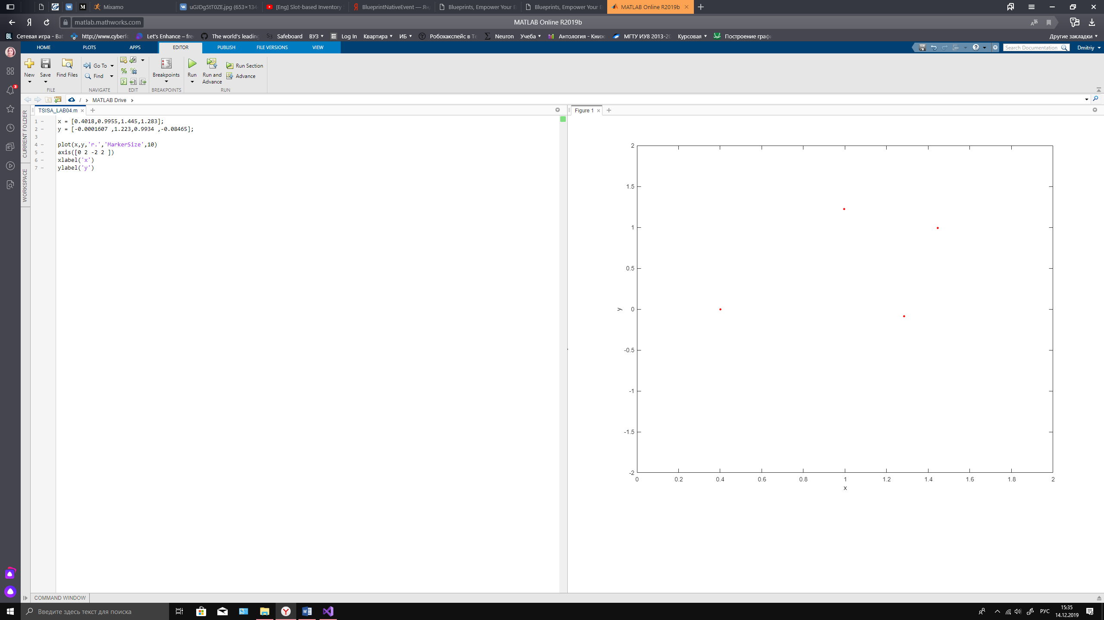

Рисунок – поколение 0

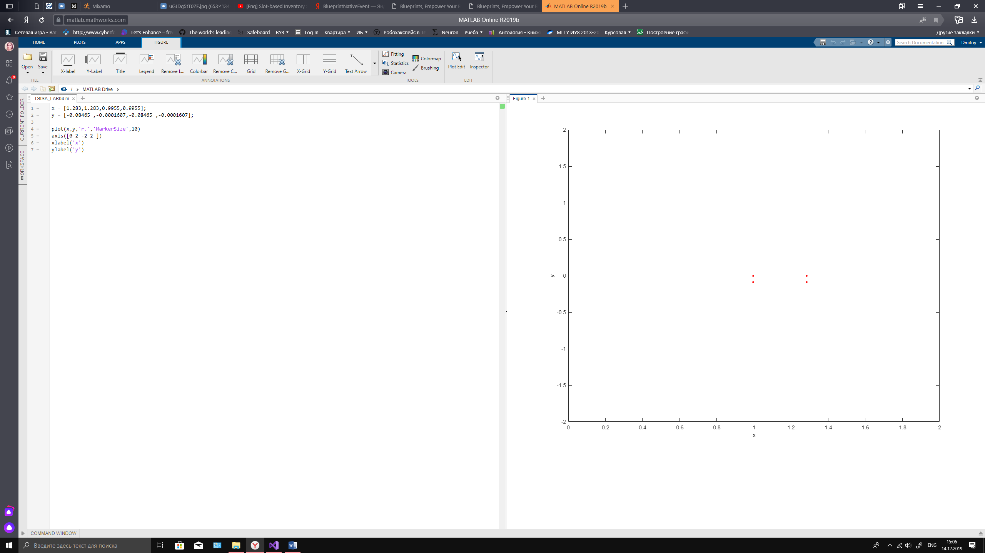

Рисунок – поколение 1

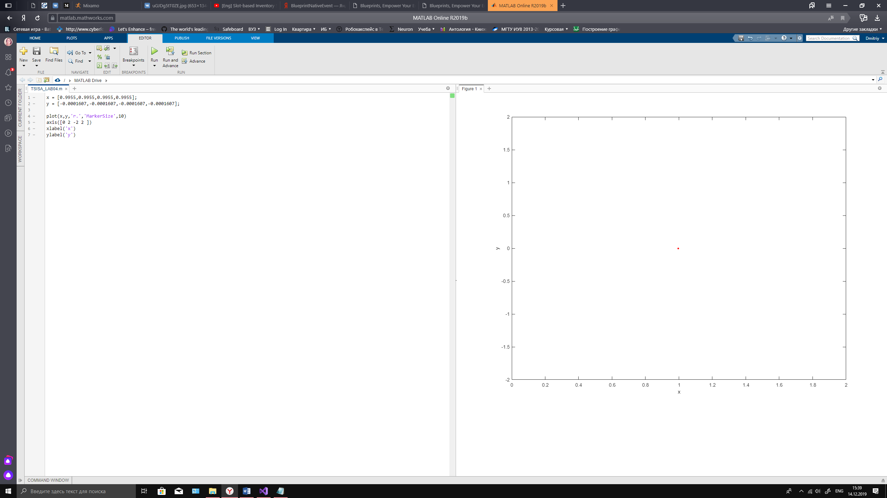

Рисунок - поколения 2-10

1. *Для 100 поколений*

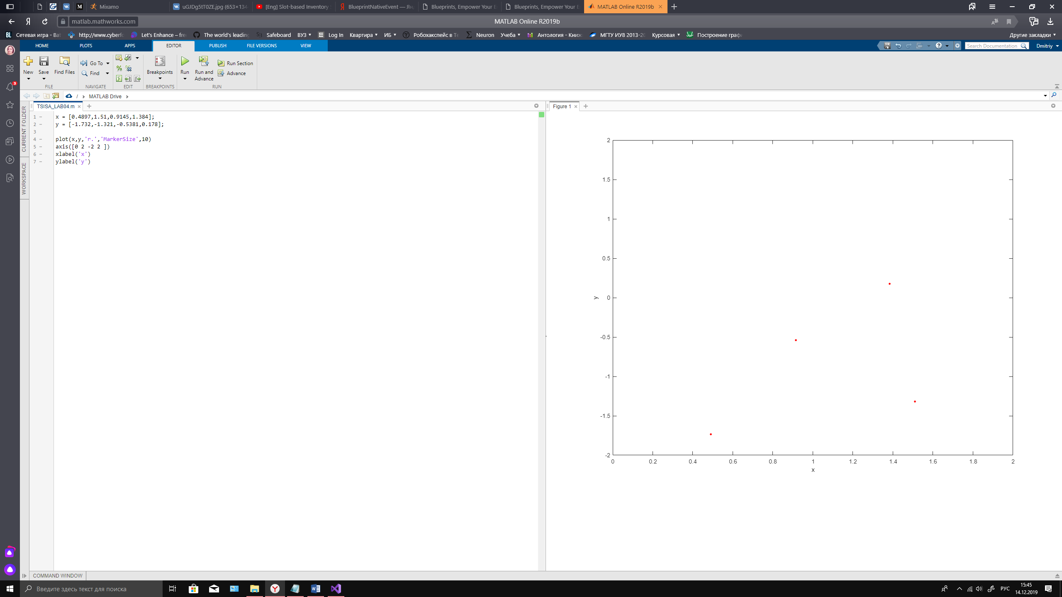

Рисунок – поколение №0

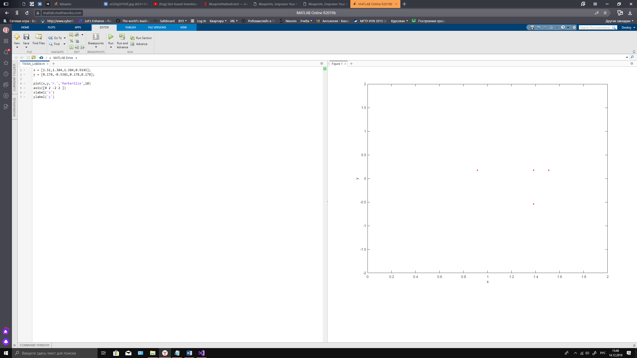

Рисунок - поколение №1

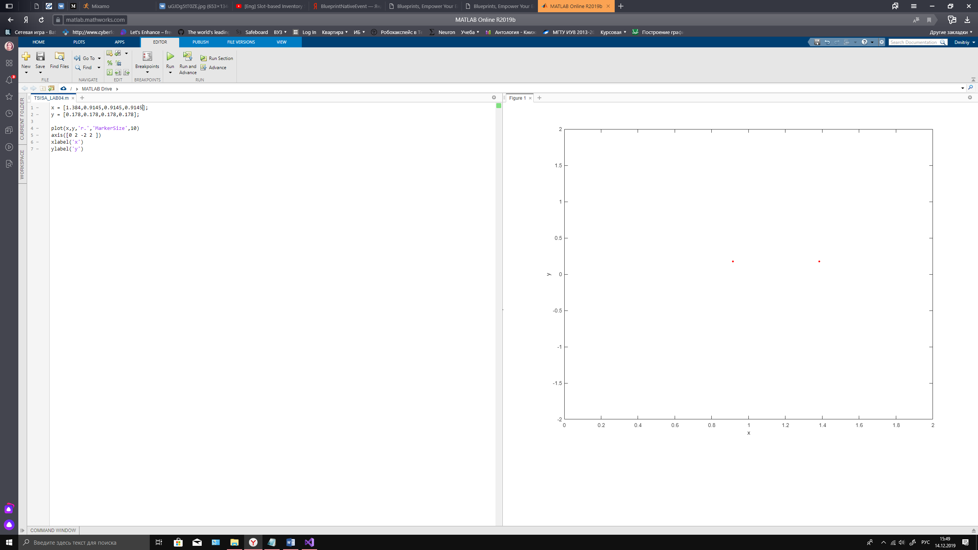

Рисунок - поколение №2

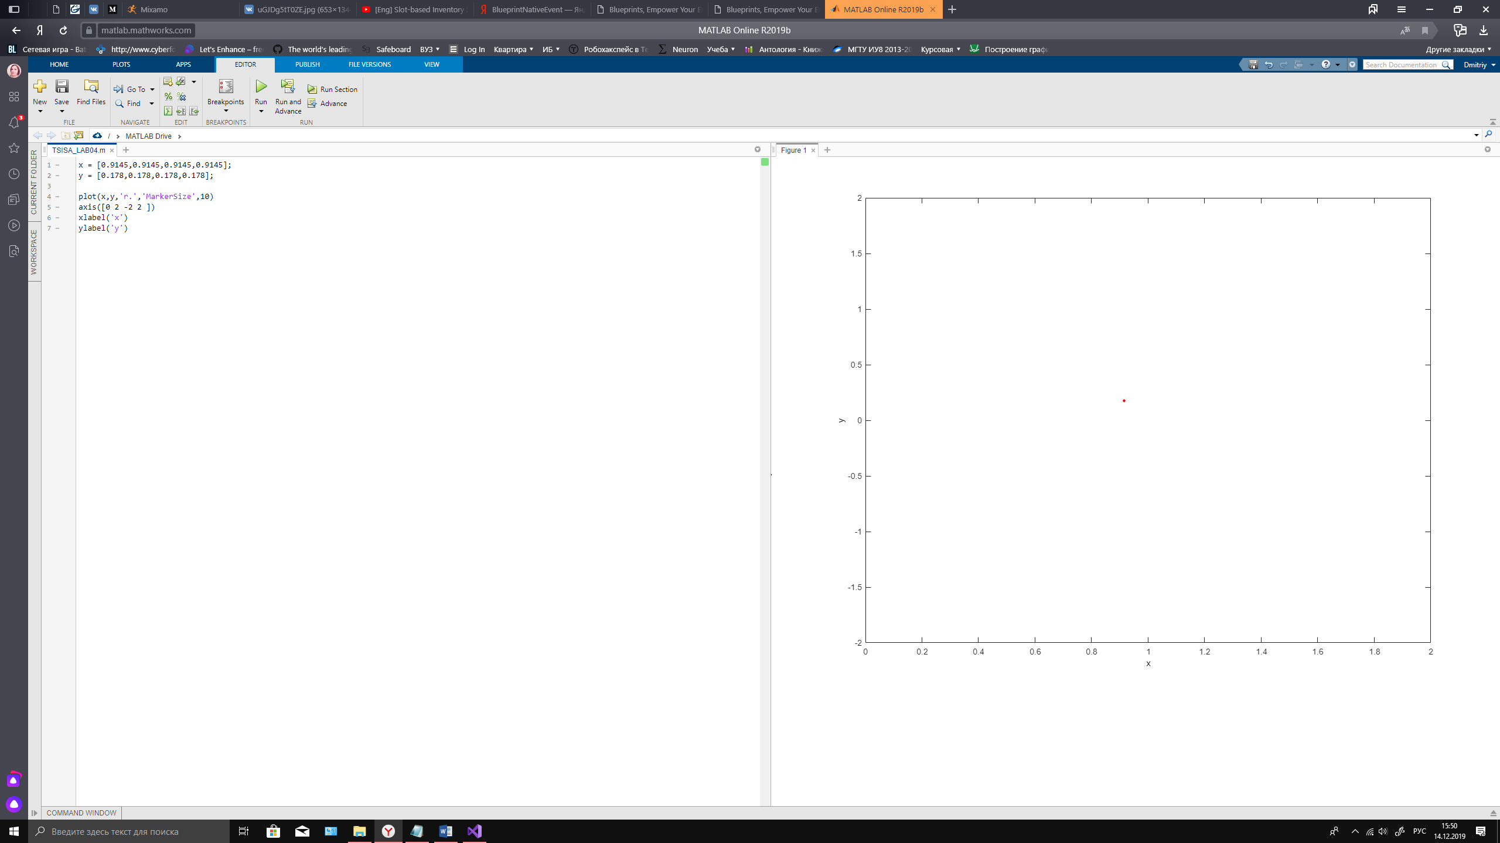

Рисунок поколения №3-11

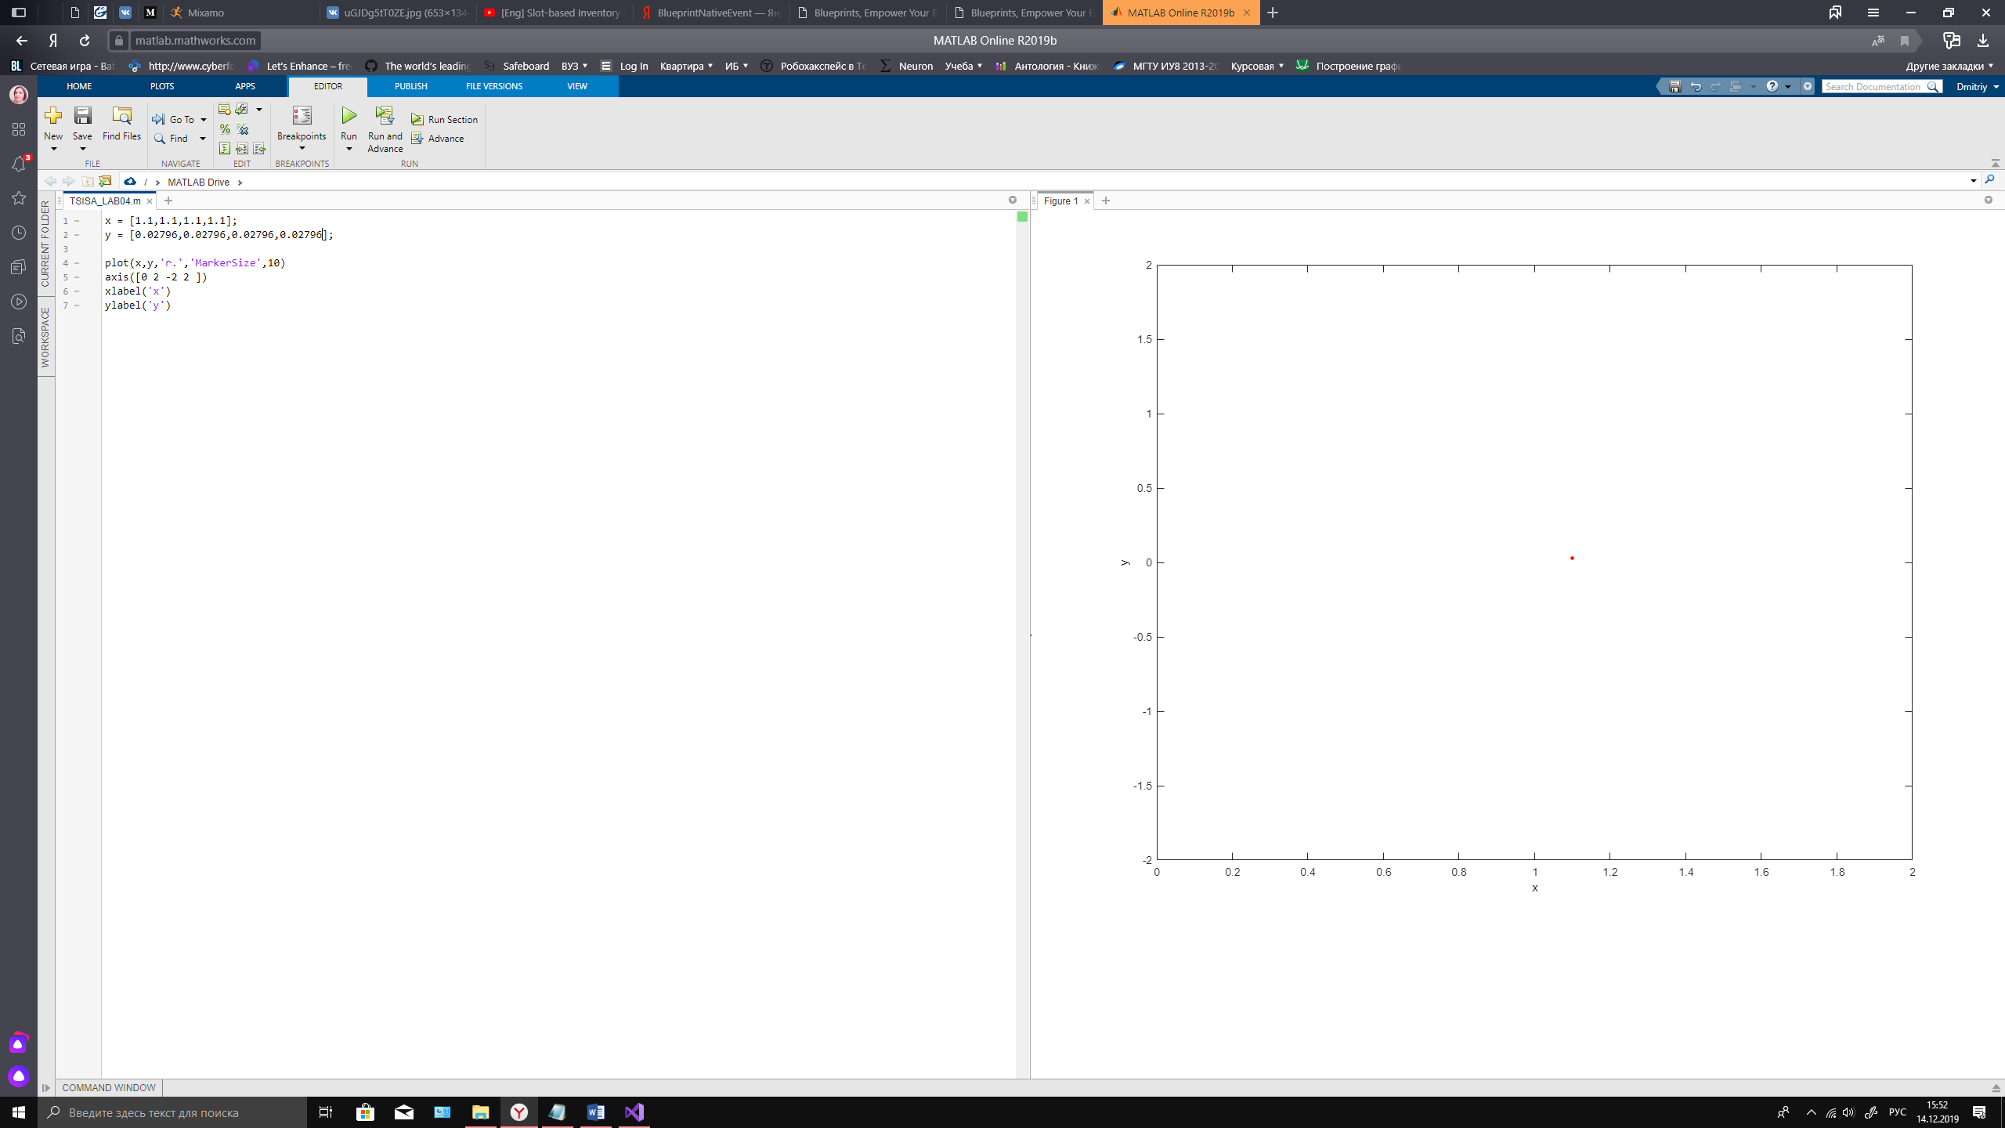

Рисунок - поколение №15

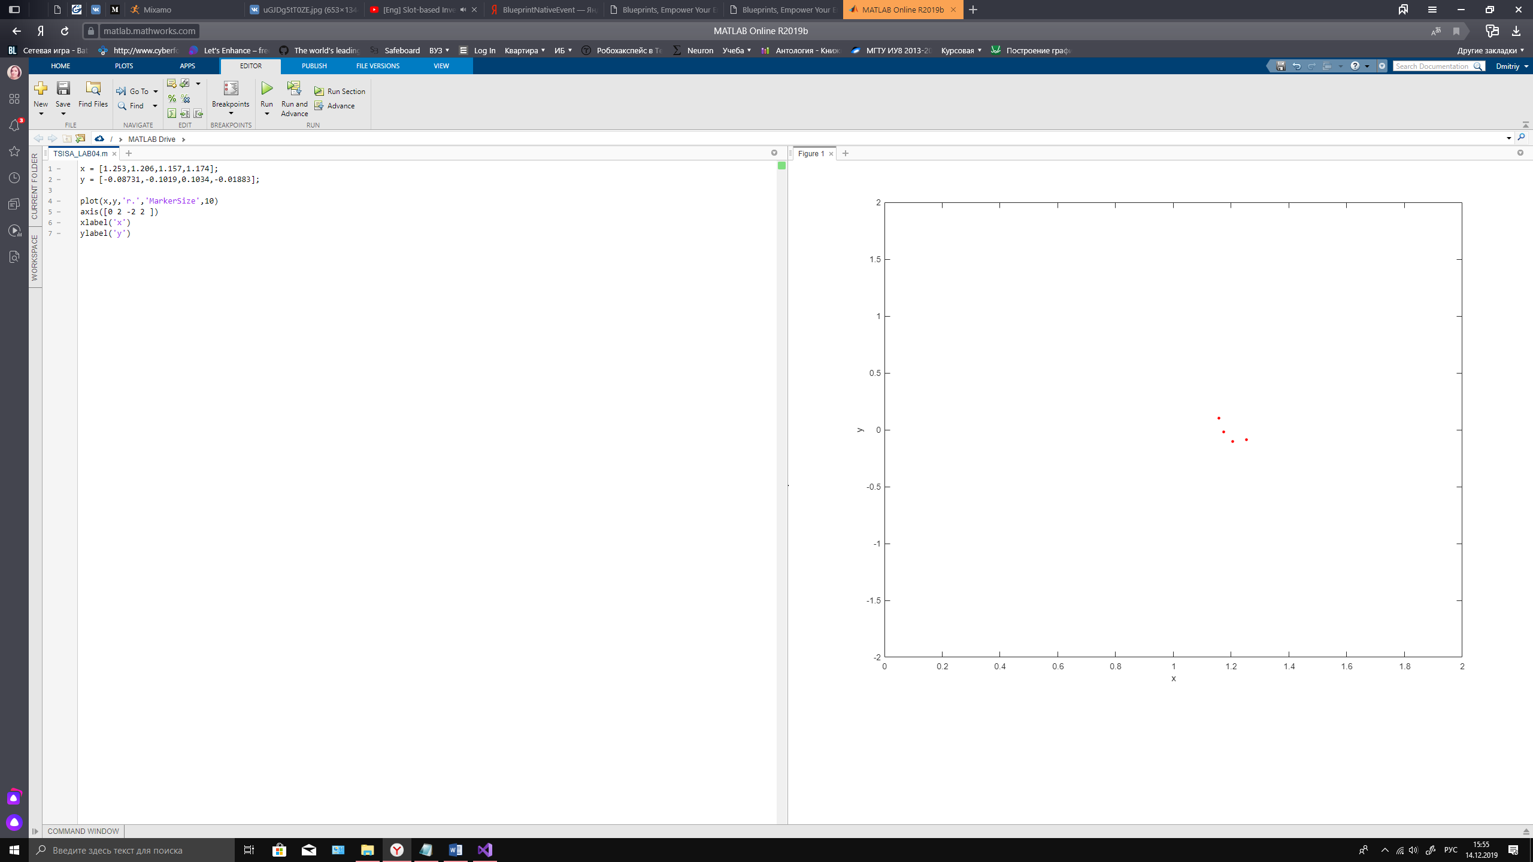

Рисунок - поколение №31

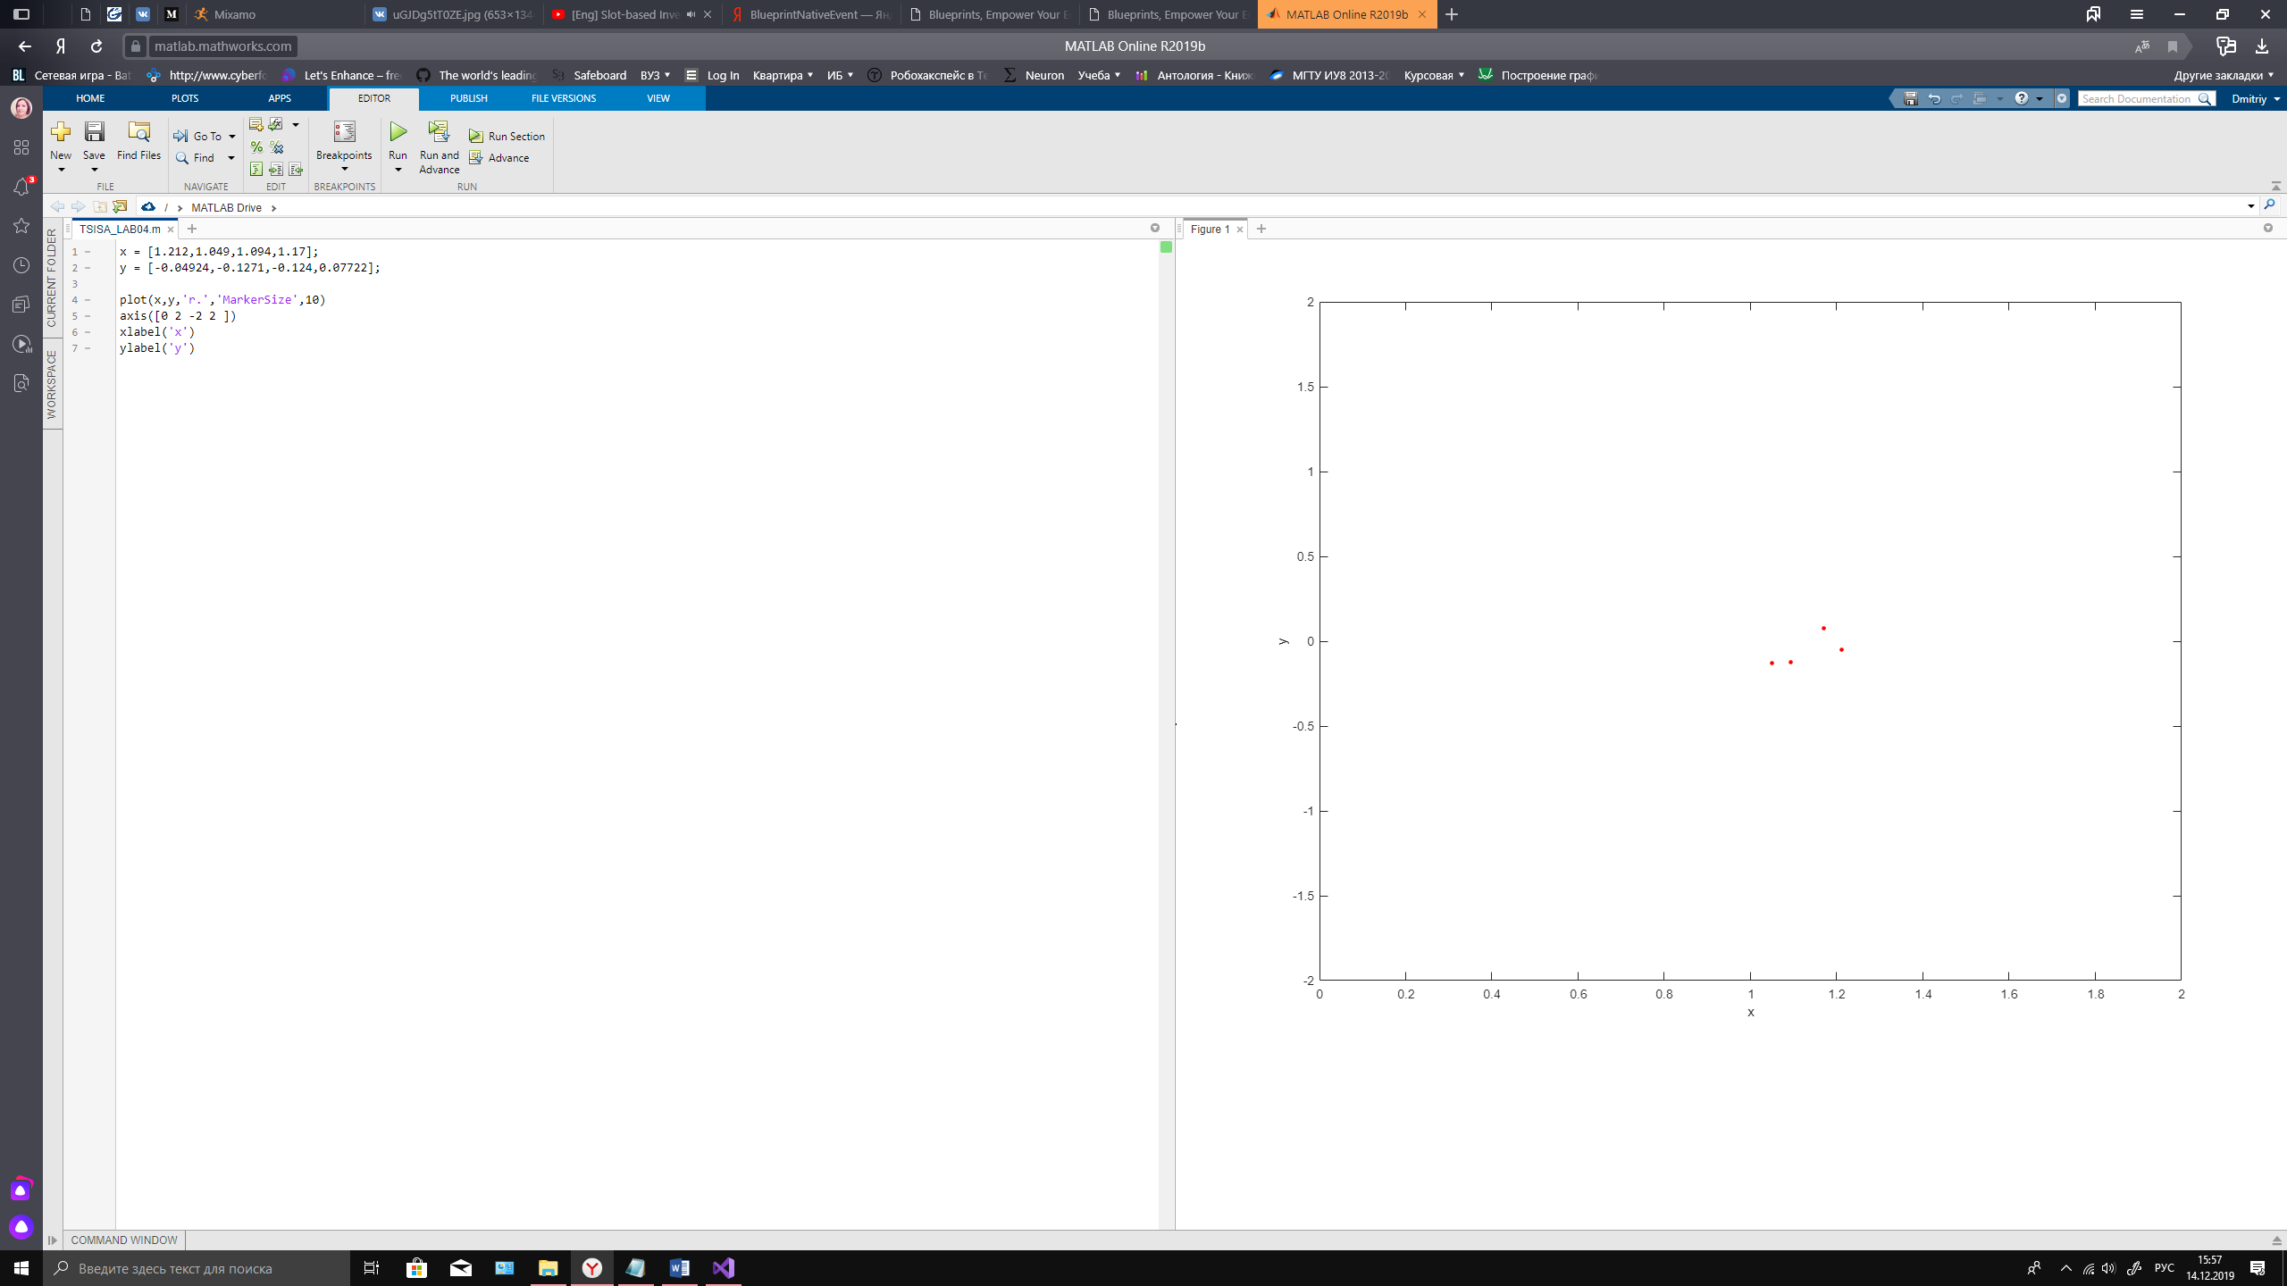

Рисунок - поколение №52

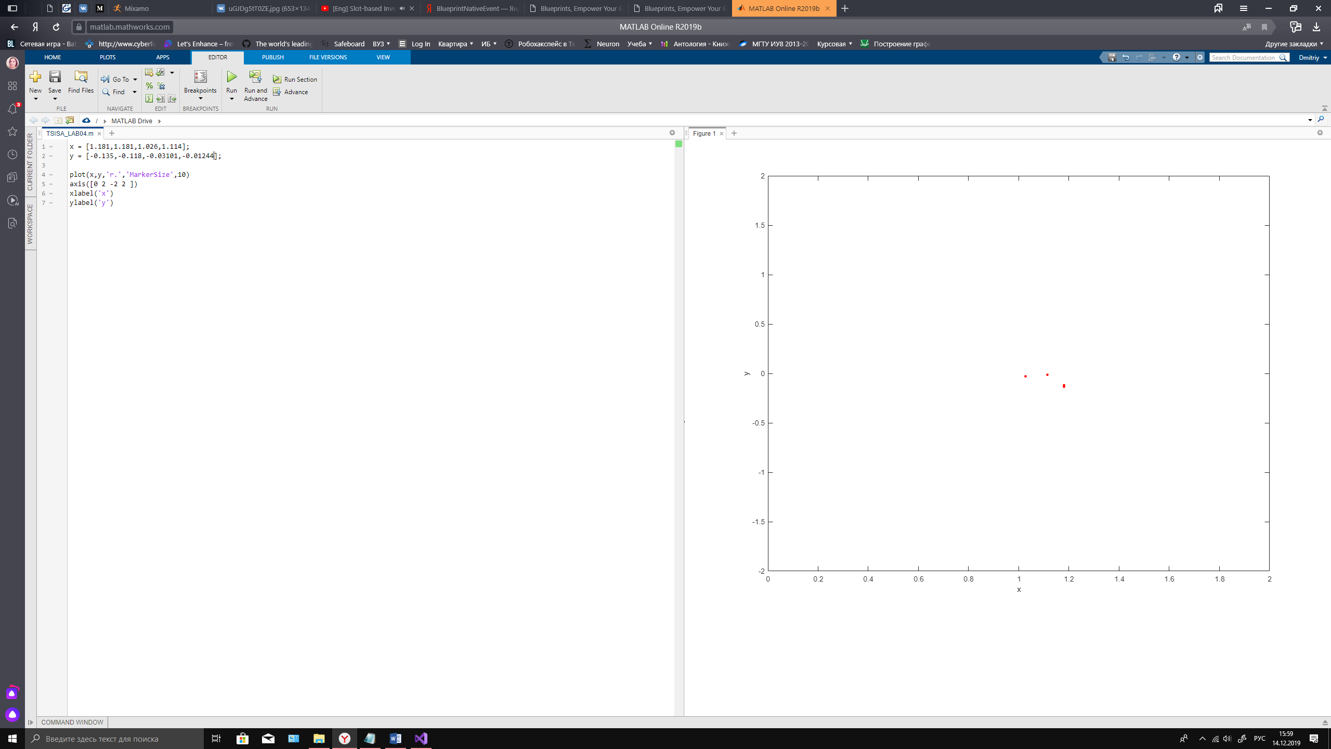

Рисунок - поколение №73

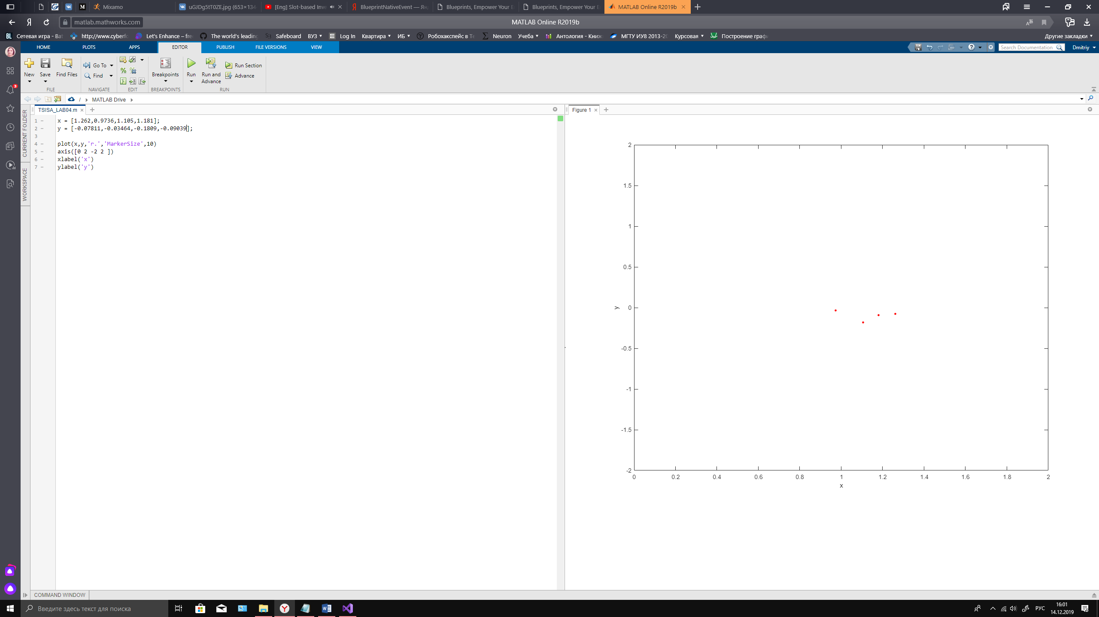

Рисунок - поколение №93

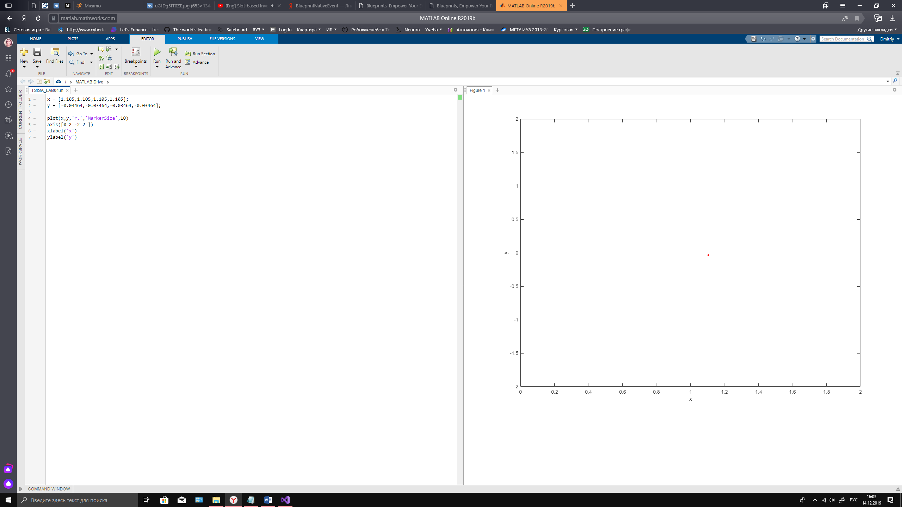

Рисунок - поколение №100

# Выводы

*В процессе выполнения рубежного контроля я изучил метод поиска экстремума функции с помощью генетического алгоритма. В ходе работы мною был использован алгоритм* *генерации промежуточной популяции, опирающийся на генетику, рулеточной селекции и мутации, в основе которой лежит случайное изменение генов. Значения полученные в ходе выполнения программы совпадают с графическими, что говорит о корректном ходе её работы.*

Приложение

Файл main.cpp

#include "GeneticAlg.h"

using namespace std;

int main()

{

std::cout<<"\t\t\t\t10 generations:\n\n";

GeneticAlgorithm A(10);

A.pass();

std::cout<<"\n\t\t\t\t100 generations:\n\n";

GeneticAlgorithm B(100);

B.pass();

system("pause");

return 0;

}

Файл GeneticAlg.h

#pragma once

#include <map>

#include <random>

#include <iostream>

#include <iomanip>

#include <string>

struct point

{

double x; // Координата x

double y; // Координата y

double z; // Координата z

point()

{

x = 0.0;

y = 0.0;

z = 0.0;

}

point(double xval,double yval,double zval = 0.0)

{

x = xval;y = yval;z=zval;

}

bool operator!=( point point\_2 )

{

if ((x != point\_2.x) && (y != point\_2.y))

{

return true;

}

return false;

}

bool operator==( point point\_2 )

{

if ((x == point\_2.x) && (y == point\_2.y))

{

return true;

}

return false;

}

};

struct borders

{

double a; // Нижняя граница

double b; // Верхняя граница

borders()

{

a = 0.0;

b = 0.0;

}

borders(double a2,double b2)

{

a=a2;

b=b2;

}

};

class GeneticAlgorithm

{

protected:

/\*\*

\* Область поиска для координат x и y

\*/

std::pair<borders,borders> border{{0.0,2.0},{-2.0,2.0}};

/\*\*

\* Родители

\*/

std::multimap<double,point> parents;

/\*\*

\* Промежуточная популяция

\*/

std::multimap<double,point> intermidiate\_generation;

/\*\*

\* Максимальное количество поколений

\*/

size\_t max\_generations;

public:

GeneticAlgorithm(size\_t generations = 100u,std::pair<borders,borders> input\_border = {{0.0,2.0},{-2.0,2.0}})

{

max\_generations = generations;

border = input\_border;

}

/\*\*

\* @brief Функция используется для полного прохождения генетического алгоритма

\*

\*/

void pass();

/\*\*

\* @brief Функция используется для создания 0 генерации

\*

\* @param[in] count\_of\_parents Количество родителей

\*

\*/

void init\_gen(size\_t count\_of\_parents = 4u);

/\*\*

\* @brief Функция, описывающая селекцию

\*

\*/

void selection();

/\*\*

\* @brief Функция, описывающая мутацию

\*

\*/

void mutation();

/\*\*

\* @brief Функция, описывающая селекцию

\*

\*/

void reduction();

/\*\*

\* @brief Функция для печати multimap

\*

\* @param[in] multimap Контейнер std::multimap<double,point>

\* @param[in] prefix Префикс перед строкой

\* @param[in] up\_border Рисует границу сверху и снизу, если значение true

\*

\*/

void print(size\_t genereation, std::multimap<double,point> multimap, std::string prefix = "", bool border = true);

};

Файл GeneticAlg.cpp

#include"GeneticAlg.h"

#include "Function.h"

#include <iterator>

#include <algorithm>

std::random\_device rd;

std::mt19937 gen(rd());

void draw\_hat()

{

std::cout<<std::left<<std::setprecision(4)<<"|"<<std::setw(9)<<"genereation"<<"|"<<std::setw(6)<<"prefix"<<" | "<<std::setw(10)<<"X"<<" | "<<std::setw(10)<<"Y"<<" | "<<std::setw(10)<<"FIT"<<" |"<<std::setw(10)<<"max element"<<" | "<<std::setw(9)<<"average"<<" |\n";

}

void GeneticAlgorithm::init\_gen(size\_t count\_of\_parents)

{

std::uniform\_real\_distribution<double> x\_border (border.first.a,border.first.b);

std::uniform\_real\_distribution<double> y\_border (border.second.a,border.second.b);

parents.clear();

point temp\_point;

for (size\_t count = 0u;count < count\_of\_parents;++count)

{

temp\_point.x = x\_border(gen);

temp\_point.y = y\_border(gen);

temp\_point.z = F(temp\_point.x,temp\_point.y);

parents.insert({temp\_point.z,temp\_point});

}

}

void GeneticAlgorithm::selection()

{

intermidiate\_generation.clear();

point temp\_point;

for(auto index = parents.begin();index != parents.end();++index)

{

/\*

Так как потомок может иметь что-то от каждого из радителей, то я сделал следующее:

у 2 родителей могут быть 2 потомка с координитами (x1,y2,f(x1,y2)) и (x2,y1,f(x2,y1)),

где (x1,y1) - координаты 1 родителя, (x2,y2) - координаты 2 родителя.

\*/

for(auto index\_2 = std::next(index);index\_2 != parents.end();++index\_2)

{

// 1)

temp\_point.x = index->second.x;

temp\_point.y = index\_2->second.y;

temp\_point.z = F(temp\_point.x,temp\_point.y);

intermidiate\_generation.insert({temp\_point.z,temp\_point});

// 2)

temp\_point.x = index\_2->second.x;

temp\_point.y = index->second.y;

temp\_point.z = F(temp\_point.x,temp\_point.y);

intermidiate\_generation.insert({temp\_point.z,temp\_point});

}

}

}

void GeneticAlgorithm::reduction()

{

for (auto temp : intermidiate\_generation)

{

parents.insert(temp);

}

intermidiate\_generation.clear();

size\_t temp = parents.size() - 4;

for (size\_t index = 0u;index < temp;++index)

{

parents.erase(parents.begin());

}

std::cout<<"";

}

void GeneticAlgorithm::mutation()

{

/\*

Заметка:

Мутация в данной реализации генного алгоритма выглядит следующим образом:

берется координата точки x и рандомно сдвигается и также с y координатой.

\*/

std::uniform\_real\_distribution<double> delta(-0.3,0.3);

std::multimap<double, point> temp\_multimap;

for (auto parent = parents.begin();parent != parents.end();++parent)

{

parent->second.x += delta(gen);

parent->second.y += delta(gen);

if (parent->second.x < border.first.a)

{

parent->second.x = border.first.a;

}

else if (parent->second.x > border.first.b)

{

parent->second.x = border.first.b;

}

if (parent->second.y < border.second.a)

{

parent->second.y = border.second.a;

}

else if (parent->second.y > border.second.b)

{

parent->second.y = border.second.b;

}

parent->second.z = F(parent->second.x,parent->second.y);

temp\_multimap.insert({parent->second.z,parent->second});

}

parents = temp\_multimap;

temp\_multimap.clear();

for (auto child = intermidiate\_generation.begin();child != intermidiate\_generation.end();++child)

{

child->second.x += delta(gen);

child->second.y += delta(gen);

if (child->second.x < border.first.a)

{

child->second.x = border.first.a;

}

else if (child->second.x > border.first.b)

{

child->second.x = border.first.b;

}

if (child->second.y < border.second.a)

{

child->second.y = border.second.a;

}

else if (child->second.y > border.second.b)

{

child->second.y = border.second.b;

}

child->second.z = F(child->second.x,child->second.y);

temp\_multimap.insert({child->second.z,child->second});

}

intermidiate\_generation = temp\_multimap;

temp\_multimap.clear();

}

void GeneticAlgorithm::pass()

{

double P = 0.0;

std::uniform\_real\_distribution<double> Probability(0.0,0.1);

draw\_hat();

init\_gen();

print(0u,parents,"p");

selection();

reduction();

std::cout<<"\n";

for (size\_t iteration = 1u;iteration <= max\_generations - 1u ;++iteration)

{

P += Probability(gen);

// std::cout<<P<<"\n"; // Debug

selection();

if (P > 0.5)

{

mutation();

P = 0.0;

}

print(iteration, parents,"p");

print(iteration, intermidiate\_generation, "ig",true);

reduction();

std::cout<<"\n";

}

print(max\_generations,parents,"result");

}

void GeneticAlgorithm::print(size\_t genereation,std::multimap<double,point> multimap, std::string prefix,bool border)

{

if (border)

{

std::cout<<" ";

for (int index = 1;index < 85;++index)

{

std::cout<<"-";

}

std::cout<<"\n";

}

double average = 0.0;

for (auto tochka: multimap)

{

average +=tochka.second.z;

}

average=average/multimap.size();

auto max\_element = std::max\_element(multimap.begin(),multimap.end(),

[](std::pair<double,point> var1,std::pair<double,point> var2)

{

return var1.first < var2.first;

}

);

for (auto tochka = multimap.begin();tochka != multimap.end();++tochka)

{

std::cout<<std::left<<std::setprecision(4)<<"| "<<std::setw(9)<<genereation<<"|"<<std::setw(6)<<' '+prefix<<" | "<<std::setw(10)<<tochka->second.x<<" | "<<std::setw(10)<<tochka->second.y<<" | "<<std::setw(10)<<tochka->second.z;

if (tochka == std::prev(multimap.end()))

{

std::cout<<" | "<<std::setw(10)<<max\_element->first<<" | "<<std::setw(10)<<average<<" |";

}

else

{

std::cout<<" | "<<std::setw(10)<<" "<<" | "<<std::setw(10)<<" "<<" |";

}

std::cout<<"\n";

}

if (border)

{

std::cout<<" ";

for (int index = 1;index < 85;++index)

{

std::cout<<"-";

}

std::cout<<"\n";

}

}