Alpha ID Inbox API – Integration Guide for PILA
Partner Integration Guide · Alpha ID Inbox API · Version 1.1 · Nov 9, 2026 · @Darth

1. Overview
The Alpha ID Inbox API is Bank Alpha ID's receiving API on the TOTM side. PILA sends files, such as signed VCs, with POST /pila/send. Each file lands in the Alpha ID inbox, where Bank Alpha ID picks it up.
Item | Value
Base URL | https://totmregistryapis-production.up.railway.app/api/v1
Authentication | X-Api-Key header (your partner API key from registration)
Your call | POST /pila/send
Upload format | Raw file bytes in the request body; the file's type in Content-Type
Response | JSON, same envelope as the other TOTM Trust API calls

2. What you need
You need only the API key you received at registration. There is no separate sign-up for the Inbox. Check that the key works with GET /partners/me (main guide, section 5.4).
Rule | Value
File types | application/json, application/pdf, image/png, image/jpeg
Content check | The bytes must match the type (a real PDF, valid JSON, a real PNG or JPEG)
Maximum size | 4 MB per file
Kept for | 30 days from sending, then removed automatically
File name | Required; letters, digits, dot, dash, underscore and space (others become _)
Delete | Done by TOTM only

3. How it works
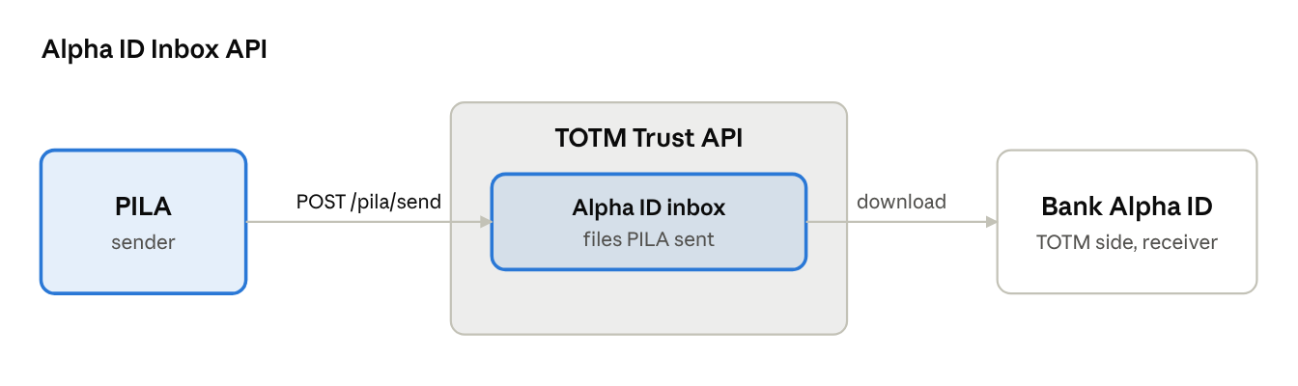
Alpha ID Inbox API · PILA to Bank Alpha ID
PILA sends with POST /pila/send. The file waits in the Alpha ID inbox until Bank Alpha ID downloads it.

4. API reference
The path is relative to the base URL and needs X-Api-Key.
Method | Path | Purpose
POST | /pila/send | Send a file to Bank Alpha ID; it lands in the Alpha ID inbox

5. Sending a file: POST /pila/send
The request body is the file itself, not JSON. Set Content-Type to the file's type. Everything else goes in the query string.
Query parameter | Required | Description
fileName | Yes | Name the receiver sees, e.g. LC-2026-10-0471.json
txId | No | Tx ID the file belongs to, e.g. TX-20261028-000001 (3–40 letters, digits or dashes)
vcId | No | VC ID the file relates to, e.g. urn:uuid:… (up to 300 characters)
note | No | Short message for the receiver (up to 500 characters)
POST /api/v1/pila/send?fileName=LC-2026-10-0471.json&vcId=urn:uuid:01a18492-3375-7665-bd7d-1a7fd8884ef3
X-Api-Key: tta_…
Content-Type: application/json
<the file's bytes>
With curl: curl -X POST "$BASE/pila/send?fileName=elc.json" -H "X-Api-Key: $KEY" -H "Content-Type: application/json" --data-binary @elc.json
Response (201):
{
"code": "E00", "message": "Success",
"data": {
"fileId": "e6b14805-507e-4ec1-ac7f-a4d4b4d8afcc",
"from": "pila", "to": "totm",
"fileName": "LC-2026-10-0471.json",
"contentType": "application/json",
"size": 12934,
"sha256": "db77bf3c15bdc69d0f48d8314eaff63b0ba2237368d16aeaeb4f7edc4cb30db3",
"txId": null,
"vcId": "urn:uuid:01a18492-3375-7665-bd7d-1a7fd8884ef3",
"note": null,
"sentBy": "PILA",
"requestId": "2f7160cb-2cf5-4895-be75-4840658d9c39",
"sentAt": "2026-11-09T11:04:26.586Z",
"readAt": null, "readBy": null,
"expiresAt": "2026-12-09T11:04:26.586Z"
}
}
Keep the fileId as your reference; quote it when you contact TOTM about the file. sha256 is the hash of the bytes stored in the Alpha ID inbox.

6. Sending a signed VC to Bank Alpha ID
- Call POST /pila/send with the VC file, Content-Type: application/json, a fileName, and the txId / vcId it belongs to.
- Check for 201 and "code": "E00".
- Store the returned fileId and sha256 with your own record.
Always set txId and vcId when the file belongs to an eLC, so Bank Alpha ID can match it to the transaction without opening it.

7. Errors, security and support
Errors use the usual envelope {"code": "…", "error": "…"}.
HTTP | Code | Meaning
400 | E400 | Missing fileName, empty body, type not allowed, or content does not match Content-Type
401 | E15 | Missing or invalid X-Api-Key
404 | E404 | No such endpoint (check the path)
413 | E400 | File larger than 4 MB
503 | E503 | Inbox storage is not available on the TOTM side; try again later
500 | E500 | Error on the TOTM side; treat the send as not done and retry
Security
- Call from your backend only, never from a browser or mobile app, and keep the API key in a secret manager.
- Files are stored in private storage with no public link; only TOTM can open them.
- TOTM logs every call with your partner name, request ID, file ID, size and hash. File names and file content are never logged.
Support: TOTM Technologies Group, harshit@totmtechnologies.com. When reporting a problem, include the X-Request-Id of the call, the fileId and the time (UTC).

8. Request to PILA and optional shared APIs
Request: please share the API and documentation for Bank Beta VN's receiving endpoint, so that TOTM / Bank Alpha ID can send signed eLCs (VCs) to it.
If PILA has no receiving API yet: TOTM can offer a common inbox API. If PILA already has one, please ignore this part.
We built the inbox with two sets of paths, one for TOTM and one for PILA. Sending and receiving files is not part of the project scope; these are helper APIs that can be used if required.
Item | Current setup
Storage | Vercel Blob (private store)
Access | Partner API key or admin key; at this stage either key can reach any inbox
Receiving endpoints | One for each portal (PILA and TOTM)
Fetching files | List and download received files, for each portal
Acknowledgement | Mark a received file as read (optional)
Please let us know if you need these. If yes, we will share the full documentation and APIs. If not, TOTM will remove the extra APIs and keep only the Alpha ID receiving endpoint (this guide) and the API the Bank Alpha ID portal uses to fetch the files it receives.

