TOTM Trust API – Inbox Guide for PILA
Partner Integration Guide · Inbox · Version 1.0 · Nov 9, 2026 · @Darth

1. Overview
The Inbox lets PILA send files, such as signed VCs, to TOTM through the TOTM Trust API. PILA sends with POST /pila/send, and the file lands in TOTM's inbox. Once TOTM has read it, PILA sees the read time with GET /pila/sent.
Item | Value
Base URL | https://totmregistryapis-production.up.railway.app/api/v1
Authentication | X-Api-Key header (your partner API key from registration)
Your calls | POST /pila/send, GET /pila/sent
Upload format | Raw file bytes in the request body; the file's type in Content-Type
Other responses | JSON, same envelope as the other TOTM Trust API calls

2. What you need
You need only the API key you received at registration. There is no separate sign-up for the Inbox. Check that the key works with GET /partners/me (main guide, section 5.4).
Rule | Value
File types | application/json, application/pdf, image/png, image/jpeg
Content check | The bytes must match the type (a real PDF, valid JSON, a real PNG or JPEG)
Maximum size | 4 MB per file
Kept for | 30 days from sending, then removed automatically
File name | Required; letters, digits, dot, dash, underscore and space (others become _)
Delete | Done by TOTM only

3. How it works
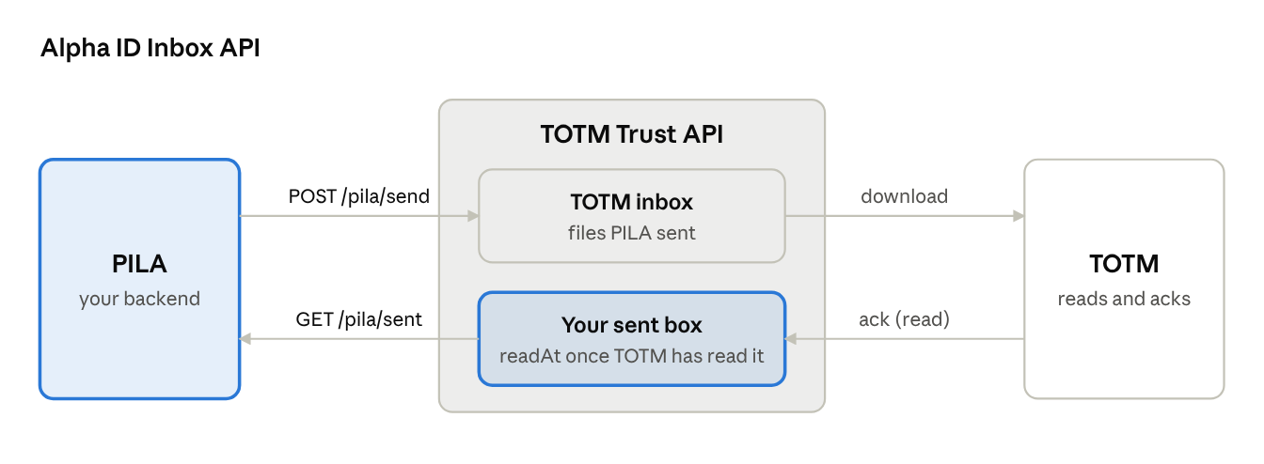
Inbox flow · PILA to TOTM
PILA sends with POST /pila/send. TOTM downloads the file and marks it as read; PILA sees that as readAt in GET /pila/sent.

4. API reference
Both paths are relative to the base URL, and both need X-Api-Key.
Method | Path | Purpose
POST | /pila/send | Send a file to TOTM; it lands in TOTM's inbox
GET | /pila/sent | List files you have sent, with readAt once TOTM has read them

5. Calls in detail

5.1 Send a file to TOTM: POST /pila/send
The request body is the file itself, not JSON. Set Content-Type to the file's type. Everything else goes in the query string.
Query parameter | Required | Description
fileName | Yes | Name the receiver sees, e.g. LC-2026-10-0471.json
txId | No | Tx ID the file belongs to, e.g. TX-20261028-000001 (3–40 letters, digits or dashes)
vcId | No | VC ID the file relates to, e.g. urn:uuid:… (up to 300 characters)
note | No | Short message for the receiver (up to 500 characters)
POST /api/v1/pila/send?fileName=LC-2026-10-0471.json&vcId=urn:uuid:01a18492-3375-7665-bd7d-1a7fd8884ef3
X-Api-Key: tta_…
Content-Type: application/json
<the file's bytes>
With curl: curl -X POST "$BASE/pila/send?fileName=elc.json" -H "X-Api-Key: $KEY" -H "Content-Type: application/json" --data-binary @elc.json
Response (201):
{
"code": "E00", "message": "Success",
"data": {
"fileId": "e6b14805-507e-4ec1-ac7f-a4d4b4d8afcc",
"from": "pila", "to": "totm",
"fileName": "LC-2026-10-0471.json",
"contentType": "application/json",
"size": 12934,
"sha256": "db77bf3c15bdc69d0f48d8314eaff63b0ba2237368d16aeaeb4f7edc4cb30db3",
"txId": null,
"vcId": "urn:uuid:01a18492-3375-7665-bd7d-1a7fd8884ef3",
"note": null,
"sentBy": "PILA",
"requestId": "2f7160cb-2cf5-4895-be75-4840658d9c39",
"sentAt": "2026-11-09T11:04:26.586Z",
"readAt": null, "readBy": null,
"expiresAt": "2026-12-09T11:04:26.586Z"
}
}
Keep the fileId; it identifies the file in every later call. sha256 is the hash of the bytes TOTM stored.

5.2 Check delivery: GET /pila/sent
Lists the files you have sent, newest first: up to 50, or set ?limit= (1–100). Each entry has the same fields as the send response. readAt is null until TOTM has read the file, then shows when.
{
"code": "E00", "message": "Success",
"data": { "side": "pila", "box": "sent", "count": 1,
"files": [ { "fileId": "…", "from": "pila", "to": "totm", "fileName": "…", "readAt": "2026-11-09T11:23:34.781Z", "…": "…" } ] }
}

6. Sending a signed VC to TOTM
- Call POST /pila/send with the VC file, Content-Type: application/json, a fileName, and the txId / vcId it belongs to.
- Store the returned fileId and sha256 with your own record.
- Check GET /pila/sent later; readAt shows when TOTM has read it.
Always set txId and vcId when the file belongs to an eLC, so TOTM can match it to the transaction without opening it.

7. Errors, security and support
Errors use the usual envelope {"code": "…", "error": "…"}.
HTTP | Code | Meaning
400 | E400 | Missing fileName, empty body, type not allowed, or content does not match Content-Type
401 | E15 | Missing or invalid X-Api-Key
404 | E404 | No such endpoint (check the path)
413 | E400 | File larger than 4 MB
503 | E503 | Inbox storage is not available on the TOTM side; try again later
500 | E500 | Error on the TOTM side; treat the send as not done and retry
Security
- Call from your backend only, never from a browser or mobile app, and keep the API key in a secret manager.
- Files are stored in private storage with no public link; only TOTM can open them.
- TOTM logs every call with your partner name, request ID, file ID, size and hash. File names and file content are never logged.
Support: TOTM Technologies Group, harshit@totmtechnologies.com. When reporting a problem, include the X-Request-Id of the call, the fileId and the time (UTC).

