**CHAPTER 1**

**INTRODUCTION**

**A. COMPANY PROFILE**

***PAMANTASAN NG LUNGSOD NG MAYNILA***

On 19 June 1965, the final bill entitled "An Act Authorizing the City of Manila to Establish and Operate the University of the City of Manila and for Other Purposes" was signed into law by President Diosdado P. Macapacal in a signing ceremony in Malacañang Palace witnessed by Atty. Primitivo de Leon, Mayor Villegas, Congressman Ramon Mitra Jr., and its main sponsor in the House of Representatives, Congressman Albert. The law was captioned as Republic Act No. 4196 which now serves as the University Charter.

On February 5, 1970, then Executive Secretary Ernesto M. Maceda, by authority of then President Ferdinand Marcos, conveyed unto the City of Manila two (2) parcels of land owned by the Republic of the Philippines. Said real properties consist the area where PLM stands today. And as solemnly endeared and inscribed by every PLM member to his heart, the University formally opened the University College on Monday, 17 July 1967 with an initial enrollment of 556 outstanding and bright scholars carefully selected from the upper 10% of the various public high schools in Manila. Indeed, excellence has been a "birthright" of PLM. The PLM also established the Graduate College a year later, followed by the Institute for Extra-Mural Studies. And the rest was history in the making.

**B. WHAT IS THE SYSTEM ALL ABOUT**

This system is about the process of Supply and Inventory of PFMO (Physical Facilities Management Office) of Pamantasan ng Lungsod ng Maynila. From the manual listing and monitoring, to borrowing, returning, recording and issuance of different materials. Supplies under this system are the Procurement Supplies and Special Project Supplies. Under Procurement supplies, categories are given such as Electronic supplies, Electronics and Communication Supplies, Electro-Mechanical Supplies, Hardware Supplies, Janitorial Supplies, Painting and Varnishing Supplies and Plumbing Supplies. This is where quarterly supplies of different departments are issued and submitted to Management for evaluation, review and approval.

Upon receipt of the approved budget, PFMO initiates corresponding request and all approved Request for Purchase of Materials are finally forwarded to the Procurement Office for appropriate action. All accepted request for procurement materials/supplies, are then delivered and stored on the stock room. Recording, issuance and control of procurement supplies are done using Materials Daily Issuance Record Sheet (MDIRS). On Special Project Supplies, these are the supplies needed for repairs and renovations for the improvement of the University. All request for the required supplies of their project, are then confirmed for approval and evaluation before delivering the needed materials to the stockroom. The recording, issuance and control of these materials are done the same way as the Procurement Supplies. Inventory for the supplies are done manually with ledgers, log book and stock cards.

**C. STATEMENT OF THE PROBLEM**

**Problem 1:** Slow and Tedious process of borrowing and returning of items and equipment.

**Problem 2:** No existing process of tracking of special project supplies.

**Problem 3:** Management receives no real time update from the custodians for each tools, equipment and supplies issued or returned.

**D. OBJECTIVES**

**GENERAL OBJECTIVES**

The main objectives of the study are to apply the principle and concepts to provide a solution to the existing problems of the company and provide an automated management system for the Pamantasan ng Lungsod ng Maynila, Physical Facilities and Management Office Inventory and Supplies Management and Tracking Section.

**SPECIFIC OBJECTIVES**

The specific objectives of the study based on the problems stated:

* 1. To immediately check tools and equipment quantity in the inventory.
  2. To directly track and monitor outgoing equipment, tools and supplies.
  3. To update the Chief PFMO of received and issued equipment, tools and supplies from the three property sections (Special Projects, Quarterly Supplies, Equipment and Tools).

**E. SCOPE AND LIMITATIONS**

This study is about the current Supply and Inventory System of PDSPO in Pamantasan ng Lungsod ng Maynila. The school has an existing manual system of monitoring and listing of supplies. The focus of this is only on the supply and inventory system of the school and all other processes that are not covered and irrelevant to the system is out of our scope and out of our bounds to be discussed.

**CHAPTER 2**

**SYSTEM ANALYSIS**

**A.DATA DICTIONARY**

**DATA DICTIONARY** - A data dictionary is a collection of descriptions of the data objects or items in a data model for the benefit of programmers and others who need to refer to them. A first step in analyzing a system of objects with which users interact is to identify each object and its relationship to other objects.

**Data Dictionary**

TBL_Custodian

|  |  |  |  |
| --- | --- | --- | --- |
| **Field Data** | **Field Type** | **Length** | **Description** |
| Custodian_Username | Alphanumeric | 15 | Log-in username |
| Custodian_Full name | Alphabet | 40 | Fullname of user |
| Custodian_Password | Alphanumeric | 15 | Log-in password |
| Custodian_Code | Alphanumeric | 15 | Custodian ID |
| Department_Code | Alphanumeric | 15 | Departement ID |

TBL_Department

|  |  |  |  |
| --- | --- | --- | --- |
| **Field Data** | **Field Type** | **Length** | **Description** |
| Department_Code | Alphanumeric | 15 | Department ID |
| Department_Name | Alphabet | 15 | Department name |

TBL_Category

|  |  |  |  |
| --- | --- | --- | --- |
| **Field Data** | **Field Type** | **Length** | **Description** |
| Category_Code | Alphanumeric | 15 | Category ID |
| Category_Name | Alphabet | 15 | Category Name |
| Depatment_Code | Alphanumeric | 15 | Department ID |

TBL_Item

|  |  |  |  |
| --- | --- | --- | --- |
| **Field Data** | **Field Type** | **Length** | **Description** |
| Item_Code | Alphanumeric | 15 | Item ID |
| Item_Name | Alphabet | 20 | Name of the item |
| Item_Desc | Numeric | 20 | Description/Name of the item |
| Target_Code | Alphanumeric | 15 | Target ID |
| Category_Code | Alphanumeric | 15 | Category ID |
| Date_Created | Numeric | 15 | Input Date of the item |
| Expiry_Date | Numeric | 15 | Expiry date of the item |
| Reorder_Point | Numeric | 15 | Reorder point of the item |
| Supplier_Code | Alphanumeric | 15 | Supplier ID |

TBL_Stocks

|  |  |  |  |
| --- | --- | --- | --- |
| **Field Data** | **Field Type** | **Length** | **Description** |
| Stock_No | Alphanumeric | 15 | Number of Stock |
| Item_Code | Alphanumeric | 15 | Item ID |
| Quantity_Bal | Numeric | 100 | Balance number of stock |
| Quantity_In | Numeric | 100 | Number of received stock |
| Quantity_Out | Numeric | 100 | Number of issued/borrowed stock |
| Date_In | Numeric | 15 | Date stock was received |
| Date_Out | Numeric | 15 | Date stock was issued/borrowed |
| Custodian_Code | Alphanumeric | 15 | Custodian ID |

TBL_Target

|  |  |  |  |
| --- | --- | --- | --- |
| **Field Data** | **Field Type** | **Length** | **Description** |
| Target_Code | Alphanumeric | 15 | Target ID |
| Target_Desc | Alphabet | 15 | Description of the target |
| Target_Type | Alphabet | 15 | Type of the target |

TBL_Supplier

|  |  |  |  |
| --- | --- | --- | --- |
| **Field Data** | **Field Type** | **Length** | **Description** |
| Supplier_Code | Alphanumeric | 15 | Supplier ID |
| Supplier_Name | Alphabet | 15 | Name of the supplier |

TBL_Office

|  |  |  |  |
| --- | --- | --- | --- |
| **Field Data** | **Field Type** | **Length** | **Description** |
| Office_Code | Alphanumeric | 15 | Office ID |
| Office_Name | Alphabet | 15 | Name of the office |

TBL_Project

|  |  |  |  |
| --- | --- | --- | --- |
| **Field Data** | **Field Type** | **Length** | **Description** |
| Project_Code | Alphanumeric | 15 | Project ID |
| Project_Name | Alphabet | 15 | Project name |

TBL_Borrower_Type

|  |  |  |  |
| --- | --- | --- | --- |
| **Field Data** | **Field Type** | **Length** | **Description** |
| Borrwer_Code | Alphanumeric | 15 | Borrower ID |
| Borrower_Type | Alphabet | 15 | Type of Borrower |

TBL_Borrower

|  |  |  |  |
| --- | --- | --- | --- |
| **Field Data** | **Field Type** | **Length** | **Description** |
| Borrower_No | Numeric | 15 | Number of the Borrower |
| Borrower_Name | Alphabet | 40 | Name of the Borrower |
| Borrower_Code | Alphanumeric | 15 | Borrower ID |
| Date_Created | Numeric | 15 | Input date of the Borrower |

TBL_Borrower_Slip

|  |  |  |  |
| --- | --- | --- | --- |
| **Field Data** | **Field Type** | **Length** | **Description** |
| Slip_No | Numeric | 15 | Number of slip |
| Borrower_No | Numeric | 15 | Number of the borrower |
| Item_Code | Alphanumeric | 15 | Item ID |
| Quantity | Numeric | 15 | Quantity of the item borrowed |
| Date_Borrowed | Numeric | 15 | Borrowed date |
| Custodian_Code | Alphanumeric | 15 | Custodian ID |

**B.RELATIONAL DATABASE**

A relational database - is a digital database whose organization is based on the relational model of data, as proposed by E.F. Codd in 1970. The various software systems used to maintain relational databases are known as relational database management system (RDBMS). Virtually all relational database systems use SQL (Structured Query Language) as the language for querying and maintaining the database.

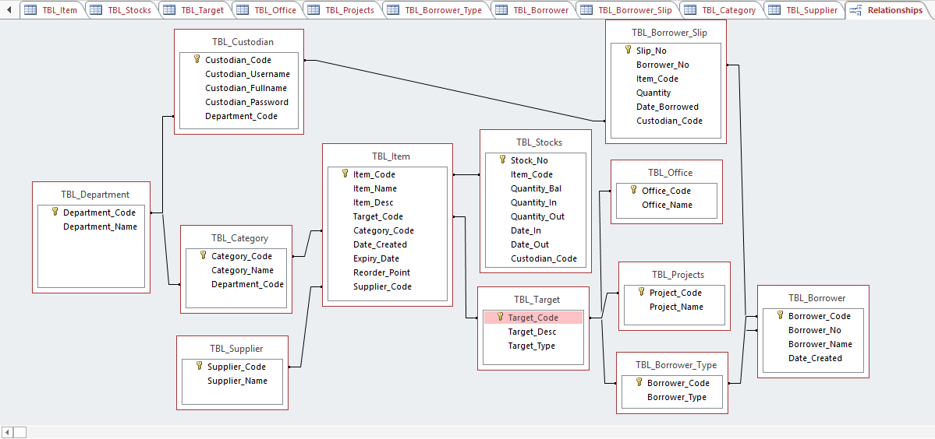

**C.NORMALIZATION**

**NORMALIZATION-** Database normalization (or normalisation) is the process of organizing the columns (attributes) and tables (relations) of a relational database to minimize data redundancy.

**UNF**

**TBL_ITEMS**

|  |  |  |  |  |  |  |  |  |  |  |
| --- | --- | --- | --- | --- | --- | --- | --- | --- | --- | --- |
| **ITEM_NO** | **ITEM_NAME** | **ITEM_DESCRIPTION** | **QUANTITY** | **UNIT** | **CUSTODIAN** | **REORDER_POINT** | **TARGET_OFFCIE** | **TARGET_PROJECT** | **DEPARTMENT_NAME** | **SUPPLIER** |
| **1** | **Paint** | **Boysen, Red** | **100** | **Liters** | **Juan** | **100** | **CET,CM,PFMO** | **Proj1,Proj2** | **Special Projects** | **PROPERTY OFFICE** |
| **2** | **Nail** | **Concrete** | **10** | **Kilo** | **Bill** | **10** | **CET,CBM** | **Proj1,Renovation1** | **Special Projects** | **PROPERTY OFFICE** |

**TBL_USERS**

|  |  |  |  |
| --- | --- | --- | --- |
| **CUSTODIAN_USERNAME** | **CUSTODIAN_FULLNAME** | **CUSTODIAN_PASSWORD** | **DEPARTMENT_NAME** |
| **Haynce03** | **Vince Aaron V. Dinglasan** | **110311** | **Special Projects** |
| **Edraith** | **Alexander Paul P. Quinit** | **090909** | **Quarterly Supply** |

**TBL_BORROWER**

|  |  |  |  |  |  |  |  |
| --- | --- | --- | --- | --- | --- | --- | --- |
| **BORROWER_NO** | **BORROWER_NAME** | **BORROWER_TYPE** | **ITEM_BARROWED** | **QUANTITY** | **CUSTODIAN** | **DATE_BORROWED** | **DATE_RETURNED** |
| **1** | **Stephanie** | **Student** | **Nail, Hammer** | **10** | **Jepoy** | **December 23, 2015** | **December 25, 2015** |
| **2** | **Wendy** | **Student** | **Hammer,** | **2** | **Bill** | **January 25, 2016** | **January 26, 2015** |

**1NF**

**TBL_ITEMS**

|  |  |  |  |  |  |  |  |  |  |  |
| --- | --- | --- | --- | --- | --- | --- | --- | --- | --- | --- |
| **ITEM_NO** | **ITEM_NAME** | **ITEM_DESCRIPTION** | **QUANTITY** | **UNIT** | **CUSTODIAN** | **REORDER_POINT** | **TARGET_OFFICE** | **TARGET_PROJECT** | **DEPARTMENT_NAME** | **SUPPLIER** |
| 1 | Paint | Boysen | 100 | Liters | Juan | 100 | CET | Proj1 | Special Projects | PROPERTY OFFICE |
| 2 | Nail | Concrete | 10 | Kilo | Bill | 10 | CBM | Renovation1 | Special Projects | PROPERTY OFFICE |

**TBL_USERS**

|  |  |  |  |
| --- | --- | --- | --- |
| **CUSTODIAN_USERNAME** | **CUSTODIAN_FULLNAME** | **CUSTODIAN_PASSWORD** | **DEPARTMENT_NAME** |
| Haynce03 | Vince Aaron V. Dinglasan | 110311 | Special Projects |
| Edraith | Alexander Paul P. Quinit | 090909 | Quarterly Supply |

**TBL_BORROWER**

|  |  |  |  |  |  |  |  |
| --- | --- | --- | --- | --- | --- | --- | --- |
| **BORROWER_NO** | **BORROWER_NAME** | **BORROWER_TYPE** | **ITEM_BARROWED** | **QUANTITY** | **CUSTODIAN** | **DATE_BORROWED** | **DATE_RETURNED** |
| 1 | Stephanie | Student | Nail, Hammer | 10 | Jepoy | December 23, 2015 | December 25, 2015 |
| 2 | Wendy | Student | Hammer, | 2 | Bill | January 25, 2016 | January 26, 2015 |

**2NF**

**TBL_CUSTODIAN**

|  |  |  |  |  |
| --- | --- | --- | --- | --- |
| **CUSTODIAN_USERNAME** | **CUSTODIAN_FULLNAME** | **CUSTODIAN_PASSWORD** | **CUSTODIAN_CODE** | **DEPARTMENT** |
| Haynce03 | Vince Aaron V. Dinglasan | 110311 | C-001 | Special Project |
| Edraith | Alexander Paul P. Quinit | 090909 | C-002 | Quarterly Supply |

**TBL_ITEM**

|  |  |  |  |  |  |  |  |  |  |  |  |
| --- | --- | --- | --- | --- | --- | --- | --- | --- | --- | --- | --- |
| **ITEM_NO** | **ITEM_NAME** | **ITEM_DESCRIPTION** | **QUANTITY** | **UNIT** | **CUSTODIAN** | **REORDER_POINT** | **TARGET_OFFCIE** | **TARGET_PROJECT** | **DEPARTMENT_NAME** | **SUPPLIER** | **TARGET_CODE** |
| 1 | Paint | Boysen | 100 | Liters | Juan | 100 | CET | Proj1 | Special Projects | PROPERTY OFFICE | T-001 |
| 2 | Nail | Concrete | 10 | Kilo | Bill | 10 | CBM | ,Renovation1 | Special Projects | PROPERTY OFFICE | T-002 |

**TBL_TARGET**

|  |  |  |
| --- | --- | --- |
| **TARGET_CODE** | **TARGET_DESCRIPTION** | **TARGET_TYPE** |
| T-001 | Special Projects | Renovation |
| T-002 | Quarterly Supply | 2nd Quarter Supply |

**TBL_SUPPLIER**

|  |  |
| --- | --- |
| **SUPPLIER_CODE** | **SUPPLIER_NAME** |
| S-001 | Property Office |
| S-002 | Golden Eagle Hardware |

**TBL_BORROWER**

|  |  |  |  |  |  |  |  |
| --- | --- | --- | --- | --- | --- | --- | --- |
| **BORROWER_NO** | **BORROWER_NAME** | **BORROWER_TYPE** | **ITEM_BARROWED** | **QUANTITY** | **CUSTODIAN** | **DATE_BORROWED** | **DATE_RETURNED** |
| 1 | Stephanie | Student | Nail | 10 | Jepoy | December 23, 2015 | December 25, 2015 |
| 2 | Wendy | Student | Hammer | 2 | Bill | January 25, 2016 | January 26, 2015 |

**3NF**

**TBL_CUSTODIAN**

|  |  |  |  |  |
| --- | --- | --- | --- | --- |
| **CUSTODIAN_USERNAME** | **CUSTODIAN_FULLNAME** | **CUSTODIAN_PASSWORD** | **CUSTODIAN_CODE** | **DEPARTMENT_CODE** |
| Haynce03 | Vince Aaron V. Dinglasan | 110311 | C-001 | D-001 |
| Edraith | Alexander Paul P. Quinit | 090909 | C-002 | D-002 |

**TBL_DEPARTMENT**

|  |  |
| --- | --- |
| **DEPARTMENT_CODE** | **DEPARTMENT_NAME** |
| D-001 | Special Projects |
| D-002 | Quarterly Supply |

**TBL_CATEGORY**

|  |  |  |
| --- | --- | --- |
| **CATEGORY_CODE** | **CATEGORY_NAME** | **DEPARTMENT_CODE** |
| CC-001 | Plumbing | D-001 |
| CC-002 | Carpentry | D-002 |

**TBL_ITEM**

|  |  |  |  |  |  |  |  |  |  |
| --- | --- | --- | --- | --- | --- | --- | --- | --- | --- |
| **ITEM_CODE** | **ITEM_NAME** | **ITEM_DESC** | **CUSTODIAN** | **REORDER_POINT** | **TARGET_CODE** | **CATEGORY_CODE** | **DATE_CREATED** | **SUPPLIER_CODE** | **EXPIRY_DATE** |
| I-001 | Paint | Boysen | Juan | 100 | T-001 | CC-001 | 1/01/2016 | S-001 | 1/5/2019 |
| I-002 | Nail | Concrete | Bill | 10 | T-002 | CC-002 | 1/03/2016 | S-002 | 1/10/2019 |

**TBL_STOCKS**

|  |  |  |  |  |  |  |  |  |
| --- | --- | --- | --- | --- | --- | --- | --- | --- |
| **STOCK_NO** | **ITEM_CODE** | **QTY_BALANCE** | **QTY_IN** | **QTY_OUT** | **DATE_IN** | **DATE_OUT** | **CUSTODIAN_CODE** | **UNIT** |
| 1 | I-001 | 100 | 100 | 0 | 15/01/2016 | 1/1/2016 | C-001 | Litre |
| 2 | I-002 | 45 | 10 | 5 | 15/03/2016 | 1/10/2016 | C-002 | Kilo |

**TBL_TARGET**

|  |  |
| --- | --- |
| **TARGET_CODE** | **TARGET_TYPE** |
| T-001 | Office |
| T-002 | Projects |
| T-003 | Borrowing |

**TBL_SUPPLIER**

|  |  |
| --- | --- |
| **SUPPLIER_CODE** | **SUPPLIER_NAME** |
| S-001 | Property Office |
| S-002 | Golden Eagle Hardware |

**TBL_OFFICE**

|  |  |
| --- | --- |
| **OFFICE_CODE** | **OFFICE_NAME** |
| O-001 | CET |
| O-002 | CBM |

**TBL_PROJECTS**

|  |  |
| --- | --- |
| **PROJECT_CODE** | **PROJECT_NAME** |
| P-001 | Renovation of GV 301 |
| P-002 | 2nd Quarter Supply of CET |

**TBL_BORROWER_TYPE**

|  |  |
| --- | --- |
| **BORROWER_CODE** | **BORROWER_TYPE** |
| B-001 | Student |
| B-002 | Faculty |

**TBL_BORROWER**

|  |  |  |  |
| --- | --- | --- | --- |
| **BORROWER_NO** | **BORROWER_NAME** | **BORROWER_CODE** | **DATE_CREATED** |
| 1 | Stephanie | B-001 | December 23, 2015 |
| 2 | Wendy | B-002 | January 25, 2016 |

**TBL_BORROWER_SLIP**

|  |  |  |  |  |  |
| --- | --- | --- | --- | --- | --- |
| **SLIP_NO** | **BORROWER_NO** | **ITEM_CODE** | **QUANTITY** | **DATE_BORROWED** | **CUSTODIAN_CODE** |
| 1 | 1 | I-001 | 10 | December 23, 2015 | C-001 |
| 2 | 2 | I-002 | 2 | January 25, 2016 | C-002 |

**CHAPTER 3**

**GENERAL DESIGN**

**A. System Flowchart**









































B. Entity Relationship Diagram (ERD)

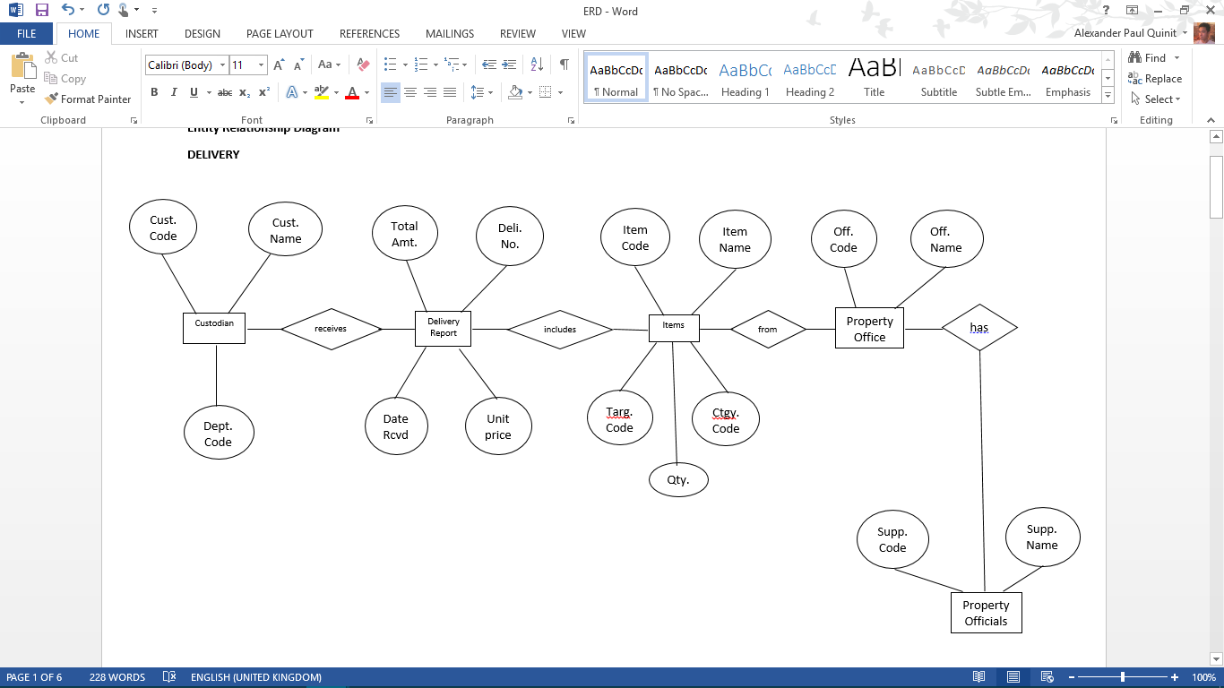

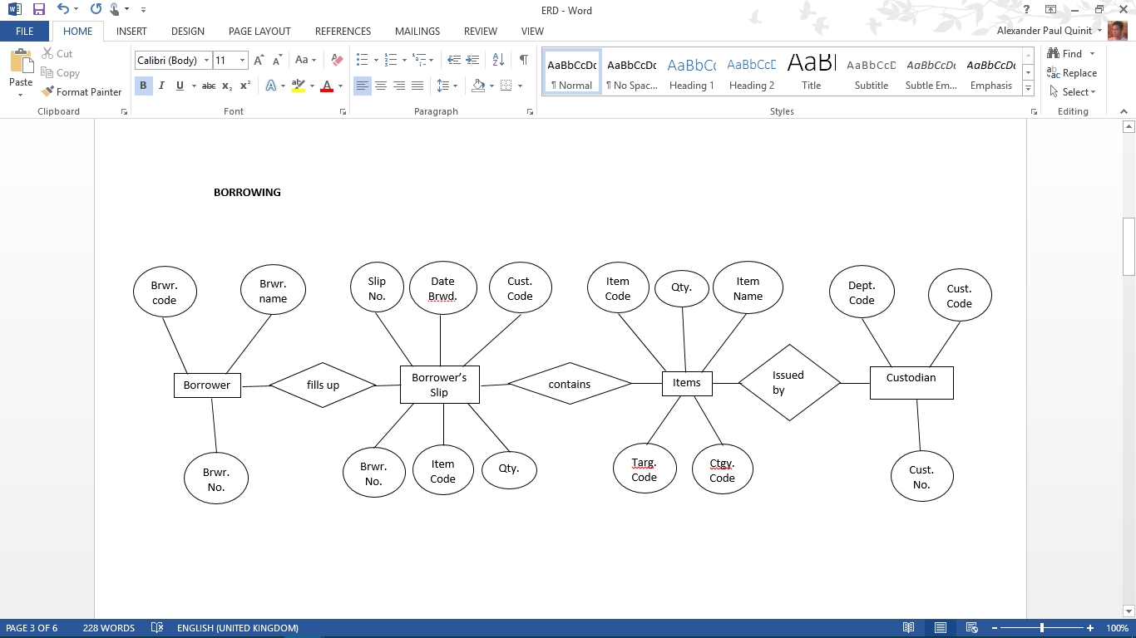

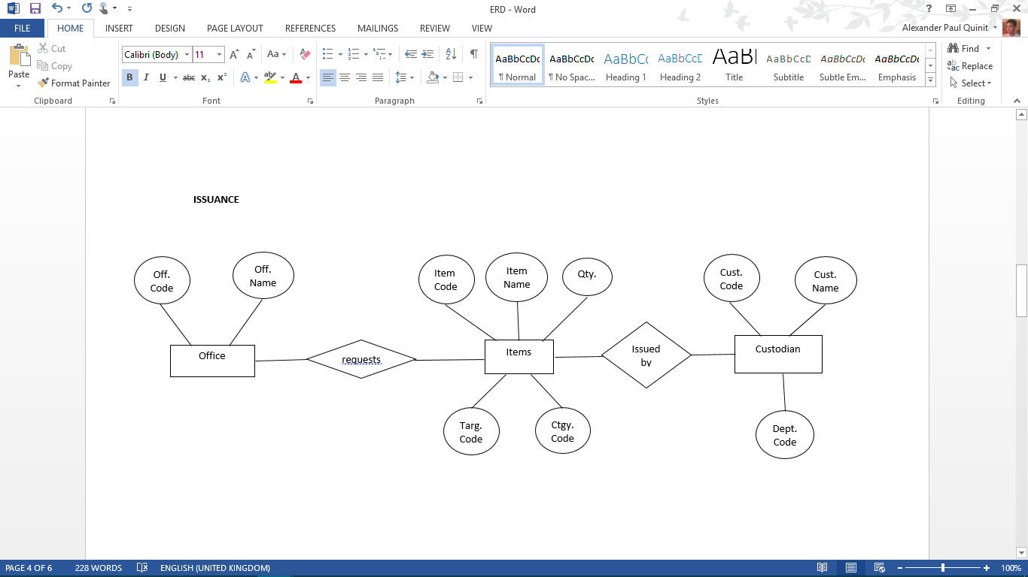

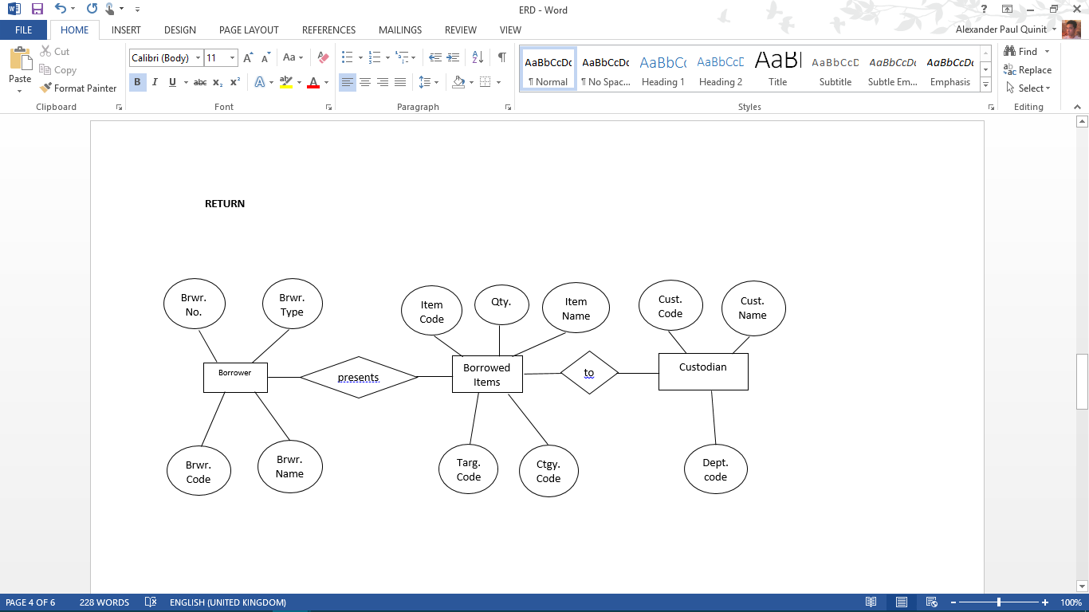

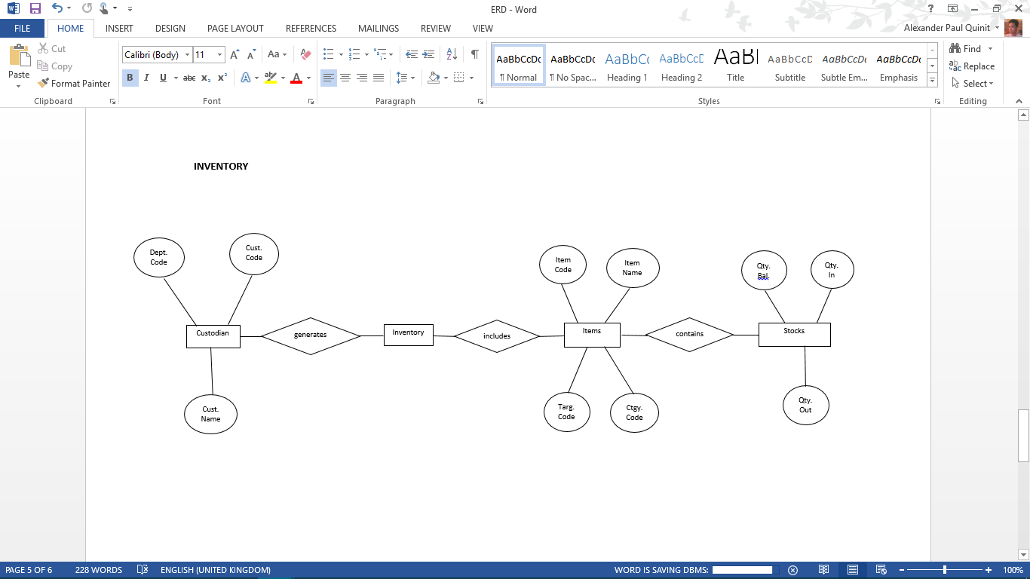

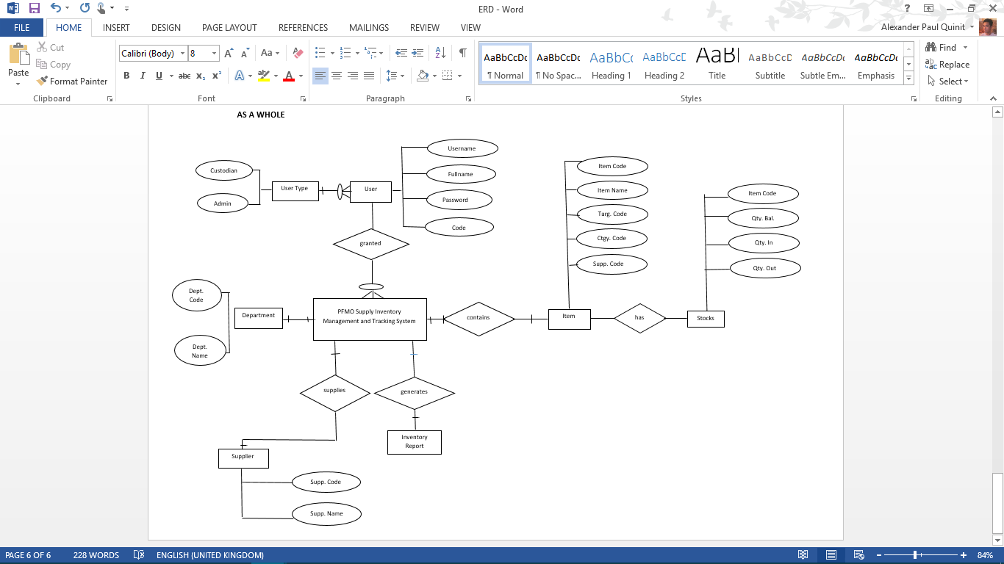

**CHAPTER 4**

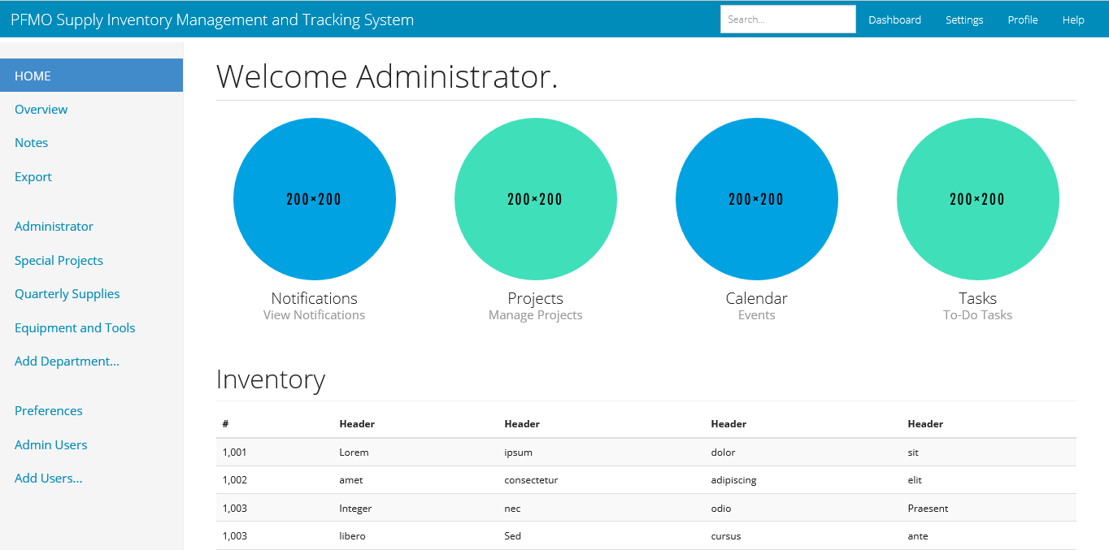**Graphical User Interface (GUI)**