TheFletchZone Game Engine Documentation

Setup Instructions
This document outlines the necessary steps to build and run TheFletchZone Game Engine.

Prerequisites
- Windows 10/11
- Visual Studio 2022 or later
- Windows SDK (latest)
- DirectX 12 runtime
- Git (optional, for version control)

Build Steps
1. Clone the repository or copy the engine source files to a folder.
2. Open `TheFletchZoneGameEngine.sln` in Visual Studio.
3. Make sure the configuration is set to `x64` and `Debug` or `Release`.
4. Build the project (Ctrl + Shift + B).

Run Instructions
1. Ensure all assets are present in the expected directories (e.g., `shaders/`, `textures/`).
2. Run the engine from Visual Studio (F5) or execute `TheFletchZoneGameEngine.exe`.
3. The engine window should launch, and ImGui overlays will display.

Troubleshooting
- If ImGui asserts or fails to load, verify `imgui_impl_dx12_custom.cpp` and `imgui_impl_win32_custom.cpp` are included.
- Check that all required ImGui and DX12 headers are present and correctly linked.
- Use `Logger::Log` output to trace initialization issues.

Documentation and Resources
- See `docs/architecture_overview.md` for understanding core systems.
- View `render_pipeline_diagram.png` to visually follow the graphics flow.

Architecture Overview
This section provides a high-level overview of the systems and modules that make up TheFletchZone Game Engine.
Key Components:
- Graphics Subsystem (DirectX 12-based rendering)
- ImGui UI System (custom multi-viewport and docking support)
- Window and DPI Management (Win32 backend)
- Game Loop, Timing, and Input Handling
- Logging and Debugging Infrastructure
Refer to the diagram on the next page for a visual representation of the rendering pipeline and module flow.

Render Pipeline Diagram
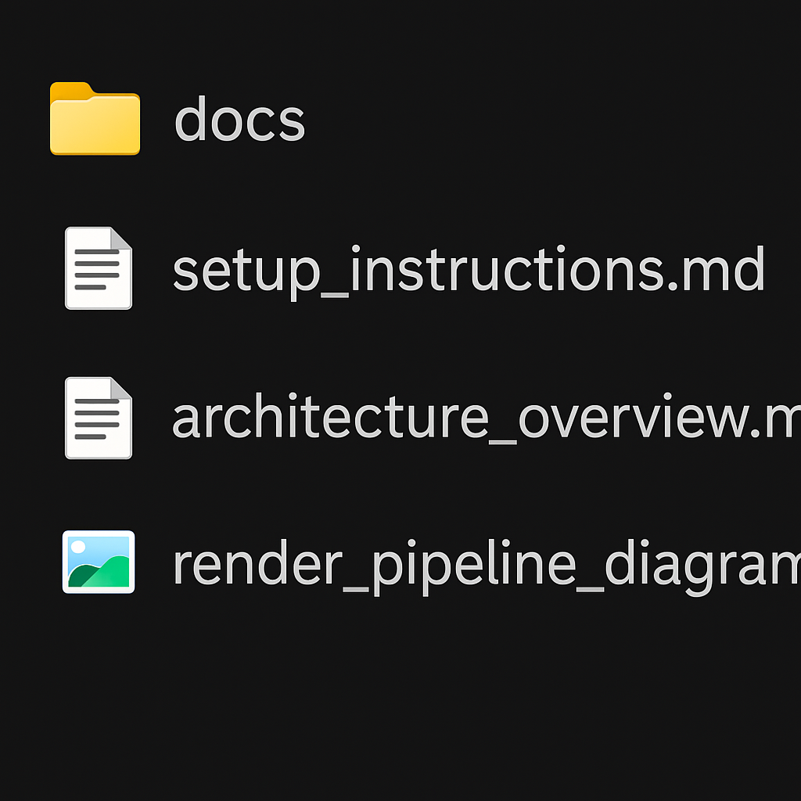

Core Modules Overview
This section outlines the core modules of TheFletchZone Game Engine, each responsible for a critical part of the system architecture. The modules are organized in a modular, scalable way to support high-performance rendering and extensibility.
- Graphics Module: Handles all DirectX 12 rendering tasks, swap chain management, frame timing, and integration with Dear ImGui.
- Input Module: Processes keyboard and mouse input, translates OS messages into engine-level events.
- UI Module: Wraps ImGui UI logic, allowing the engine to build editor tools, menus, and overlays.
- Logger Module: Centralized logging system that records info, warnings, and errors for diagnostics.
- Game Module: Contains the game loop, update/render calls, and core gameplay logic.
- Windowing System: Initializes and manages the Win32 window, DPI-awareness, and viewport handling.
- Platform Abstraction: Implements cross-module communication and ties platform-specific ImGui backends together.

