Project - PulsarDetection

Daniele

Hossein

S289615@studenti.polito.it

Politecnico di Torino

Outline

* Introduction
* Attribute Information
* Building a classifier for the Avila task
* Experimental validation
* Conclusions

Introduction

The Pulsar dataset is taken from the UCI repository (Dua, D. and Graff, C. (2019). UCI Machine Learning Repository [http://archive.ics.uci.edu/ml]. Irvine, CA: University of California, School of Information and Computer Science)

HTRU2 is a data set which describes a sample of pulsar candidates collected during the High Time Resolution Universe Survey (South) [1].

Pulsars are a rare type of Neutron star that produce radio emission detectable here on Earth. They are of considerable scientific interest as probes of space-time, the inter-stellar medium, and states of matter (see [2] for more uses).

As pulsars rotate, their emission beam sweeps across the sky, and when this crosses our line of sight, produces a detectable pattern of broadband radio emission. As pulsars rotate rapidly, this pattern repeats periodically. Thus pulsar search involves looking for periodic radio signals with large radio telescopes.

Each pulsar produces a slightly different emission pattern, which varies slightly with each rotation (see [2] for an introduction to pulsar astrophysics to find out why). Thus a potential signal detection known as a 'candidate', is averaged over many rotations of the pulsar, as determined by the length of an observation. In the absence of additional info, each candidate could potentially describe a real pulsar. However in practice almost all detections are caused by radio frequency interference (RFI) and noise, making legitimate signals hard to find.

We keep the original train / evaluation split

The training set contains 17,898 total examples with 639 positive examples and 16,259 negative examples.

We need the data to Train and Test the methods. Regarding to the two datasets offered, we will use all of the Train Dataset for Training and all of the Test Dataset for Testing.

----------------------------------------------------------------------------------------------------------------------------------------------

Source:

Dr. Robert Lyon, University of Manchester, School of Physics and Astronomy, Alan Turing Building, Manchester M13 9PL, United Kingdom, robert.lyon '@' manchester.ac.uk

[1] M. J. Keith et al., 'The High Time Resolution Universe Pulsar Survey - I. System Configuration and Initial Discoveries',2010, Monthly Notices of the Royal Astronomical Society, vol. 409, pp. 619-627. DOI: 10.1111/j.1365-2966.2010.17325.x

[2] D. R. Lorimer and M. Kramer, 'Handbook of Pulsar Astronomy', Cambridge University Press, 2005.

Attribute Information

Each candidate is described by 8 continuous variables, and a single class variable. The first four are simple statistics obtained from the integrated pulse profile (folded profile).

This is an array of continuous variables that describe a longitude-resolved version of the signal that has been averaged in both time and frequency (see [3] for more details). The remaining four variables are similarly obtained from the DM-SNR curve (again see [3] for more details). These are summarised below:

1. Mean of the integrated profile.

2. Standard deviation of the integrated profile.

3. Excess kurtosis of the integrated profile.

4. Skewness of the integrated profile.

5. Mean of the DM-SNR curve.

6. Standard deviation of the DM-SNR curve.

7. Excess kurtosis of the DM-SNR curve.

8. Skewness of the DM-SNR curve.

9. Class

[3] R. J. Lyon, 'Why Are Pulsars Hard To Find?', PhD Thesis, University of Manchester, 2016.

Histogram of the Pulsar Detection dataset features without preprocessing! (training set). Features are sorted by their order, from left to right, top to bottom. red histograms refer to false prediction (Non-Pulsar), blue histograms refer to true prediction (Pulsar)

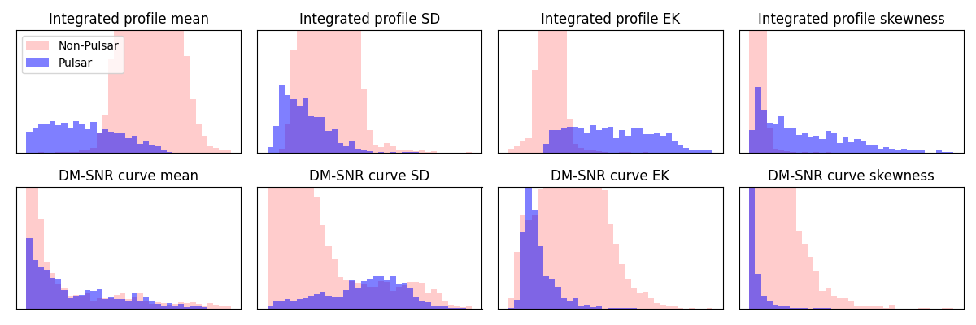

Figure 1: Histogram of the Pulsar Detection dataset features without preprocessing

We have to decide which machine learning method would be best. also, we will use Gaussian Model, Logistic Regression and Support Vector Machines models.

We need to do two things with the datasets:

1. Estimate the parameters for the machine learning methods.

* In other words, to use Logistic Regression, we have to use some of the data to estimate the shape of the curve. Here, estimating parameters is called Training the algorithm.

1. Evaluate how well the machine learning methods work.

* In other words, we need to find out if the curve will do a good job categorizing new data. Here, evaluating methods is called Testing the algorithm.

Then, we can compare methods by seeing how well each one categorized the test data. We assume that this data for training and testing are the best way to divide up the data.

Data preprocessing allows for the removal of unwanted data with the use of data cleaning, this allows to have a dataset to contain more valuable information after the preprocessing stage for data manipulation later in the data mining process. red histograms refer to false prediction (Non-Pulsar), blue histograms refer to true prediction (Pulsar)

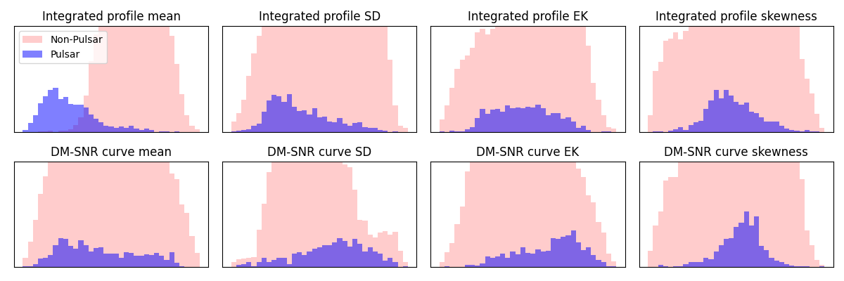

Figure 2: Histogram of the Pulsar Detection dataset features after preprocessing

By the way, Cross-validation uses them all one at a time to which block would be best for testing, and summarizes the results at the end. It keeps track of how well the method did with the test data. Then it uses combination of blocks to train the method.

Cross-validation allows us to compare different machine learning methods and get a sense of how well they will work in practice.

In this method, we divided the Train Dataset into 5 blocks (4 blocks for train, 1 for test). This is called Five-Fold cross-validation.

In the end, every block of data is used for testing and we can compare methods by seeing how well they performed.

In this case, since the Support Vector Machine did the best classifying the test datasets, we will use it.

Beside, we need to summarize how each method performed on the Training data. One way to do this is by creating a **Confusion Matrix** for each method.

Since there are only two categories to choose from: “Positives” or “Negatives”, then the bottom right-hand corner contains True Positives. These are the pulsars that had “Positives” that were correctly identified by the algorithm.

The True Negatives are in the top left-hand corner. These are the pulsars that did not have “Negatives” that were correctly identified by the algorithm.

The bottom left-hand corner contains the False Positives. These are pulsars has “Positives”, but the algorithm says they are.

Lastly, the top right-hand corner contains the False Negatives. These are when a pulsar has “Negatives”, but the algorithm said they didn’t.

The numbers along the diagonal (The True Positives and True Negatives) tell us how many times the samples were correctly classified.

The numbers not on the diagonal (the False Positives and False Negatives) are samples the algorithm messed up.

We can apply Logistic Regression to the Testing Dataset and create a Confusion Matrix.

----------------------

--------------------

The first thing we do with the Gaussian Naive Bayes classifier is making an initial guess that they are detected as Pulsar. This guess can be any probability that we want, but a common guess is estimated from the training data. That initial guesses are called Prior Probabilities.

Note: the likelihood is the y-axis coordinate on the curve that corresponds to the x-axis coordinate. And we multiply that by the maximum likelihood .

To talk about a likelihood, we assume that we have already weighed the Pulsar (or Pulsars, if it is weighed more than one). We logged transforms the individual likelihood functions.

Step 1) We have moved the log of the first likelihood function for reference.

Step 2) We have converted the multiplication into addition.

Step 3) We have converted 1 over the square root into the exponent -0.5 and convert the exponent into multiplication.

Step 4) We have converted the -0.5 exponent into multiplication and the log of e = 1

Step 5) The log can convert the multiplication of 2 into addition of and 2

Step 6) We have converted the exponent log(2) into 2 log($σ$)

Step 7) Lastly, the 2 divided by 2 term cancels out.

data_loading

cross_validation

bayes_error_plot

preprocess to clean data

roc det curves

run Gaussian main

خروجی رو ببین و پلات هارو

Tozh bede

Accureccy ha ke chap mishan

Rast bala false negative

Pain chap false positive

At lease 790