Business Requirements Document (BRD)
MiniWarehouse – 2026
Warehouse Operations Division / MiniWarehouse Product Team

Version 1.0
CONFIDENTIAL
This document contains proprietary information that is confidential to prohibited party. Disclosure of this document in full or in part, may result in material damage to prohibited party. Written permission must be obtained from prohibited party prior to the disclosure of this document to a third party.

Sign Off
 | Position | Name | Date
MiniWarehouse Product Team
Vendor

Change History
Date Modified | Modified By | Version No. | Brief Description of Change
2026-08-28 | MiniWarehouse Product Team | 1.0 | Initial document creation

Notation Document Description
Notasi | Sample | Remark
Kalimat dengan Font berwarna Merah | Text (NEW UI) | Penulisan Title Menu seperti ini menandakan bahwa menu atau fungsi tersebut baru atau belum ada di sistem.
Simbol Konektor | O -> Output / I -> Input | Notasi berupa simbol konektor aliran proses antar halaman.

I. BACKGROUND
MiniWarehouse is a small-scale, multi-tenant warehouse management system designed for operators who cannot justify enterprise WMS cost or infrastructure overhead. The system serves multiple customer tenants from a single cloud backend, supporting Android handheld scanners (PDTs) for floor activities (putaway, picking, receiving, stock counts) with offline capability, alongside a Next.js back-office web application for administrative and supervisory functions. The ASP.NET Core backend (.NET 10) acts as the single source of truth for all stock data, deriving balances exclusively by replaying an append-only Movement ledger rather than storing mutable counters.
The implementation follows a strict delivery order: Discovery (Phase 1 — documentation, complete) → Backend (Phase 2 — this specification) → Web (Phase 3) → Android (Phase 4). The backend must be scaffolded first because its OpenAPI contract is the foundation that both the web and Android clients generate against. Key architectural invariants include: dual-layer multi-tenancy enforcement (EF Core global query filters + PostgreSQL RLS), contract-first API design, industry-agnostic product modeling via per-Item capability flags, non-unique barcode resolution by task context, and an offline sync protocol based on idempotent TaskEvent batches.
Impact analysis: This is a greenfield codebase — all source files under /backend, /web, /android, and /infra are to be created. Existing documentation under /docs defines all architectural decisions, domain model shape, sync protocol, auth design, and coding conventions. The primary risks are: (1) multi-tenancy enforcement bugs causing cross-tenant data leaks, (2) sync protocol correctness under concurrent PDT operations, (3) OpenAPI contract drift between backend and generated clients, (4) barcode non-uniqueness resolution logic correctness, and (5) Movement ledger replay accuracy for stock computation. All risks are mitigated by the documented testing strategy: integration tests against real Postgres via Testcontainers for RLS/tenant isolation, dedicated concurrency tests for sync/movement logic, and contract-first code generation preventing API drift.

II. BUSINESS PROCESS

1. Deskripsi & Functional Requirement
Process Name | Version | Status | Prepared By
MiniWarehouse | 1.0 | Initial | MiniWarehouse Product Team

A. Cross-Functional Activity Diagram
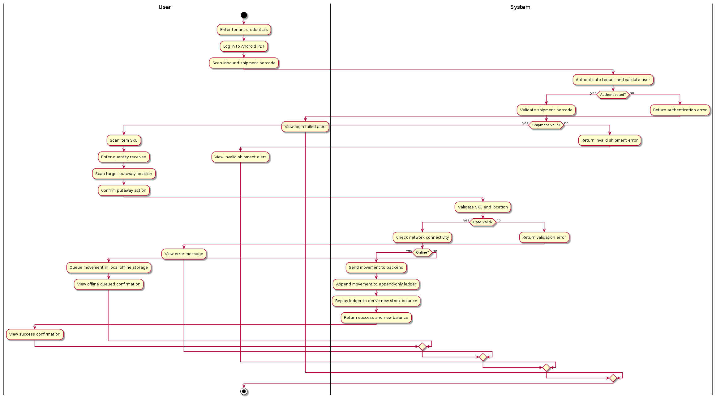

B. Explanation of User Flow
The system has two primary user journeys converging on a shared backend. The Warehouse Admin uses the Next.js web application to manage master data (items, locations, pack hierarchies, barcodes), create and assign tasks, review stock levels, and handle supervisory actions like resolving count variances or approving receipt checks. Authentication flows through OpenIddict using Resource Owner Password Credentials (ROPC) grant, producing a JWT carrying tenant_id and role claims. Every API call is scoped to the admin's tenant via EF Core global query filters and PostgreSQL RLS.
The Floor Operator uses an Android PDT (handheld scanner) for physical warehouse work. The PDT authenticates online with the same ROPC flow but additionally includes a device_id claim. While online, the PDT downloads assigned tasks; the backend soft-reserves stock using SELECT FOR UPDATE SKIP LOCKED to prevent double-allocation across concurrent operators. The operator then works offline — scanning barcodes, confirming quantities, capturing lot/expiry/serial data as required by each item's capability flags. All actions are recorded as idempotent TaskEvents in a local queue. When connectivity returns, the PDT syncs the event batch to the backend, which applies each event as an immutable Movement record in the append-only ledger. Stock balances are always derived by replaying Movements, never stored as mutable counters. This architecture ensures that multiple PDTs can operate concurrently on the same warehouse floor without data conflicts, and that offline work is never lost.

C. User Stories
- US1: Admin login and tenant-scoped access
As a warehouse admin, I want to log in to the web application with my email and password so that I can access only my tenant's data and perform administrative functions.
Acceptance Criteria:
- Login page accepts email and password
- Authentication uses ROPC grant via OpenIddict /connect/token endpoint
- JWT contains tenant_id and role claims resolved from ASP.NET Identity user record
- All subsequent API calls include the JWT and are scoped to the admin's tenant via RLS
- Invalid credentials return a clear error message without revealing which field was wrong
- Session persists across page refreshes via BFF session pattern
- US2: Create and manage item master data
As a warehouse admin, I want to create items with configurable pack-level hierarchies and barcode mappings so that floor operators can scan and identify products correctly.
Acceptance Criteria:
- Admin can create an Item with name, description, and capability flags (tracksLot, tracksExpiry, tracksSerial)
- Admin can create ItemUnit records representing pack levels (each, inner, case, pallet) with quantity multipliers
- Admin can map multiple Barcode records to an ItemUnit; barcodes are non-unique within tenant scope
- GS1-128 Application Identifier parsing is supported for barcode input
- Item list page supports search, filter, and pagination
- All operations are tenant-scoped; admin cannot see or modify other tenants' items
- US3: Create and manage warehouse locations
As a warehouse admin, I want to define a hierarchical location structure (zone, aisle, rack, bin) so that stock can be precisely located and tasks can reference specific positions.
Acceptance Criteria:
- Admin can create locations with a code, name, and optional parent location reference
- Location hierarchy supports arbitrary depth (minimum: zone → bin)
- Location list page shows hierarchy in a tree or indented view
- Locations can be marked as active/inactive; inactive locations cannot be assigned to new tasks
- All locations are tenant-scoped via RLS
- US4: Create and assign warehouse tasks
As a supervisor, I want to create pick, putaway, count, and receipt check tasks and assign them to operators or devices so that floor work is organized and trackable.
Acceptance Criteria:
- Supervisor can create tasks of type Pick, Putaway, Count, or ReceiptCheck
- Each task contains one or more task lines specifying item, unit, quantity, source/destination location
- Tasks can be assigned to a specific operator, device, or left unassigned for general pickup
- Task list page shows status (Pending, InProgress, Completed), assignment, and priority
- When a PDT pulls an assigned task, the backend soft-reserves stock using FOR UPDATE SKIP LOCKED
- Supervisor can cancel or reassign pending tasks
- US5: PDT operator login and task download
As a floor operator, I want to log in on the PDT and download my assigned tasks so that I can work through them even without network connectivity.
Acceptance Criteria:
- PDT login screen accepts email, password; device_id is sent as a header
- Authentication uses ROPC grant; JWT includes tenant_id, role, and device_id claims
- After login, PDT automatically pulls all assigned tasks from the backend
- Tasks are stored in local SQLite database for offline access
- PDT shows a task list sorted by priority with status indicators
- Login is online-only; no offline credential caching
- US6: Execute pick task offline with barcode scanning
As a floor operator, I want to execute a pick task by scanning barcodes and confirming quantities while offline so that warehouse operations continue regardless of connectivity.
Acceptance Criteria:
- Operator selects a pick task from the PDT task list
- PDT activates camera/ML Kit scanner for barcode input
- Scanned barcode is resolved against the active task's expected items; if ambiguous, operator is prompted to select
- Operator confirms picked quantity; lot/expiry/serial fields appear conditionally based on item capability flags
- Each confirmation creates an idempotent TaskEvent with a client-generated UUID
- TaskEvents are queued locally and marked as unsynced
- Task progress is visible on the PDT screen (lines completed vs total)
- US7: Sync completed TaskEvents to backend
As a floor operator, I want my completed task events to automatically sync to the backend when connectivity returns so that stock balances are updated and tasks are marked complete.
Acceptance Criteria:
- PDT detects connectivity restoration automatically
- Unsynced TaskEvents are batched and POSTed to /api/sync/events
- Backend validates each event's idempotency key; duplicate events are acknowledged but not re-applied
- Each accepted event is applied as a Movement record within a database transaction
- Backend returns sync acknowledgment; PDT marks events as synced and removes from local queue
- Failed events (e.g., task was cancelled server-side) are reported to the operator with a clear message
- Sync can be triggered manually by the operator as well as automatically
- US8: View stock levels derived from Movement ledger
As a warehouse admin or supervisor, I want to view current stock levels that are accurately computed from the Movement ledger so that I have a reliable picture of inventory.
Acceptance Criteria:
- Stock page shows on-hand quantities per item, unit, location, and lot (if applicable)
- Stock values are computed by replaying Movement records, not from stored counters
- Filters allow narrowing by item, location, lot, expiry date range, and inventory status
- Results are paginated and sortable
- Stock data is always tenant-scoped via RLS
- Page loads within acceptable performance bounds for typical tenant data volumes
- US9: Review and resolve count variances
As a supervisor, I want to review stock count results from PDT operators and approve adjustments for any variances so that the ledger accurately reflects physical inventory.
Acceptance Criteria:
- Count task detail page shows expected vs actual quantity per line with variance highlighted
- Supervisor can view operator notes attached to each count line
- Supervisor can approve or reject each variance line individually
- Approved variances generate adjustment Movement records that correct the ledger
- Rejected variances can be sent back to the operator for re-count (new task created)
- All resolution actions are audit-trailed with supervisor identity and timestamp
- US10: Manage users and devices per tenant
As a tenant owner/admin, I want to create user accounts and register PDT devices within my tenant so that operators can authenticate and be tracked.
Acceptance Criteria:
- Admin can create user accounts with email, password, role (Owner/Admin, Supervisor, Operator), and tenant association
- Email is globally unique across the entire platform (not scoped per tenant)
- Admin can register devices with a stable device_id, name, and status (active/revoked)
- Admin can revoke a device's session immediately (kills active refresh tokens)
- User list and device list pages show current status and last activity
- All user/device management is tenant-scoped

D. User Matrix
Responsible (R), Accountable (A), Consulted (C), Informed (I)
Function / UI | Administrators | User
MiniWarehouse - System | C | R, A, I

III. TECH STACK
Type | Technology
frontend | Next.js (App Router) + React, TypeScript, TanStack Query, shadcn/ui, Orval (OpenAPI client generation), BFF session auth pattern
backend | ASP.NET Core Web API, .NET 10, MediatR (Vertical Slice), FluentValidation, Minimal API, Entity Framework Core (code-first), OpenIddict (OAuth2/OIDC), ASP.NET Core Identity
database | PostgreSQL with Row-Level Security (RLS), EF Core global query filters, append-only Movement ledger
deployment | Docker Compose (backend, web, postgres services), contract-first OpenAPI spec

IV. PAGES & UI

V. SYSTEM API
No API endpoints defined.

VI. DB SCHEMA

Table: users
Column | Type | Constraints
id | UUID | PK
email | VARCHAR(255) | UNIQUE NOT NULL
password_hash | VARCHAR(255) | NOT NULL
created_at | TIMESTAMP | NOT NULL

Table: orders
Column | Type | Constraints
id | UUID | PK
user_id | UUID | FK NOT NULL
total_amount | DECIMAL(10,2) | NOT NULL
status | VARCHAR(50) | NOT NULL
created_at | TIMESTAMP | NOT NULL

