Software Requirement Specification (SRS)
MiniWarehouse – 2026
Warehouse Operations Division / MiniWarehouse Product Team

Version 1.0
CONFIDENTIAL
This document contains proprietary information that is confidential to the owning party. Disclosure of this document in full or in part may result in material damage. Written permission must be obtained prior to disclosure of this document to a third party.

Sign Off
 | Position | Name | Date
MiniWarehouse Product Team | Owner
Vendor | Business Analyst

Change History
Date Modified | Modified By | Version No. | Type of Change | Brief Description of Change
28 August 2026 | MiniWarehouse Product Team | 1.0 | Initial | Initial document creation

Notation Document Description
Notasi | Sample | Remark
Kalimat dengan Font berwarna Merah | Teacher Hub | Menandakan perubahan terhadap sistem existing.
[Title Menu/Function] (NEW UI) | Yayasan (NEW UI) | Menu atau fungsi baru / belum ada di sistem.
[Title Menu/Function] (NEW JOB) | DAPODIK Integration (NEW JOB) | Job atau fungsi baru / belum ada di sistem.

I. BACKGROUND
MiniWarehouse is a small-scale, multi-tenant warehouse management system designed for operators who cannot justify enterprise WMS cost or infrastructure overhead. The system serves multiple customer tenants from a single cloud backend, supporting Android handheld scanners (PDTs) for floor activities (putaway, picking, receiving, stock counts) with offline capability, alongside a Next.js back-office web application for administrative and supervisory functions. The ASP.NET Core backend (.NET 10) acts as the single source of truth for all stock data, deriving balances exclusively by replaying an append-only Movement ledger rather than storing mutable counters.
The implementation follows a strict delivery order: Discovery (Phase 1 — documentation, complete) → Backend (Phase 2 — this specification) → Web (Phase 3) → Android (Phase 4). The backend must be scaffolded first because its OpenAPI contract is the foundation that both the web and Android clients generate against. Key architectural invariants include: dual-layer multi-tenancy enforcement (EF Core global query filters + PostgreSQL RLS), contract-first API design, industry-agnostic product modeling via per-Item capability flags, non-unique barcode resolution by task context, and an offline sync protocol based on idempotent TaskEvent batches.
Impact analysis: This is a greenfield codebase — all source files under /backend, /web, /android, and /infra are to be created. Existing documentation under /docs defines all architectural decisions, domain model shape, sync protocol, auth design, and coding conventions. The primary risks are: (1) multi-tenancy enforcement bugs causing cross-tenant data leaks, (2) sync protocol correctness under concurrent PDT operations, (3) OpenAPI contract drift between backend and generated clients, (4) barcode non-uniqueness resolution logic correctness, and (5) Movement ledger replay accuracy for stock computation. All risks are mitigated by the documented testing strategy: integration tests against real Postgres via Testcontainers for RLS/tenant isolation, dedicated concurrency tests for sync/movement logic, and contract-first code generation preventing API drift.

II. FUNCTIONAL REQUIREMENTS
- US1: Admin login and tenant-scoped access
As a warehouse admin, I want to log in to the web application with my email and password so that I can access only my tenant's data and perform administrative functions.
- Login page accepts email and password
- Authentication uses ROPC grant via OpenIddict /connect/token endpoint
- JWT contains tenant_id and role claims resolved from ASP.NET Identity user record
- All subsequent API calls include the JWT and are scoped to the admin's tenant via RLS
- Invalid credentials return a clear error message without revealing which field was wrong
- Session persists across page refreshes via BFF session pattern
- US2: Create and manage item master data
As a warehouse admin, I want to create items with configurable pack-level hierarchies and barcode mappings so that floor operators can scan and identify products correctly.
- Admin can create an Item with name, description, and capability flags (tracksLot, tracksExpiry, tracksSerial)
- Admin can create ItemUnit records representing pack levels (each, inner, case, pallet) with quantity multipliers
- Admin can map multiple Barcode records to an ItemUnit; barcodes are non-unique within tenant scope
- GS1-128 Application Identifier parsing is supported for barcode input
- Item list page supports search, filter, and pagination
- All operations are tenant-scoped; admin cannot see or modify other tenants' items
- US3: Create and manage warehouse locations
As a warehouse admin, I want to define a hierarchical location structure (zone, aisle, rack, bin) so that stock can be precisely located and tasks can reference specific positions.
- Admin can create locations with a code, name, and optional parent location reference
- Location hierarchy supports arbitrary depth (minimum: zone → bin)
- Location list page shows hierarchy in a tree or indented view
- Locations can be marked as active/inactive; inactive locations cannot be assigned to new tasks
- All locations are tenant-scoped via RLS
- US4: Create and assign warehouse tasks
As a supervisor, I want to create pick, putaway, count, and receipt check tasks and assign them to operators or devices so that floor work is organized and trackable.
- Supervisor can create tasks of type Pick, Putaway, Count, or ReceiptCheck
- Each task contains one or more task lines specifying item, unit, quantity, source/destination location
- Tasks can be assigned to a specific operator, device, or left unassigned for general pickup
- Task list page shows status (Pending, InProgress, Completed), assignment, and priority
- When a PDT pulls an assigned task, the backend soft-reserves stock using FOR UPDATE SKIP LOCKED
- Supervisor can cancel or reassign pending tasks
- US5: PDT operator login and task download
As a floor operator, I want to log in on the PDT and download my assigned tasks so that I can work through them even without network connectivity.
- PDT login screen accepts email, password; device_id is sent as a header
- Authentication uses ROPC grant; JWT includes tenant_id, role, and device_id claims
- After login, PDT automatically pulls all assigned tasks from the backend
- Tasks are stored in local SQLite database for offline access
- PDT shows a task list sorted by priority with status indicators
- Login is online-only; no offline credential caching
- US6: Execute pick task offline with barcode scanning
As a floor operator, I want to execute a pick task by scanning barcodes and confirming quantities while offline so that warehouse operations continue regardless of connectivity.
- Operator selects a pick task from the PDT task list
- PDT activates camera/ML Kit scanner for barcode input
- Scanned barcode is resolved against the active task's expected items; if ambiguous, operator is prompted to select
- Operator confirms picked quantity; lot/expiry/serial fields appear conditionally based on item capability flags
- Each confirmation creates an idempotent TaskEvent with a client-generated UUID
- TaskEvents are queued locally and marked as unsynced
- Task progress is visible on the PDT screen (lines completed vs total)
- US7: Sync completed TaskEvents to backend
As a floor operator, I want my completed task events to automatically sync to the backend when connectivity returns so that stock balances are updated and tasks are marked complete.
- PDT detects connectivity restoration automatically
- Unsynced TaskEvents are batched and POSTed to /api/sync/events
- Backend validates each event's idempotency key; duplicate events are acknowledged but not re-applied
- Each accepted event is applied as a Movement record within a database transaction
- Backend returns sync acknowledgment; PDT marks events as synced and removes from local queue
- Failed events (e.g., task was cancelled server-side) are reported to the operator with a clear message
- Sync can be triggered manually by the operator as well as automatically
- US8: View stock levels derived from Movement ledger
As a warehouse admin or supervisor, I want to view current stock levels that are accurately computed from the Movement ledger so that I have a reliable picture of inventory.
- Stock page shows on-hand quantities per item, unit, location, and lot (if applicable)
- Stock values are computed by replaying Movement records, not from stored counters
- Filters allow narrowing by item, location, lot, expiry date range, and inventory status
- Results are paginated and sortable
- Stock data is always tenant-scoped via RLS
- Page loads within acceptable performance bounds for typical tenant data volumes
- US9: Review and resolve count variances
As a supervisor, I want to review stock count results from PDT operators and approve adjustments for any variances so that the ledger accurately reflects physical inventory.
- Count task detail page shows expected vs actual quantity per line with variance highlighted
- Supervisor can view operator notes attached to each count line
- Supervisor can approve or reject each variance line individually
- Approved variances generate adjustment Movement records that correct the ledger
- Rejected variances can be sent back to the operator for re-count (new task created)
- All resolution actions are audit-trailed with supervisor identity and timestamp
- US10: Manage users and devices per tenant
As a tenant owner/admin, I want to create user accounts and register PDT devices within my tenant so that operators can authenticate and be tracked.
- Admin can create user accounts with email, password, role (Owner/Admin, Supervisor, Operator), and tenant association
- Email is globally unique across the entire platform (not scoped per tenant)
- Admin can register devices with a stable device_id, name, and status (active/revoked)
- Admin can revoke a device's session immediately (kills active refresh tokens)
- User list and device list pages show current status and last activity
- All user/device management is tenant-scoped

III. PROCESS FLOWS

1. Tenant Admin Login and Dashboard
Trigger: user action
Warehouse admin authenticates via the web application and accesses the operational dashboard showing stock summaries, pending tasks, and recent movements.

A. Flow Diagram
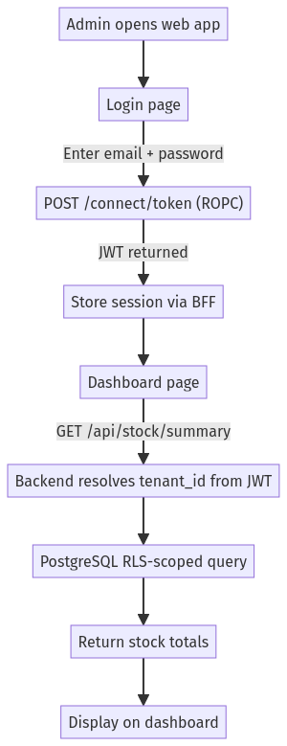

B. Process Steps
- Admin navigates to web application URL
- Admin enters email and password on login form
- Frontend sends ROPC token request to OpenIddict /connect/token
- Backend validates credentials via ASP.NET Identity, issues JWT with tenant_id and role claims
- Web app stores session via BFF pattern, redirects to dashboard
- Dashboard loads stock summary, recent movements, and pending task counts via TanStack Query
- All API calls include JWT; backend resolves tenant_id and applies RLS scoping

C. Input Data
Field | Type | Source
email | string | user
password | string | user

2. Item and Location Master Data Management
Trigger: user action
Admin creates and manages items (with capability flags for lot/expiry/serial tracking), pack-level unit hierarchies, barcode mappings, and warehouse locations.

A. Flow Diagram
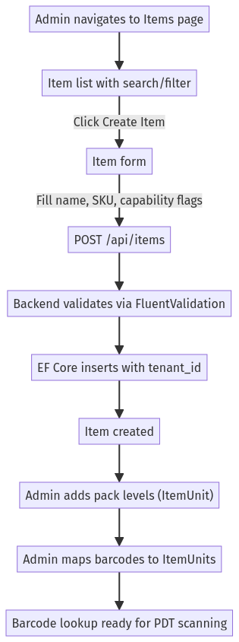

B. Process Steps
- Admin navigates to Items master data page
- Admin clicks Create Item and fills in name, description, and capability flags (tracksLot, tracksExpiry, tracksSerial)
- Frontend submits POST /api/items; FluentValidation validates input
- Backend creates Item entity with tenant_id from JWT, persists via EF Core
- Admin creates ItemUnit records for pack hierarchy (each, inner pack, case, pallet)
- Admin maps Barcode records to ItemUnits (non-unique, scoped by tenant_id + code + symbology)
- Admin navigates to Locations page and creates warehouse location hierarchy (zone → aisle → rack → bin)
- All data is immediately available for task creation and PDT scanning

C. Input Data
Field | Type | Source
item_name | string | user
sku | string | user
tracks_lot | boolean | user
tracks_expiry | boolean | user
tracks_serial | boolean | user
unit_name | string | user
unit_quantity | integer | user
barcode_code | string | user
barcode_symbology | string | user
location_code | string | user
location_name | string | user
parent_location_id | string | user

3. Task Creation and Assignment
Trigger: user action
Supervisor creates warehouse tasks (pick, putaway, count, receipt check) and assigns them to operators or devices for floor execution.

A. Flow Diagram
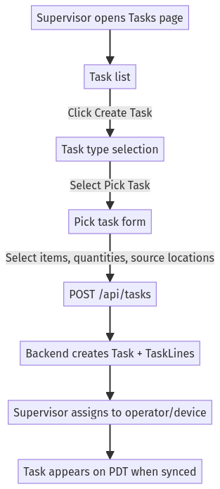

B. Process Steps
- Supervisor navigates to Tasks page in web app
- Supervisor selects task type (Pick, Putaway, Count, ReceiptCheck)
- Supervisor fills task details: items, quantities, source/destination locations, priority
- Frontend submits POST /api/tasks; backend validates and creates Task with associated TaskLines
- Supervisor assigns task to a specific operator or device
- When PDT next syncs (or immediately if online), task is included in the pull response
- Backend soft-reserves stock at task-download time using FOR UPDATE SKIP LOCKED

C. Input Data
Field | Type | Source
task_type | string | user
item_id | string | user
item_unit_id | string | user
expected_quantity | integer | user
source_location_id | string | user
destination_location_id | string | user
assigned_operator_id | string | user
assigned_device_id | string | user
priority | integer | user

4. PDT Offline Task Execution and Sync
Trigger: user action
Floor operator downloads assigned tasks on PDT, executes them offline by scanning barcodes and confirming quantities, then syncs completed TaskEvents back to the backend when connectivity returns.

A. Flow Diagram
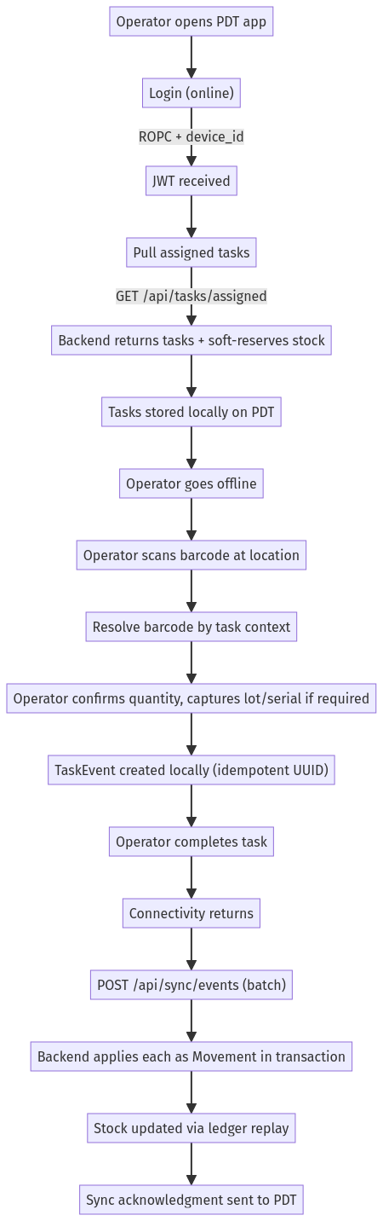

B. Process Steps
- Operator logs in on PDT (online only) using ROPC grant with device_id header
- PDT requests assigned tasks via GET /api/tasks/assigned
- Backend returns task payload and soft-reserves stock using SELECT FOR UPDATE SKIP LOCKED
- PDT stores tasks in local SQLite database
- Operator loses connectivity and continues working offline
- Operator scans barcode; PDT resolves ambiguity using active task context, prompts if still ambiguous
- Operator confirms quantity; PDT shows lot/expiry/serial fields based on item capability flags
- PDT creates idempotent TaskEvent with client-generated UUID, stores in local event queue
- Operator marks task complete; local task status updated
- When connectivity returns, PDT batches unsent TaskEvents and POSTs to /api/sync/events
- Backend validates each event's idempotency key, applies as Movement records within a single transaction
- Backend returns sync acknowledgment; PDT marks events as synced and removes from local queue

C. Input Data
Field | Type | Source
scanned_barcode | string | device
confirmed_quantity | integer | user
lot_number | string | user
expiry_date | string | user
serial_number | string | user
actual_location_id | string | user
task_event_id | string | device
device_timestamp | string | device

5. Stock Inquiry and Movement History
Trigger: user action
Admin or supervisor queries current stock levels (derived from Movement ledger replay) and reviews movement history for audit trail purposes.

A. Flow Diagram
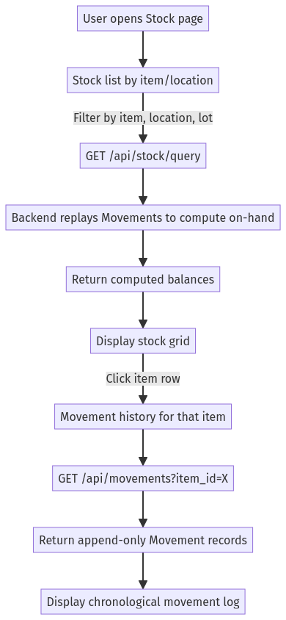

B. Process Steps
- User navigates to Stock page in web app
- User applies filters (item, location, lot, inventory status)
- Frontend calls GET /api/stock/query with filter parameters
- Backend resolves tenant_id from JWT, queries Movement ledger, computes on-hand balances
- Results displayed in a filterable, sortable grid
- User clicks on a specific item/location row to view movement history
- Frontend calls GET /api/movements with item/location filter
- Backend returns append-only Movement records with timestamps, task references, and operator info
- Movement history displayed as chronological audit log

C. Input Data
Field | Type | Source
item_id | string | user
location_id | string | user
lot_number | string | user
inventory_status | string | user
date_from | string | user
date_to | string | user

6. Count Variance Resolution
Trigger: user action
Supervisor reviews stock count results submitted by PDT operators, identifies variances between expected and actual quantities, and approves adjustments to correct the ledger.

A. Flow Diagram
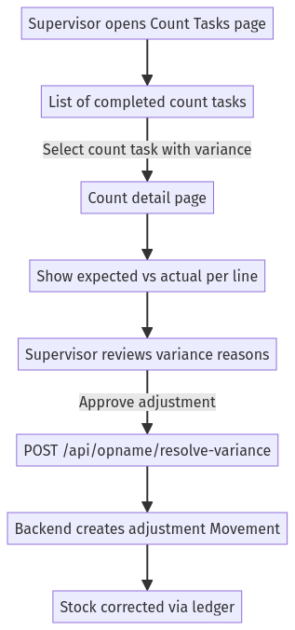

B. Process Steps
- Supervisor navigates to Count Tasks page showing all completed stock counts
- Supervisor selects a count task that has variances (expected ≠ actual)
- Detail page shows each count line with expected quantity, actual counted quantity, and variance
- Supervisor reviews operator notes and decides whether to approve the variance
- Supervisor clicks Approve Adjustment; frontend sends POST /api/opname/resolve-variance
- Backend validates the resolution, creates an adjustment Movement record
- Stock balances are automatically corrected via ledger replay
- Count task status updated to Resolved; audit trail records supervisor approval

C. Input Data
Field | Type | Source
count_task_id | string | user
count_line_id | string | user
resolution_notes | string | user
approved | boolean | user

IV. DATA MODEL

Table: users
Column | Type | Constraints
id | UUID | PK
email | VARCHAR(255) | UNIQUE NOT NULL
password_hash | VARCHAR(255) | NOT NULL
created_at | TIMESTAMP | NOT NULL

Table: orders
Column | Type | Constraints
id | UUID | PK
user_id | UUID | FK NOT NULL
total_amount | DECIMAL(10,2) | NOT NULL
status | VARCHAR(50) | NOT NULL
created_at | TIMESTAMP | NOT NULL

