**Past Simple**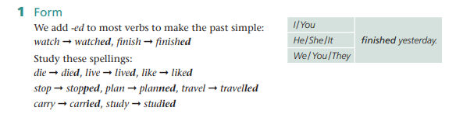

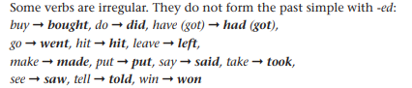

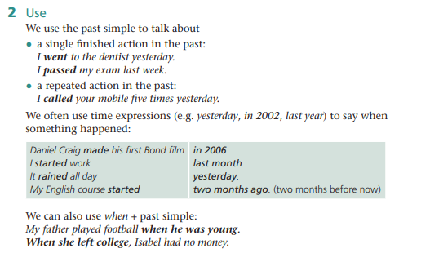

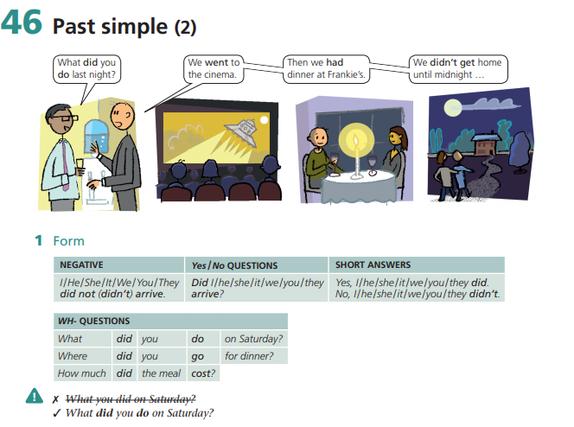

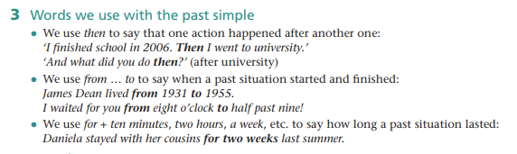

**Hello my friends I like to see you**

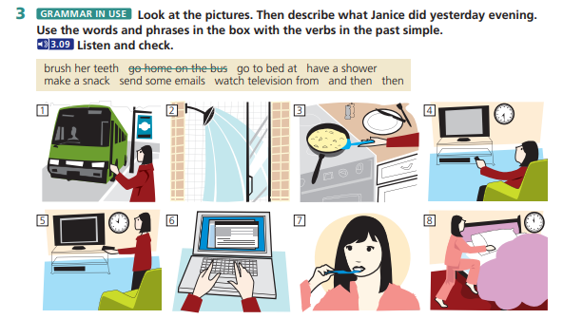

**1.**

The girl woke up and she had a shower, after that she cooked the breakfast and went to the bus stop, in the office sent emails and return to the home. She watched tv many hours, she brushed her theets and goes to the bed.

1. **Find the ones that are different.**

**0** talked /asked/ made /passed

1. died/ smiled / phoned / cried
2. walked/ played/ went/ visited
3. watched/ told/ took /had
4. stopped/ robbed/ planned/ listened
5. carried/ worried/ studied/ enjoyed

**2 . write the past form of the verbs in the box below.**

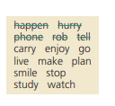

|  |  |  |  |  |
| --- | --- | --- | --- | --- |
| + ed | repeat the consonant and add -ed | +d | (+y) + -ied | irregular verbs |
| Happened | Robbed | Phoned | Hurried | told |
| Enjoyed | Planned | Lived | Carried | Went |
| Watched | Stopped | Smiled | Studied | Made |

1. **Choose past forms from exercise 2 to complete the text.**

**DanieL Craig – the new James Bond**

Daniel Craig was born in Chester, England in 1968. When he was young, he (0) **lived** in the Wirral, near Liverpool. At school he (1) enjoyed sport and he was in several teams. When he was a child, he (2) watched Star Trek on television and he says it is his ambition to appear in a Star Trek film. He (3) went to London when he was sixteen and joined the National Youth Theatre. He then (4) studied acting at the Guildhall School of Music and Drama. He (5) made his first film for the BBC in 1996 – Our Friends in the North. In 2006 he got the part of James Bond. Many people were surprised when this (6) happened, because Craig has blond hair and all the other actors who have played Bond have dark hair.

**GRAMMAR IN USE** There are five more mistakes in the conversation. Find and correct them.

**go**

**Tom:** Did you ~~went~~ to the cinema yesterday?

**Silvia:** Yes, we went.

**Tom:** What do you see?

**Silvia:** We didn’t saw anything.

**Tom:** What did you mean?

**Silvia:** Well. There was a queue when we got to the cinema, so we didn’t wait.

**Tom:** So, what did you done?

**Silvia :** We went to Video City and rented a DVD.