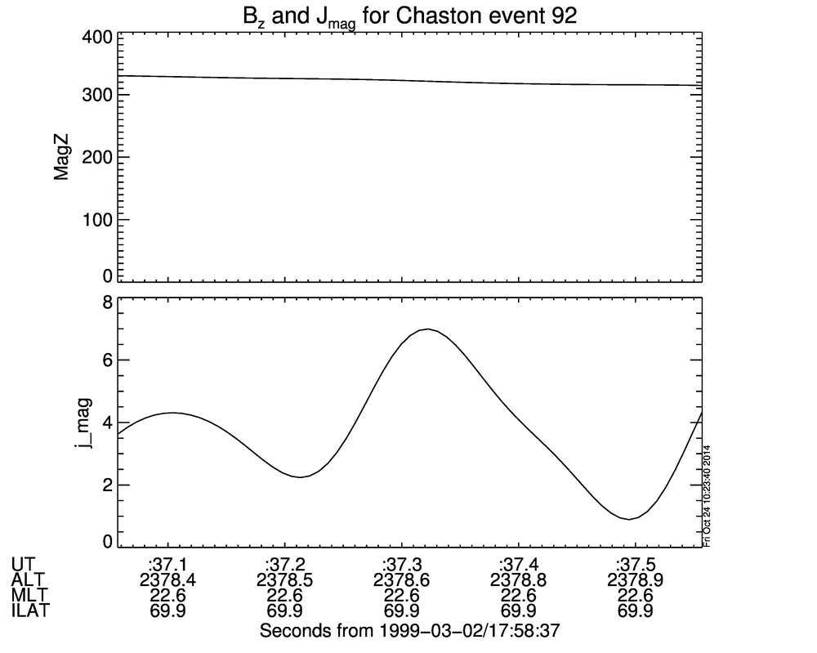92 1999-03-02/17:58:37.307 ??36.877or38.456??
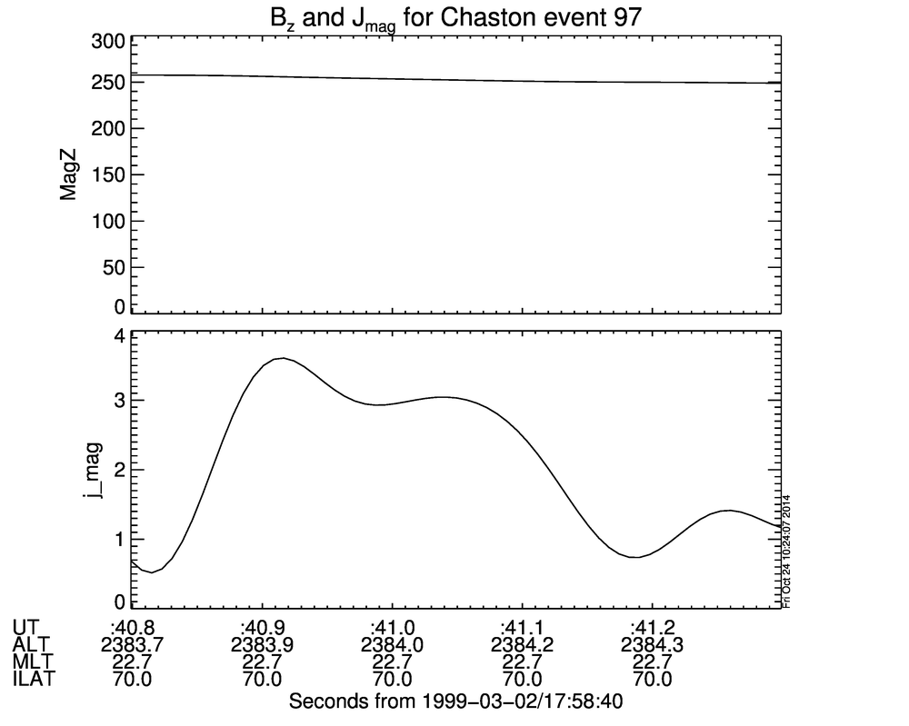97 1999-03-02/17:58:41.049 ??41.463or40.612??
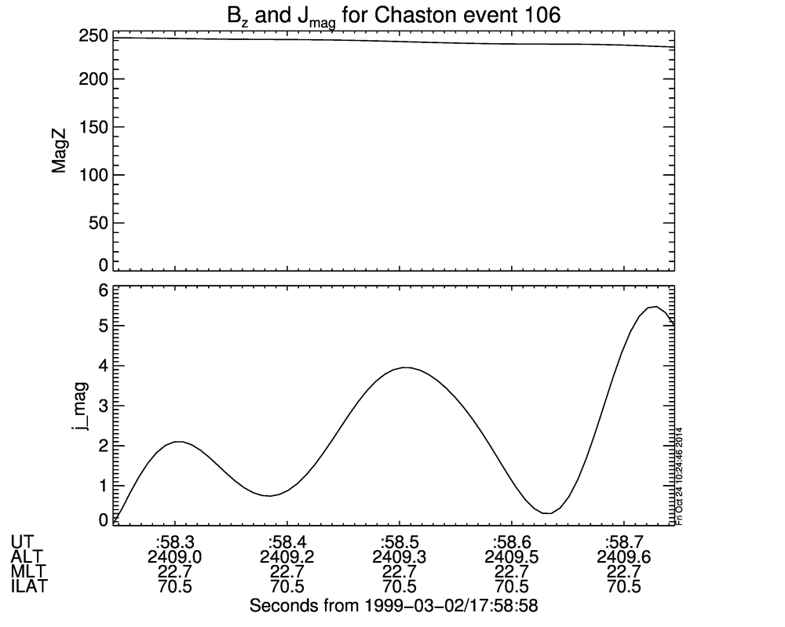106 1999-03-02/17:58:58.495 ??58.112or59.002??
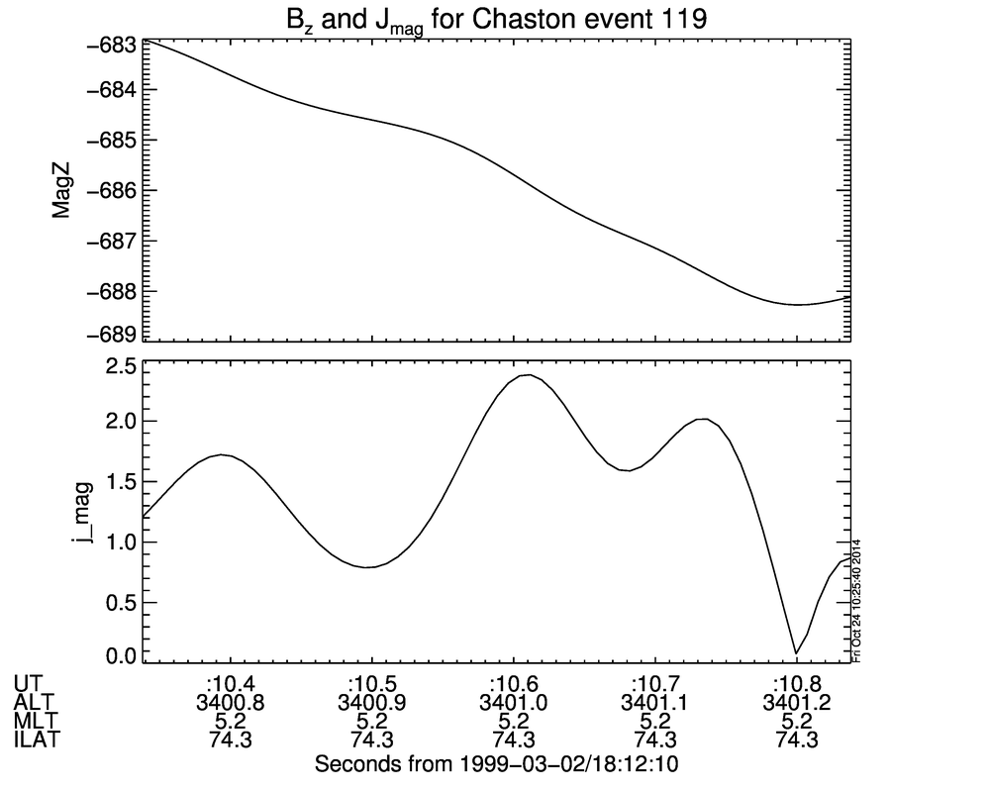119 1999-03-02/18:12:10.588 ??10.213,10.838??
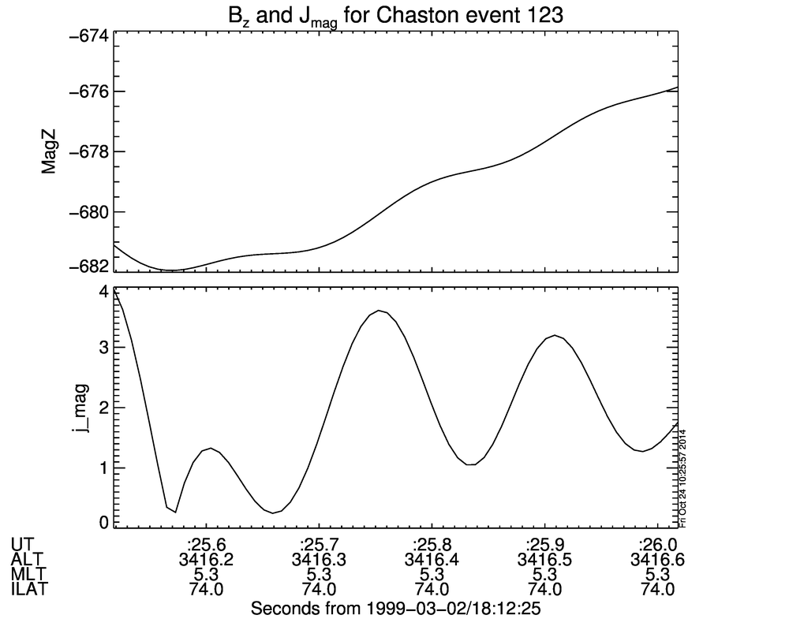123 1999-03-02/18:12:25.768 ??25.510,26.213??
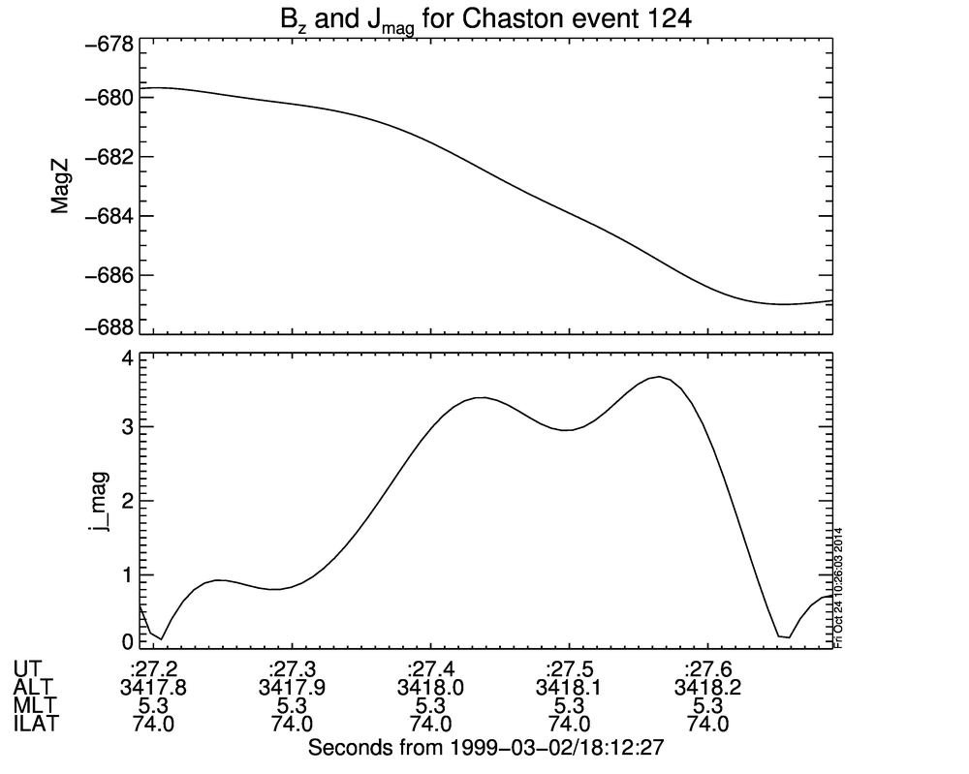124 1999-03-02/18:12:27.440 ??27.151,27.690??
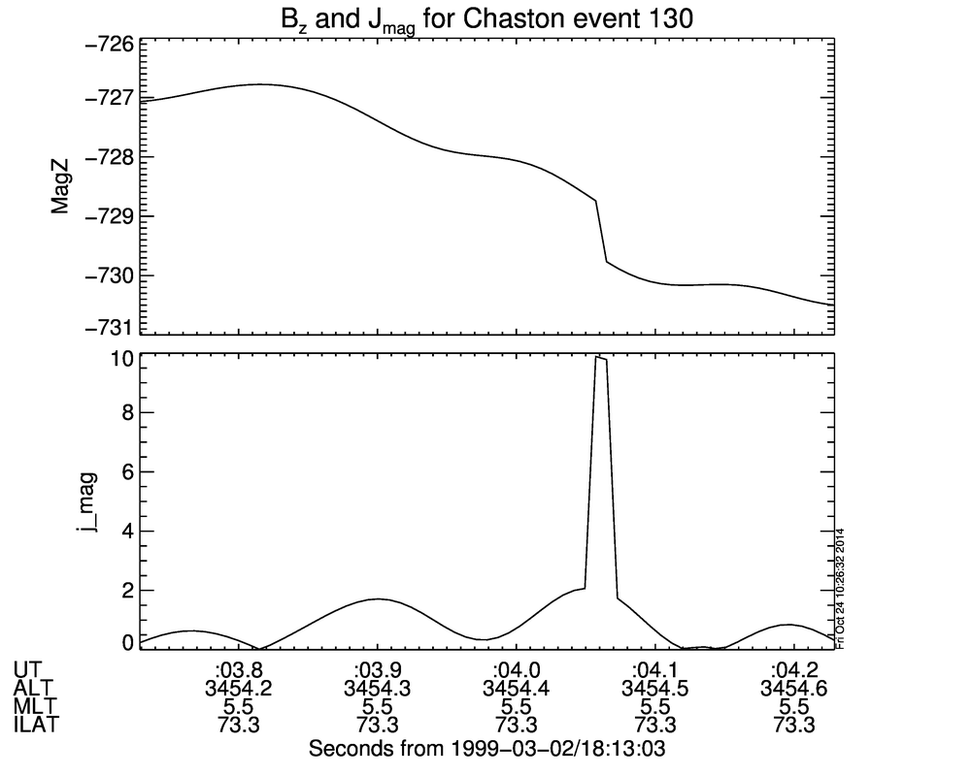130 1999-03-02/18:13:03.979 ??04.057??

