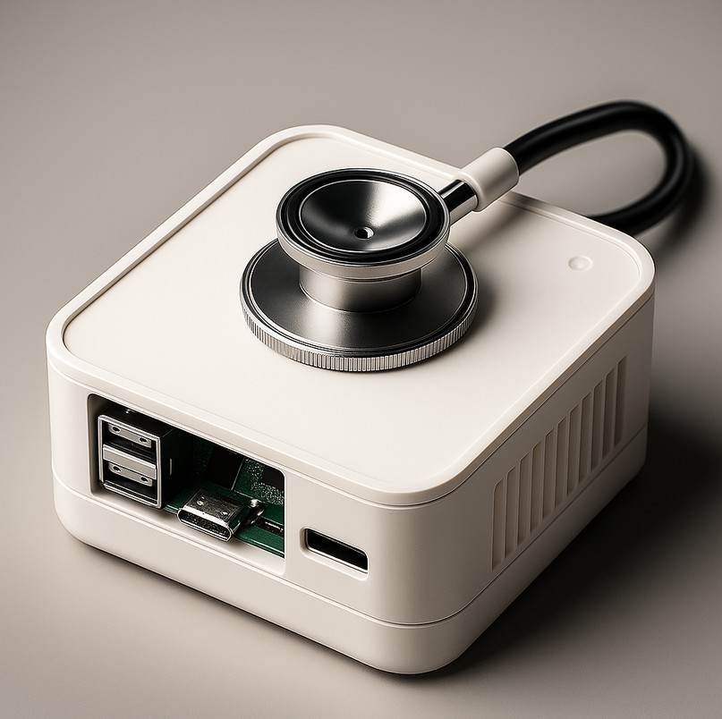PulseX: Deep Learning- Enhanced Heartbeat Audio Analysis for Early Cardiovascular Anomaly

Detection

Mr. Yassine BAZGOUR, Dr. Mohammed AMEKSA Dr. Mohamed-Amine CHADI

**PulseX is an AI system for classifying heart sounds using phonocardiogram (PCG) recordings and demographic data. Trained on 671 WAV samples with a ResNet-18 model, it achieved 92.65% accuracy (binary) and 80.62% accuracy (multi-label). Designed for IoT devices, PulseX enables real-time cardiovascular screening and remote patient monitoring.**

# Problem

**1**

Cardiovascular diseases are often diagnosed late due to limited resources. Traditional auscultation is error-prone. A noise-resilient, automated system is needed for heart sound analysis and detection in remote areas.

# Objective

An AI system combining heart sound analysis and demographics for automated heart condition detection, optimized for Raspberry Pi deployment in real-world monitoring.

**2**

# Methodology

**3**

PulseX classifies heart sounds as normal or abnormal using phonocardiogram (PCG) audio and demographic data. The dataset includes 336 normal and 335 abnormal WAV files with age, gender, smoking status, and region. Audio is converted to Mel-spectrograms and combined with metadata. A ResNet-18 model, extended with a demographic branch, performs binary classification for deployment on IoT-based embedded devices for telemedicine.

**4 Results**

The PulseX model achieved a best binary classification accuracy of 92.65% and an F1-score of 92.96% after training, demonstrating strong ability to distinguish normal from abnormal heart sounds. Precision and recall were 89.19% and 97.06%, confirming reliable detection of abnormal cases. The multi-label classification model achieved 80.62% accuracy and an F1-score of 77.57%, with precision and recall of 81.13% and 80.33%, respectively. Combining Mel-spectrogram audio features with demographic data proved effective for accurate heart sound analysis on embedded platforms like Raspberry Pi, supporting telemedicine applications.

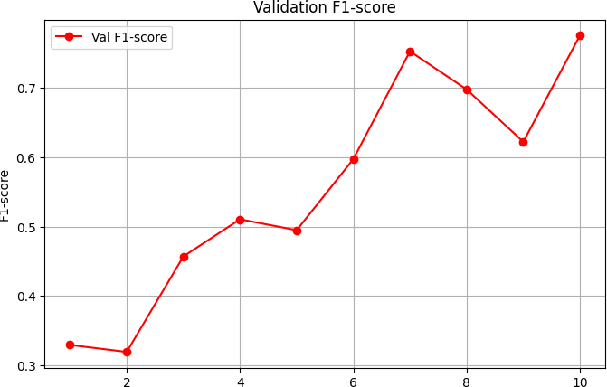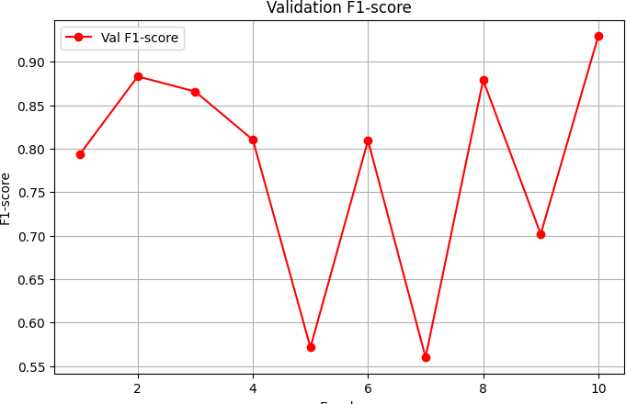

**References**

<https://www.nature.com/articles/s41598-022-18664-0> <https://www.mdpi.com/1424-8220/24/2/398>