REQUIREMENTS |  |  |  |  |  | VERIFICATION
No. | INSPECTION/TEST POINT | TYPE | CONFORMANCE CRITERIA |  | FREQUENCY | RECORDS | BY | INITIAL/DATE | REMARKS
1 | Design Plan | Written | Hold Point  - Design Plan approved  - Any updates / changes to the plan.  - Staging for the Civil Drainage Structures |  | Each Plan | - Design Plan / ITP | RE  CE
2 | Underlying Lots Closed | HP | Hold Point  - All reshape works are complete with relevant Lots closed  - Any reworks identified and documented for action  - Non-conforming grade slopes accepted and approved by SLT Managers |  | Each Lot | - Reference to lots  - ITP HP | SS  CE
3 | Authority to Proceed | Written | - Review all underlying works are complete  - Slope Conformance is accepted |  | Each Lot | - ITP | CE  SMS
4 | Excavation to Design | Survey | - Excavation completed to Design Level  - Excavated surface within acceptable tolerances -200/+500 |  | Each Lot | - Survey Report  - ITP | CE  SS
4 | Unsuitable subgrade Treatment | HP | Site Inspection | Hold Point  - Rejects encountered reshape area identified with photo evidence.  - Authorisation to proceed with capping / treatment of reshape area  - Rejects capped with min. 1 m capping thickness | Each lot | - Hold Point  - ITP  - Inspection | SS  CE
5 | Subgrade Compaction  E | WP | Site Inspection | Witness Point  - Subgrade Compaction complete with Compactor  - Proof roll of subgrade required/ instructed by SE  - Loose debris removed | As required | - Hold Point  - Inspection  - ITP | SS  CE
6 | Rock Stockpile Approval | HP | Site Inspection | Hold Point  - Inspected by SE / CE – Rock size acceptable  - Photos / Analysis recorded  - Rock Size | Each Lot | - ITP  - Inspection | SS  CE
  DESCRIPTION | D50 (mm) | D90 (mm) | D10 (mm)
  LARGE ROCK | 400 | 600 | 200
  SMALL ROCK | 150 | 225 | 75
7 | Geofabric | WP | Site Inspection | Witness Point  - Geofabric Grade / Thickness as Specified  - Overlaps at joints as per Plan Notes  - Pinning in place before rock placement | Each lot | - Witness Point  - Inspection  - ITP | SS  CE
9 | Rock Placement | WP | Site Inspection | Witness Point  - Rock sizing to design size at relevant chainages after placement.  - Uneven rock top area identified and communicated to senior civil supervisor.  - Min. Conveyance depth spot checks undertaken.  - Damage to rock size identified after placement. | Each Lot | - Witness Point  - Inspection  - ITP | SS  CE
10 | Construction Tolerances | HP | Site Inspection | Grade Tolerances(Grade to be ≤ 22.5)  Vertical Geometry Tolerances  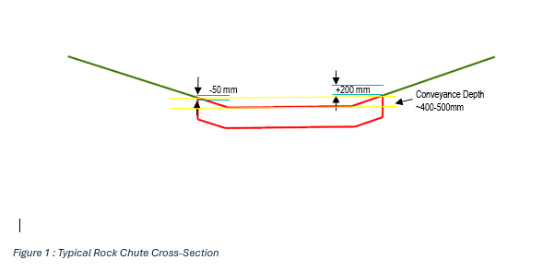 | Each Lot | - Hold Point  - Survey Report  - Inspection  - ITP | SS  CE
  LOCATION | GRADE TOLERANCE (%)
  Pad / Embankment | ± 1
  Open Channel | ± 5
  Contour Drainage | ± 5
  Rock Chute | ± 5
  LOCATION | VERTICAL TOLERANCE (mm)
  Top of earthworks | ± 200
  Contour Drainage | ± 200
  Rock Chute | -50 /+200
11 | Work Complete | Written | - Field work complete subject to any outstanding survey / replacement works within tolerance / acceptable standard  - Final survey and Conformance Report and aerial photos |  | Each lot | - ITP  - Inspection | CE
12 | Lot Closed | Written | - Lot conforms to specifications  - All NCRs actioned and closed  - All conformance reports / test results available |  | Each lot | - ITP  - Survey Report  - Test Results | RE
REFERENCES:

