Tag No. «Name» - «Description»
Subsystem: «ProcessBreakdownIdentifier» - «ProcessBreakdownName»
Drawing No. | «DocumentList» | Task No. | «TaskName»
Additional Information: | «Comments»
\
ITP Ref / No.:
Location / Lot

Item No | Description | Completed by |  | Accepted by |  | Comment
ITEMS TO BE CHECKED PRIOR TO APPROVAL |  | Initials | Date | Initials | Date
 | Verify Lot for works has been identified as per Culverts Schedule
Verify corrugated steel pipes are in accordance with AS1761 or design documentation
- Verify corrugated steel pipe are as per RVS-0000-SPE-Y-001, Sec. 14.2.2
- Verify the lengths of pipes required before installation.
- Corrugated steel pipes cut to length, if required, to minimise wastage and rework.
- Pipe length less than three times the pipe diameter plus two meters shall be used to form either end of the finished pipe.
- If pipe lengths less than above are required to be used, they shall be used in the middle of that culvert.
- Pre-cut pipe sections shorter than 1.0m shall not be used as part of any culvert barrel.
Verify backfill and bedding material is certified for use (Material test report)
- Approved CSF material
- 5% GP Cement Content by weight
- Approved selected Bedding material
 | Verify the centreline of the culverts at the inlet and outlet is pegged and marked out.
Hold Point | Have items 1-4 been checked
Excavate Trench to dimensions specified for the corrugated steel pipe location and design.
Ensure no loose or unsuitable material in trench
Verify MMDD and OMC achieved for prepared foundation for Culvert (test report)
- Minimum 90% MMDD and
- ±3% of OMC
Prepare bedding for culvert and end treatments
- Minimum of 150mm thick bedding layer between the underside of the culvert and general fill foundation.
- Minimum of 250mm thick bedding layer between the underside of the culvert and rock foundation.
- Allow for bedding to be lower at joint locations for banding
- Cement Stabilised Fill or approved material for 400mm along the outlet/inlet to a depth specified in the culvert schedule.
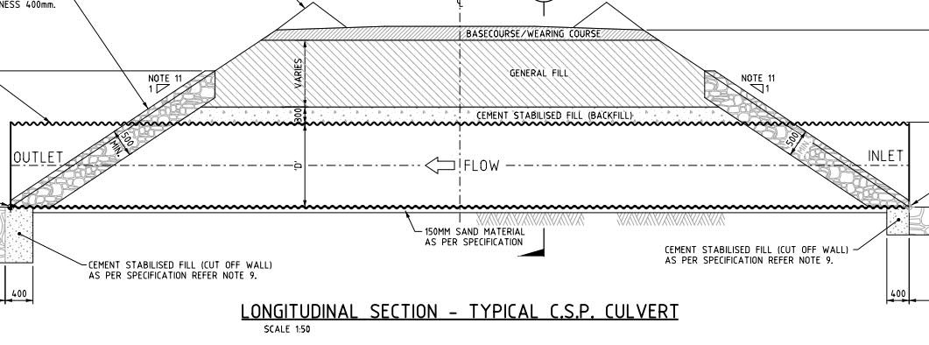
Install corrugated steel pipe onto bedding material and seal together.
- The full length of each barrel section of pipe rests upon bedding material
- Culverts secured in position to avoid “floating”.
- Multiple pipe culverts are laid with a clear distance between the adjacent pipes.
- Sections for multiple culverts are matched and culverts are laid such that the overall lengths of adjacent lines of pipes are the same
Corrugated steel pipes are jointed using coupling bands to form a single unit of length.
- Prior to installation of the coupling bands, the pipes to be aligned vertically, horizontally and pipe spirals match to ensure correct fitting. Bolts firmly tightened and gaps between barrel ends don’t exceed manufacturer’s recommendation.
- All corrugated steel pipes wrapped with 0.45mm thick PVC geo membrane for the full length of the installed pipe.
- The geo membrane to have a minimum overlap of 500mm.
The overlap to be over the top of the pipe.
Check vertical and horizontal alignment of culvert is within tolerances
- Horizontal: ±150mm from design
- Invert level: ±20mm from design level
- Rate of horizontal misalignment must not exceed 10mm in 1m length
Hold  Point | Prior to backfilling Contractor shall certify to the Engineer that all compliance has been achieved.
 | Backfill trench including Haunch and Crown with Cement Stabilised Fill Min. 300mm, unless shown otherwise in the drawings.
Place general fill at 500mm and compact to 300mm layers:
- 3no. tests per lift: 93% MMDD & ±3% OMC
Riprap Installation & geotextile underlay (Inlet & Outlet area):
- Thickness not <1/3 of length of rock, +400mm / -50mm from the lines and grade as per drawing
Hold  Point | Approval of alignment after Backfill, placement and tolerances.

COMMENTS, OBSERVATIONS & ATTACHMENTS (NO PUNCHLIST ITEMS TO BE INCLUDED HERE)
COMPLETED
I hereby confirm the work has been completed in accordance with Contract specified drawings, specifications & standards.
PERFORMED BY CONTRACTOR: |  | REVIEW BY SUPERVISOR/LEAD ENGINEER: |  | EPCM ACCEPTED BY:
Signature: |  | Signature: |  | Signature:
Name: |  | Name: |  | Name:
Title: |  | Title: |  | Title:
Date: |  | Date: |  | Date:

