Tag No. «Name» - «Description»
Subsystem: «ProcessBreakdownIdentifier» - «ProcessBreakdownName»
Drawing No. | «DocumentList» | Task No. | «TaskName»
Additional Information: | «Comments»

Item | Description | OK | N/A | Punch
 | Confirm Earth Bars conform to specification and drawings and connections are clean, tight and secure.
 | Confirm all earth cables are the correct size as per the cable schedule and have correct cable labels numbers attached as/design drawings.
 | Confirm that earth bonding connections to towers, fencing and aux equipment are clean, tight and secure.
 | Confirm that earth electrode connections are clean, tight and secure.
 | Confirm all earth grid and structural bonding connections are clean, tight and secure.
 | Confirm all earth mat bonding connections are clean, tight and secure.
Note: All tests below must be supported by an attached grid and stake layout drawing or Sketch to support the location and identification of test points. Refer to SS-273 for Test Criteria

STEP, TOUCH AND REACH
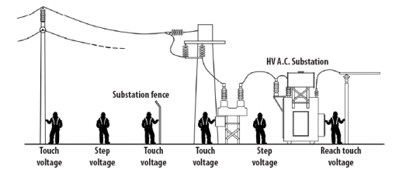
Test Equipment Used
Instrument |  |  |  | Model |  |  |  | Serial Number |  |  | Calibration Date:
Analyser
Voltmeter
Ammeter
Injection Current |  |  |  |  |  |  |  | Injection Frequency (Hz)
Ambient Temperature |  |  |  |  |  |  |  | Soil Conditions: (wet, dry, rock)
Allowable Step and Touch Voltages Reference Standard - (AS2067, IEEE80:2000)
Nominal Fault Current (Amps) |  |  |  |  |  |  | Allowable Step Voltage (Volts)
Backup Clearing Time t (secs) |  |  |  |  | (Ω.m) |  | Allowable Touch Voltage (Volts)
Measurements (Attach Layout Drawing, Standard Drawing or Grid Sketch to indicate configuration and test point locations)
Attach the report generated by the test device
Step,  Touch & Reach | Drawing/ Grid Reference or Description |  |  |  |  | Open Circuit Measured Voltage (mV) |  |  | Loaded (1000 Ω) Voltage (mV) | Injected Current (Amps) | Scaled Voltage (Volts) | Pass/  Fail
 | 1
 | 2
 | 3
 | 4
 | 5
 | 6
 | 7
 | 8
 | 9
 | 10
 | 11
 | 12
 | 13
 | 14
 | 15
 | 16
 | 17
 | 18
 | 19
 | 20
 | 21
 | 22
 | 23
 | 24
Note: Important step voltages: in the centre of large grid meshes, in corner meshes
Note: Important touch voltages: equipment that can be operated (e.g. Air Break Switch (ABS) handle, water tap), external fence corner, open gates, nearby towers, any section of perimeter fence contactable by public or any conductive object connected to perimeter fence.

COMPLETIONS & CLIENT ACCEPTANCE REQUIREMENTS – CONTRACTOR CHECK LIST
Item | Description | Initial | N/A | Comments
 | All site modifications correctly marked up on master drawings as per project procedures.
 | This form must be completed by an Authorised Electrical Worker

COMMENTS, OBSERVATIONS & ATTACHMENTS
(Complete a Punchlist Form and attach if any of the checks above marked as “Punch”)
COMPLETED
I hereby confirm the work has been completed in accordance with Contract specified drawings, specifications & standards.
PERFORMED BY CONTRACTOR: |  | REVIEW BY SUPERVISOR/LEAD ENGINEER: |  | EPCM ACCEPTED BY:
Signature: |  | Signature: |  | Signature:
Name: |  | Name: |  | Name:
EW Licence No.: |  | Title: |  | Title:
Date: |  | Date: |  | Date:

