Tag No. «Name» - «Description»
Subsystem: «ProcessBreakdownIdentifier» - «ProcessBreakdownName»
Manufacturer. | «ManufacturerName» | Model No. | «OEMPartNumber»
Field to record Serial No. | «SerialNumber»
Drawing No. | «DocumentList» | Task No. | «TaskName»
Additional Information: | «Comments»

Item | Description | OK | N/A | Punch
 | Confirm nameplate details as per datasheet and equipment labelling is as per GA and schematic.
 | Confirm equipment and cross arm location and orientation is correct, it has been mounted as per design and all mounting hardware and fasteners are secure and torqued.
 | Confirm all components are free from damage, contamination or corrosion.
 | Confirm phase identification has been fitted where required.
 | Confirm repeatability of operation and alignment of ABS linkages and arc wipes (10 Operations).
 | Confirm the force required for manual operation is accordance with the manufacturers recommendations.
If applicable, confirm EDOs are installed correctly, are of the correct size and rating. Confirm the EDO fuse identification label is attached to the pole.
EDO Id No/s If applicable _____________________________
 | If applicable, confirm EDO repeatability of operation (10 Operations) and alignment
 | If applicable, confirm maintenance access to EDOs from the ground is not impeded by additional pole hardware.
 | If applicable, confirm Fortress key identification and scheme functionality.
 | Confirm bird strike boots and bird prevention measures installed.
 | Confirm Anti-Climb devices are installed as per design
 | Confirm conductor installation and ensure no undue stress on insulator stand-offs.
 | Confirm all earthing including EP bonding, earth grid & stake, earth mat is as per design and installation is in accordance with specification SS-E109
 | Confirm ABS assembly Insulation Resistance
 | Confirm all contact resistance (Ductor) checks and torque values are recorded in the table below. Where possible contact resistance should be measured form the line conductor to the line side of the EDO as shown in image below. Use the diagram below to support test points
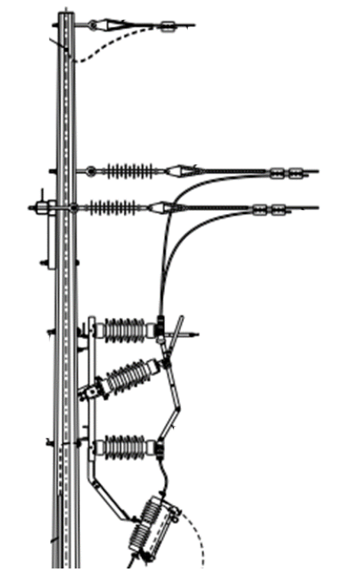
6
5
4
3
2
1
Contact Resistance – Entire Assembly
 | Attach digital photos of ABS Configuration including pole number.
 | Confirm any modifications correctly red lined and as-constructed drawings submitted.

CONTINUITY, PHASING & EARTH
Test Equipment: | Serial No.: | Calibration Date:
Test Points | Point to Point Check (Initial Pass/Fail) | Continuity Check – Result Ω
R-R
W-W
B-B
ABS Assembly E - E Bar |  | Ω
E Bar – E Stake |  | Ω
E Matt – E Bar |  | Ω
Point to Point Confirmed Y N | Continuity OK Pass Fail | Phase Markings Confirmed Y N

ABS ASSEMBLY INSULATION RESISTANCE TEST
Test Equipment |  | Serial No. |  |  | Calibration Due Date:
Test Point | R to W |  | R to B | W to B |  |  | R/W/B to E
Test Voltage | 5 kVDC |  | 5 kVDC | 5 kVDC |  |  | 5 kVDC
Test Duration
Result (GΩ) | GΩ |  | GΩ | GΩ |  |  | GΩ
Refer to SS-E115 for Test Durations and Test Pass Fail Criteria |  |  |  |  |  |  |  | Pass | Fail

CONTACT RESISTANCE - DUCTOR TEST |  |  |  |  | BOLT TORQUE
Ductor Test Equipment: |  |  | Serial No: |  |  |  | Calibration. Date:
Torque Wrench: |  |  | Serial No: |  |  |  | Calibration. Date:
Test Point | Micro Ohms | Test Point  destination |  | Micro Ohms | Ref Point | Torque Nm |  | Ref Point |  | Torque Nm
 | µΩ |  |  | µΩ |  | Nm |  |  |  | Nm
 | µΩ |  |  | µΩ |  | Nm |  |  |  | Nm
 | µΩ |  |  | µΩ |  | Nm |  |  |  | Nm
 | µΩ |  |  | µΩ |  | Nm |  |  |  | Nm
 | µΩ |  |  | µΩ |  | Nm |  |  |  | Nm
 | µΩ |  |  | µΩ |  | Nm |  |  |  | Nm
 | µΩ |  |  | µΩ |  | Nm |  |  |  | Nm
 | µΩ |  |  | µΩ |  | Nm |  |  |  | Nm
 | µΩ |  |  | µΩ |  | Nm |  |  |  | Nm
 | µΩ |  |  | µΩ |  | Nm |  |  |  | Nm
 | µΩ |  |  | µΩ |  | Nm |  |  |  | Nm
 | µΩ |  |  | µΩ |  | Nm |  |  |  | Nm
Refer to SS-E115 for Test Durations and Test Pass Fail Criteria
Contact Resistance Test Current: Contact Resistance Test Compliance |  |  |  |  |  |  |  |  | Pass |  | Fail

Item | Description | OK | N/A | Punch
 | Confirm separation - Phase to Phase and Phase to Earth clearance distances have been maintained as per design.

DIGITAL PHOTOGRAPHS
Digital photos required: Digital photos of significant terminations and general installation are to be identified and submitted with this ITR.
Photo ID |  | Description | Taken By

COMPLETIONS & CLIENT ACCEPTANCE REQUIREMENTS – CONTRACTOR CHECK LIST
Item | Description | Initial | N/A | Comments
 | All site modifications correctly marked up on master drawings as per project procedures.
 | This form must be completed by an Authorised Electrical Worker.

COMMENTS, OBSERVATIONS & ATTACHMENTS
(Complete a Punchlist Form and attach if any of the checks above marked as “Punch”)
COMPLETED
I hereby confirm the work has been completed in accordance with Contract specified drawings, specifications & standards.
PERFORMED BY CONTRACTOR: |  | REVIEW BY SUPERVISOR/LEAD ENGINEER: |  | EPCM ACCEPTED BY:
Signature: |  | Signature: |  | Signature:
Name: |  | Name: |  | Name:
EW Licence No.: |  | Title: |  | Title:
Date: |  | Date: |  | Date:

