Tag No. «Name» - «Description»
Subsystem: «ProcessBreakdownIdentifier» - «ProcessBreakdownName»
Manufacturer. | «ManufacturerName» | Model No. | «OEMPartNumber»
Field to record Serial No. | «SerialNumber»
Drawing No. | «DocumentList» | Task No. |  | «TaskName»
Additional Information: | «Comments»

Item | Description | OK | N/A | Punch
 | Tag nameplate (or stamping) is clear, legible, of correct material and securely fitted to the equipment.
 | Device location and orientation is correct as per standard drawing MA-000-M-1047
 | Belt Drift mounting allows suitable mechanical adjustment for alignment and orientation with regards to the belt position.
 | Belt Drift rocker arm has been aligned correctly with belt direction.
 | Belt Drift Rocker arm roller is within the specified operating distance of the belt (i.e. 10mm and 50mm) as per the standard drawing.
 | Inspect all components for damage, contamination or corrosion.
 | Confirm cable terminations are in accordance with termination diagram(s)
 | Check terminations to ensure that all terminals, nuts, washers and spring washers are in place and all wires are ferruled correctly.
 | Confirm all unused cable entries are plugged with suitable blanks.
 | All spare cores are terminated and ferruled as spare.
 | Terminals are numbered with one wire per terminal.
 | Confirm equipment earth bonding is connected as per applicable drawings.
 | All gaskets, seals and sight glasses are intact.
 | Circuit left safe and ready for energisation.

Safe-T-Drift
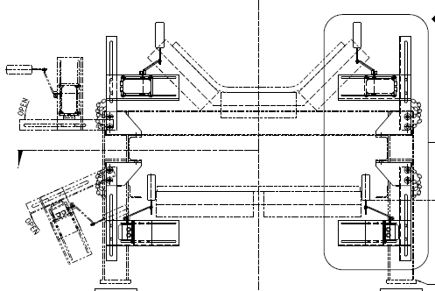

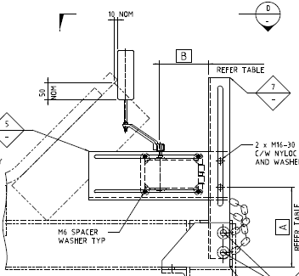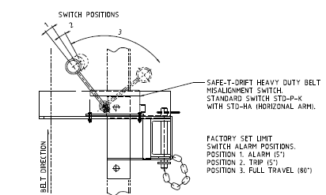

COMMENTS, OBSERVATIONS & ATTACHMENTS
(Complete a Punchlist Form and attach if any of the checks above marked as “Punch”)
COMPLETED
I hereby confirm the work has been completed in accordance with Contract specified drawings, specifications & standards.
PERFORMED BY CONTRACTOR: |  | REVIEW BY SUPERVISOR/LEAD ENGINEER: |  | EPCM ACCEPTED BY:
Signature: |  | Signature: |  | Signature:
Name: |  | Name: |  | Name:
EW Licence No.: |  | Title: |  | Title:
Date: |  | Date: |  | Date:

