Tag No. «Name» - «Description»
Subsystem: «ProcessBreakdownIdentifier» - «ProcessBreakdownName»
Manufacturer. | «ManufacturerName» | Model No. | «OEMPartNumber»
Field to record Serial No. | «SerialNumber»
Drawing No. | «DocumentList» | Task No. |  | «TaskName»
Additional Information: | «Comments»

Item | Description | OK | N/A | Punch
This check sheet applies to Three different installation types of the Belt Rip Switch.
Section 1 is applicable to all types of installations.
Make the correct selection on other sections based on the applicable installation type below.
Section 1 - Common to all Belt Rip Detector/Switch installations
PHYSICAL CHECKS
 | Mounting is firm, IP rating not compromised and not subject to vibration.
 | IP rating is correct.
 | Labelling is correct
 | Device location is correct as per conveyor layout
 | Surface finish is undamaged.
 | Cable service loop is sufficient for range of adjustment.
 | All gaskets and seals are intact.
 | Cable glands are correct and shrouded if applicable.
 | Bootlace pins or approved lugs are used on all wires and are firmly crimped.
 | Wiring looms are neat.
 | All wires are ferruled and ferrules are correct.
 | All spare cores are terminated and ferruled as spare.
 | Terminals are numbered, firmly tightened with one wire per terminal.
 | Check terminations to ensure that all nuts, washers and spring washers are in place.
 | Inspect internal equipment for defects or damage.
 | Equipment clean and free from debris internally and externally.
 | Circuit left safe and ready for energisation.
Section 2 – Applicable to Through Belt Type Belt Rip Detector (Type 1)
 | Type 1 - As per standard drawing MA-0000-M-1048
 | 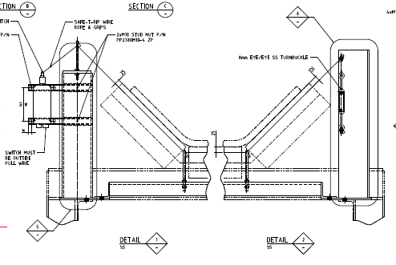
 | Device installation and orientation is correct as per standard drawing MA-0000-M-1048.
 | Confirm installation, orientation and alignment is not impacted by adjacent structural steel, removable guards or other mechanical equipment.
 | Confirm the installation bracket is in accordance with the Belt Angle profile and provides for adjustment.
 | Confirm Instrument rip wire is correctly routed through all eye bolts, fixed guides and spring guides
 | Confirm the rip wire is free of any wear or damage and rope grips are tensioned.
 | Confirm Instrument rip wire is correctly aligned with the belt profile with 25mm of separation maintained over the entire belt.
 | Confirm the rip wire turnbuckle tension and insertion mounting of the rip switch plug is satisfactory.
 | Confirm the rip switch plug tether is of adequate length and does not interfere with belt or structure when in the disengaged state.
Section 3 – Applicable to Tail Pulley String Type Belt Rip Detector (Type 2)
 | Type 2 - As per standard drawing MA-0000-M-1050
 | 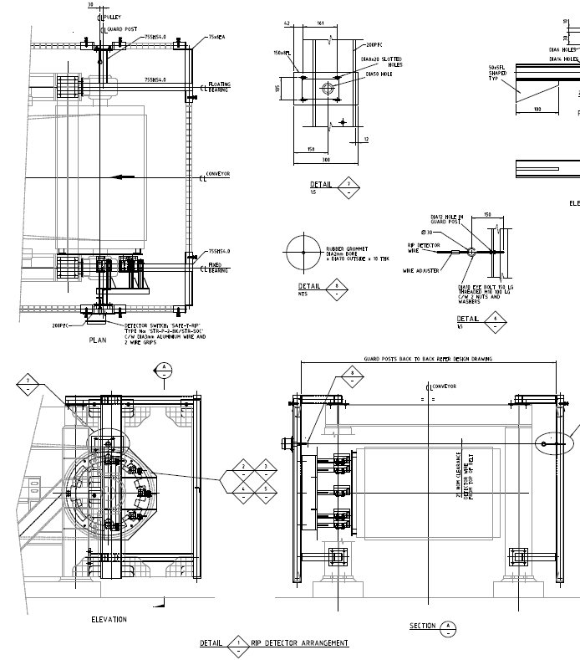
 | Device location and orientation is correct as per standard drawing MA-0000-M-1050
 | Confirm installation, orientation and alignment is not impacted by adjacent structural steel, removable guards or other mechanical equipment.
 | Confirm rip wire and switch mounting allows suitable mechanical adjustment for switch and trip wire lateral alignment.
 | Confirm the rip wire is free of any wear or damage and rope grips are tensioned.
 | Confirm Instrument rip wire is correctly aligned with the belt pulley profile with 25mm of separation maintained over the entire belt.
 | Confirm the rip wire turnbuckle tension and insertion mounting of the rip switch plug is satisfactory.
 | Confirm the rip switch plug tether is of adequate length and does not interfere with belt or structure when in the disengaged state.
Section 4 – Applicable to Pan Type Belt Rip Detector (Type 3)
 | Type 3 - As per standard drawing MA-0000-M-1049
 | 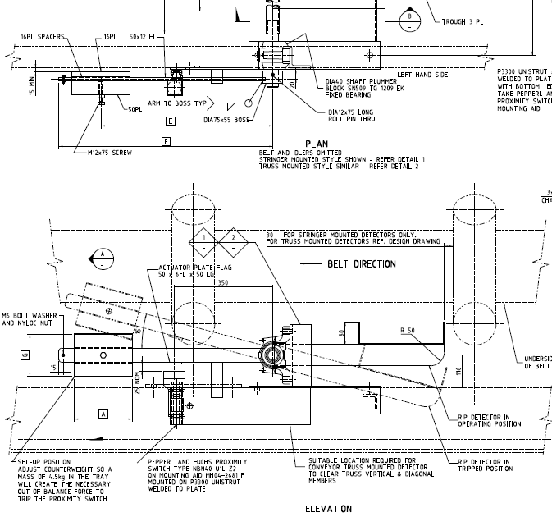
 | Device location and orientation is correct as per standard drawing MA-0000-M-1049.
 | Confirm the Pan and pivot mechanism is securely fastened and the Pan pivots through the full range of required movement and is not obstructed by conveyor structure.
 | Load the Pan with 4.5kG and adjust the counterweights to confirm RIP detector Operation. Secure the counterweights
 | Confirm Sensor mounting allows suitable mechanical adjustment for alignment and orientation with regards to its actuator plate flag.
 | Confirm Sensor mounting allows for 20mm separation between the sensor face and actuator plate in the operating position and greater than 100mm of separation in the tripped position. .

COMPLETIONS & CLIENT ACCEPTANCE REQUIREMENTS – CONTRACTOR CHECK LIST
 | Item |  |  |  | Initial | N/A | Comments
1 | All site modifications correctly marked up on master drawings as per project procedures.
2 | All Punchlist items noted on a separate Punchlist form and submitted for.
COMMENTS, OBSERVATIONS & ATTACHMENTS
(Complete a Punch List Form and attach if any of the checks above marked as “Punch”)
COMPLETED
I hereby confirm the work has been completed in accordance with Contract specified drawings, specifications & standards.
PERFORMED BY CONTRACTOR: |  |  | REVIEW BY SUPERVISOR/LEAD ENGINEER: |  |  |  |  | EPCM ACCEPTED BY:
Signature: |  |  | Signature: |  |  |  |  | Signature:
Name: |  |  | Name: |  |  |  |  | Name:
Licence No: |  |  | Title: |  |  |  |  | Title:
Date: |  |  | Date: |  |  |  |  | Date:

