Tag No. «Name» - «Description»
Subsystem: «ProcessBreakdownIdentifier» - «ProcessBreakdownName»
Manufacturer. | «ManufacturerName» | Model No. | «OEMPartNumber»
Field to record Serial No. | «SerialNumber»
Drawing No. | «DocumentList» | Task No. |  | «TaskName»
Additional Information: | «Comments»

This check sheet applies to four different installation types of the Blocked Chute Detector.
Section 1 is applicable to all types of installations.
Make the correct selection on other sections based on the applicable installation type below.
Item | Description | OK | N/A | Punch
Section 1 - Common to all Blocked Chute Detector Installations
 | Tag nameplate (or stamping) is clear, legible, of correct material and securely fitted to the equipment.
 | Inspect all components for damage, contamination, corrosion or poor quality.
 | Confirm installation location and instrument type is in accordance with the design.
 | If applicable confirm device mounting allows suitable mechanical adjustment for alignment and orientation.
 | If applicable confirm able service loops are sufficient to support the blocked chute detectors full range of movement
 | Inspect the field location of the installation to ensure the blocked chute detectors is accessible for maintenance.
 | Check mountings to ensure that all nuts, washers and spring washers are in place and tensioned correctly.
 | Confirm all unused cable entries are plugged with suitable blanks.
 | Confirm all cable terminations are correct as per the drawings
 | Confirm all spare cores are terminated and ferruled as spare.
 | Confirm terminals are numbered, firmly tightened with one wire per terminal.
 | Confirm equipment earth bonding is connected as per applicable drawings.
 | Confirm the circuit left safe and ready for energisation.
Section 2 –Chute Wall External Type 1 and External Type 2 Proximity Sensors Type 1 Type 2
 | Type 1 (Chute Wall Membrane) Sensor – Confirm the location and orientation is correct as per standard drawing MA-0000-M-1118 as shown below
 | Confirm the sensor mounting bracket allows suitable mechanical alignment and adjustment with regards to the sensing bolt.
 | Confirm the membrane seals against the chute wall
 | Confirm the membrane material is of the recommended type and suitably flexible enough to distort to the sensor.
 | Confirm the sensor head is installed with at least 50mm of clearance around the sensor head.
 | Confirm the sensor distance has a nominal 50mm operating distance with equal adjustment of the sensor mount either side of this nominal location.

Item | Description |  | OK |  | N/A |  | Punch
 | 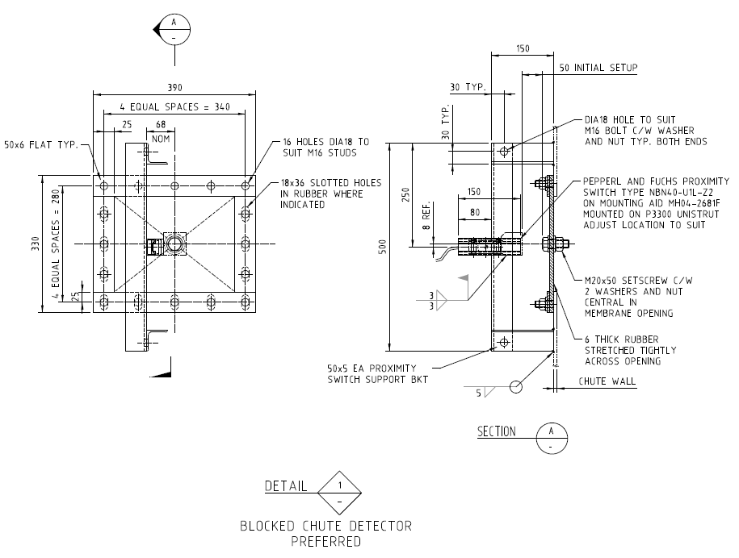
 | Type 2 (In Access Door) Sensor, the location and orientation is correct as per standard drawing MA-0000-M-1118 as shown below
 | Confirm the sensor mounting bracket allows suitable mechanical alignment and adjustment.
 | Confirm the door seals against the chute wall in its normal un-operated state.
 | Confirm the door is aligned and swings freely with light pressure
 | Confirm the sensor head is installed with at least 50mm of clearance around the sensor head.
 | Confirm the sensor trip plate is nominally 20mm operating distance of sensor face.
 | 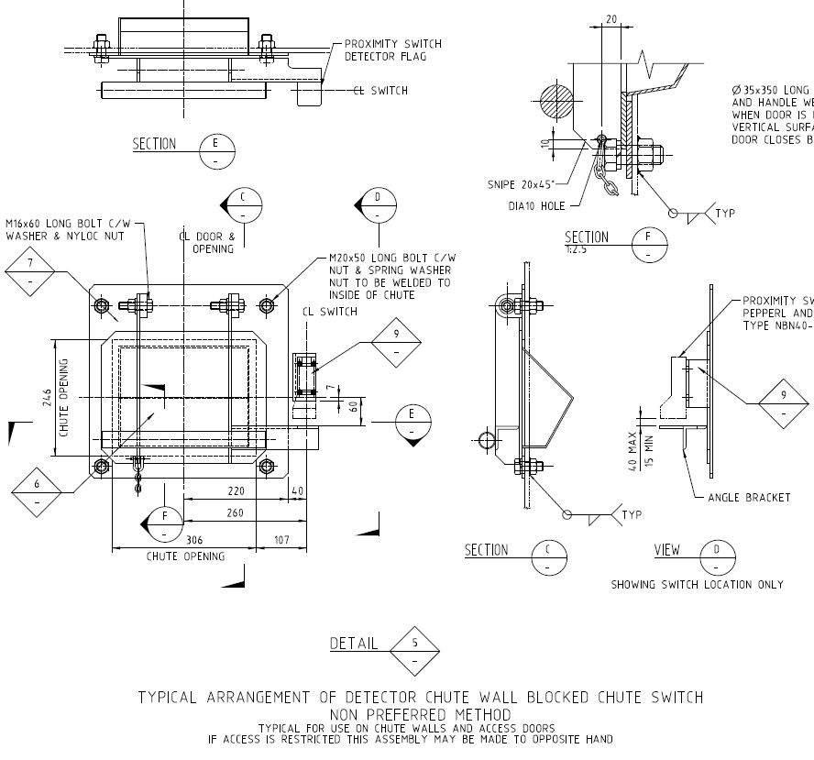

Section 3 – Applicable to Type 3 Microwave Switch (Screen & Feeder Discharge Chutes). N/A
 |  | OK | N/A | Punch
 | Confirm chute penetration Weldment windows and microwave remote sender and remote receiver mounting brackets are installed in the correct location as per chute design drawings and as per standard MA-0000-M-1117.
 | Confirm sender and receiver directional centreline alignment in both horizontal and vertical planes
 | Confirm Sender and Receiver sensor face is mounted with a nominal 50mm setback from the Weldment window.
 | Confirm remote amplifier / controller is installed in the correct location as per design drawings.
Section 4 – Applicable to Type 4 (Side or Top Entry) Tilt Sensor. N/A
 |  | OK | N/A | Punch
 | The location and orientation is correct as per standard drawing MA-0000-M-1118 as shown below
 | 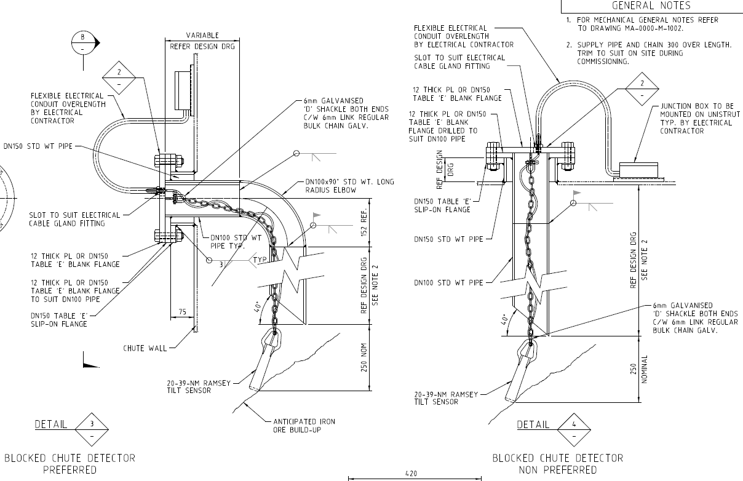
 | Ensure the blocked chute Internal cable and chain has sufficient spare length to allow vertical adjustment of the Tilt sensor height for future tuning as it applies to the process material.

COMPLETIONS & CLIENT ACCEPTANCE REQUIREMENTS – CONTRACTOR CHECK LIST
 | Item |  |  |  | Initial | N/A | Comments
1 | All site modifications correctly marked up on master drawings as per project procedures.
2 | All Punchlist items noted on a separate Punchlist form and submitted for.
COMMENTS, OBSERVATIONS & ATTACHMENTS
(Complete a Punch List Form and attach if any of the checks above marked as “Punch”)
COMPLETED
I hereby confirm the work has been completed in accordance with Contract specified drawings, specifications & standards.
PERFORMED BY CONTRACTOR: |  |  | REVIEW BY SUPERVISOR/LEAD ENGINEER: |  |  |  |  | EPCM ACCEPTED BY:
Signature: |  |  | Signature: |  |  |  |  | Signature:
Name: |  |  | Name: |  |  |  |  | Name:
Licence No: |  |  | Title: |  |  |  |  | Title:
Date: |  |  | Date: |  |  |  |  | Date:

