Tag No. «Name» - «Description»
Subsystem: «ProcessBreakdownIdentifier» - «ProcessBreakdownName»
Manufacturer. | «ManufacturerName» | Model No. | «OEMPartNumber»
Field to record Serial No. | «SerialNumber»
Drawing No. | «DocumentList» | Task No. |  | «TaskName»
Additional Information: | «Comments»

Item | Description |  |  |  |  |  |  |  |  | OK | N/A | Punch
 | Tag nameplate (or stamping) is clear, legible, of correct material and securely fitted to the equipment.
 | Inspect all components for damage, contamination, corrosion or poor quality.
 | Confirm installation location and instrument type is in accordance with the design.
 | Confirm device mounting allows suitable mechanical adjustment for alignment and orientation.
 | If applicable confirm sunshade is fitted to installations exposed to direct sunlight.
 | Inspect the field location of the installation to ensure all metal detector components are accessible for maintenance.
 | Check all mountings to ensure that all nuts, washers and spring washers are in place and tensioned correctly.
 | Confirm all unused cable entries are plugged with suitable blanks.
 | Confirm all cable terminations are correct as per the drawings
 | All spare cores are terminated and ferruled as spare.
 | Terminals are numbered, firmly tightened with one wire per terminal.
 | Confirm equipment earth bonding is connected as per applicable drawings.
 | Optimal Installation of the Metal Detector instrument coil frames must take into account the following best practice.
 | Instrument coil is not installed within 5.5 meters of Magnet.
 | Instrument coil must not be located within 1.2 meters of Metal deck plates or skirt boards.
 | Top View
 | Instrument coil must not be located within 2.4 meters of Metal feed chutes or discharge chutes.
 | Instrument coil is located such that the conveyor will stop before the tramp is discharged.
 | Side View
 | Instrument coil is located on the centreline between idler frames.
 | 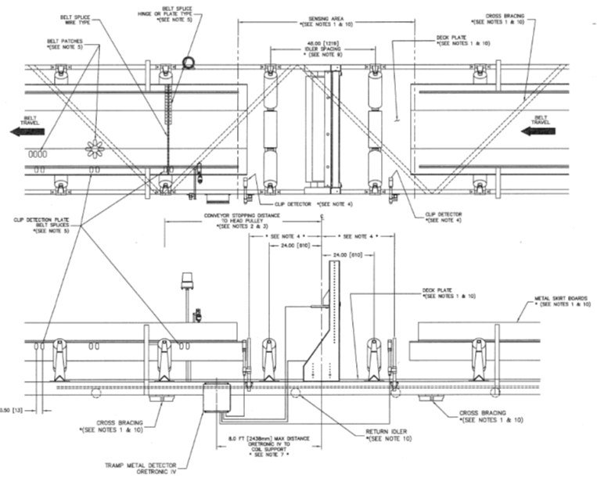
 | Idler spacing at the coil location must be greater than 1.2 m. If for mechanical reasons this spacing is not possible, the distance may be reduced by using rubber impact-type idlers.
 | To prevent signal loss insure the instrument coil positioning is not unnecessarily obstructed or interfered with by cross bracing, structural steel work or conveyor covers.
 | Instrument coil is correctly installed with the regards to the belt travel direction. The top transmitter coil must swing away with the direction of travel in high burden situations.
 | The lower instrument receiver coil (Underside belt) must be positioned 25 – 50mm below the belt line. The belt must not be able to rub on the receiver coil.
 | Optimal Installation of the Metal Detector instrument Control Panel must take into account the following best practice.
 | The Control Panel enclosure should be mounted in a vibration-free area less than 3m from the instrument coils.
 | - The instrument Coils shall be installed such that the cables are on the same side as the control panel.
 | - The instrument coil cables can be shortened but cannot be spliced.
 | 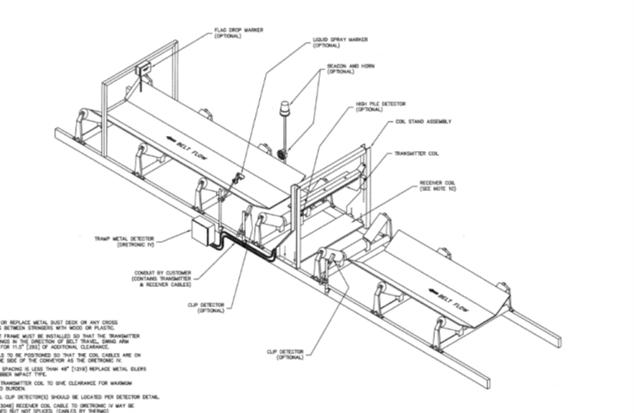
 | - The top coil high burden switch shall be mounted in such a manner that the actuator arm operates in the correct direction with transmitter coil and the direction of belt travel.
 | 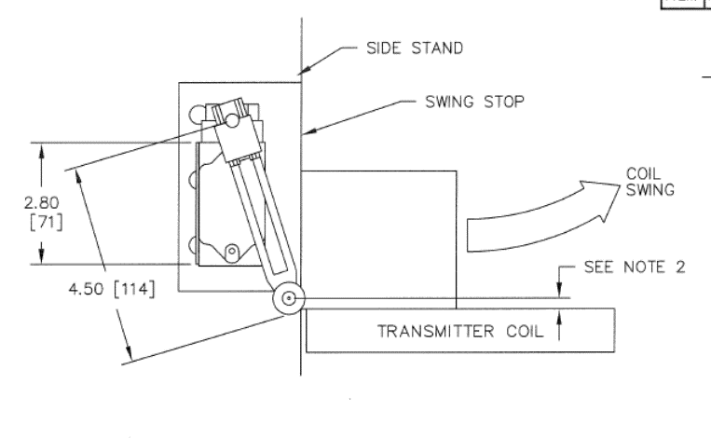
 | Confirm cables are properly segregated, supported and do not obstruct maintenance or operability of installation.
 | Confirm instrument Flag drop stand, mounting hardware and accessories are correctly located and installed.
 | Confirm Trip Indicator stand, mounting hardware and accessories are correctly located and installed.
 | Circuit left safe and ready for energisation.
 | Perform continuity test between main earth and all internal earthed equipment, devices, enclosure and other conductive parts with results recorded below
EARTH CONTINUITY TESTS
Test Equipment: |  |  |  | Serial No: |  |  |  | Calibration Date:
Equipment/Structure Type Connection to Main Earth: |  |  |  |  |  |  |  |  | Resistance Result:
1
2
COMPLETIONS & CLIENT ACCEPTANCE REQUIREMENTS – CONTRACTOR CHECK LIST
 |  | Item |  |  | Initial | N/A | Comments
1 |  | All site modifications correctly marked up on master drawings as per project procedures.
2 |  | All Punchlist items noted on a separate Punchlist form and submitted for.
3 |  | This form must be completed by an Authorised Electrical Worker.
COMMENTS, OBSERVATIONS & ATTACHMENTS
(Complete a Punch List Form and attach if any of the checks above marked as “Punch”)
COMPLETED
I hereby confirm the work has been completed in accordance with Contract specified drawings, specifications & standards.
PERFORMED BY CONTRACTOR: |  | REVIEW BY SUPERVISOR/LEAD ENGINEER: |  | EPCM ACCEPTED BY:
Signature: |  | Signature: |  | Signature:
Name: |  | Name: |  | Name:
Licence No: |  | Title: |  | Title:
Date: |  | Date: |  | Date:

